IEEE P802.11
Wireless LANs
TGn LB84 Submission Wrapper Control and +HTC Frames
Date: 2006-12-7
Author(s):
Name | Company | Address | Phone | email
Peter Loc | Marvell |  |  | ploc@marvell.com
Yuichi Morioka | Sony Corp |  |  | morioka@wcs.sony.co.jp
Vincenzo Scarpa | ST Micro |  |  | vincenzo.scarpa@st.com
Tomoko Adachi | Toshiba |  |  | tomo.adachi@toshiba.co.jp

Abstract
This document contains proposed changes to the IEEE P802.11n Draft in response to CIDs 4047 and 1553 which ask for a clarification on the frames that are intended to carry the HTC field. Since the Wrapper Control and +HTC are different types of frames that can be both used to carry the HTC field, there is a need to differentiate the support of the HT device for transmitting the wrapper control frame versus receiving +HTC frame which is carried in a QoS Null data frame. A newly proposed “Wrapper Transmit” bit is used by the HT device to declare its capability to transmit a Wrapper Control frame. Once this support is declared, the HT device is expected to respond to an incoming wrapper control frame with a wrapper control frame. If the wrapper transmit is not supported, the HT may still be able to receive a +HTC frame or a wrapper control frame if it declares support for receiving +HTC but it will respond with a +HTC frame or a regular frame.

Notice: This document has been prepared to assist IEEE 802.11. It is offered as a basis for discussion and is not binding on the contributing individual(s) or organization(s). The material in this document is subject to change in form and content after further study. The contributor(s) reserve(s) the right to add, amend or withdraw material contained herein.

Release: The contributor grants a free, irrevocable license to the IEEE to incorporate material contained in this contribution, and any modifications thereof, in the creation of an IEEE Standards publication; to copyright in the IEEE’s name any IEEE Standards publication even though it may include portions of this contribution; and at the IEEE’s sole discretion to permit others to reproduce in whole or in part the resulting IEEE Standards publication. The contributor also acknowledges and accepts that this contribution may be made public by IEEE 802.11.

Patent Policy and Procedures: The contributor is familiar with the IEEE 802 Patent Policy and Procedures <http:// ieee802.org/guides/bylaws/sb-bylaws.pdf>, including the statement "IEEE standards may include the known use of patent(s), including patent applications, provided the IEEE receives assurance from the patent holder or applicant with respect to patents essential for compliance with both mandatory and optional portions of the standard." Early disclosure to the Working Group of patent information that might be relevant to the standard is essential to reduce the possibility for delays in the development process and increase the likelihood that the draft publication will be approved for publication. Please notify the Chair <stuart.kerry@philips.com> as early as possible, in written or electronic form, if patented technology (or technology under patent application) might be incorporated into a draft standard being developed within the IEEE 802.11 Working Group. If you have questions, contact the IEEE Patent Committee Administrator at <patcom@ieee.org>.

Introduction

Interpretation of a Motion to Adopt
A motion to approve this submission means that the editing instructions and any changed or added material are actioned in the TGn Draft. This introduction is not part of the adopted material.

Editing instructions formatted like this are intended to be copied into the TGn Draft (i.e. they are instructions to the 802.11 editor on how to merge the TGn amendment with the baseline documents).

TGn Editor: Editing instructions preceded by “TGn Editor” are instructions to the TGn editor to modify existing material in the TGn draft. As a result of adopting the changes, the TGn editor will execute the instructions rather than copy them to the TGn Draft.

Summission Note: Notes to the reader of this submission are not part of the motion to adopt. These notes are there to clarify or provide context.

CIDs 4047, 1553

Summission Note: Beginning of commentary regarding the CID that is not part of the proposed TGn draft specification text changes:

Proposed resolution:

CID | Name | Page(Ed) | Line(Ed) | Clause(Ed) | Comment | Proposed Change | Proposed Resolution
4047 | Kerry, Stuart | 15 | 16 | 7.1.3.1.10 | "The HT Control Field may be included in any frame except a non-QoS Data frame." implies that this may be used in control or management frames. I believe that this is not the intention. | "The HT Control Field may be included only in QoS Data frames." If the intention is really to use it also in control or management frames, a bunch of further changes in the corresponding sections would be required. | Counter – The resolution proposed here is complementary to the resolution shown in 11-06-1886-02-0000n-tgn-lb8-submission-htc-not-legacy.doc.. A new capability bit “WTx” is added to the HT extended capability field to declare the support for the transmission of the Wrapper Control frame. New text is added (as shown below) to clarify the inter-relationship of the +HTC and WTx bits.
1553 | Haisch, Fred | 22 | 9 | 7.2.1 | Isn't the HT control field included in HT Control Frames. If so, this needs to be reflected in Clause 7.2.1 | See Comment. | Current resolution - Deferred until a decision is made on which frame types can carry HTC fields.

Summission Note: End of commentary regarding the CID that is not part of the proposed TGn draft specification text changes:

TGn Editor: In 7.3.2.46.5, change bit B12 of the extended capabilities field (Figure n41) from reserved to Wrapper Control Tx (WTx) bit to indicate the support for the transmission of the Wrapper Control frame and add appropriate text in table n22 to specify the setting to WTx bit to 0 if not supported or 1 if supported.
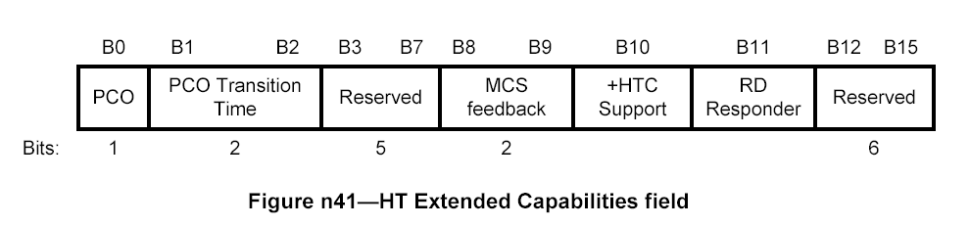

TGn Editor: Add a subclause after 9.7a to define the response to +HTC or Wrapper Control frame as follows

- +HTC = 0 (in this case, WTx must be zero)
Transmission of +HTC and Wrapper control frames are not supported.
This HT-STA shall honor the MAC/Duration ID field of +HTC and wrapper control frame. An HT-STA shall not address a +HTC or Wrapper Control frame to this HT-STA.

2) +HTC = 1 and WTx = 0
Transmission of +HTC frame is supported. Transmission of wrapper control frame is not supported.

An HT-STA may address either +HTC or Wrapper Control frame to this HT-STA.
This HT-STA shall honor the MAC/Duration ID field of +HTC and wrapper control frame. HT-STA that indicates this capability shall respond to a +HTC frame with a +HTC frame. HT-STA that indicates this capability shall respond to a Wrapper Control frame with a +HTC or a regular frame.

3) +HTC = 1 and WTx = 1
Transmission of +HTC or Wrapper control frames are supported.
This HT-STA shall honor the MAC/Duration ID field of +HTC and wrapper control frame. HT-STA that indicates this capability shall respond to a +HTC frame with a +HTC frame and to a Wrapper Control frame with a Wrapper Control frame.

