IEEE P802.11
Wireless LANs
Calibrated Over Air Test (COAT) Methodology
Date: 11-13-2006
Author(s):
Name | Company | Address | Phone | Email
Mark Kobayashi | Broadcom Corporation | 190 Mathilda Place  Sunnyvale, CA 94086 | 408-543-3318 | mmk@  broadcom.com
Dalton Victor | Broadcom Corporation | 190 Mathilda Place  Sunnyvale, CA 94086 | 408-922-5824 | dvictor@  broadcom.com

Abstract

This document provides an environment for creating path loss in a Calibrated Over Air Test (COAT). The purpose of this document is to define a procedure that will result in repeatable, reliable and comparable results. This environment is to be applied when executing a COAT test of a metric or sub-metric. All text presented is to be inserted into the TGT recommended practice document with editorial changes.
This document addresses the following CIDs: 7, 8, 10, 11, 13, 14, 15, 18, 20, 23, 29, 30, 31, 141, 229, 282
The editor is instructed to replace section 5.2 with the contents of this document minus the tracking comment.

Notice: This document has been prepared to assist IEEE 802.11. It is offered as a basis for discussion and is not binding on the contributing individual(s) or organization(s). The material in this document is subject to change in form and content after further study. The contributor(s) reserve(s) the right to add, amend or withdraw material contained herein.
Release: The contributor grants a free, irrevocable license to the IEEE to incorporate material contained in this contribution, and any modifications thereof, in the creation of an IEEE Standards publication; to copyright in the IEEE’s name any IEEE Standards publication even though it may include portions of this contribution; and at the IEEE’s sole discretion to permit others to reproduce in whole or in part the resulting IEEE Standards publication. The contributor also acknowledges and accepts that this contribution may be made public by IEEE 802.11.
Patent Policy and Procedures: The contributor is familiar with the IEEE 802 Patent Policy and Procedures <http:// ieee802.org/guides/bylaws/sb-bylaws.pdf>, including the statement "IEEE standards may include the known use of patent(s), including patent applications, provided the IEEE receives assurance from the patent holder or applicant with respect to patents essential for compliance with both mandatory and optional portions of the standard." Early disclosure to the Working Group of patent information that might be relevant to the standard is essential to reduce the possibility for delays in the development process and increase the likelihood that the draft publication will be approved for publication. Please notify the Chair <stuart.kerry@philips.com> as early as possible, in written or electronic form, if patented technology (or technology under patent application) might be incorporated into a draft standard being developed within the IEEE 802.11 Working Group. If you have questions, contact the IEEE Patent Committee Administrator at <patcom@ieee.org>.

5.2 Calibrated over the air test (COAT) environment
5.2.1 Introduction and purpose
This environment supports consistent and reliable path loss measurements for a COAT. The environment is designed to be easily repeatable in time and location while yielding accurate results. This environment
should be used for COAT measurements of primary and secondary metrics described in this recommended practice.
The general setup for tests using this environment comprises a characterized transmit antenna, an RF
shielded room (or anechoic chamber) with the desired channel characteristics, a characterized receive
antenna, a variable attenuator and a network analyzer.
5.2.2 Configuration and Setup
5.2.2.1 Resource requirements
The following equipment is necessary to carry out tests while using this environment:
a) An RF shielded screen room, partially lined chamber or anechoic chamber. Isolation in the frequency band being tested between the inside and outside of the screen room or anechoic chamber should exceed 95dB.
b) A traffic generator (reference node) capable of associating with the wireless interface(s) of the DUT
and generating traffic at the desired rate.
c) Characterized transmit/receive reference antennas for WLCP and calibration. The patterns and gains of these antennas should be known to a high degree of accuracy from vendor specification sheets or antenna characterization measurements.
  - These would be used for determining the path loss from the quiet zone through the measurement antenna, cables, etc. to the calibrated input or output of the test instrumentation.
  - Test antennas, cabling, and instrumentation for determining the quality of the quiet zone and the impact of the chamber, positioning system, etc. on the measurement.
d) Tools to be used for precise position and orientation placement (for example, mounted laser pointing
and alignment devices).
e) A network analyzer.
Any RF radiating traffic generator should be placed outside the shielded enclosure, and the data or traffic should be provided to the SUT and/or WLCP via an isolated interface that meets or exceeds the isolation requirements for the enclosure. If an RF shielded screen room is used, measurements should be taken to verify a flat channel characteristic with less than ±0.5dB ripple within the test environment for the band being tested.
f) Optional equipment depending on test needs:
- Standardized phantom head, hands, table/lap tops for near field impact measurements.
- Support structure with known RF properties for mounting the DUT in a known, repeatable position. Possibilities include:
  - Expanded polystyrene block.
  - Dielectric table.
  - Turntable capable of rotating the DUT/SUT 360°
  - Spherical positioning system with minimal RF impact capable of moving the DUT/SUT and/or measurement antenna to cover the entire spherical radiation pattern of the DUT.

5.2.2.2 Test Setup
The test setup should be configured, calibrated and reported whenever this test is performed on a DUT to determine the fixed path loss.
NOTE—The path loss determines received power, which would therefore be kept fixed as well.

Some example configurations are: Partially Lined Chamber, Shielded Room, Fully Anechoic Chamber.

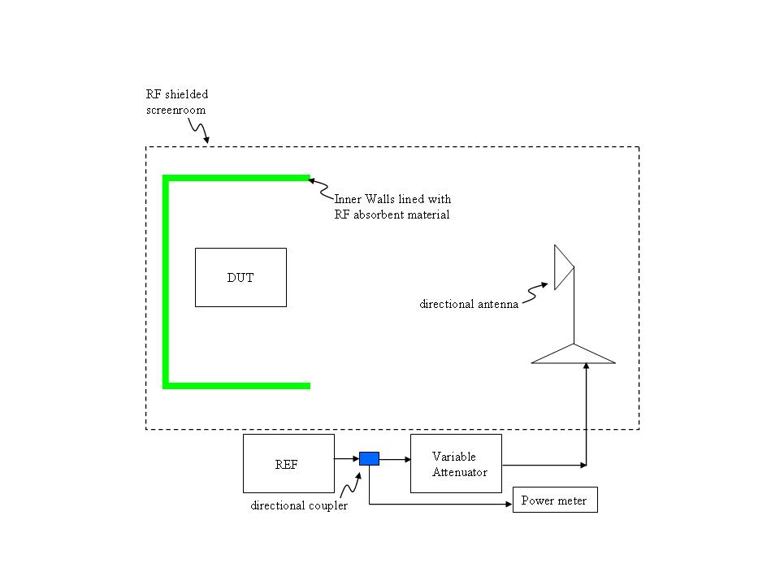
Figure 1: COAT Environment

5.2.3.3 Procedure
The procedure described in this subclause includes instructions for preparing the environment, calibrating
the environment, precisely placing the SUT and measuring performance. This procedure is to be used in
conjunction with other test procedures used for measuring a specific metric.
5.2.3.1 Preparation of the setup
The preparation of the environment should include the following steps:
a) Confirm that the test environment is free of extraneous noise. A spectrum analyzer with an attached
antenna should be used to verify that there is no extraneous noise present throughout the test environment.
There should be at least 95dB of isolation between the clean environment and other possible
external RF noise sources.
b) Place the transmit reference antenna such that it is in the far field of the SUT.
NOTE—A separation of at least 10 wavelengths is recommended between the transmit antenna and the SUT.
c) Confirm that the entire SUT can be encapsulated within the measured RF quiet zone.
While performing tests in this environment, the test conditions should confirm a flat channel (ripple <
±0.5dB) in the RF channel or channels being used for the test.
5.2.3.2 Calibration and monitoring
The following procedure provides detailed information for precise calibration of an OTA test range using a vector network analyzer, with special attention paid to possible sources of error to ensure that low uncertainty measurements can be made. The range calibration is performed in a two-step process, where first the frequency response of the test equipment and cabling used to perform the calibration is measured and then those components are used along with a calibrated reference antenna to measure the frequency response of the range, measurement antenna, and cabling used in the OTA tests. The difference between these two measurements (in dB) combined with the gain of the reference antenna provides the desired path loss calibration values.

The calibration of the environment should be performed according to the following sequence:
5.2.3.2.1 Calibration Step 1: Cable Calibration

For each configuration, perform the following steps:

- Route the reference antenna cable(s) (dash dot line) from the output port of the network analyzer to the mounting location of the reference antenna. A minimum of 3 dB (preferably 10 dB) pad is recommended at the output (reference antenna side) of the cable to minimize standing waves. This output connection is defined as the reference port.
- Connect the output of the reference antenna cable to the input port of the network analyzer through a flexible “loopback” cable (dash dot line). (See Figure 5.X.2.) An additional pad is recommended at the input port of the analyzer.
- Ensure all equipment has been powered on long enough to have stabilized.
- With the analyzer set to measure at least one data point per MHz of frequency span, perform a frequency sweep to cover the required test frequencies and record the result. It is recommended that the analyzer be set to narrow bandwidth to obtain the lowest possible noise floor. The power level of the signal source must remain fixed for all measurements.
- Ensure that the received signal is below the compression point of the receiver (linear region) and sufficiently far above the noise floor of the receiver to account for the expected range path loss.
- Prior to proceeding to the next test step, move the cables around and monitor the frequency response as the analyzer sweeps continuously. Any gross changes in response indicate bad cables or connections and should be rectified prior to continuing. Minor variations (fractions of a dB) are expected and should be accounted for in the measurement uncertainty of the resulting range calibration.
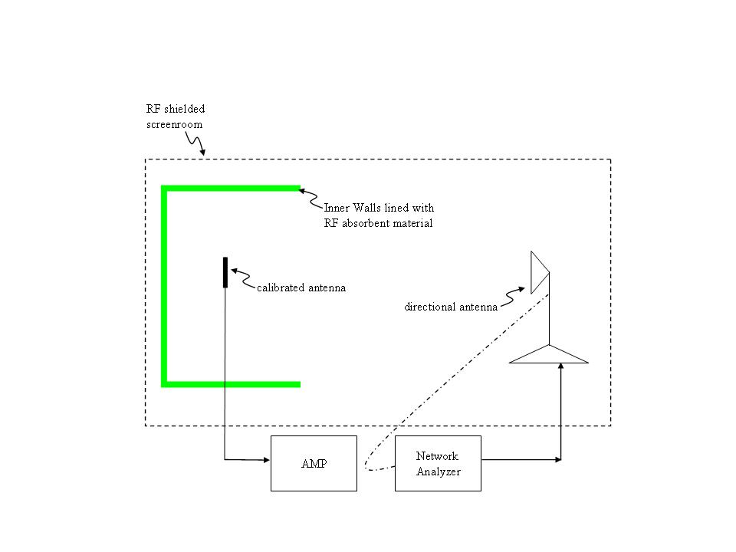
Figure 5.X.2 Example of Loop-back Configuration for Cable Calibration.

a) Place the SUT as close to the center of the quiet zone as possible, while ensuring that the entire SUT
is encapsulated by the quiet zone.
b) Precisely note the position and orientation of the SUT antenna.
NOTE—It is suggested that an array of laser pointing and alignment devices be used to precisely note the location and
orientation of the antenna.
c) Remove the SUT from the test environment.
d) Place a characterized antenna (calibration antenna) in exactly the same location and orientation as
the SUT antenna using precise locators (such as laser pointing and alignment devices).
e) Measure the path loss and channel characteristics using a network analyzer connected to the transmit
antenna and calibration antenna.
f) Confirm that the channel characteristics between the transmit reference antenna and the SUT are
within ±1dB of the desired values. A network analyzer should be used to measure channel characteristics.
The data and plots from the network analyzer should be retained for inclusion into the test
results report.
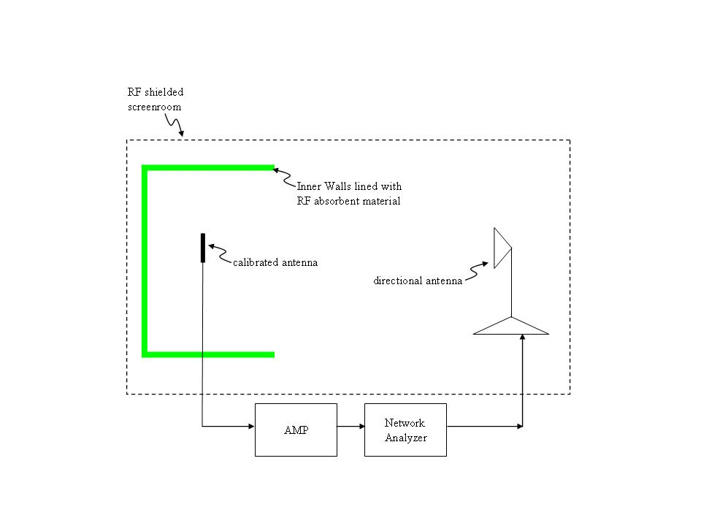
Figure 3 Typical Range Calibration Configuration

5.2.3.2.2 Calibration Step 2: Placing the SUT
The placement of the SUT should be carried out according to the following steps:
a) Remove the calibration antenna.
b) Place the SUT such that its antenna occupies exactly the same location and orientation as the calibration
antenna during path loss and channel characteristic measurements.
NOTE—Precise placement of the SUT may be accomplished using laser pointing and alignment devices.

5.2.3.2.3 Measuring performance
The performance measurement shall be carried out according to the following constraints:
a) The actual test shall be performed as outlined in the specific primary or secondary metrics measurement methodology ,
using the calibrated path loss measured during the calibration procedure in 5.2.3.2.1.
b) Allow enough time for the DUT to recover and return to a normal state
between trials.
c) The environment shall be calibrated for all required frequency bands (channel) and orientations
prior to performing the test.

5.2.4 Modifiers and variations
The following baseline DUT setup parameters may be modified to enable additional trials to be performed
for a test using this methodology. Recalibration is required when any modifications are performed to the test environment:
a) Attenuation (thereby varying received power)
b) Channels/bands of operation
c) Orientation
Only one variation should be tested at a time.

5.2.5 Special reporting requirements
Test results obtained while using this environment should include data and/or plots of the characteristics of
every tested channel. The number of points reported should be sufficient to give a resolution bandwidth less
than 100kHz.

