IEEE P802.11
Wireless LANs
MDIE Policy bit Definitions
Date: 2006-11-13
Author(s):
Name | Company | Address | Phone |  | email
Michael Montemurro | RIM | 5090 Commerce Blvd,  Mississauga, ON. L4W 5W4 | +1-905-629-4746  Ext. 4999 |  | mmontemurro@rim.com
Kapil Sood | Intel | 2111 NE 25th Ave, JF3-206, Hillsboro, OR. 97124 |  | +1-503-264-37599 | Kapil.sood@intel.com
Frank Ciotti | Motorola | 6500 River place Blvd., Bldg 7 RP-3A, Austin, TX. 78730 |  | +1-512-427-7231 | Frank.ciotti@motorola.com
Rajneesh Kumar | Cisco | 170 W Tasman Dr., San Jose, CA. 95134 |  | +1-408-527-6148 | rajneesh@cisco.com
Bill Marshall | TGr Editor | 180 Park Ave, Florham Park, NJ 07932 |  | 973-360-8718 | wtm@research.att.com
Abstract
This submission is an update to the definition of the policy bits in the Mobility Domain information element, and all the corresponding places in D3.0 that need to stay in sync.
Notice: This document has been prepared to assist IEEE 802.11. It is offered as a basis for discussion and is not binding on the contributing individual(s) or organization(s). The material in this document is subject to change in form and content after further study. The contributor(s) reserve(s) the right to add, amend or withdraw material contained herein.

Release: The contributor grants a free, irrevocable license to the IEEE to incorporate material contained in this contribution, and any modifications thereof, in the creation of an IEEE Standards publication; to copyright in the IEEE’s name any IEEE Standards publication even though it may include portions of this contribution; and at the IEEE’s sole discretion to permit others to reproduce in whole or in part the resulting IEEE Standards publication. The contributor also acknowledges and accepts that this contribution may be made public by IEEE 802.11.

Patent Policy and Procedures: The contributor is familiar with the IEEE 802 Patent Policy and Procedures <http:// ieee802.org/guides/bylaws/sb-bylaws.pdf>, including the statement "IEEE standards may include the known use of patent(s), including patent applications, provided the IEEE receives assurance from the patent holder or applicant with respect to patents essential for compliance with both mandatory and optional portions of the standard." Early disclosure to the Working Group of patent information that might be relevant to the standard is essential to reduce the possibility for delays in the development process and increase the likelihood that the draft publication will be approved for publication. Please notify the Chair <stuart.kerry@philips.com> as early as possible, in written or electronic form, if patented technology (or technology under patent application) might be incorporated into a draft standard being developed within the IEEE 802.11 Working Group. If you have questions, contact the IEEE Patent Committee Administrator at <patcom@ieee.org>.
Overview

This submission proposes two changes to the TGr D3.0:
- Expansion of the Reservation-over-air and Reservation-over-DS to apply to the Fast BSS Transition base mechanism as well as the Reservation mechanism
- Use of an additional bit in the MDIE to make the description of the policy bits easier to understand.

Beyond point (1) above, there are no technical changes being proposed to the current design of Fast BSS Transition.

Change #1: Expansion of the Reservation-over-air and Reservation-over-DS to apply to the Fast BSS Transition base mechanism as well as the Reservation mechanism.

Current text in fourth paragraph of 8A.4.1 states “The additional message exchange for reservation shall be performed using the same method (over-the-air or over-the-DS) as was used for the initial Fast BSS Transition Request/Response.”

This sentence, combined with the “Reservation-over-air” and “Reservation-over-DS” effectively placed restrictions on the first two messages, but only when a Reservation Mechanism was employed. When a STA was performing only the Base Mechanism, there were no restrictions (or recommendations) of which method to use.

This submission proposes that the policy bits in the MDIE apply to the Base Mechanism as well as to the Reservation Mechanism. They are being renamed “Fast-Transition-over-the-air” and “Fast-Transition-over-the-DS”, and normative text giving the restrictions is being inserted into the appropriate places in 8A.3.

The combination of over-the-air being zero and over-the-DS being zero, which was previously valid, is now disallowed.

Change #2: Use of an additional bit in the MDIE to make the description of the policy bits easier to understand.

The normative text regarding these policy bits was very simple to state, and very subtle to understand.

Reservation-over-air | If Reservation-over-air is clear, then the STA shall not issue an over-the-air reservation request. If neither Reservation-over-air not Reservation-over-DS is set to one, then the STA shall not send a reservation request to the AP.
Reservation-over-DS | If Reservation-over-DS is clear, then the STA shall not issue an over-the-DS reservation request. If neither Reservation-over-air not Reservation-over-DS is set to one, then the STA shall not send a reservation request to the AP.
Reserve-Option | If reservation is marked as mandatory, i.e., Reserve Option is set to one, then the STA shall not include a RIC in its Reassociation Request without first performing a reservation.

The previous combination of policy bits, and their meaning from the point-of-view of the STA (with the AP expected to support whatever it allowed the STA to do), was:
0-0-0 | No over-the-air reservation requests. No over-the-DS reservation requests. Therefore, no reservation requests. However, a RIC is allowed in the Reassociation Request.
0-0-1 | No over-the-air reservation requests. No over-the-DS reservation requests. Since the STA is not allowed to include a RIC in its Reassociation Request without first performing a reservation, and there is no way allowed to perform a reservation, no RIC is allowed in the Reassociation Request.
0-1-0 | No over-the-air reservation requests. Over-the-DS is allowed. The STA is allowed to do both a 4-message Base Mechanism (either over-the-air or over-the-DS, with a RIC in the Reassociation Request), or a 6-message Reservation Mechanism over-the-DS (with the RIC in message #4 of the sequence).
0-1-1 | No over-the air reservation requests. Over-the-DS is allowed. Reservation is required. If the STA wants resources, it is thus required to do a 6-message sequence over-the-DS with the RIC in message #4 of the sequence. Alternatively, if the STA does not want resources, it can do a 4-message sequence either over-the-air or over-the-DS without a RIC in the Reassociation Request.
1-0-0 | Over-the-air reservation is allowed. No over-the-DS reservation requests. The STA is allowed to do both a 4-message Base Mechanism (either over-the-air or over-the-DS, with a RIC in the Reassociation Request), or a 6-message Reservation Mechanism over-the-air (with the RIC in message #4 of the sequence).
1-0-1 | Over-the-air reservation is allowed. No over-the-DS reservation requests. Reservation is required. If the STA wants resources, it is thus required to do a 6-message sequence over-the-air with the RIC in message #4 of the sequence. Alternatively, if the STA does not want resources, it can do a 4-message sequence either over-the-air or over-the-DS, without a RIC in the Reassociation Request.
1-1-0 | Over-the-air reservation is allowed. Over-the-DS reservation is allowed. The STA is allowed to do both a 4-message Base Mechanism (with a RIC in the Reassociation Request), or a 6-message Reservation mechanism (with the RIC in message #4 of the sequence).
1-1-1 | Over-the-air reservation is allowed. Over-the-DS reservation is allowed. Reservation is required. If the STA wants resources, it is thus required to do a 6-message sequence with the RIC in message #4 of the sequence. Alternatively, if the STA does not want resources, it can do a 4-message sequence without a RIC in the Reassociation Request.

All of the above combinations, except for 0-0-1, indicated that the AP supported resource requests.

The combinations 0-1-1, 1-0-1, and 1-1-1 indicated that the AP could not handle a resource request as part of the Reassociation Request, and needed to see the RIC earlier. Thus it was requiring the STA to perform the 6-message sequence if it wanted resources.

The mapping from previous policy settings to new policy settings is as follows:
Reservation-over-air | Reservation-over-DS | Reserve-Option | FT-over-air | FT-over-DS | Resource-Request-Supported | Reservation-prior-to-reassociation-required
0 | 0 | 0 | 1* | 1* | 1 | 0
0 | 0 | 1 | 1* | 1* | 0 | 0
0 | 1 | 0 | 0 | 1 | 1 | 0
0 | 1 | 1 | 0 | 1 | 1 | 1
1 | 0 | 0 | 1 | 0 | 1 | 0
1 | 0 | 1 | 1 | 0 | 1 | 1
1 | 1 | 0 | 1 | 1 | 1 | 0
1 | 1 | 1 | 1 | 1 | 1 | 1

NOTE 1 – entries marked above as “1*” may be either 0 or 1 (as long as at least one of them in the row is set to 1); settings of these bits indicates the over-the-air or over-the-DS recommendation for the Base Mechanism.

NOTE 2 – Where before, all 8 possible settings were valid, now some settings of the new policy bits are illegal. In particular, setting FT-over-air and FT-over-DS both to zero is reserved, as is setting Resource-request-supported to zero and Reservation-prior-to-reassociation-required to one.

NOTE 3 – Where before the STA was allowed to do the Base Mechanism over-the-air or over-the-DS, at its option regardless of the settings of the policy bits, this is no longer allowed.

Changes to D3.0:

Change Figure 112T a follows:
“Reservation over air” to “Fast Transition over-the-air”
“Reservation over DS” to “Fast Transition over-the-DS”
“Reserve Option” to “Resource Request protocol supported”
All other bits are reserved.

Change second paragraph under Figure 112T as follows:
The policy bits in the MDIEReservation-over-air, Reservation-over-DS, and Reservation-Option control the behavior of STAs performing a resource reservationrequest as part of Fast BSS Transitions.

An AP sets Fast BSS Transition capability bit to one to indicate that Fast BSS Transition service is supported by that AP. If the Fast BSS Transition capability bit is set to 0, then bits 1-4 will also be set to 0.

The AP sets FastTransition-over-air and/or FastTransition-over-DS to one according to the policy for Fast BSS Transition for the Mobility Domain. If Fast BSS Transition Capability bit is set to one, at least one of FastTransition-over-air or FastTransition-over-DS is advertised by the AP.

If neither Reservation-over-air nor Reservation-over-DS is set to one, then the STA will not send a reservation request to the AP.If Resource-request-protocol-supported is set to one then the STA may perform the Fast BSS Transition resource request procedures of 8A.4 (was 8A.8).

If Reserve-Resource-Request-Protocol-supported is set to one then the STA may use the resource request protocol for Fast Transition.
-----deleted, as duplicate of previous sentence-----

If ReservationFastTransition-over-air is set to zero, then the STA will not issueinitiate an over-the-air reservation requestFast BSS Transition. If ReservationFastTransition-over-DS is set to zero, then the STA will not issueinitiate an over-the-DS reservation requestFast BSS Transition.

[Note to TGr editor – move this final paragraph to the end of the paragraph describing over-the-air and over-the-DS. Moving it in this submission would obscure the changes being shown by MSWord.]

Change second paragraph of 8A.1.1 as follows:
The Mobility Domain Identifier shall be the value of dot11FTMobilityDomainID. The resource policy bits in the MDIE, ReservationFast Transition over air, ReservationFast Transition over DS, and Resource request supported, shall be set according to the values of the MIB variables dot11FTReservationOverAirEnabled, dot11FTReservationOverDSEnabled, dot11FTResourceRequestSupported., respectively. If Fast BSS-Transition is supported, at least one of Fast Transition over air or Fast Transition over DS shall be set to one. The NAS-ID of the authenticator associated with the AP advertising Fast BSS Transition capability shall be the value of dot11FTNASID.

Insert a new paragraph at start of 8A.3.1:
A STA shall not initiate a Fast BSS Transition over-the-air to a target AP whose MDIE contained the Fast Transition over air bit set to zero.

Insert a new paragraph at start of 8A.3.2:
A STA shall not initiate a Fast BSS Transition over-the-DS to a target AP whose MDIE contained the Fast Transition over DS bit set to zero.

Change third paragraphof 8A.3.3 as follows:
The Information Elements in Fast BSS Transition Confirm and Fast BSS Transition Acknowledgement, and their required contents, shall be as given in 8A.5.3 and 8A.5.4. If the MDIE advertised by the target AP indicated that reservation is mandatorycontained the Resource-Request-Supported bit set to zero, the STA shall not include a RIC in the Reassociation Request without first performing a reservation.
-----changed to-----
Change third paragraph of 8A.3.3 and 8A.3.6 as follows:
The Information Elements in Fast BSS Transition Confirm and Fast BSS Transition Acknowledgement, and their required contents, shall be as given in 8A.5.3 and 8A.5.4. If the MDIE advertised by the target AP indicated that reservation is mandatory, then the STA shall not include a RIC in the Reassociation Request without first performing a reservation.

Change third paragraph of 8A.4 as follows:
Availability of the reservation mechanism is advertised by the target AP in the MDIE. If neither Reservation-over-air nor Reservation-over-DS is set to oneResource-Request-Supported is set to zero, then the STA shall not send a reservation request to the AP. If reservation is marked as mandatory, i.e., Reserve-Option is set to one, then the STA shall not include a RIC in its Reassociation Request without first performing a reservation. If Reservation-over-air is set to zero, then the STA shall not issue an over-the-air reservation request. If Reservation-over-DS is set to zero, then the STA shall not issue an over-the-DS reservation request. An AP that receives a reservation request from a STA, and does not support the reservation mechanism, shall respond with a status code 38 ("The request has not been successful as one or more parameters have invalid values").

Change fifth paragraph of 8A.5.1 as follows:
The MDIE shall contain the Mobility Domain Identifier, and the Fast BSS Transition Capability, and Resource Policypolicy settings obtained from the target AP. The target AP advertises the MDIE in beacons and probe responses. The Mobility Domain Identifier shall be identical to that obtained during the FT Initial Mobility Domain Association exchange.

Change MIB entries:
dot11FTReservationOverAirEnabled to dot11FTOverAirEnabled
dot11FTReservationOverDSEnabled to dot11FTOverDSEnabled

Remove dot11FTReservationRequired

Inset a new entry in dot11FastBSSTransitionConfigEntry as follows:
dot11FTResourceRequestSupported TruthValue,

Insert a new MID definition as follows:
dot11FTResourceRequestSupported OBJECT-TYPE
SYNTAX TruthValue
MAX-ACCESS read-write
STATUS currnet
DESCRIPTION
“When this object is set to TRUE, this shall indicate that the Fast BSS Transition resource request procedures of 8A.8 are supported onthis AP entity.”
::= {dot11FastBSSTransitionConfigEntry 5(was 13)}

Change the PICs in Annex A as follows:

Rename PC35.11.3 to PC 35.12 and make dependent on PC35.
Rename PC35.11.4 to PC 35.13 and make dependent on PC35.
Rename PC35.11.5 to PC35.13.1
Rename PC35.11.6 to PC35.13.2
Rename PC35.11.7 to PC35.14 and make dependent on PC35.
Rename PC35.12 to PC35.15

For PC35.11, rename “reservation mechanism” to “resource request mechanamism”

Final PICS table to appear as:
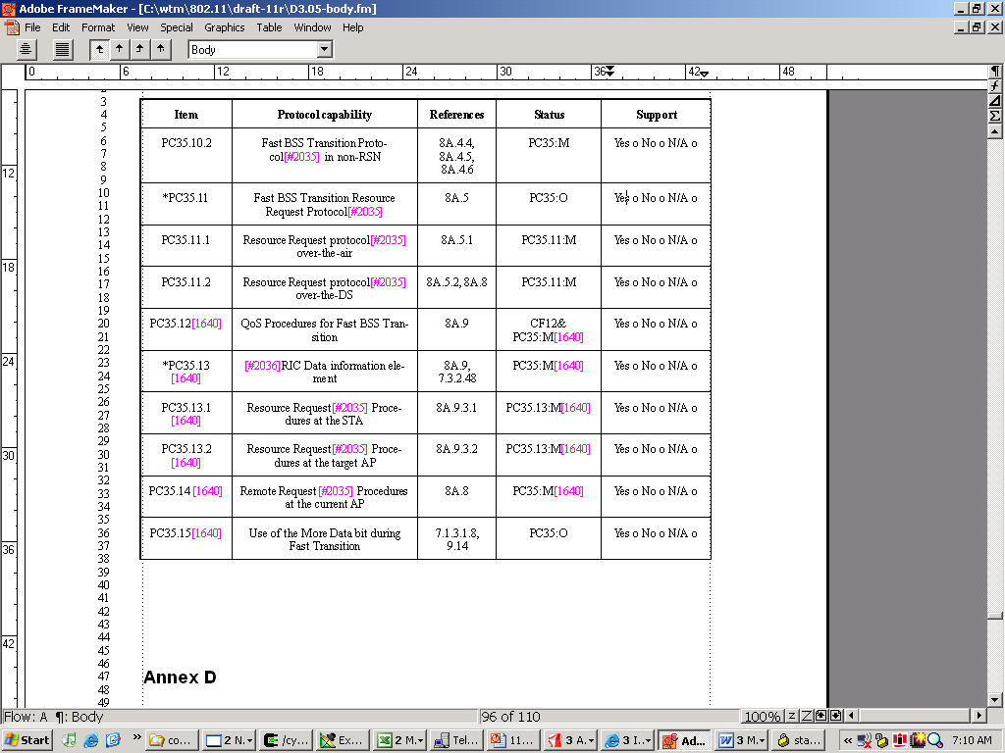

Resolve LB87 comments as follows:

490 | Counter. Table to describe these was included in previous drafts, and led to more confusion. Policy bits redefined in 11-06-1640, to make the explanation simpler. See text changes in 11-06-1640.
491 | Rejected. The normative behaviour needs to be specified in clause 8A, and normative behaviour can’t be specified in clause 7. Therefore common text can’t be used. Normative text is not confined to 8A.4, making a cross reference impractical. See 11-06-1640 for new text.
497 | Accepted. Text changes in 11-06-1640.
499 | Rejected. In some AP implementations handling of TSPECs (and in general, resource requests) take a long time. Especially true if the AP consults a back-end server for QoS authorization. Such processing can't be done in the quick response time necessary for a Reassociation Request/Response.
507 | Counter. Policy bits redefined. See changes in 11-06-1640.
520 | Counter. Split into “Resource request supported” and “Reservation prior to reassociation required. See 11-06-1640
521 | Counter. Policy bits redefined. Text changes in 11-06-1640
523 | Counter. Policy bits redefined. Text changes in 11-06-1640
1195 | Accepted. Text changes in 11-06-1640
1200 | Counter. Policy bits redefined. Text changes in 11-06-1640
1411 | Counter. Policy bits redefined. Text changes in 11-06-1640

