IEEE P802.11
Wireless LANs
TGn LB84 Submission Related to Restructuring 7.4.7
Date: 2006-09-16
Author(s):
Name | Company | Address | Phone | email
Adrian Stephens | Intel Corporation | 15 JJ Thompson Avenue, Cambridge, CB3 0FD, United Kingdom |  | adrian.p.stephens@intel.com
Abstract
This document contains proposed changes to the IEEE P802.11n Draft to address the following LB84 comments:
- 5618, 5631, 7599, 11343, 11833

The changes marked in this document are based on TGn Draft version D1.03
Notice: This document has been prepared to assist IEEE 802.11. It is offered as a basis for discussion and is not binding on the contributing individual(s) or organization(s). The material in this document is subject to change in form and content after further study. The contributor(s) reserve(s) the right to add, amend or withdraw material contained herein.

Release: The contributor grants a free, irrevocable license to the IEEE to incorporate material contained in this contribution, and any modifications thereof, in the creation of an IEEE Standards publication; to copyright in the IEEE’s name any IEEE Standards publication even though it may include portions of this contribution; and at the IEEE’s sole discretion to permit others to reproduce in whole or in part the resulting IEEE Standards publication. The contributor also acknowledges and accepts that this contribution may be made public by IEEE 802.11.

Patent Policy and Procedures: The contributor is familiar with the IEEE 802 Patent Policy and Procedures <http:// ieee802.org/guides/bylaws/sb-bylaws.pdf>, including the statement "IEEE standards may include the known use of patent(s), including patent applications, provided the IEEE receives assurance from the patent holder or applicant with respect to patents essential for compliance with both mandatory and optional portions of the standard." Early disclosure to the Working Group of patent information that might be relevant to the standard is essential to reduce the possibility for delays in the development process and increase the likelihood that the draft publication will be approved for publication. Please notify the Chair <stuart.kerry@philips.com> as early as possible, in written or electronic form, if patented technology (or technology under patent application) might be incorporated into a draft standard being developed within the IEEE 802.11 Working Group. If you have questions, contact the IEEE Patent Committee Administrator at <patcom@ieee.org>.

Introduction

Interpretation of a Motion to Adopt
A motion to approve this submission means that the editing instructions defined below are actioned against the TGn draft.

The problem

The TGn Draft (version D1.03 and earlier) does not follow the format used in the baseline for defining action frames.

An example from the baseline (REVma D7.0) follows:
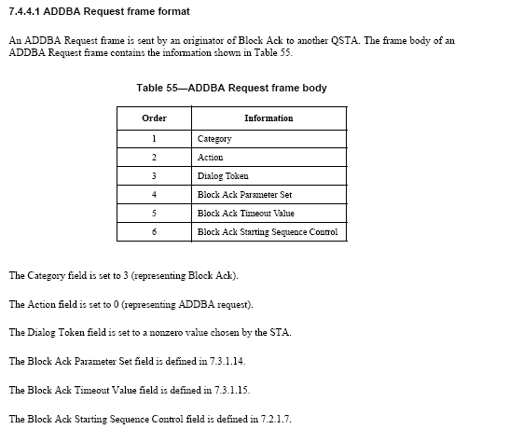

And for each “information” item, there exists a definition in 7.3.1 (fixed) or 7.3.2 (elements), for example:
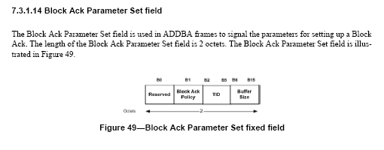
We don’t do this. Instead we have an extended table format, and definitions of the fields in place.

Proposed Change
The proposed change is to adopt the baseline style, as shown by example above. The tables will be reduced to only 2 columns, and any normative text moved to paragraphs below the table.

Any fields will be described separately in 7.3.1 in their own separate subclauses.

Because this change interacts with (and would conflict with) other submissions relating to the technical content of the HT action frames, the response to these comments is shown by a rather complicated editing instruction, rather than attempting to show the actual contents. The editor would perform all technical updates first, then apply the reformatting update.

One technical change

Note, in implementing this instruction, the beamforming control, and two sequence number fields would be grouped together into a new named structure. This would introduce one technial change compared with D1.03. The "mimo compressed steering" action frame has an RSSI field separating the segment sequence and explicit feedback control fields. The RSSI field would need to be moved to after the common fields to avoid introducing a new structure used only by this action frame.

Editing Instructions

1. Create a new subclause in 7.3.1 for each field (or consistently grouped set of fields) defined in a 7.4.7 HT action frame.
2. Definition of these fields and subfields from the 7.4.7 subclauses into the new subclauses
3. Modify action frame definitions to replace existing fields with new field names (where they have changed) and update terminology in the text. Add appropriate references to the new 7.3.1 subclause in the text that follows the table.
4. Change the structure of the HT action frame tables to 2 columns: order and information. Move any text that is in removed columns to paragraphs following the table with additional references to the name of the information item where necessary.

Related CIDs and proposed resolutions

5618 | Miller2, Robert | 7.4.7.1 | 58 | 4 | As this format of frames is used throughout the base spec, Channel Width should be defined as either a fixed field in 7.3.1 or as in Information Element in 7.3.2 | Recommend changing frame formats to a Figure instead of a table. This comment applies throughout clause 7.4.7
5631 | Miller2, Robert | 7.4.7.3 | 59 | 8 | As this format of frames is used throughout the base spec, PCO Phase should be defined as either a fixed field in 7.3.1 or as in Information Element in 7.3.2 | Recommend changing frame formats to a Figure instead of a table. This comment applies throughout clause 7.4.7
7599 | Stephens, Adrian | 7.4.7.5 |  |  | The MCMR Segment Sequence field says “see text”, but this subclause doesn’t describe it. | Move the MCMR segment sequence description into a separate section and reference from here
- Proposed accept for these comments.

11343 | Marshall, Bill | 7.4.7.1 | 58 | 4 | As this format of frames is used throughout the base spec, Channel Width should be defined as either a fixed field in 7.3.1 or as in Information Element in 7.3.2 | Recommend changing frame formats to a figure instead of a table. This comment applies throughout clause 7.4.7
11833 | Marshall, Bill | 7.4.7.4 | 60 | 2 | It seems the intent is to define a common frame format for many of the Management Action Frames, and to use the appropriate fields in that common format for each of the various messages. Suggest that 7.4.7.4 have a figure with the common format that each of the subsequent sections reference. Also have a figure with the format of the Transmit beamforming control field/CSI Matricies control field (which also appear to be identical). Each section then has a series of short paragraphs, one for each field, stating how that field is used in this frame. When it is not used, state that it is reserved and is set to zero on transmit and ignored on reception. | As in comment

- Proposed counter. See submission 11-06-1426r0. The submission modifies the presentation of the HT action frames to match the ADDBA frame in the baseline. Fields are defined in separate subclauses in 7.3.1. The table structure is retained, but reduced to 2 columns to match the example of the ADDBA frame.

