IEEE P802.11
Wireless LANs
Text Proposal for LB84 Comment Resolution CIDs Related to the Cyclic Shifts (Part I)
Date: 2006-09-14
Author(s):
Name | Company | Address | Phone | Email
Vinko Erceg | Broadcom | 15435 Innovation Dr.  San Diego, CA 92128 | 1 858 521 5885 | verceg@broadcom.com
Rohit Nabar | Marvell |  |  | rnabar@marvell.com
Krishna Pillai | Wipro |  |  | krishna.pillai@wipro.com
Nicolas Gresset | Wipro |  |  | nicolas.gresset@wipro.com
Assaf Kasher | Intel |  |  | assaf.kasher@intel.com
David Tung | Ralink Technology |  |  | dtung@ralinktech.com

Abstract

This document contains proposed text for the CIDs of the LB84 comment resolution related to the Cyclic Shifts.

CIDs: 202, 205, 206, 207, 208, 891, 4092, 4452, 4453, 4859, 7383, 11958

The changes marked in this document are based on TGn Draft version 1.0
Notice: This document has been prepared to assist IEEE 802.11. It is offered as a basis for discussion and is not binding on the contributing individual(s) or organization(s). The material in this document is subject to change in form and content after further study. The contributor(s) reserve(s) the right to add, amend or withdraw material contained herein.

Release: The contributor grants a free, irrevocable license to the IEEE to incorporate material contained in this contribution, and any modifications thereof, in the creation of an IEEE Standards publication; to copyright in the IEEE’s name any IEEE Standards publication even though it may include portions of this contribution; and at the IEEE’s sole discretion to permit others to reproduce in whole or in part the resulting IEEE Standards publication. The contributor also acknowledges and accepts that this contribution may be made public by IEEE 802.11.

Patent Policy and Procedures: The contributor is familiar with the IEEE 802 Patent Policy and Procedures <http:// ieee802.org/guides/bylaws/sb-bylaws.pdf>, including the statement "IEEE standards may include the known use of patent(s), including patent applications, provided the IEEE receives assurance from the patent holder or applicant with respect to patents essential for compliance with both mandatory and optional portions of the standard." Early disclosure to the Working Group of patent information that might be relevant to the standard is essential to reduce the possibility for delays in the development process and increase the likelihood that the draft publication will be approved for publication. Please notify the Chair <stuart.kerry@philips.com> as early as possible, in written or electronic form, if patented technology (or technology under patent application) might be incorporated into a draft standard being developed within the IEEE 802.11 Working Group. If you have questions, contact the IEEE Patent Committee Administrator at <patcom@ieee.org>.
Introduction

This document addresses the following CIDs regarding cyclic shifts related to the LB84 comment resolution:

CIDs: 202, 205, 206, 207, 208, 891, 4092, 4452, 4453, 4859, 7383, 11958

CID 202

Pg Ln
20.3.2.2 | 171 | 10-23 | Neither step (a) nor (b) mentions the addition of cyclic shift delays | The text should mention the addition of cyclic shift delays in both frequency-domain and time-domain

Proposed resolution:

TGn editor: add the following sentence, pg 171, ln 14:

“Apply cyclic shifts.”

TGn editor: add the following text, pg 171, ln 19, after “ ..more OFDM symbols,”:

“, applying cyclic shifts,”

CID 205

Pg Ln
20.3.2.2 | 173 | 20-33 | Step (p) does not mention the addition of cyclic shift delays | The text should mention the addition of cyclic shift delays in both frequency-domain and time-domain

Proposed resolution:

TGn editor: add the following text, pg 173, ln 33:

“Spatial mapping matrices may include cyclic shifts, as described in subclause 20.3.4.7.1.”

CID 206

Pg Ln
20.3.2.2 | 171 | 10-23 | No mention of the Cyclic Shift delay | Introduce text for cyclic shift delays

TGn editor: duplicate of CID 202.

CID 207

Pg Ln
20.3.2.2 | 173 | 19 | No description of what the CSD block between STBC and Spatial mapping | Introduce description of the CSD block

Proposed resolution:

TGn editor: covered by proposed resolution to CID 4452 below.

CID 208

Pg Ln
20.3.2.2 | 172 | 38 | No description of CSD block between IFFT and GI insertion | Introduce description of the CSD block

Proposed resolution:

TGn editor: covered by proposed resolution to CID 4452 below.

CID 891

Pg Ln
20.3.2.1 | 171 | Figure n50 | CSD matrix is defined as a part of the spatial mapping matrix Qk. This is not consistent with the Figure n50 where CSD on the right is separated from the spatial mapping block and it is in the time domain. | Remove CSD blocks on the right of the Fig. n50.

Proposed resolution (counter):

TGn editor: create two figures instead of figure n50:

Scrambler
FEC Encoder
Interleaver
QAM
Mapping
Insert
GI and
Window
Insert GI and
Window
Insert
GI and
Window
Insert
GI and
Window
Analog
And RF
Analog
And RF
Analog
And RF
Analog
And RF
CSD
CSD
CSD
N_{TX} Transmit Chains

IFFT

Figure n50 – Transmitter block diagram for the Mixed Mode non-HT portion of the packet and HT signal field

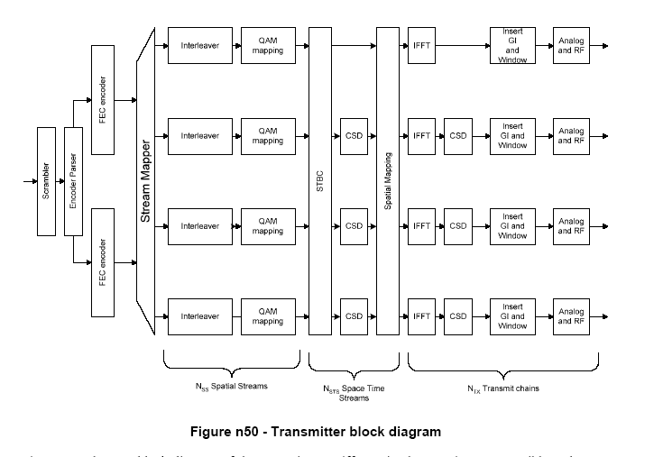
Figure n51 – Transmitter block diagram for the Green Field mode packet and HT portion of the Mixed Mode packet except HT signal field

TGn editor: change sentence on pg. 171 ln 3-4 to:

“Figures n50 and n51 show block diagrams of the transmitter. Different implementations are possible as long as they are mathematically equivalent.”

CID 4092

Pg Ln
20.3.2.1 | 171 | 1 | In Fig. n50, two CSDs have same notation but have different values. This is not clear. | Rename CSD on the left of the Fig. n50 as CSD_1 and rename CSD on the right of the Fig. n50 as CSD_2 (also everywhere in the text where it applies).

TGn editor: withdrawn by the author (Joonsuk Kim).

CID 4452

Pg Ln
20.3.2.1 | 170 | 27-29 | There are two types of cyclic shift. One is for the different space time streams, another is for different transmit chains with spatial expansion. The statement is not clear to distinguish the differences. | Specify the different CSD blocks in detail.

Proposed resolution:

TGn editor: change the complete paragraph, pg 170, ln 27-29, with the following paragraph:

“Cyclic shift (CSD) insertion – insertion of the cyclic shifts prevents unintentional beamforming. There are three cyclic shift types. The first one is specified per transmitter chains with values in table n65 (possible implementation is shown in figure n50). The second one is specified per space time streams with values in table n67 (possible implementation is shown in figure n51). The third cyclic shift type M_{CSD}(k) may be applied as a part of the spatial mapper, see section 20.3.4.7.1. When beamforming is not used it is often possible to implement the cyclic shifts and spatial mapping in the time domain.”

CID 4453

Pg Ln
20.3.2.1 | 171 | 1 | CSD blocks are not defined clear in Figure n50. | Redefine the CSD blocks before spatial mapping and after IFFT.

TGn editor: duplicate of CID 4452.

CID 4859

Pg Ln
20.3.2.2 | 173 | 19-20 | Missing information | Add description of the CSD block that occurs between STBC and Spatial Multiplexing in Figure n50.

TGn editor: duplicate of CID 207.

CID 7383

Pg Ln
20.3.2.2 | 171 | 10-23 | There is no mention of cyclic shift delays in step (a) or (b). | Frequency-domain and time-domain cyclic shift delays should be mentioned.

TGn editor: duplicate of CID 202.

CID 11958

Pg Ln
20.3.2.1 & 20.3.5 | 170 | 27 | There are two types of cyclic shift -- per antenna basis for legacy and per space-time stream basis for high throuhgput. The statement made here does not adequately capture these differences. Particularly for high throughput case, when direct mapping is not used or spatial expansion is applied the CSD values for high throughput must be applied in freqency domain. Important to mandate this particularly for channel feedback/steering matrix computation for the purposes of transmit beamforming. In particular, when operating in TxBF mode application of per space-time stream CSD in frequency domain must be made mandatory, even if direct-mapping is used. | Specify that CSD for the case of non-direct mapped transmission or spatial spreading must be in frequency domain. For TxBF CSD must be applied in frequency domain regardless, whether the station is the receiver (in the case of implicit beamforming) or is the transmitter ( in case of explicit and implicit beamforming).

Proposed resolution (counter):

TGn editor: insert the following sentence on pg. 212, after ln 8:
“The CSD of table n67 shall be applied at the input of the spatial mapper.”

TGn editor: insert the following sentence on pg. 217, ln 3:
“The channel matrix shall be determined from the transmitter spatial mapper input to the receiver FFT outputs (the beamformee removes the CSD in table n67 from the measured channel matrix).”

