IEEE P802.11
Wireless LANs
802.11 TGn representation of bitstring literals in the TGn Draft
Date: 2006-05-30
Author(s):
Name | Company | Address | Phone | email
Adrian Stephens | Intel Corporation | 15 JJ Thompson Avenue |  | adrian.p.stephens@intel.com
Abstract
This submission highlights an editorial/borderline technical issue uncovered during resolution of the following comments 3715-3717, 2146, 4734. These call for consistency within the document.

In order to maintain consistency with the baseline, it is necessary to adopt a convention that is close to one of the existing formats, while providing the features needed in the TGn draft.

The issue under discussion here is interpretation of a multi-bit field whose values are defined in the draft by a bit-string literal (e.g., “001”).

It is proposed that the existing fields are interpreted as most-significant bit on the left, and this convention is made explicit by numbering bit positions in the column or cell headers.
Notice: This document has been prepared to assist IEEE 802.11. It is offered as a basis for discussion and is not binding on the contributing individual(s) or organization(s). The material in this document is subject to change in form and content after further study. The contributor(s) reserve(s) the right to add, amend or withdraw material contained herein.

Release: The contributor grants a free, irrevocable license to the IEEE to incorporate material contained in this contribution, and any modifications thereof, in the creation of an IEEE Standards publication; to copyright in the IEEE’s name any IEEE Standards publication even though it may include portions of this contribution; and at the IEEE’s sole discretion to permit others to reproduce in whole or in part the resulting IEEE Standards publication. The contributor also acknowledges and accepts that this contribution may be made public by IEEE 802.11.

Patent Policy and Procedures: The contributor is familiar with the IEEE 802 Patent Policy and Procedures <http:// ieee802.org/guides/bylaws/sb-bylaws.pdf>, including the statement "IEEE standards may include the known use of patent(s), including patent applications, provided the IEEE receives assurance from the patent holder or applicant with respect to patents essential for compliance with both mandatory and optional portions of the standard." Early disclosure to the Working Group of patent information that might be relevant to the standard is essential to reduce the possibility for delays in the development process and increase the likelihood that the draft publication will be approved for publication. Please notify the Chair <stuart.kerry@philips.com> as early as possible, in written or electronic form, if patented technology (or technology under patent application) might be incorporated into a draft standard being developed within the IEEE 802.11 Working Group. If you have questions, contact the IEEE Patent Committee Administrator at <patcom@ieee.org>.

Current usage in D1.0
In [1], the current method to describe multi-bit fields is shown in the following example (from 7.3.2.48):

Extension Channel Offset | Values:  01= extension channel above the control channel  11= extension channel below the control channel  00= indicates no extension channel is present. | To locate the 40MHz channel in combination with the control channel

Baseline usage
The baseline doesn’t use this exact form of description.

One option is to split the table up into separate tables for each field, such as table 40.
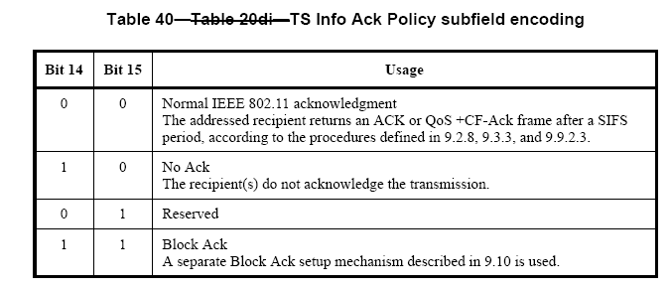

There is no explicit convention that describes the interpretation of bit fields. The text in clause 7 says:

“The MPDUs or frames in the MAC sublayer are described as a sequence of fields in specific order. Each figure in Clause 7 depicts the fields/subfields as they appear in the MAC frame and in the order in which they are passed to the physical layer convergence procedure (PLCP), from left to right.
In figures, all bits within fields are numbered, from 0 to k, where the length of the field is k + 1 bits. The
octet boundaries within a field can be obtained by taking the bit numbers of the field modulo 8. Octets
within numeric fields that are longer than a single octet are depicted in increasing order of significance, from lowest numbered bit to highest numbered bit. The octets in fields longer than a single octet are sent to the PLCP in order from the octet containing the lowest numbered bits to the octet containing the highest numbered bits.”

There is no statement that says, in a field of multiple bits, how the bits are shown. The mosts consistent convention consistent with the above is “least significant first/left”, which is consistent with the octet ordering rules. However, this is inconsistent with table 1, which defines these fields with a bitstring most significant bit on the left.
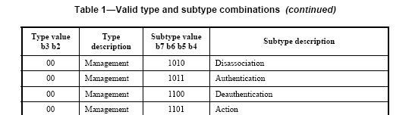

Proposal
The proposal consists of two parts, one borderline technical, one editorial. Note, the proposal does not limit the scope of additional editorial work such as splitting fields out into separate tables.

Interpretion of existing fields
Existing fields in D1.0 that are defined in terms of bit-strings are to be interpreted most significant bit on the left.

In the example we started with, this interpretation leads to the integer values show below in bold underline.
Extension Channel Offset | Values:  01= extension channel above the control channel (value 1)  11= extension channel below the control channel (value 3)  00= indicates no extension channel is present. (value 0) | To locate the 40MHz channel in combination with the control channel

Representation in future drafts
To make the interpretation unambiguous, we will add the bit positions of any existing multi-bit fields in the header as shown below with bold underline:
Extension Channel Offset | Values (b1 b0):  01= extension channel above the control channel  11= extension channel below the control channel  00= indicates no extension channel is present. | To locate the 40MHz channel in combination with the control channel

References: [1] IEEE P802.11n D1.0

