IEEE P802.11
Wireless LANs
Data transfer capabilities in Figure 154B
Date: 2006-04-24
Author(s):
Name | Company | Address | Phone | email
Bill Marshall | TGr Editor | 180 Park Ave, Florham Park, NJ 07932 | 973-360-8718 | wtm@research.att.com
Abstract
Three alternatives are given for showing the ability of the STA to continue data transfers with the Current AP up through sending the Reassociation Request frame.

While this is an editorial matter, the Editor needs some guidance from the group.

Which is the best presentation? Straw poll is desired by the Editor.
Notice: This document has been prepared to assist IEEE 802.11. It is offered as a basis for discussion and is not binding on the contributing individual(s) or organization(s). The material in this document is subject to change in form and content after further study. The contributor(s) reserve(s) the right to add, amend or withdraw material contained herein.

Release: The contributor grants a free, irrevocable license to the IEEE to incorporate material contained in this contribution, and any modifications thereof, in the creation of an IEEE Standards publication; to copyright in the IEEE’s name any IEEE Standards publication even though it may include portions of this contribution; and at the IEEE’s sole discretion to permit others to reproduce in whole or in part the resulting IEEE Standards publication. The contributor also acknowledges and accepts that this contribution may be made public by IEEE 802.11.

Patent Policy and Procedures: The contributor is familiar with the IEEE 802 Patent Policy and Procedures <http:// ieee802.org/guides/bylaws/sb-bylaws.pdf>, including the statement "IEEE standards may include the known use of patent(s), including patent applications, provided the IEEE receives assurance from the patent holder or applicant with respect to patents essential for compliance with both mandatory and optional portions of the standard." Early disclosure to the Working Group of patent information that might be relevant to the standard is essential to reduce the possibility for delays in the development process and increase the likelihood that the draft publication will be approved for publication. Please notify the Chair <stuart.kerry@philips.com> as early as possible, in written or electronic form, if patented technology (or technology under patent application) might be incorporated into a draft standard being developed within the IEEE 802.11 Working Group. If you have questions, contact the IEEE Patent Committee Administrator at <patcom@ieee.org>.

Alternative #1: The Note below the figure

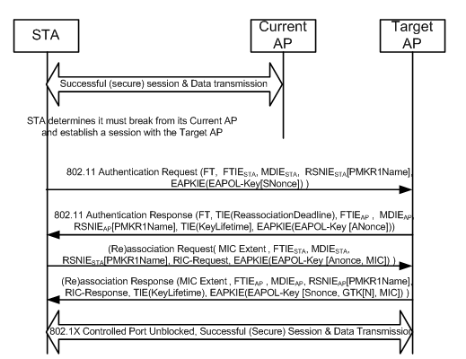

NOTE – Data transmission between the STA and Current AP may continue until the STA sends the Reassociation Request frame to the Target AP.
Alternative #2: The fat arrow

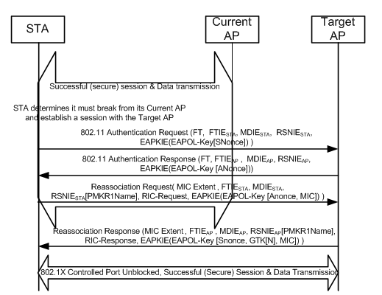
Alternative #3: The shaded box

