IEEE P802.11
Wireless LANs
Table of Resource Types
Date: 2006-04-13
Author(s):
Name | Company | Address | Phone | email
Bill Marshall | TGr Editor | 180 Park Ave, Florham Park, NJ 07932 | 973-360-8718 | wtm@research.att.com
Abstract
TGr D2.0 defines a general purpose mechamism for negotiating resources prior to a transition. It defines a Resource Information Container, consisting of a sequence of IEs that express the resource requirements and/or desires of the STA.

In order to make the draft more specific as to implementation requirements, this submission proposes the addition of a Table to the definition of the Resource Information Container, containing a list of the IEs that may appear in an RDIE. Such a table could be extended by other amendments to add other resource types to this framework.
Notice: This document has been prepared to assist IEEE 802.11. It is offered as a basis for discussion and is not binding on the contributing individual(s) or organization(s). The material in this document is subject to change in form and content after further study. The contributor(s) reserve(s) the right to add, amend or withdraw material contained herein.

Release: The contributor grants a free, irrevocable license to the IEEE to incorporate material contained in this contribution, and any modifications thereof, in the creation of an IEEE Standards publication; to copyright in the IEEE’s name any IEEE Standards publication even though it may include portions of this contribution; and at the IEEE’s sole discretion to permit others to reproduce in whole or in part the resulting IEEE Standards publication. The contributor also acknowledges and accepts that this contribution may be made public by IEEE 802.11.

Patent Policy and Procedures: The contributor is familiar with the IEEE 802 Patent Policy and Procedures <http:// ieee802.org/guides/bylaws/sb-bylaws.pdf>, including the statement "IEEE standards may include the known use of patent(s), including patent applications, provided the IEEE receives assurance from the patent holder or applicant with respect to patents essential for compliance with both mandatory and optional portions of the standard." Early disclosure to the Working Group of patent information that might be relevant to the standard is essential to reduce the possibility for delays in the development process and increase the likelihood that the draft publication will be approved for publication. Please notify the Chair <stuart.kerry@philips.com> as early as possible, in written or electronic form, if patented technology (or technology under patent application) might be incorporated into a draft standard being developed within the IEEE 802.11 Working Group. If you have questions, contact the IEEE Patent Committee Administrator at <patcom@ieee.org>.

Change 7.3.2.46 as follows:
(Note – other submissions move the changed portion of 7.3.2.46 to 8A.7. It is intended that these changes also be moved to 8A.7 if that submission is also accepted.)

7.3.2.46 Resource information container information elements
The Resource Information Container (RIC) refers to a collection of Information Elements that are used to express a resource request in a resource request message. A RIC is also used to convey responses to the corresponding requests.

Two IE types are used to define the RIC structure:
- RIC_ROOT (RRIE): used as the RIC header
- RIC_DATA (RDIE): used to describe each Resource Request. A simple Resource Request is an RDIE followed by single Resource IE (e.g., a TSPEC).
A Resource Information Container has one RRIE and a list of zero or more Resource Requests, as shown in Figure 113R.
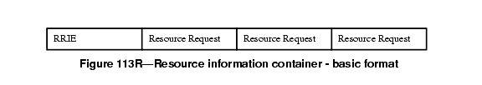

When multiple Resource Requests appear in a RIC, the STA's intent is that all of them be allocated. Thus an "AND" relationship exists between the Resource Requests.

Each Resource Request consists of an RDIE followed by one or more alternative Resource descriptions. Each resource alternative is described by one Information Element, referred to here as a "Resource IE." The Resource IEs may be followed by one or more additional information elements (referred to here as "Auxiliary IEs") that provide additional information that applies to all of the alternative Resource IEs. The possible resources that may be specified by a RIC, and the information elements that describe that resource, are given in Table XX:

Table XX: Resource Types and Resource/Auxiliary IEs describing them
Resource Type | Resource IEs | Auxiliary IEs | Reservation Procedures | Notes
QoS | TSPEC (see 7.3.2.30) | TCLAS (7.3.2.31)  TCLAS Processing (7.3.2.33)  Schedule (7.3.2.34) | See 11.4 | May only be sent by a QSTA to a QAP.

An example of a Resource Request, consisting of both Resource information elements and Auxiliary information elements, is shown in Figure 113S.
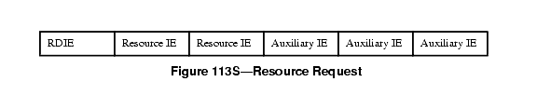

For example, when the resource being requested is QoS for downstream traffic, the set of TSPEC information elements may be followed by one or more TCLAS information elements and, only when multiple TCLAS information elements are present, a TCLAS Processing element. Such an example Resource Request is shown in Figure 113T.
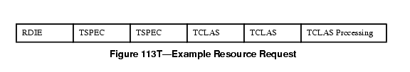

If there are multiple Resource IEs then these are treated as "choices" by the target AP. The AP shall attempt to allocate whatever is specified in the first Resource IE; if this fails the AP shall attempt to allocate whatever is specified in the next Resource IE instead, and so on until a successful allocation or the AP reaches the end of the Resource IE list. Thus, an "OR" relationship exists between Resource IEs that follow an RDIE, with the Resource IEs appearing in order of preference.
An example of a RIC with two resource requests, each with a single TSPEC, is given in Figure 113U.
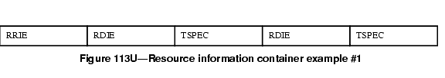

An example of a RIC with one resource request, with a choice of two TSPECs, is given in Figure 113V. This indicates that the target AP can select one of the two TSPECs
.
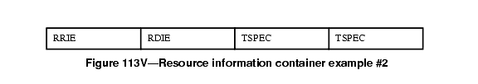

7.3.2.46.1 RIC root information element (RRIE)
The Resource Information Container Root Information Element (RRIE) is defined in Figure 113W.
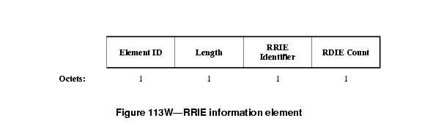

The length field shall contain a value 2.
The RRIE Identifier contains an arbitrary value that shall be unique among outstanding resource allocation requests at a STA to enable the matching of responses to requests.
The RDIE Count contains the number of RDIEs in this RIC.
7.3.2.46.2 RIC data information element (RDIE)
The Resource Information Container Data Information Element (RDIE) is defined in Figure 113X.
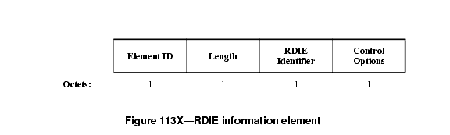

The length field shall contain a value 2.
The RDIE Identifier is an arbitrary value, chosen by the resource requestor, which uniquely identifies the RDIE within the RIC. It is used in the response to refer to a specific resource allocation request.
The Control Options field is defined in Figure 113Y.

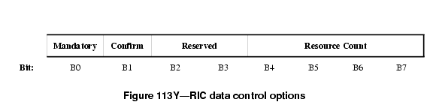

The Mandatory bit set to 1 indicates that one of the Resource IEs that follow the RDIE needs to be allocatable/allocated for the resource request to be considered successful. If the Mandatory bit is set to 0, and none of the Resource IEs is allocatable/allocated, the AP continues processing the remainder of the RIC.
The Confirm bit is used only in response messages to indicate success or failure of the allocation. It is ignored in request messages, and shall be set to zero.
The Resource Count indicates the number of alternative Resource IEs that follow this RDIE. Auxiliary IEs are not included in the Resource Count.

