IEEE P802.11
Wireless LANs
Updated Annex L For Review
Date: 2006-01-17
Author(s):
Name | Company | Address | Phone | email
W. Fisher | ARINC | 2551 Riva Road, Annapolis, MD 21401 | 410-266-4958 | wfisher@arinc.com
Mary Ann Ingram | Georgia Institute of Technology | Atlanta, GA |  | mai@ece.gatech.edu
Abstract
This is a draft of Annex L “WAVE RF Channel Emulator Model” for P802.11p. This is for review and discussion and resolution for inclusion as part of draft amendment P802.11p.
Notice: This document has been prepared to assist IEEE 802.11. It is offered as a basis for discussion and is not binding on the contributing individual(s) or organization(s). The material in this document is subject to change in form and content after further study. The contributor(s) reserve(s) the right to add, amend or withdraw material contained herein.

Release: The contributor grants a free, irrevocable license to the IEEE to incorporate material contained in this contribution, and any modifications thereof, in the creation of an IEEE Standards publication; to copyright in the IEEE’s name any IEEE Standards publication even though it may include portions of this contribution; and at the IEEE’s sole discretion to permit others to reproduce in whole or in part the resulting IEEE Standards publication. The contributor also acknowledges and accepts that this contribution may be made public by IEEE 802.11.

Patent Policy and Procedures: The contributor is familiar with the IEEE 802 Patent Policy and Procedures <http:// ieee802.org/guides/bylaws/sb-bylaws.pdf>, including the statement "IEEE standards may include the known use of patent(s), including patent applications, provided the IEEE receives assurance from the patent holder or applicant with respect to patents essential for compliance with both mandatory and optional portions of the standard." Early disclosure to the Working Group of patent information that might be relevant to the standard is essential to reduce the possibility for delays in the development process and increase the likelihood that the draft publication will be approved for publication. Please notify the Chair <stuart.kerry@philips.com> as early as possible, in written or electronic form, if patented technology (or technology under patent application) might be incorporated into a draft standard being developed within the IEEE 802.11 Working Group. If you have questions, contact the IEEE Patent Committee Administrator at <patcom@ieee.org>.

Annex L
(normative)

WAVE RF Channel Emulator Models
EDITOR NOTE: Latest Update provided by Mary Ann Ingram, Ga. Tech, 1/17/06.
This document provided for Review.

L.1 Introduction
To ensure that a WAVE device can operate in a dynamic mobile RF environment this Annex presents the requirements that the device shall meet, an RF Channel Emulator model, and the parameters to be used to evaluate the device. The devices shall be evaluated for Doppler effects and multi-path signals at normal highway speeds and at very high closure speeds for vehicle-to-vehicle communications. The “very high closure speed” model is not available at this time, and is under development.

L.2 Test Environment
The test evaluates the packet error rate (PER) for the open highway condition. For vehicle-to-vehicle transmission on the open highway, consistent with same-direction travel and vehicle speeds of 140km/hr, the packet error rate (PER) shall be less than 10% for PSDU length of 1000 bytes for signals that have passed through an RF channel emulator with settings according to Table XXX below, over a period of 5 seconds for 3, 6, and 12 Mbps data rates. The multi-path effects reflected in the table are (being) developed by Mary Ann Ingram and her staff at the Georgia Institute of Technology¹.

L.3 RF Channel Emulator Model

L.3.1 Introduction
Edit Note: [Adapt text for this Annex.]
The following channel model has been approximately fit to a large volume of channel measurements taken in 2003. The channel was measured between two moving vehicles, traveling the same direction on an expressway in Atlanta, Georgia. The data was measured at 2.4 GHz and the vehicles were traveling approximately 55 mph. To produce the model parameters below, the Doppler spectra were scaled to be consistent with 5.9GHz and 85 mph (140km/hr). It is noted that same-direction travel produces single-bounce paths of propagation with closing speeds approaching +/- 170mph (283km/hr), which correspond to path Doppler shifts of up to +/- 1547 Hz. The data collection procedure was described in a number of presentations to the DSRC standards group in Fall 2003, a final report for that project [1], and a conference papers [2]. The channel modeling approach is described in [3,4,7].

School of Electrical and Computer Engineering, Georgia Institute of Technology, Atlanta GA, 30332, USA.

L.3.2 The 12-path Channel Emulator Model
The parameters for a 10-tap channel model for the expressway, same direction travel, are given below in Table pL.1. The model uses 12 channel emulator paths to craft 10 channel taps. The first tap is crafted from 3 channel emulator paths, to provide a good fit to the measured spectrum for this strongest tap. One of the paths (a pure frequency shift) provides the spectral line that represents the deterministic component of the tap. The other two paths (one rounded and one flat) provide the diffuse, or random, part of the first tap. The K factor for the first tap is implicit in the channel emulator model. The ratio of the power of the spectral line to the sum of the powers of the diffuse components equals the K factor for the first tap. The remaining 9 taps are each described by one path of the channel emulator, with the K factor specified explicitly.
Table pL.1─12-path Expressway Channel Emulator Model

Path No. | Tap No. | Tap Power (dB), K | Path Power (dB) | Excess Delay (ns) | Path K factor | Freq. offset (fd) in Hz | Spectrum half-width (ff) in Hz | Angle of Arrival  (deg) | Spectrum shape
1 | 1 | 0, 102 | -0.0424 | 0 | 0 | 264.6 | - | - | Freq. Shift
2 | 1 |  | -24.8927 | 0 | 0 | -75.6 | 476.3 | 0 | Rounded
3 | 1 |  | -21.8927 | 0 | 0 | -37.8 | 1001.7 | 0 | Flat
4 | 2 | -6.5 | -6.5 | 50 | 7.3 | 0 | 1088.6 | 86 | Rounded
5 | 3 | -14.4 | -14.4 | 100 | 4.7 | 0 | 1266.3 | 95 | Rounded
6 | 4 | -17.5 | -17.5 | 150 | 3.6 | 0 | 1266.3 | 87 | Rounded
7 | 5 | -19.7 | -19.7 | 200 | 1.8 | -71.8 | 1247.4 | 76 | Rounded
8 | 6 | -22.0 | -22.0 | 250 | 0.5 | -30.2 | 1251.2 | 82 | Rounded
9 | 7 | -24.4 | -24.4 | 300 | 0.2 | 75.6 | 1228.5 | 90 | Rounded
10 | 8 | -25.3 | -25.3 | 350 | 0.2 | 71.8 | 1247.4 | 85 | Rounded
11 | 9 | -27.1 | -27.1 | 400 | 0.0 | -3.8 | 1156.7 | 90 | Rounded
12 | 10 | -28.1 | -28.1 | 450 | 0.0 | -75.6 | 1311.7 | 90 | Rounded

The menu of path spectra in the channel emulator is limited to rounded, classic 6dB, classic 3dB, and flat. These are illustrated in Figure pL.1. A pure frequency shift is also available. Spirent has defined [5] the classic 6dB as follows:
$$S_{6}(f)=\left\{\begin{matrix}\frac{a}{\sqrt{1−{\left(\frac{f−\text{fd}}{\text{ff}}\right)}^{2}}} & \left|f−\text{fd}\right|<0\text{.}\text{999}\text{ff} \\ 0 & \text{otherwise}\end{matrix}\right.$$
where ff is the maximum Doppler shift (for the path) and fd is the Doppler offset (the point of symmetry of the spectrum shape). The truncation of the region of support for this spectrum to 0.999ff avoids the singularities that are shown in most textbooks on wireless communications, and achieves and approximate 6 dB from the peaks to the trough of this spectrum shape. The factor a is chosen so that the integral of the spectrum (the average power of the path process) is set to a specified value (given as Path Power in Table pL.1). The “classic 3 dB” spectrum is found from the classic 6 dB, simply by taking the square root: $S_{3}(f)=\sqrt{S_{6}(f)}$. The rounded spectrum is the inverse of the classic 6 dB:
$$S_{\text{rounded}}(f)=\left\{\begin{matrix}a\sqrt{1−{\left(\frac{f−\text{fd}}{\text{ff}}\right)}^{2}} & \left|f−\text{fd}\right|<0\text{.}\text{999}\text{ff} \\ 0 & \text{otherwise}\end{matrix}\right.$$
The Flat spectral shape is defined
$S_{\text{flat}}(f)=\left\{\begin{matrix}a & \left|f−\text{fd}\right|≤\text{ff} \\ 0 & \text{otherwise}\end{matrix}\right.$.
The spectral shapes are illustrated in the Figure pL.1 below.
Figure pL.1─Available spectral shapes on the Spirent 5500 RF Channel Emulator [6].

L.3.3 12-path Model Compared to Empirical Spectra

The average measured spectra of the unscaled data are compared to the channel emulator spectra for the unscaled data in this section. In other words, the measured and channel emulator spectra shown in this section are consistent with 2.4 GHz and 55 mph vehicle speeds. The “fd” and “ff” parameters in Table pL.1 are equal to those illustrated in the figures in this section, scaled by a factor of 3.78; all other parameters in Table pL.1 are not affected by the scale factor. The fitting is done on unscaled data to avoid having to re-sample the measured data. Details on the creation of this model may be found in [8]. In each tap, the resulting channel emulator spectrum matches the averaged measured spectrum in both K-factor and in total power (the integral of the spectrum). The method of shape fitting was subjective for Taps 1 and 2, and performed by a genetic algorithm on Taps 3 through 10. The genetic algorithm maximized the inverse of the summed square error between the measured spectrum (not in dB) and the channel emulator tap spectrum (not in dB).
Figures pL.2 and pL.3 show the spectra for taps 1 through 6, and 7 through 10, respectively. In each subplot of the figures, the channel emulator tap spectrum is plotted against the averaged measured spectrum.

Figure pL.2─Comparison of fitted spectral shapes to averaged measured spectra for the first 6 taps of the 12-path Expressway Model (unscaled).
The channel emulator spectral lines do not match exactly the measured spectral lines for the following reason. The samples of measured spectra per tap were aligned prior to averaging. It is the averaged aligned spectra that are shown in the above two figures. This was done to eliminate the broad peak that results from averaging spectra without alignment. An example of the broad peak for Tap 1 is shown in Figure pL.4. In this figure, non-aligned spectra are superimposed and the black bold line indicates the average. The broad peak of the average occurs because the spectral lines associated with each sample spectrum generally have different frequencies because the relative speeds of the vehicles are different in each sample. Figure pL.5 shows aligned spectra superimposed, and the bold black line indicates the average. The average of the aligned spectra has a much narrower peak.
In creating the channel emulator model, the measured (aligned) spectral peak is replaced with an offset pure spectral line. The offset is chosen differently for each tap, yet within the range of spectral line positions observed in the sample spectra for each tap. The offset selection was arbitrarily chosen to be the rightmost within the range for Tap 1, midrange for Tap 2, leftmost within the range for Tap 3, midrange for Tap 4, rightmost within the range for Tap 5, and so forth.
Figure pL.3─Comparison of fitted spectral shapes to averaged measured spectra for the second 6 taps of the Expressway model (unscaled).

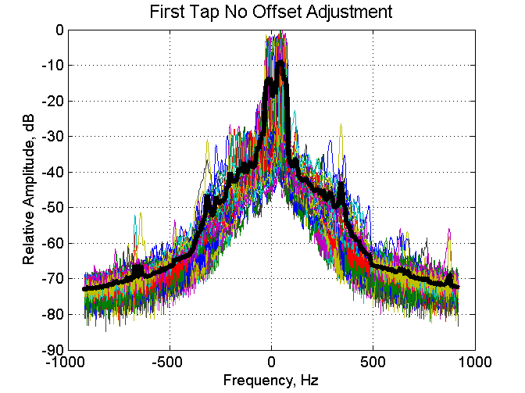
Figure pL.4─A superposition and average of non-aligned measured first tap spectra (unscaled).

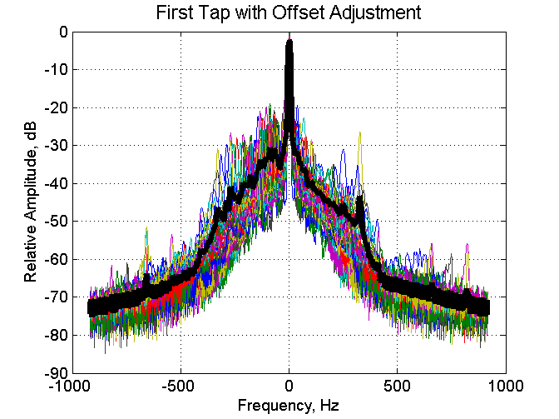
Figure pL.5─A superposition and average of aligned measured first tap spectra (unscaled).

L.4.2 WAVE Compliant Devices
WAVE devices that have been tested to the test cases defined in L.4.1.1 and L.4.1.2 will be WAVE compliant with respect to P802.11p.

L.5 References:

- M. A. Ingram, K. L. Tokuda, and Guillermo Acosta , “Analysis and Measurement Support for the ASTM 5.9 GHz Standards Writing,” Final Report, December 2004.
- G. Acosta, K. Tokuda, and M.A. Ingram, “Measured joint doppler-delay power profiles for vehicle-to-vehicle communications at 2.4 GHz,” Proc. IEEE Global Telecommunications Conference (Globecom), Dallas, TX, Nov. 29-Dec. 3, 2004.
- Guillermo Acosta and Mary Ann Ingram, “Model Development for the Wideband Vehicle-to-vehicle 2.4 GHz Channel,” submitted to IEEE Wireless Communications & Networking Conference (WCNC 2006), Las Vegas, NV, 3-6 April 2006.
- W. Mohr, “Modeling of wideband mobile radio channels based on propagation measurements,” in Proc. 16th Int. Symp. Personal, Indoor, Mobile Radio Commun-ications, vol. 2, pp. 397-401, 1995.
- Personal communication with Wayne Lee of Spirent, October 2005.
- SR 5500 Operations Manual
- Presentation at the November 2005 802.11 meeting. 11-05-1176-00-000p-WAVE Motion Related Channel Model.ppt
- G. Acosta-Marum and M.A. Ingram, “A BER-Based Partitioned Model for a 2.4 GHz Vehicle-to-Vehicle Expressway Channel,” submitted for a special issue of Springer's International Journal on Wireless Personal Communication, July 2006.

