IEEE P802.11
Wireless LANs
General purpose RIC
Date: 2006-01-16
Author(s):
Name | Company | Address | Phone | email
Bill Marshall | TGr Editor | 180 Park Ave, Florham Park, NJ 07932 | 973-360-8718 | wtm@research.att.com
Abstract
This document contains the changes needed to the latest TGr draft in order to clarify that the RIC mechanism is intended as a general purpose resource pre-reservation mechanism, and not just a QoS mechanism.

Changes are identified by MSWord “Track Changes”
Notice: This document has been prepared to assist IEEE 802.11. It is offered as a basis for discussion and is not binding on the contributing individual(s) or organization(s). The material in this document is subject to change in form and content after further study. The contributor(s) reserve(s) the right to add, amend or withdraw material contained herein.

Release: The contributor grants a free, irrevocable license to the IEEE to incorporate material contained in this contribution, and any modifications thereof, in the creation of an IEEE Standards publication; to copyright in the IEEE’s name any IEEE Standards publication even though it may include portions of this contribution; and at the IEEE’s sole discretion to permit others to reproduce in whole or in part the resulting IEEE Standards publication. The contributor also acknowledges and accepts that this contribution may be made public by IEEE 802.11.

Patent Policy and Procedures: The contributor is familiar with the IEEE 802 Patent Policy and Procedures <http:// ieee802.org/guides/bylaws/sb-bylaws.pdf>, including the statement "IEEE standards may include the known use of patent(s), including patent applications, provided the IEEE receives assurance from the patent holder or applicant with respect to patents essential for compliance with both mandatory and optional portions of the standard." Early disclosure to the Working Group of patent information that might be relevant to the standard is essential to reduce the possibility for delays in the development process and increase the likelihood that the draft publication will be approved for publication. Please notify the Chair <stuart.kerry@philips.com> as early as possible, in written or electronic form, if patented technology (or technology under patent application) might be incorporated into a draft standard being developed within the IEEE 802.11 Working Group. If you have questions, contact the IEEE Patent Committee Administrator at <patcom@ieee.org>.

7.3.2.45 Resource information container information elements
The Resource Information Container (RIC) refers to a collection of Information Elements that are used to express a resource request in a resource request message. A RIC is also used to convey responses to the corresponding requests.
Each resource is described by one Information Element, referred to here as a “Resource IE”. For example, a TSPEC describes a QoS resource, and is contained in an Information Element defined in clause 7.3.2.29.
NOTE - above cross reference to 7.3.2.29 is to the clause entitled "Traffic Specification (TSPEC) element", contained in amendment 802.11e, and given there as clause 7.3.2.15. It is anticipated that this will become 7.3.2.29 when 11e is merged into the next draft of 11ma.
Two IE types are used to define the RIC structure:
- RIC_ROOT (RRIE): used as the RIC header
- RIC_DATA (RDIE): used to describe each Resource Request. A simple Resource Request is an RDIE followed by single Resource IE, (e.g., a TSPEC).
A Resource Information Container has one RRIE and a list of zero or more Resource Requests, as shown in Figure 80AG.
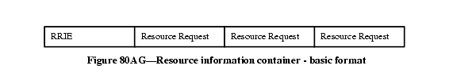

When multiple Resource Requests appear in a RIC, the STA's intent is that all of them be allocated. Thus an "AND" relationship exists between the Resource Requests.
Each Resource Request comprises an RDIE followed by one or more Resource information elements. The Resource IEs may be followed by one or more additional information elements (referred to here as “Auxiliary IEs”) that provide additional information that applies to all of the Resource IEs. For example, when the resource being requested is QoS for downstream traffic, the set of TSPEC information elements may be followed by one or more TCLAS information elements and, only when multiple TCLAS information elements are present, a TCLAS Processing element. Such an example Resource Request is shown in Figure 80AH.
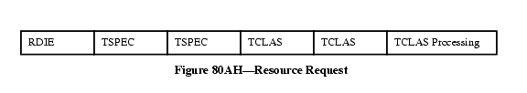

If there are multiple Resource IEs then these are treated as "choices" by the target AP. The AP shall attempt to allocate whatever is specified in the first Resource IE; if this fails the AP shall attempt to allocate whateber is specified in the next Resource IE instead, and so on until a successful allocation or the AP reaches the end of the Resource IE list. Thus, an "OR" relationship exists between Resource IEs that follow an RDIE, with the resources appearing in order of preference.
An example of a RIC with two resource requests, each with a single TSPEC, is given in Figure 80AI.
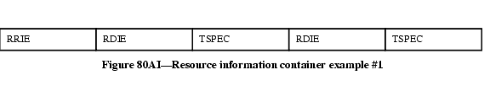

An example of a RIC with one resource request, with a choice of two TSPECs, is given in Figure 80AJ. This indicates that the target AP can select one of the two TSPECs
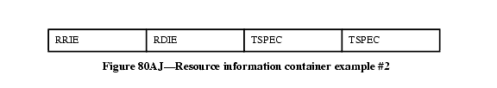
.
7.3.2.45.1 RIC root information element (RRIE)
The Resource Information Container Root Information Element (RRIE) is defined in Figure 80AK.
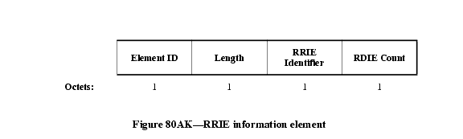

The length field shall contain a value 2.
The RRIE Identifier contains an arbitrary value that shall be unique among outstanding resource allocation requests at a STA to enable the matching of responses to requests.
The RDIE Count contains the number of RDIEs in this RIC.
7.3.2.45.2 RIC data information element (RDIE)
The Resource Information Container Data Information Element (RDIE) is defined in Figure 80AL.
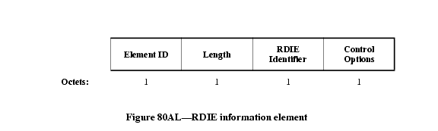

The length field shall contain a value 2.
The RDIE Identifier is an arbitrary value, chosen by the resource requestor, which uniquely identifies the RDIE within the RIC. It is used in the response to refer to a specific resource allocation request.
The Control Options field is defined in Figure 80AM.

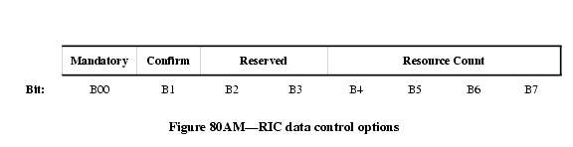

The Mandatory bit set to 1 indicates that one of the Resource IEs that follow the RDIE needs to be allocatable/allocated for the resource request to be considered successful. If the Mandatory bit is set to 0, and none of the Resource IEs is allocatable/allocated, the AP continues processing the remainder of the RIC.
The Confirm bit is used only in response messages to indicate success or failure of the allocation.
The Resource Count indicates the number of alternative Resource IEs that follow this RDIE. Auxiliary IEs are not included in the Resource Count.

8A.6 Resource pre-reservation procedures
8A.6.1 General
When using the pre-reservation procedure, the STA has the option to request a resource allocation at the target AP. To request resources the STA creates a Resource Information Container (RIC) and inserts it in an appropriate request message to the target AP. The request message is sent to the target AP either directly (over-the-air), or via the Current AP (over-the-DS), according to the Fast BSS Transition procedures described in clauses 8A.3 and 8A.4. Since resource reservation procedures are only available in an RSNA, and all resource requests and responses are exchanged only after the establishment of the PTK, they are protected by message integrity checks.
The initial RIC is "fully specified" in that it contains a complete description of all the required resources. Subsequent resource requests may be fully specified (such as a replacement RIC), or may be "partly specified" (such as a confirmation RIC or an update RIC).
This clause contains procedures for generation of an initial fully specified RIC, procedures for replacing or updating existing reservations, and procedures when performing a final resource allocation at (re)association time. The following clauses describe the pre-reservation procedures: clause 8A.6.2 for an initial fully specified RIC; clause 8A.6.3 for a replacement RIC; clause 8A.6.4 for an update RIC; and clause 8A.6.5 for a confirmation RIC. Clause 8A.6.6 contains the additions to the procedures of 8A.6.2 through 8A.6.5 that are necessary when the request is contained in a (re)association request.
If the STA is performing the FT Base Mechanism, described in clause 8A.3, it shall generate an initial fully specified RIC and process the RIC response according to the procedures of 8A.6.2.1 and 8A.6.6.1, performing the exchange in the (re)association request/response.
If the STA is performing a Pre-Reservation, described in clause 8A.4, it shall generate an initial fully specified RIC and process the RIC response according to the procedures of 8A.6.2.1, performing the exchange in the Authentication-Confirm/Authentication-Acknowledgement frames (or FT Confirm/FT Acknowledgement Action frames). At the time of (re)association, the STA shall issue either (a) a confirmation RIC, as described in clause 8A.6.5.1, (b) an update RIC, as described in clause 8A.6.4.1, or (c) a replacement RIC, as described in clause 8A.6.3.1. In all cases, the procedures are augmented by those of 8A.6.6.1, and the exchange is performed in the (re)association request/response.
Once a STA has made a pre-reservation, and prior to (re)association, it may change that reservation by (a) sending an update RIC to the target AP , or (b) sending a replacement RIC to the target AP. In this case the STA shall generate the RIC and process the response according to the procedures of 8A.6.4.1 or 8A.6.5.1, performing the exchange in the Authentication-Confirm/Authentication-Acknowledgement frames (or FT Confirm/FT Acknowledgement Action frames). The STA may repeat this process as necessary within the constraints of the reassociation deadline timer. At the time of (re)association, the STA shall issue either (a) a confirmation RIC, as described in clause 8A.6.5.1, (b) an update RIC, as described in clause 8A.6.4.1, or (c) a replacement RIC, as described in clause 8A.6.3.1. In all cases, the procedures are augmented by those of 8A.6.6.1, and the exchange is performed in the (re)association request/response.
When an AP receives a RIC from a STA, it shall first determine whether the request is a new reservation request. This is done by comparing the STA MAC address against current reservations at the AP. If this is an initial request (i.e., no current reservation exists), the procedures of 8A.6.2.2 are followed. If this is an update to a previous request, or a replacement, then the procedures of 8A.6.3.2, 8A.6.4.2, or 8A.6.5.2 are followed. In all cases, the procedures are augmented by those in 8A.6.6.2 if the request is contained in a (re)association request.
8A.6.2 Initial resource request by a STA
8A.6.2.1 STA procedures
The resource reservation request enables a STA that is also a non-AP QSTA to reserve resources based on specified Resource IEs (e.g., TSPECs) before the STA associates with the target AP. In using TSPECs for requesting QoS resources, the TSPECs in the request need not belong to only active Traffic Streams; the STA can send TSPECs for any Traffic Stream that it intends to use after the transition. These Resource IEs are included in a Resource Information Container (RIC). For each Resource, the STA may provide the AP with a choice of Resource IEs in order of preference, any one of which will meet the needs of the application.
For a new reservation request (the initial request) the STA shall construct the RIC as follows: The RIC comprises a series of information elements concatenated in sequence. Three types of information elements are used: "RIC Root" (RRIE), "RIC Data" (RDIE) and Resource information elements. In the RRIE, the RRIE Identifier shall contain an arbitrary value intended to enable the matching of the response to this request. The "Count of RDIEs" field shall contain the number of RDIEs present in the RIC.
The STA shall consider the resources that it desires at the next AP. For QoS resources, each traffic stream shall be requested by a separate RDIE and associated TSPEC(s). The RDIE Identifier in the RDIE shall be an arbitrary value chosen by the STA that uniquely identifies the RDIE within the RIC. In the Control Options field, the Mandatory bit shall indicate whether the allocation of this resource is mandatory or optional; the Confirm bit shall be set to zero, and the Resource Count shall be set to the number of alternative Resource information elements that follow.
Following each RDIE, the STA shall include one or more Resource IEs that define the resources required. When multiple TSPECs follow an RDIE as part of a single QoS resource request, a logical "OR" relationship exists between them, and at most one of these TSPECs will be accepted by the AP. The STA shall order the Resource IEs by preference, most desired first.
A response to the reservation request is considered successful by a STA if the status code 0 is returned in the response message. This indicates that the AP has reserved one of the Resource IEs in each RDIE marked as "Mandatory" in the Control Options field. Resource IEs in RDIEs that were not marked "Mandatory" may or may not have been reserved, as indicated by the "Confirm" bit.
If the response to the reservation request contains a status code other than 0, the STA considers that the request has failed, and that no resources are being held at the target AP.
The response from the target AP may contain a RIC, with the RRIE Identifier matching the value present in the original RIC request. The RDIEs in the response indicate which resources were considered by the target AP and the setting of the Confirm bit indicates which Resource IEs could be reserved by the AP. If the status code of the response is zero, all the Resource IEs with the confirm bit set are reserved at the target AP. If the reservation response returns a failure code no resources are reserved by the AP but those with the confirm bit set could have been reserved. This information may be useful to the STA in formulating another reservation request.
The RDIE Identifier in the RDIE enables the STA to match the response with the RDIE in the request. The "confirm" bit in the RDIE Control Options is interpreted as follows:
- Confirm = '1' indicates that the resources were available when the AP processed the request. If the response has the status SUCCESS the resources will have been allocated or reserved. The RDIE may be followed by the Resource IE that was accepted.
- Confirm = '0' indicates that the resources could not be allocated. The RDIE may be followed by a suggested Resource IE that could have been allocated.
A response to a successful resource request (other than in a (re)association request) contains the reassociation deadline. It is the responsibility of the STA to initiate a (re)association request to associate with the target AP within the specific time indicated in the resource reservation response. Failure to do so will result in the release of any resources held by the target AP.
8A.6.2.2 AP procedures
When a Resource Information Container appears in a Request, the AP shall check its ability to allocate one resource for each RDIE in the RIC in the order appearing in the RIC.
The behavior of the AP is described in the flowchart in Figure 121I below:

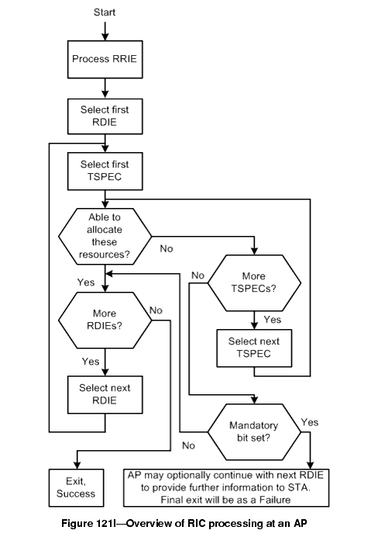

In Figure 121I, change “Select First TSPEC” to “Select First Resource IE”; change “More TSPECs?” to “More Resource IEs?”; change “Select next TSPEC” to “Select next Resource IE”

The SME examines the resource requests in the RIC. For those that require processing by the MAC layer, it generates a MLME.RESERVATION_LOCAL.request; the MAC shall respond with MLME.RESERVATION_LOCAL.response that will indicate whether the MAC has accepted the resource request or not. The SME may also send these resource requests to an external entity such as a back-end QoS module for its consideration; these procedures are beyond the scope of this specification. The acceptance of a TSPEC by the target AP results in the resource allocation for a traffic stream at the target AP.
The AP shall construct a response RIC and include it in the response message. The RRIE Identifier in the RRIE shall match the value in the request. The response RIC shall comprise one RDIE for each resource that the AP has assigned or attempted to assign. The RDIEs shall be in the same order as in the request and the RDIE Identifier in each RDIE shall be the value of the RDIE Identifier in the corresponding RDIE in the request. The "confirm" bit in the Control Options in the RDIE shall be set according to the result of the allocation request as follows:
- Confirm = '1' indicates that the resources are available. If the response has the status SUCCESS the resources have been allocated or reserved. The RDIE shall also be followed by the Resource IE that was accepted.
- Confirm = '0' indicates that the resources could not be allocated. In this case the AP may include a single Resource IE following the RDIE indicating a suggested resource that could have been allocated. The Resource Count field shall be set to '0' or '1' depending whether the suggested Resource IE is attached.
If a mandatory resource request fails, the AP need not process RDIEs that follow but may choose to do so in order to provide information to the STA. Absence of an RDIE in the response indicates that the RDIE and related Resource IEs were not considered by the AP.
If the AP is unable to meet the resource request, then the AP shall indicate a failure status code in the response message. The status code provides a reason for the failure, such as if a TSPEC is invalid, if resources are unavailable, or if authentication timed out. If the request fails, no resources are actually allocated.
If the resource request included QoS resources and is successful, then the AP shall place the Traffic Stream into the "Accepted" state. If the request is other than a (re)association request, the AP shall include a reassociation deadline time in the response message.
If the STA does not invoke a (re)association within the reassociation deadline, then the Traffic Streams that had been "Accepted" shall become "Inactive" and the resources shall be released.
8A.6.3 Subsequent resource request by a STA: replacement RIC
8A.6.3.1 STA procedures
After making a reservation using a fully specified RIC, the STA may modify the request, providing a new fully specified RIC as a replacement for the previous reservation.
If the STA wishes to discard an existing reservation and replace with a new reservation, it shall construct a fully specified RIC as specified in 8A.6.2.1, but using a new RRIE Identifier value. Upon receipt of such a request the AP discards any previous reservation for the STA and attempts to make new allocations based on the new RIC.
Procedures for handling the response to a replacement RIC are as given in 8A.6.2.1. Note that if the response indicates a failure, all previous reservations by this STA at the target AP will have been discarded.
8A.6.3.2 AP procedures
If the AP receives a reservation request from a STA for which
a) it already has an existing uncommitted successful reservation, and
b) the RRIE Identifier in the RRIE does not match the RRIE Identifier of the previous request
then this resource request is a Replacement RIC.
The AP shall release the existing reservation, and treat the request as a new request.
NOTE-- The AP may take into consideration any resources for the pre-existing reservation when allocating resources for the new Resource IEs (as an implementation optimization the target AP may "transfer" resources from the prior reservation to the new reservation in a way that is transparent to the STA.)
The procedures for the AP handling of the request and generation of the response shall otherwise be as given in 8A.6.2.2.
8A.6.4 Subsequent resource request by a STA: update RIC
8A.6.4.1 STA procedures
If the STA is making a resource request that is intended to modify an earlier accepted pre-reservation request, within the reassociation deadline, the procedures described in this clause are followed in generation of the RIC.
The RIC Identifier in the RRIE shall be set to the same value as appeared in the previous request's RRIE. The STA shall consider the set of resources that it now desires at the target AP, and compare it against the previous reservation request. The STA shall generate an RDIE for each of the currently desired resources, according to the following rules:
1) for a resource that was successfully pre-reserved and the current requirements are unchanged, an RDIE shall be included with the RDIE Identifier value and Mandatory flag identical to the values that appeared in the RDIE in the previous request. The Resource IEs from the previous request shall not be included in this case, so the Resource count shall be zero.
2) for a resource that was successfully pre-reserved but no longer required, the RDIE shall be excluded from this RIC.
3) for a resource that was successfully pre-reserved but the Resource IE parameters have changed, an RDIE shall be included with the RDIE Identifier value identical to the value that appeared in the RDIE in the previous request. The modified Resource IEs are appended to the RDIE. The Resource Count shall be non-zero.
4) for a resource that was not previously reserved, a new RDIE shall be included with a new RDIE Identifier and one or more new Resource IEs.
The procedures for the STA handling of the response shall be as given in 8A.6.2.1. Note that if the response indicates a failure, all reservations at the target AP will have been discarded.
8A.6.4.2 AP procedures
If the AP receives a reservation request from a STA for which
a) it already has an existing uncommitted successful reservation,
b) the RRIE Identifier in the RRIE matches the RRIE Identifier of the previous request, and
c) the RDIE count of the request is non-zero
then this resource request is considered an Update RIC.
The AP shall inspect the RDIEs to determine what modifications are being requested. For each RDIE the AP shall take the following action:
1) If the RDIE Identifier matches that of an existing Accepted traffic stream and the Resource Count is zero, then the reservation is confirmed and no action is taken.
2) If the RDIE Identifier matches that of an existing reserved resource and the Resource Count is non-zero, then the existing reserved resource is discarded and a new allocation is attempted.
3) If the RDIE Identifier does not match that of an existing reserved resource and the Resource Count is non-zero then a new allocation is attempted.
4) If the RDIE Identifier of an existing reserved resource does not appear in the RIC, then the existing reserved resource is discarded.
If any new allocation fails and the RDIE is marked as "Mandatory" then all reserved resources associated with the RRIE Identifier shall be discarded and a failure status code returned as described in 8A.6.2.2.
The AP shall construct and include a response RIC in the reply as specified in 8A.6.2.2.
8A.6.5 Subsequent resource request by a STA: confirmation RIC
8A.6.5.1 STA procedures
If the STA is making a resource request that is intended to confirm an earlier accepted pre-reservation request, within the reassociation deadline, the procedures described in this clause are followed in generation of the RIC.
When all the required resources were successfully pre-reserved, and still required, then the RIC Identifier in the RRIE shall be set to the same value as appeared in the previous request's RRIE, and the count of RDIEs shall be set to zero. The RIC in this case consists of just the RRIE.
Procedures for handling the response to a confirmation RIC are as given in 8A.6.2.1
8A.6.5.2 AP procedures
If the AP receives a reservation request from a STA for which
a) it already has an existing uncommitted successful reservation,
b) the RRIE Identifier in the RRIE matches the RRIE Identifier of the previous request, and
c) the RDIE count of the request is zero
then this resource request is a Confirmation RIC, and is considered satisfied. The RIC sent in the response shall be identical to the response to the previous request.
8A.6.6 Additional procedures at (re)association
8A.6.6.1 STA procedures
This clause defines additions to the procedures of 8A.6.2.1 through 8A.6.5.1 that shall be followed by a STA when the resource request/response is contained in a (re)association request/response.
In generating the RDIE for QoS resources for a Traffic Stream, if the TS is a downstream flow then the RDIE may also include one or more TCLAS element(s) (defined in clause 7.3.2.30), and (if multiple TCLAS elements are included) a TCLAS Processing element (defined in clause 7.3.2.32). If present, the TCLAS shall appear after the corresponding TSPEC.
NOTE - The above cross reference to 7.3.2.30 is to the clause entitled "Traffic Classification (TCLAS) element", contained in amendment 802.11e, and given there as clause 7.3.2.16. It is anticipated that this will become 7.3.2.30 when 11e is merged into the next draft of 11ma. The above cross reference to 7.3.2.33 is to the clause entitled "TCLAS processing", contained in amendment 802.11e, and given there as clause 7.3.2.18. It is anticipated that this will become 7.3.2.32 when 11e is merged into the next draft of 11ma.
8A.6.6.2 AP procedures
This clause defines additions to the procedures of 8A.6.2.2 through 8A.6.5.2 that shall be followed by an AP when the resource request/response is contained in a (re)association request/response.
Procedures for handling of TCLAS and TCLAS Processing elements shall be as specified in clause 11.4A.
NOTE - The above cross reference is to clause 11.4 of 11e, which is anticipated to become 11.4A, following the existing clause 11.4 of 11ma.
If the status code in the response indicates success, then the RIC shall contain additional information for QoS resources. The RDIE shall contain the updated admitted TSPEC. The response TSPECs may contain information like Medium Time, etc. Each RDIE may also include a Schedule information element (as defined in clause 7.3.2.33) after the admitted TSPEC. The AP shall also move all of the Traffic Streams from the "Accepted" state into the "Active" state.
NOTE - The above cross reference to 7.3.2.33 is to the clause entitled "Schedule element", contained in amendment 802.11e, and given there as clause 7.3.2.19. It is anticipated that this will become 7.3.2.33 when 11e is merged into the next draft of 11ma.

10.3.31.5 MLME-RESERVATION_LOCAL.request
10.3.31.5.1 Function
This primitive is used to enact the security and QoS reservation method with a specified peer MAC entity.
10.3.31.5.2 Semantics of the service primitive
The primitive parameters are as follows:
MLME-RESERVATION_LOCAL.request (
MACAddress,
Content of Resource Information Element(s)
)
Name | Type | Valid range | Description
MACAddress | MAC Address | Any valid individual MAC address | Specifies the MAC address of the STA that is requesting the resource reservation.
Content of Resource Information Elements | Sequence of Information Elements | As defined in 7.3.2.45 | Specification of resource that is being requested.

10.3.31.5.3 When generated
This primitive is generated by the SME at a Target AP to request resource reservation from MAC.
10.3.31.5.4 Effect of receipt
Upon receipt of this primitive the MAC checks for resource availability and allocates resources as requested.
10.3.31.6 MLME-RESERVATION_LOCAL.confirm
10.3.31.6.1 Function
This primitive is used to respond to the reservation request for resources from the SME.
10.3.31.6.2 Semantics of the service primitive
The primitive parameters are as follows:
MLME-RESERVATION_LOCAL.confirm (
MACAddress,
Content of Resource Information Element(s)
ResultCode
)
Name | Type | Valid range | Description
MACAddress | MAC Address | Any valid individual MAC address | Specifies the MAC address of the STA that is requesting the resource reservation.
Content of Resource Information Element(s) | Sequence of Information Elements | As defined in 7.3.2.45 | Specification of resource that is being requested.
ResultCode | Enumeration | SUCCESS, INVALID PARAMETERS, REFUSED, or UNSPECIFIED FAILURE | Result of the outcome of a Resource reservation request.

10.3.31.6.3 When generated
This primitive is generated by the MAC in response to the successful reservation_local.
10.3.31.6.4 Effect of receipt
Upon receipt of this primitive the SME prepares a success or failure response to be sent to the STA via the Current AP.

