IEEE P802.11
Wireless LANs
Simulation Results for SEEMesh Congestion Control Protocol
Date: 01-10-2006
Author(s):
Name | Company | Address | Phone | email
Bahareh Sadeghi | Intel Corp. | 2111 NE 25th Ave, JF3-206 Hillsboro, OR 97124 | +1-503-217-8367 | Bahareh.sadeghi@intel.com
Akira Yamada | NTT DoCoMo, Inc | 3-5, Hikarino-oka, Yokosuka-shi, Kanagawa, Japan | +81-46-840-6527 | yamadaakir@nttdocomo.co.jp
Atsushi Fujiwara | NTT DoCoMo, Inc | 3-5, Hikarino-oka, Yokosuka-shi, Kanagawa, Japan | +81-46-840-3477 | atsushi@mlab.yrp.nttdocomo.co.jp
Lily Yang | Intel Corp. | 2111 NE 25th Ave, JF3-206 Hillsboro, OR 97124 | +1-503-264-8813 | Lily.l.yang@intel.com
Abstract
This document provides simulation results studying the performance of an example implementation of congestion control mechanism as described in SEEMesh proposal. The document first describes the simulations setup, including the simulated congestion control scheme and the simulation parameters. It then compares the performance of the system in a few different topologies with and without congestion control. The results show how use of a layer-2 back-pressure based congestion control mechanism results in efficient utilization of the resources in a multi-hop network.

Notice: This document has been prepared to assist IEEE 802.11. It is offered as a basis for discussion and is not binding on the contributing individual(s) or organization(s). The material in this document is subject to change in form and content after further study. The contributor(s) reserve(s) the right to add, amend or withdraw material contained herein.

Release: The contributor grants a free, irrevocable license to the IEEE to incorporate material contained in this contribution, and any modifications thereof, in the creation of an IEEE Standards publication; to copyright in the IEEE’s name any IEEE Standards publication even though it may include portions of this contribution; and at the IEEE’s sole discretion to permit others to reproduce in whole or in part the resulting IEEE Standards publication. The contributor also acknowledges and accepts that this contribution may be made public by IEEE 802.11.

Patent Policy and Procedures: The contributor is familiar with the IEEE 802 Patent Policy and Procedures <http:// ieee802.org/guides/bylaws/sb-bylaws.pdf>, including the statement "IEEE standards may include the known use of patent(s), including patent applications, provided the IEEE receives assurance from the patent holder or applicant with respect to patents essential for compliance with both mandatory and optional portions of the standard." Early disclosure to the Working Group of patent information that might be relevant to the standard is essential to reduce the possibility for delays in the development process and increase the likelihood that the draft publication will be approved for publication. Please notify the Chair <stuart.kerry@philips.com> as early as possible, in written or electronic form, if patented technology (or technology under patent application) might be incorporated into a draft standard being developed within the IEEE 802.11 Working Group. If you have questions, contact the IEEE Patent Committee Administrator at <patcom@ieee.org>.

- Congestion Control Scheme
The SEE-Mesh proposal [1] specifies the requied signaling for implementation of a layer-2 back-pressure based congestion control scheme in mesh networks. It also provides informative text on possible implementations of such a scheme. One of the mechanisms described in the proposal utilizes dynamic adjustment of 802.11e EDCA parameters in the nodes to achieve the target rate specified in the “Congestion Control Request” message (defined in [1]). The simulation results provided here are based on implementation of such a scheme in OPNET 10.5. Specifically, each node periodically measures its outgoing traffic rate and compares it with the incoming rate. If the incoming rate is bigger than α% of the outgoing rate (where α is an adjustable parameter), the node is considered congested and it would send “Congestion Control Request” message to its upper stream neighbors with a more conservative target data rate. The upstream node then, slows down its transmission by increasing the AIFSN parameter by one. Otherwise if channel utilization over a link is below a given threshold, the link is considered under utilized, and the node would notify its upper stream node by sending “Congestion Control Request” message with a more aggressive target data rate so that the upper stream node can increase its transmission by decreasing its AIFSN parameter. Note that the AIFSN value is bounded by certain upper and lower thresholds.

The simulation parameters are provided in Appendix A.

Simulation Results

a. Baseline Scenario
Consider the scenario depicted in Figure1. There are two two-hop flows which share one common link. The two flows are both offered equal load and are always backlogged.

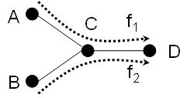

Figure 1. Simulation scenario with two flows.

Figure 2 depicts the throughput and end-to-end delay of each flow vs. offered load. As it is seen in Figure 2.a as the offered load at Nodes A and B increases these nodes increase the amount of the traffic they transmit and their throughput increases. After the network reaches saturation, however, without use of congestion control the throughput is reduced due to collisions and contention overhead. Additionally, as contention increases, the share of Node C of the network resources is reduced to the share of Node A and B, and hence Node C will experience queue build-up and eventually packet drop. With use of congestion control Node C feedbacks the amount of the traffic that it can forward to its upstream nodes. Nodes A and B then adjust their MAC transmission rate and hence network throughput is maintained at the right level. For similar reasons, as illustrated in Figure 2.b, the end-to-end delay is improved when congestion control is implemented in the network.

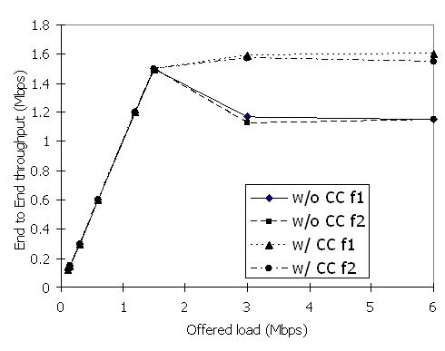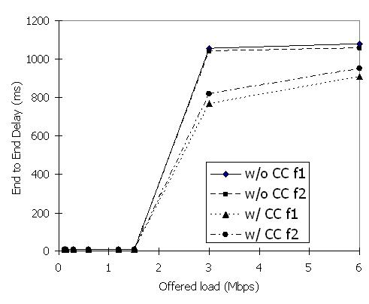
a. Throughput b. Delay

Figure 2. End-to-end throughput and delay vs. offered load for scenario of Figure 1.

Figure 3 depicts the transient behaviour of the network in presence of system dynamics. To study performance of the congestion control algorithm in a dynamic environment we keep Flow 1 in scenario of Figure 1 always on and turn Flow 2 on and off every 5 seconds. At the beginning, when there is only Flow 1 active, the first and second hop of the flow achieve roughly the same throughput of 3 Mbps. As Flow 2 is turned on, the throughput of Flow 1 drops as the channel resource is shared between the two flows. Additionally, the second hop of both flows (link C-D) becomes congested. Comparing Figures 3.a and 3.b it is visible that use of congestion control ensures that the transmission rates of sources A and B remain within the limit that Node C can handle. In Figure 3.b, where there is no congestion control implemented in the system, the throughput of each flow over its first hop is larger than its second hop; this is the indication of congestion and waste of resources in the network. Hence, when both flows are active, without congestion control the throughput of each flow is in average about 1 Mbps, which increases to approximately 1.5 Mbps with congestion control. At the 10th second, Flow 2 is turned off. As illustrated in Figure 7.a, congestion control detects the presence of extra resource in the network and increases the transmission rate of Node A accordingly.
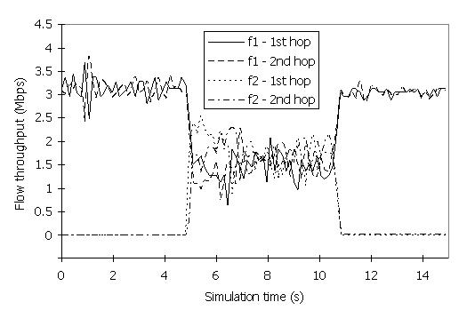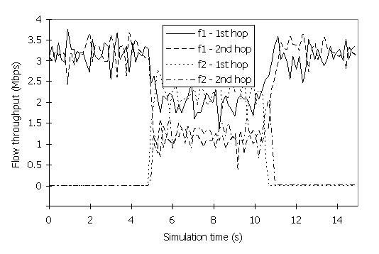

a. With congestion control b. Without congestion control

Figure 3. Transient throughput variations in a dynamic scenario (Figure 1).

b. Baseline Scenario with an Independent Flow

Figure 8 depicts a scenario in which there are three flows all within a contention neighborhood; however, one flow does not share any link with the other two.
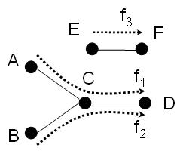

Figure 4. Simulation scenario with an independent flow.

Per link throughput of each of the flows as well as the network total throughput in this scenario is shown in Figure 5 with and without congestion control. As it is seen, without use of congestion control, the throughput of Flows 1 and 2 is higher over their first links, which indicates occurrence of congestion. With implementation of congestion control, however, the throughput of the flows becomes equal on their consecutive links and with reduction of the wasted resources the total throughput increases as well. Note that the extra available resource is being utilized by f3.

Figure 5. Per flow throughput comparison; with and without congestion control for scenario of Figure 4.

c. Parking Lot Topology

Figure 6 depicts the scenario known as parking lot [2], which is a good example to illustrate the poor performance and inefficiency of IEEE 802.11 MAC in a multi-hop setting. In this scenario, without any rate control mechanism, Flow 3 which is only one hop away from the destination (Node D) receives the highest throughput. While Flow 2 receives some throughput in such a setting, Flow 1 is totally starved due to hidden terminal problem and being three hops away from the destination [2].

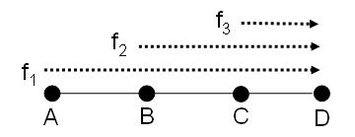

Figure 6. Linear simulation scenario -- parking lot scenario

As shown in Figure 7 use of TCP as an application layer congestion control mechanism is not enough to remove congestion in the system due to its negative reaction to long round trip delays emphasized by the MAC related issues like hidden terminal problem. However, a Layer 2 congestion control scheme is capable of adjusting the MAC transmission rate of the three sources such that not only Flow 1 is not starved, but also the three flows receive equal share of the bottleneck link and the network is congestion free.
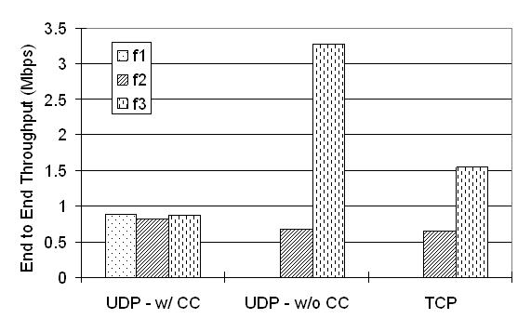
Figure 7. End-to-end per flow throughput comparison; with TCP and with and without congestion control for scenario of Figure 6.

d. Multiple Access Categories

Figure 8 shows the simulation scenario used to study the performance of the congestion control scheme in presence of flows with different traffic types.

d.I Voice traffic with equal AIFSNmin and AIFSNmax
In the scenario depicted here f3 carries 200 Kbps voice traffic, for which the AIFSNmin and AIFSNmax have been set to 2.

f₃
Figure 8. Simulation scenario with multiple traffic types.

The throughput comparison of the 3 flows with and without congestion control is illustrated in Figures 9.a and 9.b, respectively. As it is seen the congestion control scheme adjusts the transmission rate of flows 1 and 2 such that node C does not suffer congestion, however, the voice application as a higher priority access category is not affected by the congestion control scheme. The average end-to-end delay for voice traffic improves in this scenario from 20 ms to 6.7 ms due to decrease in contention and efficient utilization of the network resources by the congestion control scheme. Note that in this scenario the voice packets that violate the end-to-end delay requirements are dropped.

a. With congestion control b. Without congestion control

Figure 9. Throughput of different flows in the scenario depicted in Figure 8 with f2 carrying voice traffic.

d.II Always backlogged traffic with equal AIFSNmin and AIFSNmax
Here, we change the traffic model of f3 from voice to an always backlogged model and maintain the AIFSNmin and AIFSNmax values for this AC equal to 2. The throughput result for this scenario is depicted in Figure 10. Without congestion control f3 dominates the channel due to its higher priority. However, the flow experiences congestion and hence packet drop. With use of congestion control, the throughput of all three flows on their two hops becomes equal and the wasted resource is eliminated which results in a higher overall network throughput. However, we notice that because of the absolute priority given to f3, the throughput of this flow compared to the other two is much higher.

a. With congestion control b. Without congestion control

Figure 10. Throughput of different flows in the scenario depicted in Figure 8 with f3 always backlogged.

d.III Always backlogged traffic with non equal AIFSNmin and AIFSNmax
Here, in the scenario of Section d.II, we change the AIFSNmax parameter of f3 from 2 to 7. The throughput results are shown in Figure 11.

Figure 11. Throughput of different flows in the scenario depicted in Figure 8 with f3 having always backlogged traffic and different AIFSNmin and AIFSNmax values.

As it is shown in Figure 11, having a higher limit on the value of AIFSN for flow 3, reduces its dominancy over the channel and f1 and f2 experience an increase in their throughput. This result shows sensitivity of the performance of the system and the congestion control scheme to the AIFSN limits defined for different ACs.

Summary

In this document we studied the performance of a layer 2 congestion control mechanism as proposed in SEEMesh proposal using OPNET simulations. The simulated congestion control scheme utilizes dynamic adjustment of EDCA parameters to achieve the specified target rate. We simulated multiple different two-dimensional and linear scenarios. We showed that the overall end-to-end throughput is much higher with the use of congestion control in the system. We also showed how the proposed congestion control algorithm is capable of realizing the existence of excess resources in the system and utilizing them while maintaining the control on the amount of data injected to the network. We also compared the performance of the simulated layer-2 congestion control scheme with TCP in a linear topology and showed that the proposed congestion control scheme is capable of achieving the desired performance where TCP fails. Finally, we studied the performance of the proposed congestion control scheme in presence of flows with different Access Categories and showed that AIFSN limits can be set such that QoS sensitive applications are not inversely affected by the congestion control function.

Appendix
Unless otherwise mentioned in the text the following simulation parameters were used to produce the results presented in this document:

Parameters |  | Description
General Simulation Parameters | Simulation Program | OPNET ver.10.5
General Simulation Parameters | Data PHY Speed | IEEE802.11b 11 Mbit/s
General Simulation Parameters | Ctrl PHY Speed | 1 Mbit/s
General Simulation Parameters | Mgmnt PHY Speed | 1 Mbit/s
General Simulation Parameters | Slot time | 20 micro sec
General Simulation Parameters | SIFS | 10 micro sec
General Simulation Parameters | Transmission range | Only neighboring nodes
General Simulation Parameters | Interference Range | < 2* Transmission range
General Simulation Parameters | Simulation Duration | 30 or 60 seconds
Traffic Models | Packet Size * | 1500 Bytes
Traffic Models | Applied Traffic | CBR with 1.8 Mbit/s, 2.4 Mbit/s  at both ends
MAC Parameters | Retry Limit | 7
MAC Parameters | Buffer Size * | 100 Packets
MAC Parameters | CWmin * | 31
MAC Parameters | CWmax * | 1023
MAC Parameters | AIFSNmin | 2
MAC Parameters | AIFSNmax | 31
MAC Parameters | TXOP Limit | 0
Congestion Control Parameters | Peak Data Rate | Successful transmission rate to downstream divided by number of traversing flows through the node
Congestion Control Parameters | Rate Control Method | Increment / Decrement AIFSN
Congestion Control Parameters | Congestion Control Period | 250 msec
Congestion Control Parameters | Traffic observation window | 1 sec
Congestion Control Parameters | Expiration Timer | 1 sec

* In Section d: For f1 and f2: CWmin and CWmax are set to 31 and 1023, respectively.
For f3: CWmin and CWmax are set to 7 and 15, respectively.
Packet size of voice traffic is set to 300 Bytes with traffic rate of 64 Kbps and the queue size of the voice traffic is set to 5 packets.

References:
[1] IEEE 802 11-05/562r4, 802.11 TGs Simple Efficient Extensible Mesh (SEE-Mesh) Proposal
[2] V. Gambiroza, B. Sadeghi, E. Knightly, “End-to-end performance and fairness in multihop wireless backhaul networks” in proceedings of ACM MobiCom’04, Philadelphia, PA, September 2004.

