IEEE P802.11
Wireless LANs
LB73 Location draft text
Date: 2005-05-19
Author(s):
Name | Company | Address | Phone | email
Peter Ecclesine | Cisco Systems | 170 West Tasman Dr.  MS SJ-10-5  San Jose, CA 95134-1706 | +1-408-527-0815 | petere@cisco.com
Abstract
This contribution uses the IETF RFC 3825 Location Configuration Information format to return to a STA the location information that the queried STA creates through an unspecified means. Refer to the IETF ‘geopriv’ area for background information.
Notice: This document has been prepared to assist IEEE 802.11. It is offered as a basis for discussion and is not binding on the contributing individual(s) or organization(s). The material in this document is subject to change in form and content after further study. The contributor(s) reserve(s) the right to add, amend or withdraw material contained herein.

Release: The contributor grants a free, irrevocable license to the IEEE to incorporate material contained in this contribution, and any modifications thereof, in the creation of an IEEE Standards publication; to copyright in the IEEE’s name any IEEE Standards publication even though it may include portions of this contribution; and at the IEEE’s sole discretion to permit others to reproduce in whole or in part the resulting IEEE Standards publication. The contributor also acknowledges and accepts that this contribution may be made public by IEEE 802.11.

Patent Policy and Procedures: The contributor is familiar with the IEEE 802 Patent Policy and Procedures <http:// ieee802.org/guides/bylaws/sb-bylaws.pdf>, including the statement "IEEE standards may include the known use of patent(s), including patent applications, provided the IEEE receives assurance from the patent holder or applicant with respect to patents essential for compliance with both mandatory and optional portions of the standard." Early disclosure to the Working Group of patent information that might be relevant to the standard is essential to reduce the possibility for delays in the development process and increase the likelihood that the draft publication will be approved for publication. Please notify the Chair <stuart.kerry@philips.com> as early as possible, in written or electronic form, if patented technology (or technology under patent application) might be incorporated into a draft standard being developed within the IEEE 802.11 Working Group. If you have questions, contact the IEEE Patent Committee Administrator at <patcom@ieee.org>.

Document IEEE 802.11-05/0191rxx is the working document for tracking the comments received in 802.11 Letter Ballot 73, and proposed draft text to resolve some comments in the ‘Location’ category is shown herein.

Comment numbers are braced in bold italic, e.g. {577}

The following draft text is provided for incorporation in the revision to Draft 2.0 of 802.11k.

3. Definitions

{577} Delete the second sentence in the LCI definition:

Location Configuration Information (LCI): As defined in IETF RFC 3825, includes latitude, longitude, and altitude, with resolution indicators for each. The reference datum for each is also included.

7. Frame formats

7.3 Management frame body components

7.3.2 Information elements

7.3.2.21 Measurement Request element

{116, 444, 1217, 1426} Replace the text in 7.3.2.21.10 as shown, inserting Figure k8a and renumber figures and tables accordingly:

7.3.2.21.11 Location Configuration Indication Request
The Measurement Request field corresponding to an LCI request is shown in Figure k8a.

LCI Location subject | Latitude accuracy | Longitude accuracy | Altitude accuracy

Octets 1 2 3 4

Figure k8a—LCI Request field format

The LCI Location subject field of an LCI Request is a single octet as defined in Table k8.

Table k8 — LCI Location subject definition
LCI Measurement Request | LCI Measurement Subject
0 | Local LCI Request
1 | Remote LCI Request
2-255 | reserved

The term ‘Local’ refers to the location of the requesting STA, and ‘Remote’ refers to the location of the reporting STA.
Latitude accuracy is the number of valid bits requested in the fixed-point value of Latitude. Values above 34 (decimal) are undefined and reserved.
Longitude accuracy is the number of valid bits requested in the fixed-point value of Longitude. Values above 34 (decimal) are undefined and reserved.
Altitude accuracy is the number of valid bits requested in the Altitude. Values above 30 (decimal) are undefined and reserved.

7.3.2.22 Measurement Report element

7.3.2.22.11 LCI Report element

{116, 123, 124, 125, 291, 292, 577, 804, 905, 944, 1141, 1142, 1143, 1216, 1217, 1379, 1380} Replace the text in 7.3.2.21.10 as shown:

A Location Configuration Information report, as described in IETF RFC 3825, “Dynamic Host Configuration Protocol Option for Coordinate-based Location Configuration Information”, includes latitude, longitude and altitude. The LCI report format shall be as described in RFC 3825, and the length shall be 16 octets.

A Location Configuration Information report includes latitude, longitude and altitude information. The LCI report format is shown in figure k20. This format is based on that described in IETF RFC 3825, “Dynamic Host Configuration Protocol Option for Coordinate-based Location Configuration Information” and the length shall be 16 octets. Fields within the LCI report shall be as defined in RFC3825 section 2.1.

The LCI format is shown in Figure k20.
Replace the Figure k20 with one showing sizes of all fields:

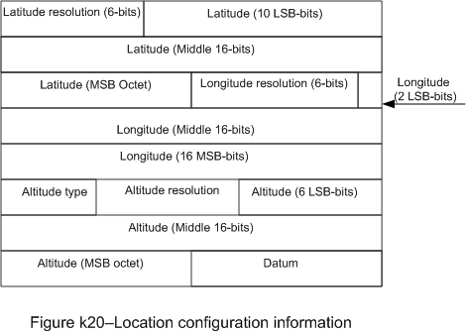

Is replaced by
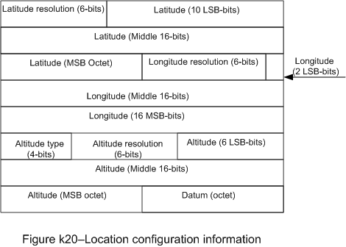

Latitude resolution is 6 bits indicating the number of valid bits in the fixed-point value of Latitude.
An LCI with Latitude resolution, Longitude resolution and Altitude resolution set to zero shall indicate that the location is not known.
An LCI report with Latitude resolution, Longitude resolution and Altitude resolution set to zero shall indicate that the requested location cannot be reported with the requested accuracy.

Datum is an eight-bit value encoding the horizontal and vertical references used for the coordinates given in this LCI. The Datum byte has 256 possibilities, of which 3 have been registered with the Internet Assigned Numbers Authority (IANA):
1: WGS 84 (Geographical 3D) - World Geodesic System 1984, Coordinate Reference System (CRS) Code 4327, Prime Meridian Name: Greenwich;
2: NAD83 - North American Datum 1983, CRS Code 4269, Prime Meridian Name: Greenwich; The associated vertical datum is the North American Vertical Datum of 1988 (NAVD88);
3: NAD83 - North American Datum 1983, CRS Code 4269, Prime Meridian Name: Greenwich; The associated vertical datum is Mean Lower Low Water (MLLW).

The WGS 84 datum shall be used when referencing locations anywhere.
The Datum value shall be 1 (WGS 84), unless another datum is required for operation in the regulatory domain.

The GeoConf Option refered to in IETF RFC 3825 defines two fields for which the IANA maintains a registry: The Altitude type (AT) field and the Datum field. The initial values of the Altitude registry are as follows:
AT = 1 meters of Altitude defined by the vertical datum specified.
AT = 2 building Floors of Altitude.
If the Altitude Type is 2 (Floors of Altitude), the value reported shall be as required for operation in the regulatory domain.

11 MLME

11.7 Radio measurement procedures

11.7.8 Specific measurement usage
{488} Change ‘report’ as shown:

11.7.8.8 Location Configuration Information rReport
{304, 814, 1198, 1538} Replace the text in 11.7.8.8 as shown:

A STA receiving an LCI request shall respond with a Radio Measurement Report frame containing a Measurment Report element (LCI report).
A STA receiving an LCI request shall respond with a Radio Measurement Report frame including one Location Configuration Information element (LCI report).

The mechanism by which the information in the LCI report is generated is not specified, to allow the accuracy of the reported location to be ‘best effort’.

An LCI request may indicate a location request for the local STA or the remote STA by setting the LCI request Location subject octet to Local LCI Request or Remote LCI Request respectively. For a Local LCI Request, the reporting STA shall send an LCI report that indicates the location of the requesting STA. For a Remote LCI Request, the reporting STA shall send an LCI report that indicates the location of the reporting STA.

If the reporting STA’s location determination is not known, then the LCI Report element returned in the Measurement Report frame shall set the Latitude resolution, Longitude resolution and Altitude resolution to zero.

If the STA receiving an LCI request lacks the means to report the requested location to the requested accuracy, then the LCI report shall have Latitude resolution, Longitude resolution and Altitude resolution set to zero. If the STA has no information about the physical location of the ‘Local’ requestor, then it shall set the Incapable bit in the Measurement Report Mode field. The method by which the physical location information in the LCI report is generated is not specified, to allow the accuracy of the reported location to be ‘best effort.’ NOTE-The physical location information of the STA may be set by administrative means. A STA receiving an LCI report with the Incapable bit set can make an LCI request for the location of the ‘Remote’ STA to obtain the reporting STA’s physical location.
References:
11-05-0191-22-000k-lb73-comments-spreadsheet.xls

