IEEE P802.11
Wireless LANs
White Paper
Handset related technical requirements for IEEE802.11n
Date: 2005-16-09
Author(s):
Name | Company | Address | Phone | email
Marc de Courville | Motorola Labs | Parc les Algorithmes, Gif-sur-Yvette 91193 France | +33 1 69352518 | Marc.de.Courville@motorola.com
Markus Muck | Motorola Labs | Parc les Algorithmes, Gif-sur-Yvette 91193 France | +33 1 69352573 | Markus.Muck@motorola.com
Stéphanie Rouquette-Léveil | Motorola Labs | Parc les Algorithmes, Gif-sur-Yvette 91193 France | +33 1 69354824 | stephanie.rouquette@motorola.com
Jean-Noel Patillon | Motorola Labs | Parc les Algorithmes, Gif-sur-Yvette 91193 France | +33 1 69352522 | Jean-Noel.Patillon@motorola.com
Steve Emeott | Motorola Labs | 1301 E. Algonquin Rd.  Schaumburg, IL 60196 | +1 8475768268 | Steve.Emeott@motorola.com
Jari Jokela | Nokia | Visiokatu 1, 33720 Tampere, Finland | +358718060445 | Jari.Jokela@Nokia.com
Naveen Kakani | Nokia | 6000 Connection Dr,  Irving TX 75039 | +1 9728946024 | Naveen.Kakani@Nokia.com
Nico van Waes | Nokia | 6000 Connection Dr,  Irving TX 75039 | +1 9728945669 | Nico.vanWaes@Nokia.com
Dongjun Lee | Samsung | Mt. 14-1 Nongseo-Ri,  Giheung-Eup,Yongin-Si,  Gyeonggi-Do, Korea 449-712 | +82 312809614 | djthekid.lee@samsung.com
Youngsoo Kim | Samsung | Mt. 14-1 Nongseo-Ri,  Giheung-Eup,Yongin-Si,  Gyeonggi-Do, Korea 449-712 | +82 312809614 | KimYoungsoo@samsung.com
Notice: This document has been prepared to assist IEEE 802.11. It is offered as a basis for discussion and is not binding on the contributing individual(s) or organization(s). The material in this document is subject to change in form and content after further study. The contributor(s) reserve(s) the right to add, amend or withdraw material contained herein.
Release: The contributor grants a free, irrevocable license to the IEEE to incorporate material contained in this contribution, and any modifications thereof, in the creation of an IEEE Standards publication; to copyright in the IEEE’s name any IEEE Standards publication even though it may include portions of this contribution; and at the IEEE’s sole discretion to permit others to reproduce in whole or in part the resulting IEEE Standards publication. The contributor also acknowledges and accepts that this contribution may be made public by IEEE 802.11.
Patent Policy and Procedures: The contributor is familiar with the IEEE 802 Patent Policy and Procedures <http:// ieee802.org/guides/bylaws/sb-bylaws.pdf>, including the statement "IEEE standards may include the known use of patent(s), including patent applications, provided the IEEE receives assurance from the patent holder or applicant with respect to patents essential for compliance with both mandatory and optional portions of the standard." Early disclosure to the Working Group of patent information that might be relevant to the standard is essential to reduce the possibility for delays in the development process and increase the likelihood that the draft publication will be approved for publication. Please notify the Chair <stuart.kerry@philips.com> as early as possible, in written or electronic form, if patented technology (or technology under patent application) might be incorporated into a draft standard being developed within the IEEE 802.11 Working Group. If you have questions, contact the IEEE Patent Committee Administrator at <patcom@ieee.org>.

Table of Content

1. Introduction 3
1.1 Market and forecasts 3
1.2 Application support requirements 4
2. Device size requirements and asymmetric antenna configuration 5
3. Range enhancement requirements for enterprise/home/limited outdoor environments: support for robust lower rates 6
4. Enhanced predictability and power saving requirements : 8
4.1 Power and throughput efficiency improvements for multi-destination aggregation 8
4.2 Power and throughput efficiency improvements for single-destination aggregation 10
5. Small packets support requirements: MAC efficiency mechanisms, relevance of advanced coding 11
5.1 MAC efficiency mechanisms: Problems of small sized packets 11
5.2 Relevance of advanced coding 12

Introduction

The purpose of this document is to provide the IEEE802.11n body with a list of technical requirements that are alliance agnostic to ensure that TGn addresses handset specificities in order to capture this growing business.

Market and forecasts

The sales of WiFi enabled handsets is expected to grow sharply in the next few years. Though forecasts vary wildly as Figure 1 shows, an assumption of 200 million units annually by 2009 is a reasonable outlook. This may be compared to the sales volume of all other WLAN implementations (APs, PCMCIA cards, integrated implementations etc..), which are forecast to reach a volume of 125 million by 2009 (extrapolated from Yankee Group’s March 2003 forecast of 85 million units by 2007) [1].

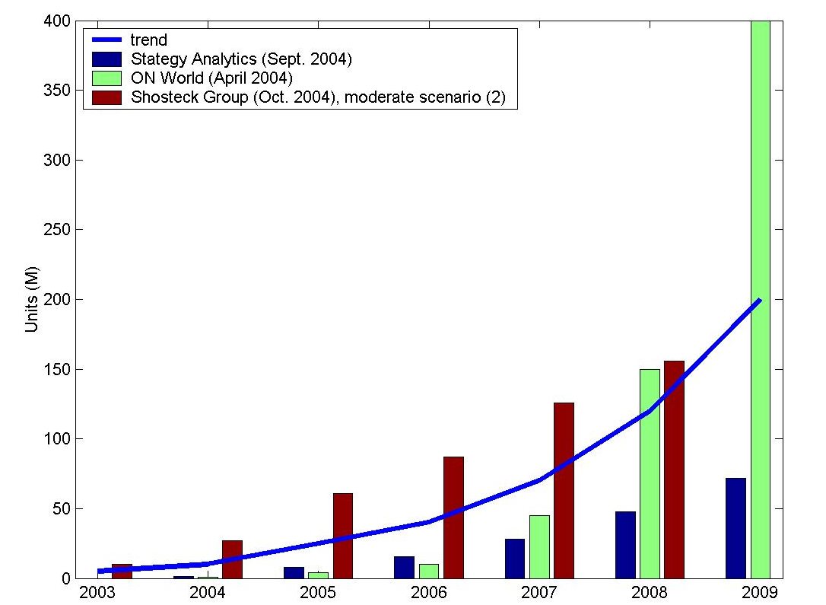
Figure 1: WiFi enabled handset sales forecasts

From this, it may be concluded that handsets will by far be the dominant platform on which WiFi is implemented. To ensure successful and speedy migration from legacy WiFi technology to 802.11n enhanced WiFi, it is therefore imperative that TGn enables the implementation of 802.11n into handsets.

As shown in Figure 2, 802.11n can provide a very natural service addition to handsets, enabling the handset to provide a full range of throughputs as range allows. Despite the fact that some overlap may be created in capabilities, the distinction between the capabilities of the various advanced air-interfaces is deemed sufficiently substantial that implementation of each of these air interfaces is justified.
Figure 2: Air interface evolution

Application support requirements

The applications deemed important for the handset are the following:
- Voice & gaming
Voice and gaming are characterized by low latency, low jitter, small packets and low throughput demands.
The typical operational requirement is 6 hours on a single battery charge.
- Browsing
Browsing is characterized by a mixture of long and short packets. The desired latency is less than 1 s for a page. No meaningful jitter requirements exist. Needed throughput varies drastically by site and by whether the content is scaled server-side or handset-side. The average size per page for handset-side scaling can be approximated as 100 kB. The typical viewing type is 48 s per page.
The typical operational requirement is 6 hours on a single battery charge.
- Data storage and transport.
Many types of data may be created by a handset, but the types that will likely be the most substantive are still-images and video-segments created by inbuilt still- and video cameras. As the quality of capturing devices increases, so does the demand on being able to transport this data off the device, even real-time in the case of video. Besides high-speed FTP transport for still-images, a capability of transporting 7 Mbp video-streams in both directions is hence not deemed unnecessary. With the increase in storage capacity (well upwards of 10 GB), the handset may increasingly serve as portable storage device for all kinds of data (music, presentations etc..).
The typical operational requirement for video-streaming is 1 hour on a single battery charge.
- Standby time
Though standby time is no application in the strict sense, a sufficiently long standby time is essential to meet customer expectations. It should be noted that legacy WiFi currently has only half the standby and operation time of 2.5/3G.
The typical required standby time is 200-300 hours on a single battery.

The key enablers for supporting handset business is to offer a consistent solution to:
- have built in support for asymmetric TX/RX antenna configurations to accommodate various terminal sizes (PDA/Phone) offering a scalable and evolutionary solution separable from the evolution of AP configurations;
- support heterogeneous traffic: increase overall peak data rate without jeopardizing lower data rates modes;
- grant range extension for decreasing deployment cost in the home (full home coverage) and enterprise environment (fewer access points) or for limited outdoor operation (hotspot);
- focus on a proven and simple implementable solution;
- provide required QoS to support consumer electronics: not only multimedia home environment but also VoIP enterprise.

Device size requirements and asymmetric antenna configuration

One goal of the TGn body is to capture a wider range of environments, devices and applications compared to legacy IEEE802.11a/g [2],[3].

Handhelds devices (PDA/Phone) will definitely play a major role in the Internet anywhere anytime concept. It is therefore very important to take into account in the specification of TGn standard of their physical specificity and constraints. It is clear that from both an integration and a cost standpoint, that handsets will be restricted in the number of antennas supported compared to for example an access point. Thus a scalable MIMO physical layer need to be specificed in order to cover the whole spectrum of devices requirements.

The number of antennas in a mobile device is mainly constrained by two parameters: i) an increased number of antennas requires independent RF-front-ends and thus leads to cost in IC surface and power consumption and ii) antennas should be spatially separated by at least one half of the wave length λ: for an operating frequency of 2.4GHz λ/2 = 6.25 cm and for 5GHz λ/2 = 3cm. The second point is considered to be a major issue for small handheld devices: a typical small-sized handheld phone has a surface of approx. 7cm x 4cm or less.

The minimum number of antennas supported will have an immediate impact on the adoption rate of 11n. Expectations on the feasibility of implementing dual-antenna (dual-chain) configurations are in the 2008-2009 time-frame for medium to high-end handsets as illustrated in Figure 3, whereas feasibility of offering 3-4 antennas is not expecting until the 2012 timeframe for high-end PDA-like handsets only (larger screen sizes create more space for antennas).

Figure 3: Constraints on antenna positioning in a mobile device.

It is therefore important to build in support for asymmetric TX/RX antenna configurations to accommodate various terminal sizes (PDA/Phone) offering at the same time a scalable and evolutionary solution for all the equipments.

As a primary goal TGn should define new OFDM MIMO modes with the constraints to handle asymmetric TX/RX antenna configurations with 1, 2 or 3 parallel streams focusing for its basic operation on an open-loop solution for stability, avoiding calibration circuit or any form of feedback signaling.

Range enhancement requirements for enterprise/home/limited outdoor environments: support for robust lower rates

The TGn solution is expected to deliver higher throughput relying on the use of multiple transmit multiple receive antenna configurations in order to benefit from a diversity gain provided by the exploitation of the MIMO channel that is turned into either a higher peak data rate or an increase of the link robustness. This means that for the lower rate modes of TGn it is inherently possible to achieve an extended range of coverage compared to a pure legacy IEEE802.11a [2] solution. This range extension is still limited and falls under what is expected from WLAN scenarios and environments (at most 50% with a 2x2 solution) and by no means compete with the application envisioned in Wireless Metro Area Networks or traditional cellular Networks: Figure 4 illustrates available gains if a legacy system is improved by introducing an additional antenna to the transmitter and/or receiver. A further increase of the number of antennas leads to further performance improvements for both, symmetrical and asymmetrical antenna configurations.

Thus three environments are of interest for the handset business demanding larger range of operation compared to legacy IEEE802.11a [2] devices:

- the enterprise environment where the cost of the infrastructure is an important parameter: a solution offering fewer access points for covering the same area while serving more connections is appealing
- the home environment: deployment model is to have one access point per home and with the success of VoIP telephony over ADSL, there is a need to ensure full home coverage for devices such as a .11n handset;
- limited outdoor environment (hotspot) as an extension of the home environment or to provide a solution to be coupled with 3G services in an heterogeneous radio system model where base stations would provide both WLAN and cellular coverage .

Figure 4: Typical gains of MIMO techniques (PER = 0.05, QPSK, R=1/2 CC; CDD = Cyclic Delay Diversity, FRFD = Full Rate Full Diversity Coding, MRC = Maximal Ratio Combining).

Several key features need to be present into the TGn standard in order to materialize a range extension compared to legacy IEEE802.11a [2] operation, it is required to

- ensure PHY modes that enables enough coverage for target packet error rate envisaged for handset applications: VOIP, video streaming using diversity gain provided by the exploitation of the MIMO channel into link robustness instead of an increase of the peak data rate;
- secure association at larger range as illustrated in Figure 5: current legacy IEEE802.11a [2] beacon itself doesn't allow long range stations to associate at larger distance, another more robust IEEE802.11n beacon need to be defined with the required MAC protection mechanisms
- enable robust signaling: define an IEEE802.11n specific signal field or extension of current legacy one that enables stations at a larger range to be able to understand the parameters of the incoming packets.

AP
ER-
STAs
NR-
STAs
ER-
STAs
ER-
STAs
Figure 5: Example of near range (NR) and extended range (ER) coverage areas and inherent requirements on frame structure.

The cost of eliminating a single access point in-building in a modern enterprise can be approximated as $75-$150 for labor and material to install the Cat. 5 wire, $50-$100 for the Ethernet switch port, $150 for the installation and mounting hardware and $500-$2000 for an enterprise-class AP. Optionally, the installion of a power outlet will cost $250. Total installation in a modern office environment will hence cost in the range of $775-$2650. Labor and material for hotspot AP deployment, outdoor coverage or installation in older buildings can be many times higher. (sources: technologyforfinance.com and wi-fi planet). Even a modest range increase of 16% as indicated in Figure 4 can decrease the number of APs up to a third, allowing substantial infrastructure savings.

Enhanced predictability and power saving requirements :

Power and throughput efficiency improvements for multi-destination aggregation

Aggregation has been identified as a preferred mechanism for efficiency improvement of the 11n WLAN air interface. This efficiency improvement is in general achieved in two categories: aggregation of multiple datagrams intended for a single destination into a single burst and aggregation of multiple datagrams intended for multiple destinations into a single burst. In this section, only the second type is addressed, as the first has no known potential negative consequences for the handset.
The fundamental drawback of aggregation to multiple destinations is that is no longer possible to strictly be aware only of the data transfers to and from the STA itself, which provides optimum power efficiency. Throughput efficiency and power efficiency are hence conversely affected by the introduction of multiple destination aggregation. From the handset perspective, this problem could of course be solved by permitting the STA to opt out of a multiple destination aggregate, specifically for low throughput, high packet rate applications such as VOIP. Though this remains always possible as a matter of admissions control signaling, another attractive option is to define the multiple-destination aggregation mechanism such that it enables minimization of the negative power efficiency effect while providing the sought throughput efficiency (and without affecting the operation of STAs that are not battery operated). This would guarantee handset manufacturers a mechanism to minimize power consumption while at the same time taking advantage of the throughput efficiencies of aggregation to multiple destinations.
The legacy method of achieving power efficiency is predominantly defined by means of the APSD mechanisms defined in 802.11e [4]. In U-APSD mechanism the STA is in charge to trigger the data retrieval from the AP and the AP can send all the buffered data to the STA. The S-APSD mechanism relies on the notion that a power-limited STA wakes up at scheduled intervals known to the AP for a potential brief exchange of data after which it goes back to sleep. Using these mechanisms, the STA avoids detection and demodulation of most data with other destinations.
A battery operated STA, in particular handsets, generally have several distinct states of activity, typically of the generic types indicated in Table 1: STA states. As can be noted, the differences between the most power consuming and less power consuming is substantial resulting in a strong bias towards the later to preserve battery-life. The numbers shown are intended to be representative of a mobile STA having 1 transmit and 1 receive antenna.

Table 1: STA states
State | Generic description | % approximate average power consumption  (peak consumption=100%)
Active Tx | Device in the process of transmitting a burst | 80%
Active Rx | Device in the process of receiving a burst | 50%
Listen | Device actively listening to the medium | 30%
Standby | Device ignoring the medium, but capable of Active Tx, Active Rx and Listen within a short time span (typically < 10 μs) | 5%
Sleep | Device substantially turned off, with change time to a different state in the order of > 1 ms | < 0.1%

The introduction of aggregation to multiple destinations without resource announcement has the effect of requiring all STAs to receive the whole aggregated frame even if the portion target to the particular STA can be relatively small compared to the total size of the aggregated frame. As a result, each STA will be in the Active Rx case far longer than warranted by the data destined to the device, resulting in a substantial deterioration of battery-life compared to the legacy method.
A method of partially mitigating this deterioration is the inclusion of a header field with destination addresses at the start of the aggregation burst. This substantially reduces the Active Rx state for any STA not using APSD, and reduces Active Rx for STAs using U-APSD or S-APSD in cases where devices wake up to find no data addressed to themselves. For STAs using S-APSD who are receiving their scheduled data, no mitigation is achieved at all.
A more complete approach to mitigating the reduced power-efficiency inherent in aggregation is hence to initiate the aggregate with a resource announcement at the beginning of the burst, which would need to contain both a list of destination addresses as well as pointers to the start of the data for each of those particular addresses. The aggregate structure should further be structured such, that devices are capable of switching to Standby state for the predominant period of time preceeding their own indicated data. If implemented efficiently, such a mechanism would substantially preserve the throughput efficiency sought by the aggregation mechanism, while substantially preserving the battery-life of handsets. As an extension, such a resource announcement mechanism could be used to schedule the uplink responses of STAs addressed in the aggregate, to allow for more efficient reverse traffic.

Figure 6: Power consumption schematic for legacy, blind aggregation and aggregation with resource annoucement
In Figure 6, the power consumption is shown for an STA which wakes up to receive a burst of data. Wake-up and sleep announcement exchanges which would be part of U-APSD are not shown. The exchange of data is assumed to consist of forward data, backward data with ACK and forward ACK for the backward data.
For the legacy case, this exchange is straightforward, with the exchange interspersed only by SIFS.
In the blind aggregation case, where the aggregate may or may not be initiated by an address list of the STAs addressed, it can be seen that the STA maintains Active Rx throughout the entire forward data burst, as the STA does not know where its data is in the burst. Then dependent on the scheme used, it will have to listen through various transmissions of other STAs providing their backward data until it finds an opportunity to inserts its backward data. The exchange ends with an assumed aggregate of (block)-ACKs.
In the case where the aggregate initiates with a resource announcement, an STA is capable of going into standby mode for substantial portions of the forward data, whereas it can also stay in standby mode during the known backward transmissions of other STAs.

Power and throughput efficiency improvements for single-destination aggregation

With the development of new applications that could be used with a handset it can be envisioned to have the following scenarios:
- Data of multiple QoS type need to be aggregated: For example, a Video Telephony application in an handset might have Voice, Video and Control Messaging (TCP based) data that needs to be conveyed to have effective communication
- Within the same QoS class it is possible that data can have different characteristics: For example a Voice application can tolerate 4-5% packet error rate, while on the other hand it is likely that a video stream cannot tolerate more than 1% error rate
Taking into consideration the characteristics of different application that can be run over the handset the existing aggregation and ARQ mechanism should be revisited to address the issue of channel bandwidth utilization and to provide better power saving for the handheld. However, the proposed changes should be within the context of 802.11e [4] so that there is no QoS violation.
Possible mechanism to address throughput and power saving issue: Based upon the applications that a STA would be running it is possible that, in an aggregate destined to the STA there would be multiple packets either of same or different TID. The existing ARQ mechanism provides a mechanism to Acknowledge either one (ACK frame) or 1024 number of frames (Block-ACK) of a particular TID. A simple enhancement can be modify the existing Block-ACK to carry data of multiple TID and the amount of information carried for each TID can be the required length instead of being a choice between 1 or 1024 frames.

This can help handhelds to conserve the battery power
- in accessing the medium to send ACK for each TID;
- send unnecessary data (data for 1024 frames)

Minimizing the number of packets send on the medium to convey the same information substantially improves channel utilization

Small packets support requirements: MAC efficiency mechanisms, relevance of advanced coding

MAC efficiency mechanisms: Problems of small sized packets

In this section, we performed a simple analysis in order to illustrate the efficiency problems with small packets. In this analysis, 54Mbps for the data frame transmissions, and 24Mbps for the ACK transmissions are used. The analysis results are shown in Figure 7, in which the throughput performance is depicted as the size of the payload varies. Currently, a payload is transmitted via a single 802.11 MAC frame. As shown in the figure, the throughput performance is compromised as the payload size is reduced. We observe that small-size payloads achieve extremely small throughput. For example, using 100 byte payload only achieves about 5Mbps throughput over the 54Mbps link.

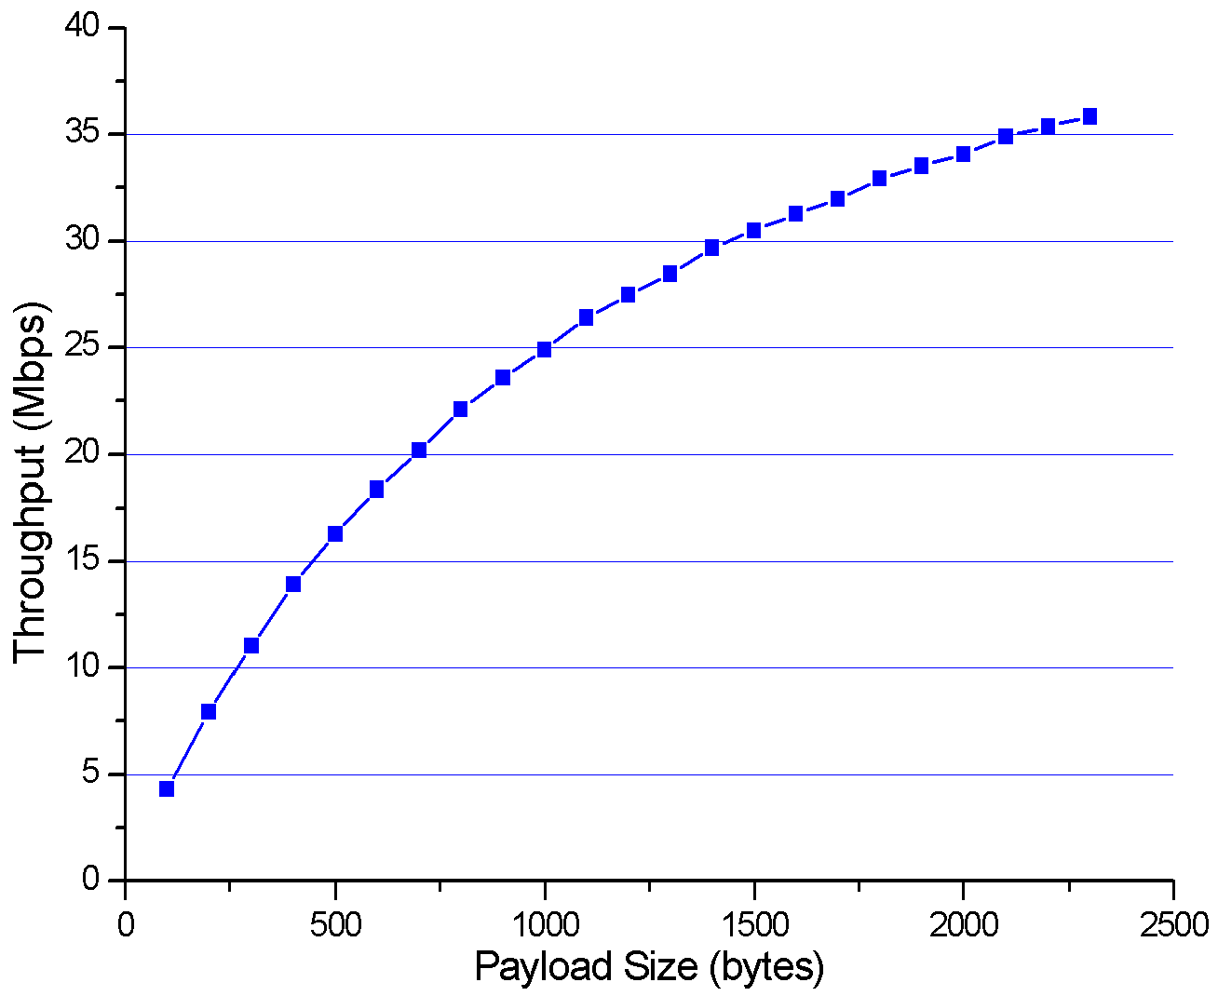
Figure 7: Throughput performance vs payload size
However, in reality, the IP packets, which are the payload in MAC sub-layer, generated by different applications have various sizes. Unfortunately, the distribution of Internet packet sizes is dominated by small-size packets. Figure 8 shows the packet size distribution captured in a large size meeting room. This statistics are derived from measurement taken in IEEE 802.11 standard meeting in the morning of July 22nd 2003. More than half of the packets have the size of less than 200 bytes. Small-sized packets can degrade the throughput performance as we have seen above. With the use of VoIP by 11n handheld devices, the number of small sized packets will increase, since the packet sizes used in a VoIP application are usually small.

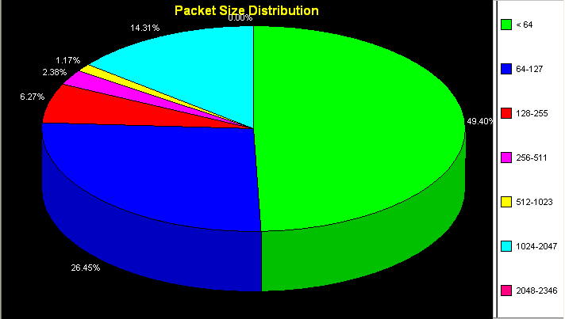
Figure 8: Packet Size Distribution

Relevance of advanced coding

The use of advanced coding techniques is attractive for the handset market, because it allows the use of the additional coding gain for range extension, rate increases and especially transmit power reduction. The advanced coding option (e.g. LDPC, Turbo Codes) needs to satisfy the following two key requirements:

- Codeword sizes should cover all frame sizes, allowing for largest gain as frame size permits. The amount of throughput and power efficiency that is lost due to block-size granularity should be minimized.
- Decoder complexity should be reasonable while allowing for sufficient gain (i.e. decoder iterations) to meet latency requirements

From these requirements, it is arguably believed that the most suitable codeword size falls on the range of 500~2500 bits.
On the other hand, due to the strict delay requirement for the voice communication, most of the prevailing VoIP codecs available only supports the frame size of 5 and 20 milliseconds, which can be translated into different frame size in terms of octets depending on the peak rate that individual codec supports. The following table summarizes the basic features of the various VoIP codecs.
Table 2: VoIP codecs
CODEC | Peak rate  (Kbps) | Frame size  (Bytes) | Bandwidth  (including overhead) | Compression gain  (relative to PCM/STM)
G.711  (PCM) | 64 | 40 (5 ms) | 142.4 kb/s | 0.45
G.711  (PCM) | 64 | 160 (20 ms) | 83.6 kb/s | 0.77
G.726  (ADPCM) | 32 | 20 (5 ms) | 110.4 kb/s | 0.58
G.726  (ADPCM) | 32 | 80 (20 ms) | 51.6 kb/s | 1.24
G.728  (LD-CELP) | 16 | 10 (5ms) | 94.4 kb/s | 0.68
G.728  (LD-CELP) | 16 | 40 (20 ms) | 35.6 kb/s | 1.8
G.729  (CS-ACELP) | 8 | 5 (5 ms) | 86.4 kb/s | 0.74
G.729  (CS-ACELP) | 8 | 20 (20 ms) | 27.6 kb/s | 2.32
G.723.1 | 6.3 | 4 (5 ms) | 83.5 kb/s | 0.77
G.723.1 | 6.3 | 16 (20 ms) | 25.6 kb/s | 2.5

As shown in the table, except the 20 milliseconds frame option for G.711 codec, all the other codecs support very short frame sizes, which should hence be a focus point in terms of providing adequate gain at minimum overhead for a code designed to handle handset implementation.

It is reported ([7],[8]) that depending on the channel conditions the LDPC codes typically achieve 1.5-3dB improvement over convolutional codes with the same code rate, when the codeword length is close to 2000 bits. In the context of small packet services such as VoIP (shorter than 1000 bits as implied in the Table I), few performance results for any type of advanced coding have been presented to the task group’s attention. However, referring to a technical contribution on LDPC codes presented to Task Group 802.16e [5](IEEE C802.16e-05/066r3), it can be concluded that the performance advantage of LDPC codes over convolutional codes would be diminished down to approximately 0.5 dB, when the codeword size is as small as 576 bits. On the other hand, [6] shows that the turbo codes with the identical codeword size outperforms the LDPC codes given in 802.16e [5] contribution by at least 0.2-0.3 dB with 8 iterations, which is believed to be realistic in terms of the implementation complexity.
The complexity associated with implementing the advanced coding in terms of gate count, for a particular coding gain, does not only depend on the codeword size but also other factors such as degree of parallelism and the number of iterations. For example, a duo-binary Turbo decoder designed for a maximum encoded block size of 2048 bits can achieve a decoded throughput of 480Mbps at the clock rate of 200MHz, when the number of iterations is restricted to 5 (according to [6]). This results in a required gate count of roughly 450K. The complexity estimation for LDPC code is not very well documented compared to Turbo code but it is believed that the gate count for implementing LDPC code is in the range of 400-600K when similar or lower decoder throughputs are attempted.

We hence recommend that all the advanced coding (LDPC and turbo code) solutions be evaluated in the context of small packet services such as VoIP in order to:
- have a proper assessment of the relevance of advanced coding for handset business and future use for the definition of a handset profile
- motivate the proposal of dedicated advanced coding solution tailored to the handset traffic specificities

Bibliography

Device Convergence: Three Worlds Coming Together, October, 2004. Copyright 2004, The Shosteck Group.
Part 11:Wireless LAN Medium Access Control (MAC) and Physical Layer specifications (PHY) - High Speed Physical Layer in the 5GHz band, IEEE Std 802.11a-1999, IEEE Standards Department, New York, January 1999.
IEEE 802.11g(tm)-2003, Part11 Wireless LAN Medium Access Control (MAC) and Physical Layer (PHY) Specifications Further Higher-Speed Physical Layer Extension in the 2.4 GHZ Band, Supplement to IEEE Standard, 2003.
Draft Supplement to IEEE Std 802.11 - Part 11: Wireless LAN Medium Access Control (MAC) and Physical Layer specifications (PHY) - Medium Access Control (MAC) Enhancements for Quality of Service (Qos), IEEE Std 802.11e/D6.0, New York, November 2003
IEEE802.16e/D5, Draft IEEE Standard for Local and Metropolitan Area Networks – Part 16: Air Interface for Fixed and Mobile Broadband Wireless Access Systems, IEEE802.16, September 2004
IEEE 802.11-05/0146r3, Advanced Coding Comparison, John Benko et al., France Telecom, March 14, 2005
IEEE 802.11-05/0193r1, TGn Sync Additional Material, Syed Aon Mujtaba, Agere, March 16, 2005
IEEE 802.11-05/0214r0, WWISE LDPCC performance, Anuj Batra et al., Texas Instruments, March 15, 2005

Source of Shosteck data: Device Convergence: Three Worlds Coming Together, October, 2004. Copyright 2004, The Shosteck Group. Reproduced under license; further reproduction prohibited.

