IEEE P802.11
Wireless LANs
11n Partial Proposal: Quantized Precoding with Feedback
Date: August 13, 2004
Author: Robert W. Heath Jr., Johann Chiang, Bishwarup Mondal, and Roopsha Samanta
The University of Texas at Austin
Department of Electrical and Computer Engineering
Wireless Networking and Communications Group
1 University Station C0803, Austin, TX 78712-0240
Phone: +1-512-425-1305
Fax: +1-512-471-6512
e-Mail: {rheath, jchiang, mondal, roopsha}@ece.utexas.edu
Abstract
This document describes the technical specification and FRCC compliance report of “Precoding with Limited Feedback” for IEEE 802.11n as a partial prospal. The proposed system is based on 802.11a and provides robust operating modes with backward compatibility through the use of precoding based on limited channel state information at the transmitter. The existing RTS/CTS mechanism is used to inform the transmitter about the channel state. Quantizing the precoding matrices using codebook of precoding matrices reduces the overall feedback requirements. PHY and MAC enhancements are discussed.

1. Introduction
Precoding is a method of using additional antennas at the transmitter, beyond the number of substreams, to provide higher reliability and range through increased diversity. This advantage is achieved by customizing the transmitted signal to the channel; which requires the transmitter to be informed about the current channel state. While the channel state is generally available in TDD systems through channel reciprocity, it may be difficult to exploit, as it requires frequent calibration of the RF front ends. An alternative is to estimate the relevant parameters of the channel state using the RTS frame, and then to inform the transmitter about the parameters using a few additional bytes in the CTS frame. This is feasible thanks to the advanced QoS and frame aggregation features in IEEE 802.11e, which reduce the overhead introduced by RTS/CTS.

Quantized precoding is a means of achieving the diversity gains of precoding with only a few bytes of feedback. It uses a predetermined codebook of (precoding) matrices known to both the transmitter and receiver. Based on an estimate of the channel state information, the receiver chooses a set of precoding matrices and sends the corresponding indices back to the transmitter. The transmitter reconstructs the precoding matrices from the indices and uses them for payload transmission. With a few bytes of feedback it is possible to realize near-ideal precoding gains with both beamforming [1] and spatial multiplexing [2] modes of operation. Thus quantized precoding with feedback provides a practical means for implementing closed-loop diversity modes, supports mupltiple data streams [3], and is compatible with a wide range of proposals [4-9].

This proposal provides a framework for quantized precoding with feedback that is an extension of the IEEE 802.11a standard operating in the 5GHz band. Modificaitons to the PHY and MAC layers are discussed for the transmission of one or two data streams in a MIMO-OFDM system with four antennas at the AP and two to four antennas at the STA.

2. Quantized Precoding

A MIMO OFDM system is considered with M_{t} transmit antennas, M_{r} receive antennas and N subcarriers, in a spatial multiplexing mode, transmitting M_{s} (M_{s} <= M_{t,} ,M_{r}) data-streams. The channel for subcarrier k is denoted by H(k), consisting of complex entries in M_{r} rows and M_{t} columns. A precoder is a complex matrix F of M_{t} rows and M_{s} columns. The precoder matrix spreads M_{s} data-streams over M_{t} antennas for each subcarrier.
Fig. 1. Block diagram of precoding with limited feedback

In each subcarrier, the precoding matrix F(k) is determined by the channel matrix H(k) of that particular subcarrier. The codebook consists of an indexed set of possible precoder matrices. So the codebook can be represented as C = {F₁, …, F_{M}} where F_{i} is the ith codeword (a complex M_{t} x M_{s} matrix). In the case Ms =1, the precoding matrix reduces to a vector, commonly called a beamforming vector. This case has been dealt with in detail in [1].

2.1 Receiver Processing

Channel Estimation: The receiver estimates the channel for each sub-carrier. It is assumed that the receiver knows H(k) perfectly.

Rx Codeword Selection: The receiver chooses a codeword for each subcarrier based on H(k). Denoting the index of the codeword by I(k), the codeword selection block implements a function given by I(k) = f(H(k)).

For a typical implementation, the function f: H(k) -> I(k) can related to the mean square error of a minimum-mean-squared error receiver, so that
$$f=\text{arg}\underset{i}{\text{min}}\text{tr}[\frac{E_{s}}{M_{s}}$$
where E_{s} /N_{o} is the signal to noise ratio and tr is the trace of a matrix.

Further, to reduce the amount of feedback, the same precoding matrix can be used for a group of subcarriers. As an example, we can consider an OFDM system of N = 48 tones for data, where each group of 8 adjacent subcarriers uses one precoding matrix and the codebook is of size 2^6. Then the total feedback required for one frame of data-transmission is 36 bits.

2.2 Feedback
The indices chosen by the Rx codeword selection block are fed back to the transmitter using predetermined bits of feedback.

2.3 Transmitter Processing

Tx Codeword Selection: The transmitter uses the indices sent by the receiver to select codewords (precoder matrices) from the codebook for each subcarrier.

Precoder: The chosen precoder matrix from the codebook is used to spread the M_{s} datastreams over M_{t} transmit antennas. The input data streams are linearly combined by the precoding matrix and the resulting M_{t} streams are transmitted.

3. PHY modification

The proposed system reuses most of the legacy blocks to provide fast time-to-market and backward compatibility. As illustrated in Fig.1, the preamble and SIGNAL symbol in IEEE 802.11a are reused for legacy, however, a MIMO compatible training sequence is inserted appropriately based on other proposals.

Feedback from a feedback field in the CTS frame (described in Section 3) is used to choose a set of transmit precoding matrices for the data.

The LENGTH field of 17.3.4 Signal field (SIGNAL) will also be adjusted. It will be set with the equalivalent length instead of the actual length for legacy to setup NAV (virtual carrier sensing) properly because the actual data rate is higher than the nominal data rate in SIGNAL.
Fig. 2. Modification of PHY frame format

4. MAC Extension
This section describes the extension to the 7.2.1.2 Clear To Send (CTS) frame format. We propose to use a 24 bit field extension (i.e. one OFDM symbol in basic data rate) for limited feedback as illustrated in Fig. 1. By following FCS field of legacy a CTS, it ensures the MAC backward compatibility.
Fig. 3. Extension to CTS frame format

Since there are only 134 bits in legacy CTS frame format including both SERVICE and TAIL of PPDU, we have free 10 bits available, which is required to fill the integer number of OFDM symbol, for advanced mode control, as illustrated in Fig. 3.
Fig. 4. New MAC Tail of CTS frame

Two bits will be used for control of the feedback packaging block size (i.e. number of subcarrier per block) that implies a tradeoff between MIMO quantization loss and OFDM frequency selectivity, as listed in Table 1.

Table 1. Mode table of feedback packaging block size
Mode | Quantization | Block Number | Number of Subcarrier per Block
00 | 2b | 24 | 2
01 | 3b | 16 | 3
10 | 4b | 12 | 4
11 | 6b | 8 | 6

Three bits can be used for control of the antenna configuration from mandantory two-antenna STA to optional four –antenna STA. Table 2 lists the optional mode table for downlink with four-antenna HT AP with various numbers of STA antennas (denoted as # AP x # STA). Allowing a variable number of modes provides for both beamforming (1 data stream) as well as spatial multiplexing with 2 or 3 data streams.

Table 2. Mode table of antenna configuration (downlink)
Mode | Configuration | Data Stream | Data Rate
000 | 4x2 | 1 | 6/9/12/18/24/36/48/54
001 | 4x2 | 2 | 12/18/24/48/72/96/108
010 | 4x3 | 1 | 6/9/12/18/24/36/48/54
011 | 4x3 | 2 | 12/18/24/48/72/96/108
100 | 4x3 | 3 | 18/27/36/54/72/108/144/162
101 | 4x4 | 1 | 6/9/12/18/24/36/48/54
110 | 4x4 | 2 | 12/18/24/48/72/96/108
111 | 4x4 | 3 | 18/27/36/54/72/108/144/162

5. Result Disclosure
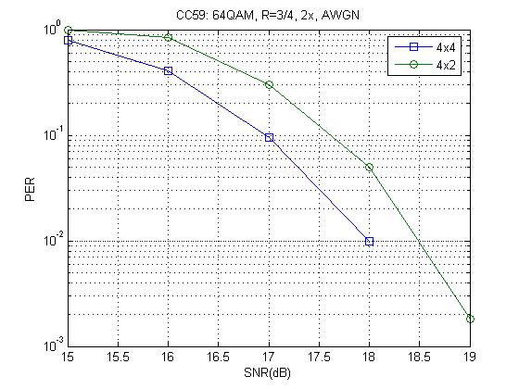
Fig.5 PER performance in AWGN
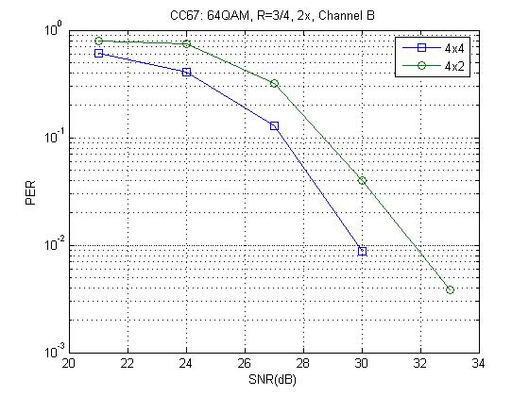
Fig.6 PER performance in channel model B

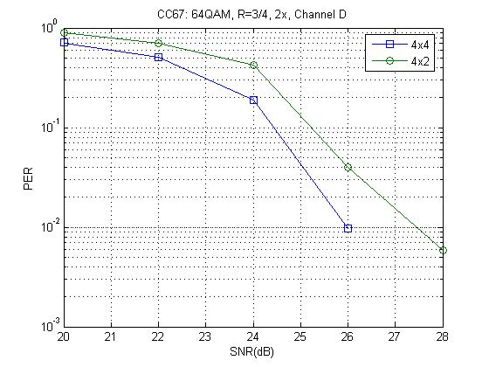
Fig.7 PER performance in channel model D

6. Compliance of Functional Requirements
Number | Name | Coverage | Results Reference
R3 | Supports 5GHz bands | Yes | Same as IEEE 802.11a
R4 | .11a backwards compatibility | Yes | Sec. 2 and Sec. 3
R5 | .11g backwards compatibility | Yes | System does not operate in 2.4 GHz ISM Band
R8 | Spectral Efficiency | Yes | With conventional 3/4CC+64QAM and 2 data stream precoding, the spectral efficiency is 9 bps/Hz.

7. Compliance of Comparison Criteria
Number | Name | Disclosure
CC2 | Regulatory compliance | Same as IEEE 802.11a
CC6 | PHY complexity | PHY complexity increases moderately with codebook search and receiver space-time processing. It requires double computational power for 2 data stream system.
CC7 | MAC processing complexity | MAC complexity increases neglibly to process the extension to CTS frame
CC11 | Backward compatibility with 802.11-1999 (Rev 2003) and 802.11g | The required modification of PHY and extension of MAC is fully backward compatible as described in Sec. 2 and Sec. 3.
CC46 | MAC Compatibility and parameters. | The MAC compatibility and new fields can be referd to Sec. 3.
CC47 | MAC extensions | Three byte limited feedback field followes FCS field in CTS frame.
CC51 | Data rates | The achievable data rate is listed in Table 2.
CC42 | Preambles | The preamble includes legacy preamble followed by any compatible MIMO training sequences defined in other proposals.
CC51.5 | Channelization | Same as IEEE 802.11a
CC52 | Spectral Mask | Same as IEEE 802.11a
CC59 | AWGN PER performance | Fig.5
CC67 | PER performance in non AWGN channels | Fig 6-7
CC80 | Required changes to 802.11 PHY | PHY requires modification of a new PLCP preamble and precoding on payload as desribed in Sec. 4.

8. Acknowledgement
We would like to thank Prof. David Love of Purdue University for the shared resource of his research.

9. Reference
[1] J. Choi and R. W. Heath, Jr., ``Interpolation Based Transmit Beamforming for MIMO-OFDM with Limited Feedback,'' in Proc. of IEEE Int. Conf. on Communications, Paris, France, June 2004.
[2] R. W. Heath Jr., ``Precoding and Interpolation for Spatial Multiplexing MIMO-OFDM with Limited Feedback,'' delivered to The 2004 Workshop on Smart Antennas in Communications, Stanford, California, July 2004.
[3] D. J. Love, R. W. Heath, Jr., W. Santipach, and M. L. Honig, "What is the Value of Limited Feedback for MIMO Channels?," to appear in IEEE Communications Magazine.
[4] Call for Proposals for 802.11n, IEEE 802.11-03/858r6.
[5] Functional Requirements, IEEE 802.11-03-0813-12-000n
[6] Comparision Criteria, IEEE 802.11-03-0814-31000n
[7] Usage Models, IEEE 802.11-03-0802-23-000n
[8] IEEE 802.11-02-798r7, 802.11 HT PAR
[9] IEEE 802.11-02-799r6, 802.11 HT 5 Criteria

