IEEE P802.11
Wireless LANs
Partial Proposal for TGn
Date: August 13, 2004
Author: Takashi Fukagawa, et al
Panasonic
BCC Matsushita Electric Industrial Co. Ltd.
4-5-15 Higashi shinagawa Shinagawa-ku Tokyo 140-8632 Japan
Phone: +81-3-5460-2725
Fax: +81-3-5460-2836
e-Mail: fukagawa.takashi@jp.panasonic.com

Abstract

This document describes a partial proposal for consideration by Task Group n of the 802.11 Working Group. The document is structured as four largely independent proposals that individually describe how each can be implemented to realise higher throughput in the envisioned TGn network.

At the MAC layer, the proposal examines reducing the inefficiencies introduced due to high access overheads, primarily by means of MAC frame aggregation. Another technique, IFS reduction, which reduces the physical overhead of the IFS and is particularly beneficial towards enhancing throughput in networks with a dominant number of small packets, is also described.

The PHY layer component of this proposal focuses on two main aspects – improving the tracking of the carrier phase offset at the receiver in the presence phase noise and local oscillator offset through the use of scattered and staggered pilot subcarriers; and improving the performance of spatially multiplexed MIMO transmissions using varied interleave patterns on different antenna streams.

MAC Aggregation

Introduction
Access overheads contribute a significant overhead towards data transmission in an 802.11 WLAN system. One of the means of reducing these overheads and consequently, improving the throughput of the network, is MAC aggregation.

The use of aggregation results in fewer medium access events per station in the network, resulting in a saving on the associated overheads – IFSs, backoff periods, training sequences and, PLCP headers. This results in an improvement in the overall efficiency, realising an improvement in throughput, independent of the PHY in use.

In the following an approach towards MAC aggregation is described that is implemented as an extension to the IEEE 802.11 standard [1]and the IEEE 802.11e draft specification ver 8.0 [2]. In the subsequent parts of this chapter, we describe the settings of the various fields of the MAC header, required to support the proposed MAC aggregation technique. Where necessary, additions to the existing specifications [1] and [2] are explicitly described, while in some cases, existing definitions are called out in order to exemplify certain behaviour that is characteristic of the proposal.

As will become obvious in subsequent sections, the proposed MAC aggregation mechanism is tied to the Block ACK mechanism described in [2] and hence this proposal is implicitly applicable to QSTAs only.

Frame Format
The proposed MAC aggregation technique makes use of a MAC frame format that consists of: (i) a MAC header and (ii) a frame-body, as described in the following. Note that while [2] specifies that in addition to the above, each MAC-frame shall consist of a frame FCS; in the context of MAC Aggregation, as described in this proposal, this is deemed redundant. As such, while there is no explicit FCS field for the frame, the FCS of the last MSDU compartment may be interpreted as a placeholder to satisfy this requirement.

Figure 1: Aggregated Frame Structure

MAC Header
The MAC header shall consist of the general MAC frame format, as described in [1], with the additional Aggregation Control and Header FCS fields as shown in Figure 2. Note that as per the above description, we explicitly limit the aggregation mechanism to QSTAs. Transmissions having the type/subtype – Extended/Aggregated-Data do not have the QoS Control field in their MAC headers.

Figure 2: MAC Header

Frame Control
The Frame Control field is defined in [1] and consists of a series of subfields as described below.

Frame Control.Protocol Version
The Protocol Version field of the Frame Control is set according to the rules specified by the baseline standard [1]. As such, the proposed aggregation mechanism is a mere revision of the standard and does not result in a fundamental incompatibility. Hence, this parameter is set to 0b00.

Frame Control.Type
Aggregated data frames are represented by a new frame type – Extended, represented by 0b11.

Frame Control.Subtype
Aggregated data frames are represented by a new frame subtype – Aggregated data, represented by 0b0000.

Frame Control.To DS
Stations transmitting and receiving aggregated data frames set and interpret this value in accordance with Table 1.

Frame Control.From DS
Stations transmitting and receiving aggregated data frames set and interpret this value in accordance with Table 1.

Frame Control.More Fragments
Aggregation and Fragmentation are viewed as complimentary mechanisms, one catering to the improving MAC transmission efficiency by exploiting a relatively invariant channel by simultaneously sending several frames; and the other, dividing packets into smaller fragments to counter the effects of rapidly changing channel conditions. As such, the use of the fragmentation together with aggregation is not envisaged and this value shall be set to 0b0 for all aggregated data frames.

Frame Control.Retry
The Retry bit shall be set to 0b1 if the transmitter is retransmitting the aggregated frame in its entirety. In all other cases, it shall be set to 0b0.

Frame Control.Power Management
The Power Management bit shall be set in accordance with the guidelines specified in [1].

Frame Control.More Data
The More Data bit shall be used by the transmitter of an aggregated data frame to indicate whether or not it has additional data to transmit.

Frame Control.WEP
The MAC aggregation scheme described herein supports point to multi-point transmission, implying a station can simultaneously transmit to both an AP as well as to another station in the BSS (provided DLP has been setup). This field is set to 0 in the header of the aggregated frame. It may be set to 1 on individual MSDU compartments, if encryption is supported.

Frame Control.Order
In keeping with the specification of [2], the Order field shall be set to 0 in all aggregated-data frames.

Duration/ID
The 16bit duration/ID field in the aggregated frame is set as per the rules applicable to frames of type Data, as per the guidelines in [1] and [2].

ToDS | FrmDS | Address1 | Address2 | Address3 | Address4 | Scenario
0 | 0 | DA  (Broadcast/  Unicast) | SA | BSSID | N/A | This mode is used to facilitate simultaneous SL and UL aggregate transmissions OR aggregate transmissions in an IBSS.  Address1 is set to the broadcast address when supporting both UL and SL, or multiple SL transmissions in the aggregate frame.  When all compartment frames are destined to the same destination (point-to-point transmission), Address 1 is the DA of the end station.
0 | 1 | DA  (Broadcast/  Unicast) | BSSID | SA  (BSSID) | N/A | This mode is used to facilitate DL aggregate transmissions.  Address1 is set to the broadcast/unicast depending on whether the transmission is point-tomultipoint/point-to-point, respectively.  Address3 is set to the AP address (BSSID) for all DL aggregate transmissions.
1 | 0 | BSSID | SA | DA  (Broadcast/Unicast) | N/A | This mode is used to facilitate UL transmissions.  Address3 is set to the Broadcast/Unicast, depending on whether all the compartments are destined to a single endpoint or not, respectively.
1 | 1 | RA  (Intermediate Rx AP) | TA  (Tx AP) | DA  (Broadcast/Unicast) | SA  (Tx AP) | This mode is used to facilitate aggregated frame transmission in the wireless distribution system (WDS).  Address1 is set to the intermediate recipient AP. In the case where the aggregated frame carries compartments destined to stations in different BSSs, this is set to the broadcast address.  Address2 is set to the address of the transmitter of the current aggregated frame.  Address3 is set to broadcast/unicast depending on whether all the compartment MSDUs are destined to the same endpoint or not, respectively.  Address4 is set to the value of Address2 in the context of the proposed aggregation mechanism.

Table 1: To/From DS and Address Combinations in Aggregated Data Frames

Address fields
Note that the aggregated-data frame is viewed as a ‘carrier’ of multiple packets, facilitating point to multi-point transmission. It is used only on a single hop relay of a transmission. As such, it is expected that nodes that support Layer 2 routing (eg: Wireless Distribution System [1]), upon receiving an aggregated frame, would perform segregation and reconstitute multiple (aggregated) frames depending on the destination addresses of the compartment frames.

The address fields of the aggregated-data frame are populated as per the conditions specified in Table 1. Accordingly, it is apparent from the table that MSDUs with different ToDS/FromDS combinations, as stated in the table may not be aggregated in the same aggregated-data frame.

Sequence Control
The sequence control field is a 16bit field consisting of the sequence number and the fragment number subfields.

Sequence Control.Sequence Number
The sequence number is a 12-bit field indicating the sequence number of the aggregated frame. In the context of aggregated-data frames the sequence number may be drawn from a counter that is not associated with any TID at the station. Receivers of an aggregated data frame may ignore the sequence number field as aggregated data frames are individually unacknowledged.

Sequence Control.Fragment Number
The fragment number is a 4-bit field indicating the fragment number of the associated transmission. As aggregation and fragmentation are complementary mechanisms and are not performed simultaneously, this value is always set to 0b0000 for the aggregated frame.

Aggregation Control
The aggregation control field is a variable length field consisting of two subfields – Compartment Count and Compartment Length(s). The Aggregation Control field is present in all frames with type and subtype set to Extended and Aggregated Data, respectively.

Aggregation Control.Compartment Count
The Compartment Count is a 16-bit field containing the number of MSDU compartments carried by the aggregated data frame. This is also used to define the number of Compartment Length fields that follow the Compartment Count in the Aggregation Control field.

Aggregation Control.Compartment Length(s)
This is a variable length field, 2*m octets in length, where ‘m’ is the value in the Compartment Count field. Each value in the Compartment Length field describes the length of its corresponding MSDU compartment appearing in the frame body of the MAC frame.

Header FCS
This is a 32-bit FCS designed to protect the MAC header defined according to the same polynomial specified in [1], used for the entire MAC frame.

Frame Body
The MAC frame body shall consist of a Compartment Count number of individual Compartment MSDUs concatenated as shown in Figure 3, below. Each MSDU Compartment shall carry a MSDU, having its own MAC header, frame-body and FCS, as described by the specifications in [1] and [2].

Only MSDUs that have the type Data and subtypes – Qos_Data; QoS_Data+CF_ACK and QoS_Data+CF_ACK can be subject to aggregation. Note that the aggregated compartment MSDUs support only the No ACK or Block ACK policies in their ACK Policy field. Also note that, for the purposes of protocol consistency, only those MSDUs that have the same combination of the ToDS and FromDS bits may be placed into compartments of the same aggregated data frame.

Figure 3: Structure of an MSDU Compartment

FCS
As an overall frame FCS is redundant, the aggregated data frame described in this proposal shall not have a dedicated FCS.

Functional Description
Stations can use the Aggregated-data frame format as described previously in order to effect more efficient data transfer when they have several data packets to send and they either win or are granted a TXOP. Note that as the Burst ACK transmission scheme is used to facilitate data acknowledgement, it is implicit that stations using the MAC aggregation technique described herein have done a prior burst ACK setup with their intended destination stations. Likewise, it is assumed that where the direct link protocol (DLP), as specified in [2] is used, prior setup has been achieved.

Aggregation
A station having several MSDUs of type Data and subtype(s) – Qos_Data; QoS_Data+CF_ACK and QoS_Data+CF_ACK may use the proposed aggregation mechanism to improve the medium utilization efficiency during a transmission. When such a station obtains a transmission opportunity (TXOP) it constructs an aggregated MAC frame subject to the limitation of the MaxMSDUSize, as specified by the MIB.

The headers of the compartment MSDUs are constructed independent of whether aggregation is performed or not, subject to the previously described limitations on the ACK Policy, as per the specifications defined in [1] and [2].

As explained previously, the aggregated data frame is merely a ‘carrier’ of compartment MSDUs on a single hop of the network. The header of the aggregated-data frame is constructed as per the guidelines defined in the section on Frame Formats, above. Note that the key differences between legacy MAC headers are the presence of the Aggregation Control and the Header FCS fields.

Segregation
A station receiving an aggregated data frame first verifies the sanctity of the header by computing a check-sum on the header and comparing it to the Header FCS. If the header checksum fails, the packet is discarded outright. If valid, the station determines the number of Compartment MSDUs and their respective positions within the Frame body using the Aggregation Control field in the MAC header. It then deconstructs the aggregated data frame to obtain the individual MSDUs, which are then handled accordingly by the receiving station.

Compartment MSDUs whose Address1 field matches the recipient station’s address are delivered to the upper-layer entity of the station itself, while those that do not match are either discarded by non-AP STAs, or routed/forwarded by the AP.

Depending on the ACK Policy of a compartment MSDU, individual MSDUs are either acknowledged or not acknowledged. Acknowledgement of compartment MSDUs are facilitated using the burst-ACK mechanism as described in [2].

Reduced Inter-frame Spaces

Introduction
While MAC aggregation, described previously, helps to improve medium utilization efficiency by increasing the transmission time on the medium, a fundamental source of inefficiency – access overheads, which include the IFSs and the backoff time, still remains.

Measurements on current WLANs [3] indicate that the dominant traffic on WLANs today is in the form of short packets (about 75% of the traffic measured in a meeting room environment was of MSDUs smaller than 128Bytes). While aggregation goes to a certain length in solving this problem, not all packets are subject to aggregation. Examples of such traffic are from sources that generate short bursts of intermittent traffic, such as a web-browsing application or a remote control; and short packets from applications bounded by an inelastic delay, such as VoIP, videoconferencing etc. The use of the proposed IFS Reduction scheme helps to reduce the idle-time overheads associated with a MAC frame transfer, while maintaining full backward compatibility with legacy stations operating in the same network. This is particularly advantageous in networks where one expects a non-greenfield deployment i.e. both TGn and ‘legacy 802.11x’ devices.

In the following, the proposed IFS Reduction scheme is described as an extension to the current IEEE 802.11 specification [1] and the IEEE 802.11a specification [4]. In the subsequent parts of this chapter, we describe the modifications to the PLCP header that would be required to support IFS Reduction and how these additional fields are set and interpreted by various stations in the network to effect a more efficient medium access. Where necessary, additions to the existing specifications [1] and [2] are explicitly described, while in some cases, existing definitions are called out in ordre to exemplify certain behaviour that is characteristic of the proposal.

PLCP Header
The proposed IFS Reduction technique makes use of a single bit field in the PLCP Header of the transmitted frame, the RCE-field (Response Continuation Expected) to signal the timing scheme used by stations attempting medium access in the period immediately succeeding the current medium access.

For the purposes of coexistence with legacy stations operating in the network, it is expected that TGn devices will precede their transmissions with the legacy preamble and SIGNAL field. As the current SIGNAL field has only one unused bit, it is expected that this is used as a means to indicate whether the transmission is a legacy one or not. As such it is anticipated that a SIGNAL2 field will be created, in order to support the additional signalling required for the new TGn PHY.

The RCE-bit will be placed in the SIGNAL2 field.

Figure 4: RCE bit in the SIGNAL2 field

Inter-frame Spaces
In order to support the proposed IFS Reduction scheme, two new interframe spaces – namely the short PIFS (sPIFS) and the short DIFS (sDIFS) are defined in addition to the three specified in [1]. The collection of inter-frame spaces is as shown in Figure 5.

Figure 5: IFS Relationships

SIFS
The usage of the SIFS is as per defined in the legacy standard. It is primarily used to solicit a response to a frame transmission, or a continuation of a frame transfer.

PIFS and sPIFS
The PIFS is used by the access point to gain priority access to the medium. Under conditions described subsequently, the proposal advocates the use of the sPIFS in place of the PIFS, in order to improve medium utilization efficiency and consequently throughput.

DIFS and sDIFS
The DIFS is used by stations operating under the DCF to transmit data frames (MPDUs) and Management Frames (MMPDUs). Under conditions described subsequently, the proposal advocates the use of the sDIFS in place of the DIFS, in order to improve medium utilization efficiency and consequently throughput.

In [2], prioritization of different traffic classes is achieved through the use of different AIFSs in place of the DIFS, specified in [1]. As will be subsequently seen, the behaviour of this proposal is not modified, in that it realizes a one-slot advantage in the medium access time.

Functional Description
The RCE bit is used to effect the proposed IFS Reduction Mechanism as described in the following.

Setting the RCE field
Stations expecting to Continue to hold of the medium (such as for a burst-transmission) after their current frame transmission or stations expecting a Response within an SIFS to their current transmission set the Response/Continuation Expected field to 0b1 in the PLCP header. Consequently, stations not expecting a response or a continuation to their current frame, set the RCE field to 0b0.

The RCE field of the PLCP header is set by the transmitter MAC signalling the context dependent value, using the TXVECTOR interface, as specified in [4], appropriately modified to convey this additional information.

Interpreting the RCE field
Stations detecting a medium-busy event and receiving the PLCP Header, read the contents of the RCE field. If the RCE field is set to 0b0, implying that a response or continuation is not expected, a medium access immediately succeeding the current transmission is effected using the sPIFS and the sDIFS timing parameters in place of the PIFS and DIFS, respectively, as described in [1].

Stations detecting a transmission with the RCE field set to 0b1, implying the expectation of a response/continuation transmission, make use of the legacy protocol, as described in [1].

The contents of the RCE field are signalled to the recipient MAC using the RXVECTOR interface, as specified in [4], appropriately modified to convey this additional information.

Examples of Frame Transfer
This section depicts how the proposed IFS Reduction mechanism alters the behaviour of common frame exchange sequences and timing diagrams, depicted in [1].

Basic Access Method

Figure 6: Basic Access Method

RTS/CTS/data/ACK and NAV setting

Figure 7: RTS/CTS/data/ACK and NAV setting

Transmission of multiple fragment MSDUs using SIFS

Figure 8 Transmission of multiple fragment MSDUs using SIFS

RTS/CTS with fragmented MSDU

Figure 9: RTS/CTS with fragmented MSDU

RTS/CTS with transmitter priority and missed acknowledgement

Figure 10: RTS/CTS with transmitter priority and missed acknowledgement

Directed data/ACK MPDU

Figure 11: Directed data/ACK MPDU

DCF timing relationships

Figure 12: DCF timing relationships

Example of PCF frame transfer

Figure 13: Example of PCF frame transfer

Scattered & Staggered Pilot Subcarriers

Introduction
Carrier frequency offset is a significant problem in OFDM transmission systems. Legacy (802.11a) systems employ the use of continuous pilot symbols that are transmitted on a fixed set of subcarriers using a preset PN-sequence. In frequency selective fading channels, the residual carrier offset estimate at the receiver may be degraded when a channel null corresponds to the pilot subcarrier position.

To overcome this limitation, in the following we propose using a scattered pilot subcarrier approach, using which, a certain amount of diversity is obtained for the transmission of the pilot subcarriers.

In MIMO systems, using the spatial multiplexing scheme, different antennas transmit different sets of data simultaneously on different antennas. In order to improve the accuracy of the carrier-offset estimation at the receiver, the proposal describes a staggered transmission scheme for the pilot subcarriers, whereby during any one OFDM symbol duration, pilots are transmitted using only one of the transmit chains at the transmitter.

Collectively, these techniques result in the proposed scattered and staggered pilot subcarrier scheme for MIMO OFDM, as is described in the following.

PPDU Frame Format
Figure 14 depicts a structure of the proposed PPDU frame for transmission using a HT-mode of operation. It consists of a PLCP preamble that can be ‘understood by legacy STAs’ and the SIGNAL field to facilitate coexistence with legacy stations. This is followed by the SIGNAL2 field which contains additional information required to initialize a MIMO-OFDM receiver for correctly decoding the ensuing data packet.

Among other information, it is expected that the SIGNAL2 field shall contain information regarding the transmission rate – antenna configuration, coding and modulation scheme in use; and the Response/Continuation Expected (RCE) bit (described previously in the MAC proposal).

The High Throughput Training Sequences (HTTS) shall follow the SIGNAL2 field. The structure (i.e. transmission scheme) of the HTTS sequences will depend on the transmission scheme in use for the current packet, as is signalled by the SIGNAL2 field. Subsequent to the HTTS will be the data payload of the packet which will consist of four interspersed pilot subcarriers per OFDM symbol, the exact subcarrier positions dependent on the scattered and staggered scheme described in the following.

Fig 14 – PPDU frame format

Pilot Subcarriers

In each OFDM symbol, four of the subcarriers are dedicated to pilot signals in order to make coherent detection robust against frequency offsets and phase noise.

In high throughput transmission modes, parts of the packet (up to the SIGNAL field for legacy STAs and SIGNAL2 filed for high throughput stations using an incompatible antenna configuration) need to be demodulated by all stations for the purposes of coexistence. Pilot symbols for these symbols shall be placed in subcarriers -21, -7, 7 and 21; and modulated by the PN sequence, as specified in [4].

In each of the data symbols using the high throughput transmission mode, four subcarriers are dedicated to pilot signals. These pilot signals shall be put in different subcarrier positions for each symbol in order to make coherent detection more robust against frequency offsets and phase noise in frequency selective fading environments. In order to facilitate tracking of each path in the MIMO channel, during any OFDM symbol duration, the pilots shall be transmitted only on one transmit antenna – the corresponding subcarrier of the other antenna(s) being set to a Null.

OFDM Modulation
As per legacy specifications [4], the stream of complex data is divided into blocks of N_{SD}=48 symbols, for each transmit antenna. We shall denote this by writing the complex number d_{k,n}, which corresponds to subcarrier k of OFDM symbol n and antenna, m, as follows:

$d_{k,n,m}≡d_{k+N_{\text{SD}}×n,m}$ k=0,...N_{SD}-1, n=0,...N_{SYM}-1, m=0,...N_{TXANT}-1
(1)

The number of OFDM symbols, N_{SYM}, was introduced in Section 17.3.5.3 of [4].

An OFDM symbol, r_{DATA,m,n}(t), is defined as

$$\begin{aligned}r_{\text{DATA},m,n}(t)=w_{\text{TSYM}}(t)(\sum_{k=0}^{N_{\text{SD}}−1}{d_{k,n,m}\text{exp}((j2πM(k,n)Δ_{F}(t−T_{\text{GI}}))} \\ +p_{n+\text{ofs}}\sum_{k={−N_{\text{ST}}}/2}^{{N_{\text{ST}}}/2}{P(k,n,m)\text{exp}(j2{πkΔ}_{F}(t−T_{\text{GI}}))})\end{aligned}$$
(2)

where the function M(k,n), defines a mapping from the logical subcarrier number 0 to 47 into frequency offset -26 to 26, while skipping the pilot subcarrier locations and the 0th (dc) subcarrier).

The polarity of the pilot subcarriers is controlled by the sequence, p_{n}, which is a cyclic extension of the 127 element sequence given by:

p_{0..126v} = {1,1,1,1, -1,-1,-1,1, -1,-1,-1,-1, 1,1,-1,1, -1,-1,1,1, -1,1,1,-1, 1,1,1,1, 1,1,1,1,
1,1,-1,1, 1,-1,-1,1, 1,1,-1,1, -1,-1,-1,1, -1,1,-1,-1, 1,-1,-1,1, 1,1,1,1, -1,-1,1,1,
-1,-1,1,-1, 1,-1,1,1, -1,-1,-1,1, 1,-1,-1,-1, -1,1,-1,-1, 1,-1,1,1, 1,1,-1,1, -1,1,-1,1,
-1,-1,-1,-1, -1,1,-1,1, 1,-1,1,-1, 1,1,1,-1, -1,1,-1,-1, -1,1,1,1, -1,-1,-1,-1, -1,-1,-1}
(3)

The sequence, p_{n}, can be generated by the scrambler defined in Figure 113 of [4], when the “all ones” initial state is used, and by replacing all “1’s” with “-1’s” and all “0’s” with “1’s”. Each sequence element is used for one OFDM symbol.

In a single antenna transmission mode, the sequence index ofs is set to 1. The elements starting from p₁ are then used for the DATA symbols. In a multi-antenna transmission mode, the sequence index offset ofs, is set to 2, implying that elements p₀ and p₁ modulate the SIGNAL and SIGNAL2 fields, respectively and elements starting from p₂ are used to modulate data symbols.

The function M(k, n) and P(k, n, m) depend on the transmission mode and the transmitted data-type – i.e. SIGNAL or DATA, as described subsequently.

Modulation of SIGNAL and SIGNAL2
For the SIGNAL and SIGNAL2 field, the function M(k, n) and the pilot carrier sequence, P(k, n, m), are described as follows:

$$M(k,n)=\begin{aligned}\left\{k−\text{26} 0≤k≤4 | \right.\left\{k−\text{25} 5≤k≤\text{17} | \right.\left\{k−\text{24} \text{18}≤k≤\text{23} | \right.\left\{k−\text{23} \text{24}≤k≤\text{29} | \right.\left\{k−\text{22} \text{30}≤k≤\text{42} | \right.\end{aligned}$$
(4)
$$P(k,n,m)=\begin{aligned}\left\{+1 k=−\text{21},−7,7 | \right.\left\{−1 k=\text{21} | \right.\end{aligned}$$
(5)

Modulation of DATA
In a high throughput transmission mode, the pilot subcarrier position shall be scattered every DATA symbol. The scattered pilot subcarrier position, PC_{pos}(n) is defined as:

$${\text{PC}}_{\text{pos}}(n)={\text{PC}}_{\text{offset}}+\text{mod}((6+(\text{ceil}(n/{N_{\text{TXANT}}})−1)×3),\text{13})$$
(6)

Where,
PC_{offset}=-26,-13,1,4;
n=1...N_{sym_per_antenna stream}, which is the DATA symbol index within a transmit stream; and
N_{TXANT} is the number of transmit antennae in use.

As described previously, a staggered transmission scheme is used across transmit antennas. The staggered pilot insertion described by PC_{pat}(n) for the pilots having the subcarrier position PC_{pos}(n), is defined as follows:

$${\text{PC}}_{\text{pat}}(n,m)=\begin{aligned}\left\{1, \text{mod}(n−1,N_{\text{TXANT}})=m−1 | \right.\end{aligned}$$
(7)

where,
n=1...N_{sym_per_antenna stream}; and
m=1...N_{TXANT} which is number of transmit antennas in use.

When PC_{pat}(n,m)=1, the pilot signal shall be inserted. Otherwise a null shall be inserted.

According to the pilot subcarrier position and pattern described above, the data subcarrier mapping function, M(k,n), is defined as per equations (8) through (19):

$$M(k,n)=\begin{aligned}\left\{k−\text{26} 0≤k≤5 | \right.\left\{k−\text{25} 6≤k≤\text{17} | \right.\left\{k−\text{24} \text{18}≤k≤\text{23} | \right.\left\{k−\text{23} \text{24}≤k≤\text{29} | \right.\left\{k−\text{22} \text{30}≤k≤\text{41} | \right.\end{aligned}$$
(8)
$$M(k,n)=\begin{aligned}\left\{k−\text{26} 0≤k≤8 | \right.\left\{k−\text{25} 9≤k≤\text{20} | \right.\left\{k−\text{24} \text{21}≤k≤\text{23} | \right.\left\{k−\text{23} \text{24}≤k≤\text{32} | \right.\left\{k−\text{22} \text{33}≤k≤\text{44} | \right.\end{aligned}$$
(9)
$$M(k,n)=\begin{aligned}\left\{k−\text{26} 0≤k≤\text{11} | \right.\left\{k−\text{25} \text{12}≤k≤\text{23} | \right.\left\{k−\text{23} \text{24}≤k≤\text{35} | \right.\end{aligned}$$
(10)
$$M(k,n)=\begin{aligned}\left\{k−\text{26} 0≤k≤1 | \right.\left\{k−\text{25} 2≤k≤\text{13} | \right.\left\{k−\text{24} \text{14}≤k≤\text{23} | \right.\left\{k−\text{23} \text{24}≤k≤\text{25} | \right.\left\{k−\text{22} \text{26}≤k≤\text{37} | \right.\end{aligned}$$
(11)
$$M(k,n)=\begin{aligned}\left\{k−\text{26} 0≤k≤4 | \right.\left\{k−\text{25} 5≤k≤\text{16} | \right.\left\{k−\text{24} \text{17}≤k≤\text{23} | \right.\left\{k−\text{23} \text{24}≤k≤\text{28} | \right.\left\{k−\text{22} \text{29}≤k≤\text{40} | \right.\end{aligned}$$
(11)
$$M(k,n)=\begin{aligned}\left\{k−\text{26} 0≤k≤7 | \right.\left\{k−\text{25} 8≤k≤\text{19} | \right.\left\{k−\text{24} \text{20}≤k≤\text{23} | \right.\left\{k−\text{23} \text{24}≤k≤\text{31} | \right.\left\{k−\text{22} \text{32}≤k≤\text{43} | \right.\end{aligned}$$
(12)
$$M(k,n)=\begin{aligned}\left\{k−\text{26} 0≤k≤\text{10} | \right.\left\{k−\text{25} \text{11}≤k≤\text{22} | \right.\left\{k−\text{24} k=\text{23} | \right.\left\{k−\text{23} \text{24}≤k≤\text{34} | \right.\left\{k−\text{22} \text{35}≤k≤\text{46} | \right.\end{aligned}$$
(13)
$$M(k,n)=\begin{aligned}\left\{k−\text{26} k=0 | \right.\left\{k−\text{25} 1≤k≤\text{12} | \right.\left\{k−\text{24} \text{13}≤k≤\text{23} | \right.\left\{k−\text{23} k=\text{24} | \right.\left\{k−\text{22} \text{25}≤k≤\text{36} | \right.\end{aligned}$$
(14)
$$M(k,n)=\begin{aligned}\left\{k−\text{26} 0≤k≤3 | \right.\left\{k−\text{25} 4≤k≤\text{15} | \right.\left\{k−\text{24} \text{16}≤k≤\text{23} | \right.\left\{k−\text{23} \text{24}≤k≤\text{27} | \right.\left\{k−\text{22} \text{28}≤k≤\text{39} | \right.\end{aligned}$$
(15)
$$M(k,n)=\begin{aligned}\left\{k−\text{26} 0≤k≤6 | \right.\left\{k−\text{25} 7≤k≤\text{18} | \right.\left\{k−\text{24} \text{19}≤k≤\text{23} | \right.\left\{k−\text{23} \text{24}≤k≤\text{30} | \right.\left\{k−\text{22} \text{31}≤k≤\text{42} | \right.\end{aligned}$$
(16)
$$M(k,n)=\begin{aligned}\left\{k−\text{26} 0≤k≤9 | \right.\left\{k−\text{25} \text{10}≤k≤\text{21} | \right.\left\{k−\text{24} \text{22}≤k≤\text{23} | \right.\left\{k−\text{23} \text{24}≤k≤\text{33} | \right.\left\{k−\text{22} \text{34}≤k≤\text{45} | \right.\end{aligned}$$
(17)
$$M(k,n)=\begin{aligned}\left\{k−\text{25} 0≤k≤\text{11} | \right.\left\{k−\text{24} \text{12}≤k≤\text{23} | \right.\left\{k−\text{22} \text{24}≤k≤\text{35} | \right.\end{aligned}$$
(18)
$$M(k,n)=\begin{aligned}\left\{k−\text{26} 0≤k≤2 | \right.\left\{k−\text{25} 3≤k≤\text{14} | \right.\left\{k−\text{24} \text{15}≤k≤\text{23} | \right.\left\{k−\text{23} \text{24}≤k≤\text{26} | \right.\left\{k−\text{22} \text{27}≤k≤\text{38} | \right.\end{aligned}$$
(19)

Likewise, the pilot subcarrier sequence P(k,n,m), is defined as per equations (20) through (32):

$$P(k,n,m)=\begin{aligned}\left\{+a k=−\text{20},−7,7 | \right.\left\{−a k=\text{20} | \right.\end{aligned}$$
(20)
$$P(k,n,m)=\begin{aligned}\left\{+a k=−\text{17},−4,\text{10} | \right.\left\{−a k=\text{23} | \right.\end{aligned}$$
(21)
$$P(k,n,m)=\begin{aligned}\left\{+a k=−\text{14},−1,\text{13} | \right.\left\{−a k=\text{26} | \right.\end{aligned}$$
(22)

$$P(k,n,m)=\begin{aligned}\left\{+a k=−\text{24},−\text{11},3 | \right.\left\{−a k=\text{16} | \right.\end{aligned}$$
(23)
$$P(k,n,m)=\begin{aligned}\left\{+a k=−\text{21},−8,6 | \right.\left\{−a k=\text{19} | \right.\end{aligned}$$
(24)
$$P(k,n,m)=\begin{aligned}\left\{+a k=−\text{18},−5,9 | \right.\left\{−a k=\text{22} | \right.\end{aligned}$$
(25)
$$P(k,n,m)=\begin{aligned}\left\{+a k=−\text{15},−2,\text{12} | \right.\left\{−a k=\text{25} | \right.\end{aligned}$$
(26)
$$P(k,n,m)=\begin{aligned}\left\{+a k=−\text{25},−\text{12},2 | \right.\left\{−a k=\text{15} | \right.\end{aligned}$$
(27)

$$P(k,n,m)=\begin{aligned}\left\{+a k=−\text{22},−9,5 | \right.\left\{−a k=\text{18} | \right.\end{aligned}$$
(28)
$$P(k,n,m)=\begin{aligned}\left\{+a k=−\text{19},−6,8 | \right.\left\{−a k=\text{21} | \right.\end{aligned}$$
(29)
$$P(k,n,m)=\begin{aligned}\left\{+a k=−\text{16},−3,\text{11} | \right.\left\{−a k=\text{24} | \right.\end{aligned}$$
(30)
$$P(k,n,m)=\begin{aligned}\left\{+a k=−\text{26},−\text{13},1 | \right.\left\{−a k=\text{14} | \right.\end{aligned}$$
(31)
$$P(k,n,m)=\begin{aligned}\left\{+a k=−\text{23},−\text{10},4 | \right.\left\{−a k=\text{17} | \right.\end{aligned}$$
(32)

Figures 15 through 19 illustrate examples of pilot carrier allocation, based on the description above.

h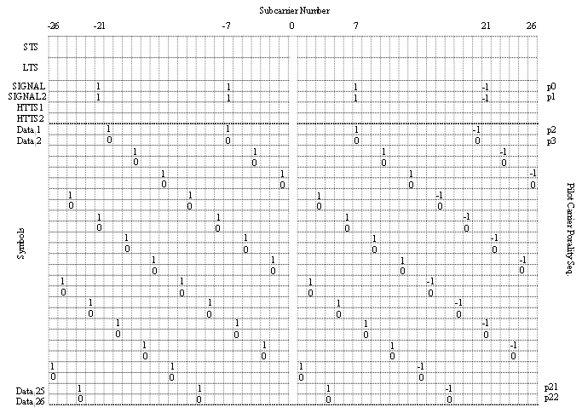

Figure 15 – Pilot carrier frequency allocation (2x2 MIMO – TX1)

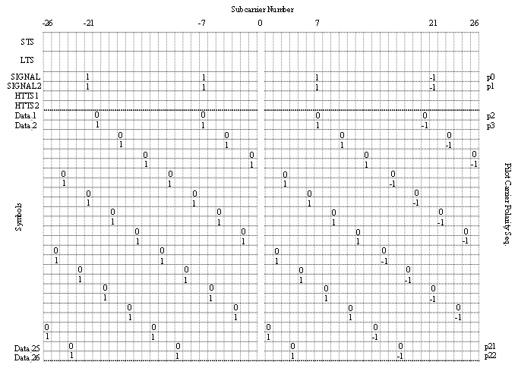

Figure 16 – Pilot carrier frequency allocation (2x2 MIMO – TX2)

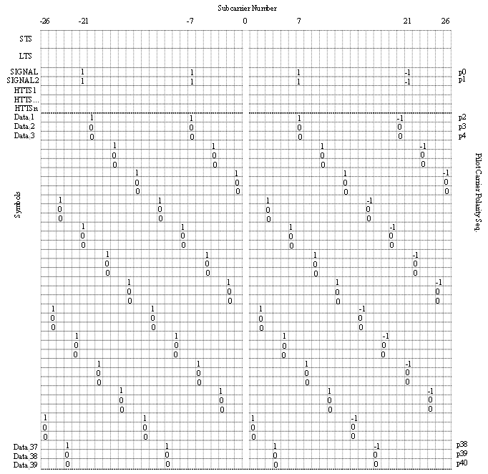

Figure 17 – Pilot carrier frequency allocation (3x3 MIMO – TX1)

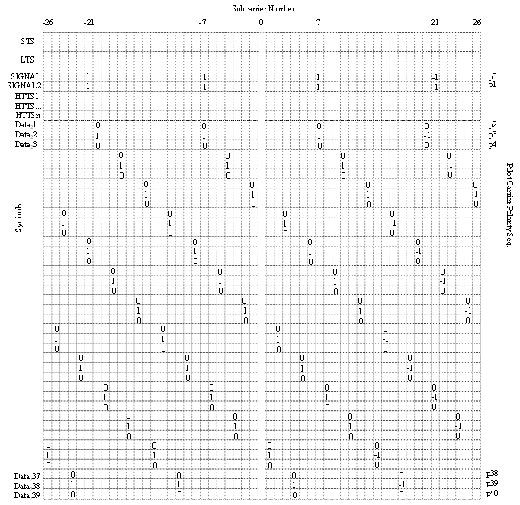

Figure 18 – Pilot carrier frequency allocation (3x3 MIMO – TX2)

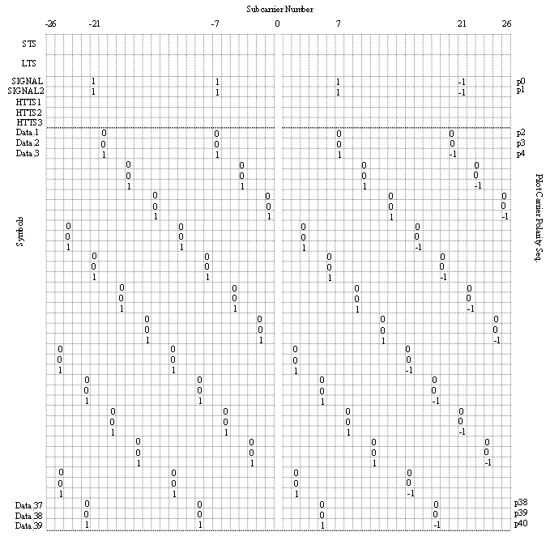

Figure 19 – Pilot carrier frequency allocation (3x3 MIMO – TX3)

VIP MIMO OFDM

Introduction
Spatial Multiplexing is a MIMO transmission scheme aimed at realizing a higher PHY rate and consequently throughput. To attain optimal benefits of spatial multiplexing, ideally the channel matrix should be uncorrelated. However, realistic channels have a certain degree of correlation, for example, due to line of sight conditions.

In the following, the proposed VIP-MIMO transmission scheme, in which different antenna streams are interleaved differently prior to transmission, is described. The proposed scheme helps to realise improved performance by decreasing the degree of spatial correlation between channels and improving the performance of iterative decoding architectures by isolating the occurrence of burst errors.

Data Interleaving

It is anticipated that different high throughput transmission modes may use different FEC schemes. As the proposed VIP MIMO scheme is closely tied to the FEC scheme, we describe how VIP may be implemented with either Convolutional codes or LDPC codes.

Convolutional encoders make use of a discrete interleaver to isolate burst errors. Hence, the proposed VIP mechanism advocates the use of different interleaver patterns on different antenna streams. In subsequent sections, we describe how interleaving may be done to effect VIP in a system using convolutional codes.

In the case of LDPC codes, the interleaver may be incorporated into the encoder design itself [5]. Therefore one of the ways in which VIP can be realized is through the use of multiple (different) LDPC encoders.

Interleaving (single-antenna transmission mode)
When a HT transmission mode employs the use of a single antenna for transmission, the interleaving pattern is the same two stage process as used in legacy systems, described in [4].

Interleaving (multi-antenna transmission mode)
In order to improve PER performance in a multi-antenna transmission mode, interleaving is performed in such a manner so as to result in varying interleave patterns (VIP) on different antenna streams.

When using a multi-antenna transmission mode, a new variable length interleaver having a maximum interleaver depth of 6 OFDM symbols per antenna stream is proposed, and described in the following:

The number of OFDM symbols in the transmission is first computed using equation (33).

$N_{\text{SYM}}=\text{ceil}((\text{16}+8×\text{LENGTH}+6)/{N_{\text{DBPS}}})$ (33)

The number of transmitted symbols, N_{TSYM} is then obtained by padding N_{SYM} to the nearest multiple of the number of transmit antennas N_{ANT}.

$N_{\text{TSYM}}=N_{\text{SYM}}+\text{mod}(N_{\text{SYM}},N_{\text{ANT}})$ (34)

The number of pad bits is computed using (35).

$N_{\text{PAD}}=N_{\text{TSYM}}×N_{\text{DBPS}}−(\text{16}+8×\text{LENGTH}+6)$ (35)

The number of OFDM symbols per antenna stream may then be determined by:

$N_{\text{SYM}−\text{STREAM}}=N_{\text{TSYM}}N_{\text{ANT}}$ (36)

The N_{SYM-STREAM} OFDM symbols are grouped in blocks of IL_{DEPTH} OFDM symbols (which is set to 6 in this proposal). The IL_{DEPTH} of the last group of OFDM symbols in the stream is given by mod(N_{SYM-STREAM}, 6).

In order to achieve the benefits of the proposed VIP scheme, different antenna streams are interleaved differently. As per the legacy specification [4], the interleaver process consists of 2 permutations – the first to ensure that adjacent coded bits are mapped into non adjacent subcarriers and the second to ensure that adjacent coded bits are mapped alternately into less and more significant bits of the constellation, and thereby, long runs of low reliability LSBs are avoided.

For the VIP transmission scheme, the first permutation of the interleaver (and consequently the last permutation of the deinterleaver) is different for different antenna streams – described in equations (37) through (42), whereas the second permutation of the interleaver (and consequently the first permutation of the deinterleaver) is described in equations (43) and (44) and are common to all antenna streams.

First (Second) Permutation Interleaving (Deinterleaving) – Tx1
The first permutation on Tx1 (using a two or three transmit antenna mode) is defined by the rule:

i = (IL_{DEPTH}×N_{CBPS}/16) (k mod 16) + floor(k/16) k = 0, 1,..., IL_{DEPTH}×N_{CBPS} – 1 (37)

Correspondingly, the second permutation of the deinterleaver is defined by:

k = 16 × i - (IL_{DEPTH}×N_{CBPS} – 1)floor(16 × i/( IL_{DEPTH} ×N_{CBPS})) i = 0, 1,…, IL_{DEPTH} ×N_{CBPS} – 1 (38)

First (Second) Permutation Interleaving (Deinterleaving) – Tx2
The first permutation on Tx2 (using a two or three transmit antenna mode) is defined by the rule:

i = (IL_{DEPTH}×N_{CBPS}/16) (((IL_{DEPTH} ×N_{CBPS}-1)-k) mod 16) + floor(((IL_{DEPTH} ×N_{CBPS}-1)-k)/16)
k = 0, 1,..., IL_{DEPTH} ×N_{CBPS} – 1 (39)

Correspondingly, the second permutation of the deinterleaver is defined by:

k = 16 × ((IL_{DEPTH}×N_{CBPS}-1)-i) - (IL_{DEPTH} ×N_{CBPS} – 1)floor(16 ×(( IL_{DEPTH} ×N_{CBPS}-1)-i)/(IL_{DEPTH} ×N_{CBPS}))
i = 0, 1,…, IL_{DEPTH} ×N_{CBPS} – 1 (40)

First (Second) Permutation Interleaving (Deinterleaving) – Tx3
The first permutation on Tx3 (using a three transmit antenna mode) is defined by the rule:

i = ( (IL_{DEPTH}×N_{CBPS}/16) (k mod 16) + floor(k/16)+ IL_{DEPTH} ×N_{CBPS}/2) mod IL_{DEPTH} ×N_{CBPS}
k = 0, 1,..., 6× IL_{DEPTH} – 1 (41)

Correspondingly, the second permutation of the deinterleaver is defined by:

k = 16 × ((i+IL_{DEPTH}×N_{CBPS}/2) mod IL_{DEPTH} ×N_{CBPS}) – (IL_{DEPTH} ×N_{CBPS} – 1)floor(16 ×
((i+ IL_{DEPTH} ×N_{CBPS}/2) mod IL_{DEPTH} ×N_{CBPS})/ IL_{DEPTH} ×N_{CBPS})
i = 0, 1,…, 6×N_{CBPS} – 1 (42)

Common Permutations
As mentioned previously, to effect VIP, the first permutation on each antenna streams is modified, as described above. The common permutation for all antenna streams i.e. the second permutation for interleaving and the first permutation during deinterleaving is described in equations (43) and (44), respectively.

The second permutation for interleaving all streams is:

j = s × floor(i/s) + (i + IL_{DEPTH}×N_{CBPS} – floor(16 ×i/(IL_{DEPTH} ×N_{CBPS}))) mod s
i = 0, 1,…, IL_{DEPTH} ×N_{CBPS} – 1 (43)

The first permutation for deinterleaving all streams is:

i = s × floor(j/s) + (j + floor(16 × j/( IL_{DEPTH} ×N_{CBPS}))) mod s
j = 0, 1,…, IL_{DEPTH} ×N_{CBPS} – 1 (44)

where the parameter ‘s’ in equations (43) and (44) is given by (45):

s = max(N_{BPSC}/2, 1) (45)

References

[1] | “Local and Metropolitan Area Networks – Specific Requirements – Part 11: Wireless LAN Medium Access Control (MAC) and Physical Layer (PHY) specifications”, IEEE Std 802.11-1999, IEEE, August 1999.
[2] | “Draft Supplement to LAN/MAN Specific Requirements – Part 11: Wireless Medium Access Control (MAC) and Physical Layer (PHY) specifications: MAC Enhancements for Quality of Service (QoS)”, IEEE Std 802.11e/D8.0 March 2004.
[3] | Y. Kim et al, “Throughput Enhancement via Frame Aggregation – A Sequel”, IEEE 802.11-03/567r1
[4] | “Local and Metropolitan Area Networks – Specific Requirements – Part 11: Wireless LAN Medium Access Control (MAC) and Physical Layer (PHY) specifications: Higher-Speed Physical Layer Extension in the 5 GHz Band”, IEEE Std 802.11a-1999, IEEE, September 1999.
[5] | Jilei Hou, Paul H. Siegel and Laurence B. Milstein, “Performance Analysis and Code Optimization of Low Density Parity-Check Codes on Rayleigh Fading Channels,” IEEE Journal on Selected Areas in Communications, vol.19, no.5, May 2001.
[6] | K. Kobayashi, Y. Murakami, M. Orihashi and T. Matsuoka, “Varying Interleave Patterns with Iterative Decoding for Improved Performance in MIMO systems,” in Proc. of IEEE PIMRC 2004, Sep. 2004.
[7] | K. Kobayashi, Y. Murakami, M. Orihashi and T. Matsuoka, “Varying Interleave Patterns with Iterative Decoding for Improved Performance in MIMO systems in LOS Environments,” in Proc. of WPMC 2004, Sep. 2004.

Annex

Recommended Items in the PLCP Header
This section describes the recommended parameters of the PLCP Header required to support the proposal.

HT-MODE
This field describes the sets of transmission modes proposed for the high throughput mode of operation.

The proposed rate-set is tabulated in Table A1.

PHY Layer Data Rate (Mbps) | Modulation Technique | Number of TX Antennas | Coding Scheme | Coding Rate | Bandwidth  (MHz)
6 | BPSK | 1 | CC | ½ | 20
12 | QPSK | 1 | CC | ½ | 20
24 | 16-QAM | 1 | CC | ½ | 20
48 | 64-QAM | 1 | CC | 2/3 | 20
54 | 64-QAM | 1 | CC | ¾ | 20
36 | QPSK | 2 | CC | ¾ | 20
72 | 16-QAM | 2 | CC | ¾ | 20
96 | 64-QAM | 2 | CC | 2/3 | 20
108 | 64-QAM | 2 | CC | ¾ | 20
115 | 64-QAM | 2 | LDPC | 4/5 | 20
126 | 64-QAM | 2 | CC | 7/8 | 20
108 | 16-QAM | 3 | CC | ¾ | 20
144 | 64-QAM | 3 | CC | 2/3 | 20
172 | 64-QAM | 3 | LDPC | 4/5 | 20

Table A1: Additional Rates for HT operation

HT-LENGTH
This field describes the length of the payload (in octets) that a high throughput station is expected to support. An addressability for MPDUs of upto 8192Bytes is proposed.

RCE
This single-bit field describes whether the transmitter of the current MPDU expects a response/continuation to its current transmission or not. Details on the usage of this field may be found in the chapter on Reduced Inter-frame Spaces.

