IEEE P802.11
Wireless LANs

AFR partial MAC proposal for IEEE 802.11n
Date: August 13, 2004
Authors: Qiang Ni
Hamilton Institute, National University of Ireland, Maynooth
Phone: +353 1 708 4532
e-Mail: Qiang.Ni@ieee.org
Tian-ji Li
INRIA Sophia Antipolis
Phone: +33 4 92 38 71 69
e-Mail: Tianji.Li@sophia.inria.fr
Thierry Turletti
INRIA Sophia Antipolis
Phone: +33 4 92 38 78 79
e-Mail: Thierry.Turletti@sophia.inria.fr
Yang Xiao
University of Memphis, USA
Phone: +1 901 678 2487
e-Mail: yangxiao@ieee.org

Abstract

In this document we propose a scheme of packet Aggregation with Fragment-Retransmission (AFR) for the IEEE 802.11n. Simulation results show that the AFR scheme allows to meet the requirements of the IEEE 802.11n PAR [1], i.e. 100Mbps data throughput at MAC layer. Comparisons with 802.11 [2] and 802.11e [3] MAC layer protocols show that the AFR scheme outperforms both 802.11 DCF and 802.11e burst-ACK.

1. INTRODUCTION
Recent research works [4] show that the throughput of 802.11 wireless LANs is bounded by the overhead of the MAC layer protocols, i.e., under current MAC layer protocols, a theoretical MAC layer throughput upper limit exists even if the PHY data rate goes up to infinite high. Packet aggregation is known to be an effective solution that can improve MAC layer throughput under an ideal channel environment. However, when the wireless channel is a noisy channel with fading/shading effects, packet aggregation may lead to corrupted frames using large frame size and thus cause huge overhead when the channel is quite noisy. In order to improve throughput performance in all channel conditions, we propose a packet Aggregation with Fragment-Retransmission (AFR) scheme for 802.11n.

The remainder of this document is organized as follows: In Section 2 we investigate the 802.11n MAC layer throughput by tuning MAC/PHY layer parameters. We propose in Section 3 the AFR scheme to provide high throughput in all PHY channel conditions. In Section 4, we show simulation results of the AFR scheme and compare its performance with a simple packet aggregation scheme and the 802.11e burst-ACK scheme. We explain in Section 5 compliance with the Function Requirements (FR) [5] and the Comparison Criteria (CC) [6] of the proposal.

2. PERFORMANCE INVESTIGATION BY TUNING PHY/MAC PARAMETERS

First, we study the 802.11n throughput in the ideal case, i.e., when the channel is a perfect one without transmission errors. The ideal throughput can be calculated as follows [4]:
$S_{\text{ideal}}=\frac{8L\text{payload}}{T_{\text{DIFS}}+T_{\overline{\text{CW}}}+T_{\text{PHYhdr}}+T\text{payload}+T_{\text{SIFS}}+T_{\text{PHYhdr}}+T\text{ack}+2δ}$

If the PHY data rate increases up into infinite high, the throughput of 802.11 networks has such an upper bound:
$S_{\text{TUL}}=\frac{8L\text{payload}}{T_{\text{DIFS}}+T_{\overline{\text{CW}}}+T_{\text{PHYhdr}}+T_{\text{SIFS}}+T_{\text{PHYhdr}}+2δ}$

Table 1 illustrates the notations in the above two equations:

Tab. 1 Notations for throughout models
L_{payload} | Payload sizes in bytes | T_{PHYhdr} | Sum of time durations of PLCP preamble and PLCP header
T_{DIFS} | Time duration of DIFS | T_{payload} | Transmission time of a payload
T_{SIFS} | Time duration of SIFS | T_{ack} | Transmission time of an ACK frame
$$T_{\overline{\text{CW}}}$$ | Time duration of the mean CW or the mean backoff time | δ | Propagation delay

While the PHY/MAC layer parameters of 802.11n have not been decided by the TGn group, we assume its compatibility with the IEEE 802.11a/g standards as follows: the SIFS length, slot time length, MAC header length, symbol time, ACK length, backoff values, propagation delay, PHY preamble and PHY header length are the same as in the 802.11a standard. For doubled, tripled, and quadrupled data rates, control rates and data bits per OFDM symbol are respectively doubled, tripled, and quadrupled. Table 2 summarizes the default MAC/PHY layer parameters for the 802.11n standard used in this document. Figure 1 plots the curve of the ideal throughput and the upper bound when the frame size is 1000 bytes and the PHY data rate increases up to infinite high. As shown in the figure, the maximum throughput of 802.11n achieved is bounded by 50Mbps when the fame size is 1000 bytes. This confirms that to reach the target of providing MAC layer throughput higher than 100Mbps, it is essential to improve performance of the MAC layer protocol.
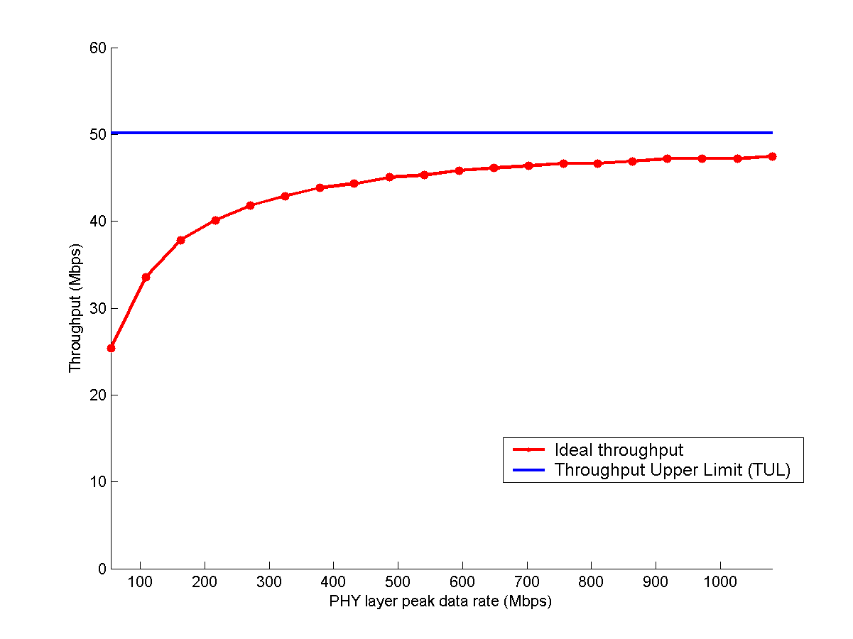

Fig. 1 802.11 ideal throughput and throughput upper limit (frame size: 1000bytes)
Tab.2 Default 802.11n PHY/MAC parameters
T_{SIFS} (μs) | 16 | ACKLength (bits) | 112
Slot time - σ (μs) | 9 | CRC (bits) | 32
T_{DIFS} (μs) | 34 | δ (μs) | 1
T_{PHYhdr} (μs) | 20 | OFDM symbol delay -T_{symbol} (μs) | 4
CW_{min} | 15 | PHY peak data rate (Mbps) | 54⋅k (k=1,2,3, …)
MACheader (bytes) | 30 | NBpS (Number of bits per symbol) | 216⋅k

In order to investigate the impact of different MAC/PHY parameters on the throughput, we have modified the values of different MAC/PHY layer parameters individually and in a whole as well. Figure 2 and Figure 3 show the ideal throughput curves while only the value of one parameter is decreased, and when the values of multiple parameters are decreased respectively. In all the simulations, the PHY data rate is selected as 216Mbps. As shown in Figure 2, the slot time is the most important parameter which affects the throughput. If the slot time of 802.11n can be smaller than 9μs as specified in 802.11a, throughput performance of 802.11n can be improved significantly. Although the CW_{min} is the second important parameter, it can be neglected since we cannot decrease it in reality because of the collision avoidance mechanism. Furthermore, we can observe in Figure 3 that when the values of multiple parameters are decreased, a MAC layer throughput higher than 100Mbps can be achieved even when PHY data rate is only 216Mbps.

Fig. 2 Ideal throughput when one parameter is modified. Fig. 3 Ideal case when multiple parameters are modified

Fig. 4 Ideal throughput for packet aggregation Fig. 5 PHY effective throughput when channel is noisy

Then, we look into a simple packet aggregation scheme under the ideal case. In this document, the simple packet aggregation scheme refers to the mechanism which concatenates multiple IP packets into a single MAC frame without changing the ARQ scheme at MAC layer. As shown in Figure 4, a simple packet aggregation scheme can improve the throughput in the ideal channel case significantly. When the aggregated frame size is larger than 3000bytes, the MAC layer throughput can exceed 100Mbps in the ideal case. However, throughput performance of 802.11n is degraded significantly when the channel is noisy. Figure 5 shows the actual PHY layer effective throughput. We can observe that a simple packet aggregation scheme can cause throughput degradation in noisy/fading wireless channel environments. Thus, we propose a new scheme called packet Aggregation with Fragment-Retransmission (AFR) scheme in the next Section.

3. PACKET AGGREGATION WITH FRAGMENT RETRANSMISSION (AFR)
In this section we propose a new scheme called packet Aggregation with Fragment-Retransmission (AFR) for 802.11n. In this scheme, the MAC layer protocol aggregates the data packets from the upper layer into a large MAC frame. We allow the aggregated MAC layer frame length to exceed the maximum MAC layer service data unit (MSDU) size, which is 2304 bytes defined in the legacy 802.11 standard [2]. In our proposal, the maximum value of aggregated MAC layer frame is selected as 32768bytes, which is an optimal value found by our simulation tests. If there are not multiple IP data packets available, the MAC layer will not use AFR and the 802.11 DCF or 802.11e HCF (EDCA/HCCA) will be used as default. As shown in Figure 6, the new MAC layer frame format is compatible with the current 802.11(e) MAC frame format. The MAC frame of the AFR scheme is composed of a MAC header, a frame body that includes multiple fragments, and each fragment with a corresponding fragment check sum, i.e. IEEE 32-bit CRC (compatible with the 802.11/802.11e MAC protocols). When transmission errors occur in a MAC frame, the only retransmitted fragments are those with errors detected by their CRCs. By allowing fragment retransmissions in a large MAC frame, the MAC layer throughput can be significantly improved whatever the channel conditions.

Fig. 6 Example of Aggregation with Fragment-Retransmission (AFR) scheme

The detailed MAC data frame and ACK frame formats for the AFR scheme are described in Figure 7 and Figure 8 respectively. When the channel is very good and the application generates a very high data rate with large packets, the fragment size can choose the maximum value 32KB. In the case of noisy environment, the frame size can be choosen very small which is robust against the noisy channels. The optimal fragment size can be calculated according to the channel conditions.

Fig. 7 MAC data frame for the AFR scheme

Fig. 8 MAC ACK frame for the AFR scheme
As shown in Figure 8, the length of the new Fragment Bitmap field is 32 octets, which allows the maximum number of fragments in a MAC frame is 256.
We explain in Figure 9 one example of how the AFR protocol works: At the sender side, on receiving one IP data packet from the upper layer, the MAC layer divides it into several fragments and save them into the MAC queue. After receiving some other IP data packets, the MAC queue aggregates all the available fragments into a large MAC frame and transmits the aggregated frame through the PHY layer. At the receiver side, after receiving the aggregated frame, the receiver’s MAC sends back an ACK frame confirming which fragments have been correctly received in the ACK frame’s Fragment Bitmap field. If all the fragments of an aggregated frame have been successfully received, the receiver’s MAC layer transmits the whole frame to the upper layer and deletes it from the queue.
The AFR scheme adds some overheads and complexity: 3 bytes fragment numbers/size fields in the MAC header, 4bytes CRC on each fragment, and 32bytes Fragment Bitmap field in the ACK frame. These overheads are minor compared to the packet length gains. The AFR scheme can result in out-of-order packet delivery at upper layer, which requires the large queues to buffer those un-ACKed fragments.
Fig. 9 One example of the AFR protocol

4. SIMULATION ANALYSIS
We have implemented the AFR scheme in the NS simulator [9]. We have compared performance of the AFR scheme with the one of the 802.11e burst-ACK scheme in Figure 10. Our simulation results show that the AFR scheme outperforms both the simple packet aggregation scheme and 802.11e burst-ACK scheme.
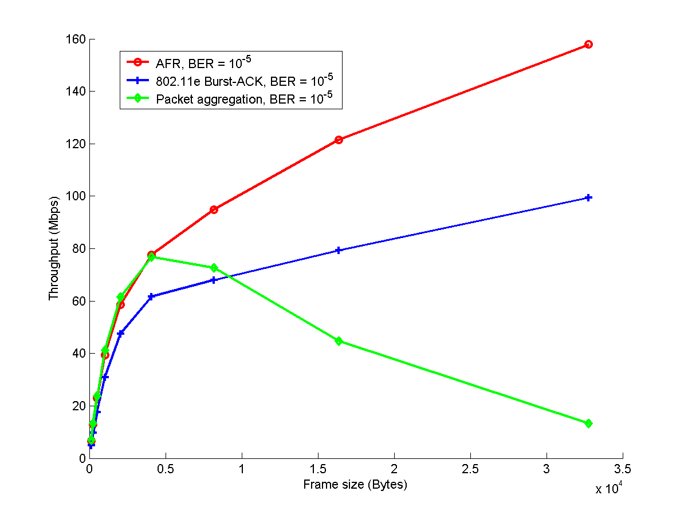

Fig. 10 Simulation comparisons between AFR scheme, 802.11e and simple packet aggregation

5. COMPLIANCE WITH FR AND THE CC
Our AFR proposal is compliant with the TGn Function Requirements (FR) [5] and the Comparison Criteria (CC) [6] as shown in the following two tables.
Tab.3 Functional Requirements
Number | Name | Coverage (Yes/No) | Results Reference
R1 | Single Link HT rate supported | Yes
R2 | HT rate supported in 20MHz channel | Yes
R3 | Supports 5GHz bands | Yes
R4 | .11a backwards compatibility | Yes
R5 | .11g backwards compatibility | Yes
R6 | Control of support for legacy STA from .11n AP | Yes
R7 | .11e QoS support | Yes
R8 | Spectral Efficiency | Yes
R9 | Compliance to PAR | Yes

Tab.4 Comparison Criteria
Number | Name | Mandatory / optional | Coverage (Yes/No) | Disclosure
General
CC2 | Regulatory compliance | Mandatory | No
Marketability
CC3 | List of goodput results for usage models 1,4 and 6. | Mandatory | Yes
CC6 | PHY complexity | Optional
CC7 | MAC processing complexity | Optional
Backward Compatibility and Coexistence with Legacy Devices
CC11 | Backward compatibility with 802.11-1999 (Rev 2003) and 802.11g | Mandatory | Yes
CC15 | Sharing of medium with legacy devices | Mandatory | Yes
MAC Related
Performance Measurements at the MAC SAP
CC18 | HT Usage Models Supported (non QoS) | Mandatory | Yes
CC19 | HT Usage Models Supported (QoS) | Mandatory | Yes
CC20 | BSS Aggregate Goodput at the MAC data SAP | Mandatory | Yes
CC24 | MAC Efficiency | Mandatory | Yes
CC27 | Throughput / Range | Mandatory | No
CC28 | Throughput / Range in 20MHz | Mandatory | No
MAC Changes
CC46 | MAC Compatibility and parameters. | Mandatory | Yes
CC47 | MAC extensions | Mandatory | Yes
PHY Related
PHY Rates and Preambles
CC51 | Data rates | Mandatory | No
CC42 | Preambles | Mandatory | No
Channelization
CC51.5 | Channelization | Mandatory | No
CC52 | Spectral Mask | Mandatory | No
Spectral Efficiency
CC58 | HT Spectral Efficiency | Mandatory | No
PHY Performance
CC59 | AWGN PER performance | Mandatory | No
CC67 | PER performance in non AWGN channels | Mandatory | No
CC67.2 | Offset Compensation | Mandatory | No
PHY Changes
CC80 | Required changes to 802.11 PHY | Mandatory | No

Below is a complete list of IEEE submissions, both documents and presentations, for AFR partial MAC proposal:

IEEE 802 11-04/0950, AFR partial MAC proposal for IEEE 802.11n
- Partial MAC proposal
IEEE 802 11-04/0949, AFR partial MAC proposal for IEEE 802.11n Presentation
- Partial MAC protocol presentation

REFERENCES
- IEEE 802.11-02/798r7, Draft PAR for High Throughput Study Group.
- IEEE STD 802.11-1999, Part 11: wireless LAN MAC and physical layer specifications, reference number ISO/IEC 8802-11:1999(E), IEEE STD 802.11, 1999.
- IEEE 802.11e/D8.0, Draft supplement to Part 11: wireless MAC and physical layer specifications: MAC enhancements for QoS, February 2004.
- Y. Xiao and J. Rosdahl, “Performance analysis and enhancement for the current and future IEEE 802.11 MAC protocols”, ACM SIGMOBILE Mobile Computing and Communications Review (MC2R), special issue on Wireless Home Networks, Vol. 7, No. 2, Apr. 2003, pp. 6-19.
- IEEE 802 11-03/813r12, TGn Functional Requirements.
- IEEE 802 11-03/814r31, TGn Comparison Criteria.
- IEEE 802 11-03/802r23, TGn Usage Models.
- IEEE 11-03/940r5, TGn Channel Models.
- NS simulator website. http://www.isi.edu/nsnam/ns/index.html.

