IEEE 802.11n
Wireless LANs
Partial Proposal (Physical Layer) for extending the 802.11-1999 standard.
Date: August 13th, 2004
Authors: Patrik Eriksson, Anders Edman, Christian Kark
Wavebreaker AB,
Bredgatan 34, SE-602 21, Norrkoping, Sweden.
Phone: +46 11 36 36 00
Fax: +46 11 36 36 01
e-Mail: patrik.eriksson@acreo.se
Scott Leyonhjelm (Editor), Mike Faulkner, Melvyn Pereira, Jason Gao, Aaron Reid, Tan Ying, Vasantha Crabb.
Australian Telecommunication Co-operative Research Centre,
P.O Box 14428, Melbourne, Vic 8001, Australia.
Phone: +61 3 9688 4247
Fax: +61 3 9688 4058
e-Mail: scott.leyonhjelm@vu.edu.au
Abstract: A “High Throughput” physical layer extension to the 802.11-1999 standard that demonstrates physical layer data rates of up to 216Mbps in 20MHz bandwidth and demonstrates throughputs in excess of 100Mbps at the MAC SAP is proposed. The key benefits of the proposal are:
Higher data throughput due to use of higher order QAM modulation and multiple antennas:
- 256QAM, specifically 64Mbps (256QAM @ R2/3) and 72Mbps (256QAM @ R¾)
- up to 3 transmit antennas (mandatory), 4 antennas (optional)
Higher data throughput due to reduced overhead achieved by
- Shorter allowed SIFS, down to 8 us.
- Frames without short and long training sequences
- Frame aggregation – max 16kbyte packet size
Higher data throughput due to adaptive loading achieved by
- Adapting the data rate on a per layer (mandatory) or per a subgroup (optional) level
- Fast adaptation to best rates as each frame reports back a recommended rate.
All structures are simple extensions to 11a.
- Enables reuse of design and logic between 11a and 11n
- lla STS and LTS sequences are used in conjunction with progressive cyclic delay per antenna
Frame format designed to increase available time for inverting channel estimate.
- Simplified hardware for the matrix inversion made possible.

Notice | This document has been prepared to assist the IEEE P802.11. It is offered as a basis for discussion and is not binding on the contributing individual(s) or organization(s). The material in this document is subject to change in form and content after further study. The contributor(s) reserve(s) the right to add, amend or withdraw material contained herein.
Release | The contributor acknowledges and accepts that this contribution becomes the property of IEEE and may be made publicly available by P802.11.
Table of Contents

1 Abbreviations 4
2 Physical Layer Proposal 5
2.1 Introduction 5
2.2 MIMO-OFDM-AdaptLoad PLCP sublayer 5
2.2.1 Introduction 5
2.2.2 PLCP frame formats 6
2.2.2.1 RATE dependent options 7
2.2.3 PLCP preamble 8
2.2.4 Signal (Sig) Symbol 8
2.2.4.1 Short Rate field (Short Rate) 8
2.2.4.2 High Throughput field (HT) 9
2.2.5 Signal 2 (Sig2) Symbol 9
2.2.5.1 Adaptive Loading Mode field (AL) 9
2.2.5.2 Channel State Information Indication field (CSI) 9
2.2.5.3 High Throughput field (HT) 9
2.2.5.4 802.11n Transmission Mode field (Mode) 10
2.2.5.5 Sig3 Symbol On field (Sig3On) 10
2.2.5.6 Sig3 Symbol Rate field (Sig3R) 10
2.2.5.7 Channel Bonding field (CB) 10
2.2.5.8 Reserved (Res), Parity (P) and Tail (Tail) fields 11
2.2.6 Signal 3 (Sig3) Symbols 11
2.2.6.1 Reverse Link Channel State Information field (Rev CSI) 11
2.2.6.2 Forward link rate field (FWD Rate) 11
2.2.6.3 Request for Training MIMO Type 1 Frame field (Req) 11
2.2.6.4 MIMO 802.11n data length field (11nLength) 12
2.2.6.5 Pad with Zeros field (Pad) 12
2.2.6.6 Reserved (Res), Parity (P) and Tail (Tail) fields 12
2.2.7 Data Symbols 12
2.2.7.1 Subcarrier Modulation Mapping Additions 12
2.2.8 PMD operating specifications 13
2.2.8.1 Parallel Spatial Multiplexing Transmitter Architecture 13
2.2.8.2 Adaptive Loading Overview 13
2.3 MIMO-OFDM-AdaptLoad Frame Transmission Modes 14
2.3.1 5 GHz Band Proposal 14
2.3.1.1 Single Packet Transmission Mode 14
2.3.1.2 RTS/CTS Transmission Mode 14
2.3.2 2.4 GHz Band Proposal 16
2.3.2.1 Single Packet Transmission Mode 16
2.3.2.2 RTS/CTS Transmission Mode 16
2.3.3 Implementation Details of the Proposed Frame Format 17
2.3.3.1 802.11n Channel Environment 18
2.3.3.2 Tracking Algorithm Simulations 20
3 Addressing the Functional Requirements 21
4 Addressing Section 3 of the Comparision Criteria 22
4.1 AD1 – Reference Submissions 22
4.2 AD2 – TCP Model Parameters 22
4.3 AD3 – MAC Simulation Methodology 22
4.4 AD4 – MAC Simulation occupied channel width 22
4.5 AD5 – Justification of low packet loss rate (PLR) rates achieved 22
5 Addressing Section 4 of the Comparision Criteria 23
5.1 General 23
5.1.1 CC2 - Regulatory Compliance 23
5.2 Marketability 23
5.2.1 CC3 - List of goodput results for usage models 1,4 and 6. 23
5.2.2 CC6 – PHY complexity 23
5.2.3 CC7 – MAC processing complexity 23
5.3 Backward Compatibility and Coexistence with Legacy Devices 23
5.3.1 CC11 – Backward compatability with 802.11-1999 (Rev 2003) and 802.11g 23
5.3.2 CC15 – Sharing of medium with legacy devices 23
5.4 MAC Related 24
5.4.1 CC46 – MAC Compatibility and Parameters 24
5.4.2 CC47 – MAC extensions 24
5.5 PHY related 25
5.5.1 PHY Rates and Preambles 25
5.5.1.1 CC51 - Data Rates 25
5.5.1.2 CC42 – Preambles 25
5.5.2 Channelisation 26
5.5.2.1 CC51.5 - Channelisation 26
5.5.2.2 CC52 – Spectral Mask 26
5.5.3 Spectral Efficiency 27
5.5.3.1 CC58 – HT spectral Efficiency 27
5.5.4 PHY Performance 33
5.5.4.1 CC59 – AWGN PER performance 33
5.5.4.2 CC67 – PER performance in non AWGN channels 36
5.5.4.3 CC67.2 – Offset Compensation 38
5.5.5 PHY Changes 38
5.5.5.1 CC80 – Required Changes to 802.11 PHY 38
6 References 38
7 Appendices 39
7.1 Appendix A – Background to Cyclic Delay Technique 39
7.2 Appendix B – Example of Length Calculation of the Sig3 field 42
7.2.1 Transmitter to Receiver 42
7.2.2 Receiver to Transmitter 42
7.3 Appendix C – Frame Aggregation 43
7.4 Appendix D - CC58 Calculation Technique and Assumptions 44
7.5 Appendix E – Rate Estimation for Channel Bonding 46

Abbreviations

ACK | Acknowledgement
AGC | Automatic gain control
AL | Adaptive loading
AOD | Angle of departure
AP | Access point
AWGN | Additive white gaussian noise
BPSK | Binary phase shift keying
BW | Bandwidth
CB | Channel bonding
CP | Cylic prefix
CSI | Channel state information
CTS | Clear to send
DSSS | Direct spread spectrum sequence
EVM | Error Vector Magnitude
FFT | Fast fourier transform
FWD | Forward
HCF | Hybrid co-ordination function
HT | High Throughput
LAN | Local area network
LOS | Line of sight
LTS | Long training sequence
MAC | Medium access controller
MIMO | Multiple Input Multiple Output
MSE | Minimium Square Error
N.A. | Not applicable
NAV | Network allocation vector
OFDM | Orthogonal Frequency Division Multiplexing
P | Parity bits
Pad | Padding bits
PAR | Project Authoritation Request
PER | Packet error rate
PHY | Physical layer
PLCP | Physical layer convergence procedure
PMD | Physical medium dependent
PSDU | PHY sublayer service data unit
QAM | Quadrature Amplitude Modulation
QoS | Quality of service
QPSK | Quadrature phase shift keying
RTS | Request to send
RX | Receiver/reception
SAP | Service access point
SIFS | Short InterFrame Space
SISO | Single input single output
SNR | Signal to noise ratio
STA | Station
STS | Short training sequences
TX | Transmitter/transmission
TXOP | Transmission opportunity

Physical Layer Proposal

Introduction
This clause specifies the PHY entity for a multiple input multiple output antenna orthogonal frequency division multiplexing (MIMO-OFDM) system with adaptive loading (AdaptLoad) mechanisms and the additions that have to be made to the base standard (802.11-1999 revision 2003) to accommodate the MIMO-OFDM-AdaptLoad PHY. The radio frequency LAN system is initially aimed for both the
- 5GHz band in Europe, Asia and the Americas.
- 2.4GHz band (Optional)

The OFDM system provides a wireless LAN with data payload communication capabilities of up to 3*72 = 216 Mbps in the mandatory modes and with extension up to 4*72 = 288 Mbps in optional mode. The system uses a total of 52 sub-carriers per transmit antenna that are modulated using BPSK, QPSK, 16QAM, 64QAM, and 256QAM in 20 MHz bandwidth. The proposal supports 1-4 transmit antennas (layers), where support for 1-3 antennas is mandatory. Forward error correction coding (convolutional coding) is used with coding rates of ½, 2/3 and ¾.

MIMO-OFDM-AdaptLoad PLCP sublayer

Introduction
In addition to the frame formats defined in IEEE stds 802.11a-1999 and 802.11g, 3 new MIMO frame types are proposed:
- MIMO - Type 1 frames with Training. Note that the STS, LTS and Sig2 sequence can be received by legacy equipment.
- MIMO - Type 2 frames without Training. Note that channel tracking algorithms will be required.
- MIMO – Type 3 frames with Training used only in 5GHz band.

Extt
D1
D2
Note: Sig3 and Data Symbols can be turned off.
802.11n MIMO - Type 1
802.11n MIMO - Type 2
STS1
LTS1
Sig2
LTS1a
LTS1b
LTS1c
STS2
LTS2
Sig2
LTS2a
LTS2b
LTS2c
STS3
LTS3
Sig2
LTS3a
LTS3b
LTS3c
STS4
LTS4
Sig2
LTS4a
LTS4b
LTS4c
Sig3
Sig3
Sig3
Sig3
D1
D1
D1
D1
D2
D2
D2
D2
Dn
Dn
Dn
Dn
Sig3
Sig3
Sig3
Sig3
D1
D1
D1
D1
D2
D2
D2
D2
Dn
Dn
Dn
Dn
802.11n MIMO - Type 3
Sig2
LTS1a
LTS1b
LTS1c
Sig2
LTS2a
LTS2b
LTS2c
Sig2
LTS3a
LTS3b
LTS3c
Sig2
LTS4a
LTS4b
LTS4c
Sig3
Sig3
Sig3
Sig3
D1
D1
D1
D1
D2
D2
D2
D2
STS1
LTS1
Sig
STS2
LTS2
Sig
STS3
LTS3
Sig
STS4
LTS4
Sig
D1
D1
D1
D1
D2
D2
D2
D2
Dn
Dn
Dn
Dn
802.11a OFDM Frame format
802.11g DSSS Frame format
802.11g OFDM Frame format
STS
LTS
Sig
D1
D2
Preamble
Head
STS
LTS
Sig
D1
D2
Figure 1: Overview of Proposed Frame Formats – All symbols are assumed to be 4us except for STS and LTS which are 8us.

MIMO - Type 3 frames are only used for single frame transmissions, they are backward compatible with SISO transmissions, and they contain MIMO training and Data. However, no adaptive loading is activated for single frame transmissions. Adaptive loading is activated in a RTS/CTS transmission mode where the other 2 new frame types are used. The RTS/CTS frames are Type 3 and they are backward compatible with 11a/g frames and contain MIMO training (but no data) which is used to calculate the initial bit loading for transmission. A sequence of Type 2 frames, essentially only carrying data, follow. It is assumed free-wheeling tracking algorithms are needed to maintain time, frequency and channel estimates. The Type 1 frames are used to re-synchronise during a longer transmission. These frames are similar to Type 3 frames but they are only backward compatible with SISO transmissions up until the Sig symbol.

Note that the Sig3 symbol has been placed between the MIMO long training sequences (LTS) and the MIMO data, which increases the time available for inverting the channel matrix with one symbol period. This reduces the hardware implementation cost. It is a basic assumption that the Type 2 frames will occur more often than the Type 1 and 3 frames, otherwise 100Mbps data throughput at the MAC layer will not be possible unless frame aggregation is used. Also the Sig3 and Data symbols can be turned off in type 1 and 3 frames. The different frame types are illustrated above in Figure 1 for up to 4 antennas. The next section defines the new symbols which should make it clear to the reader that the proposal is scalable for more than 4 antennas. Note that the 4 pilot tones are continuous throughout all the symbols, and are as defined in the 802.11a standard. Further, cyclic delay is implemented at a rate of 1 sample/antenna for symbols transmitted with same information on each antenna, see Appendix A, Section 7.1.

PLCP frame formats
The different Signal and Data Symbol definitions used in the frame formats are summarized in Table 1.
Table 1: Signal and Data Symbol Definitions.
Symbol | Definition | Used For
Sig  (BPSK R1/2) | Same 11a Signal Symbol field format transmitted on each antenna but;  - Rate set to indicate SISO data transmission rate  - R reserved bit indicate MIMO mode i.e. 1  - Length to indicate data payload size in RTS/CTS transmission  TX Power per antenna reduced proportional to Ntx  Cyclic delay at a rate 1sample/antenna  For field definitions see Figure 3. | - Coexistance requirement due to indication that transmission is a MIMO (HT field) and Length field can be detected to defer during transmission.  - Backward Compatible requirement due to indication that transmission is not a SISO mode (R field) and Length field can be detected to defer during remainder of RTS/CTS transmission.
D1,D2 | Same 11a RTS data (service +20byte PSDU) or CTS data (service +14byte PSDU) transmitted on each TX antenna.  TX Power per antenna reduced proportional to Ntx  Cyclic delay at a rate 1sample/antenna | - Backward Compatible requirement due to 11a user can interpret destination address for forthcoming transmission.
Sig2  (BPSK R1/2) | Same MIMO Signal Symbol transmitted on each antenna.  TX Power per antenna reduced proportional to Ntx  Cyclic delay at a rate 1sample/antenna .  For field definitions see Figure 2 & Figure 3. | - Specifies MIMO mode to receiver indicating Transmission mode for Data and ACK frames.  - Backward Compatible Reserved bit in Sig symbol same location as bit which is always set to 1
Sig3  (see Sig2) | Adaptive Loading Symbol transmitted on each antenna.  TX Power per antenna reduced proportional to Ntx  Cyclic delay at a rate 1sample/antenna .  For field definitions see Figure 2 & Figure 3. | - DATA frame : Indicates Actual Adaptive Loading being used for every subgroup on each layer.  - ACK/CTS frame : Indicates Adaptive Loading Maximum rates to be used for every subgroup on each layer.

Figure 2: 802.11n MIMO Type 1 frame showing Sig2 and Sig3 fields.

Figure 3: 802.11n MIMO Type3 frame showing Sig, Sig2 and Sig3 symbol fields.

RATE dependent options
The additional modulation parameters dependent on data rate used shall be set according to Table 2.
Table 2: Additional Rate dependent parameters
Rate (Mbits/s) | Modulation | Coding Rate (R) | Coded bits per subcarrier (N_{BPSC}) | Coded bits per OFDM symbol (N_{CBPS}) | Data bits per OFDM symbol (N_{DBPS})
0 | N.A. | N.A. | 0 | 0 | 0
64 | 256-QAM | 2/3 | 8 | 384 | 256
72 | 256-QAM | 3/4 | 8 | 384 | 288

PLCP preamble
The PLCP preamble fields used for synchronisation are based on those defined in the IEEE stds 802.11a-1999. The definitions are given in Table 3.
Table 3: PLCP preamble field definitions.
PLCP preamble field | Definition | Used For
STS1-4 | Same 11a STS on each antenna  TX Power per antenna reduced proportional to Ntx  Cyclic delay at a rate 1sample/antenna | - AGC  - Timing detection  - Coarse freq offset estimation
LTS1-4 | Same 11a LTS on each antenna  TX Power per antenna reduced proportional to Ntx  Cyclic delay at a rate 1sample/antenna | - Channel estimation  - Fine frequency estimation
LTS1-4,a-d | Same 11a LTS phase loaded onto each antenna e.g.  2TX: LTS1a=11a, LTS2a=11a *exp(j180º), all others not required.  3TX: LTS1a=11a, LTS2a=11a *exp(j120º), LTS3a = 11a *exp(j240º).  LTS1b=11a, LTS2b=11a *exp(j240º), LTS3b = 11a *exp(j120º), all others not required.  4TX: etc  TX Power per antenna reduced proportional to Ntx  Cyclic delay at a rate 1 sample/antenna | - Allows for MIMO channel estimation

Signal (Sig) Symbol
The Sig Symbol fields are defined according to the existing 802.11a standard, except for the rate and reserved fields. Table 4 shows the standard rate field according to the 802.11a standard.
Table 4: 802.11a Standard Rate field
Rate (Mbps) | R0-R3 | Modulation, Code Rate
6 | 1101 | BPSK, ½
9 | 1111 | BPSK, ¾
12 | 0101 | QPSK, ½
18 | 0111 | QPSK, ¾
24 | 1001 | 16QAM, ½
36 | 1011 | 16QAM, ¾
48 | 0001 | 64QAM, 2/3
54 | 0011 | 64QAM, ¾
As R3 is always a one we can ensure backward compatibility by reducing the existing 802.11a Sig Symbol rate field to 3 bits (R0-R2) and include an aditional HT field that has two valid responses 10 and 11, see Figure 3. Note that this is equivalent to the current definition of the Sig Symbol, where bits R0-R3 are defined as the rate field and R4 is the reserved bit which is set to zero for SISO and one for MIMO.

Short Rate field (Short Rate)
The new Short Rate field is specified in Table 5 below.
Table 5: Contents of Short Rate field
Short Rate (Mbits/s) | R0-R2 | Modulation, Code Rate
6 | 110 | BPSK, ½
9 | 111 | BPSK, ¾
12 | 010 | QPSK, ½
18 | 011 | QPSK, ¾
24 | 100 | 16QAM, ½
36 | 101 | 16QAM, ¾
48 | 000 | 64QAM, 2/3
54 | 001 | 64QAM, ¾

High Throughput field (HT)
The new High Throughput field is defined in Table 6 below.
Table 6: Contents of High Throughput field
 | HT | Comment
Sig-field according to 11a | 10 | 802.11a compliant
N.A | 01
Type 3 MIMO Frame | 11 | Indicates a MIMO transmission instead of an 802.11a
N.A. | 00 | This combination will cause an invalid rate for 11a

Signal 2 (Sig2) Symbol
The Signal 2 symbol’s purpose is to specify the MIMO transmission mode that is to be employed, see Figure 2 and Figure 3. It contains information relating to;
- Adaptive Loading mode
- MIMO mode
- Indication if a Signal 3 symbol is appended
- Indication if CSI information is contained in Signal 3 symbol
- Indication if channel bonding is used

Adaptive Loading Mode field (AL)
The Adaptive Loading Mode field assists in determining the length of the Rev CSI and FWD Rate fields in the Sig3 symbol. The field is specified in Table 7 below.
Table 7: Contents of field
 | AL | Comment
No Adaptive Loading | 00 | Same rate for all layers
Layered Adaptive Loading | 01 | 1 rate per layer
Subgroup Adaptive Loading | 10 | 4 subgroups (rates) per layer
Reserved | 11

Channel State Information Indication field (CSI)
A zero in this field represents that the Channel State Information field in the Sig3 (Rev CSI) contains no information (length =0 in the present frame). When a RTS frame or a training frame is transmitted after a missed ACK there is no valid knowledge of the CSI length, thus any frame that is commencing or restarting a packet transmission should have this bit set to zero when the CSI is unknown. All Sig3 symbols thereafter will have a CSI length that can be calculated from the information in the AL and Mode fields of Sig2 in the opposite link direction. See Section 7.2.1 for the length calculation.

High Throughput field (HT)
The High throughput field is used in the Sig2 symbol to indicate a Type 1 or Type 3 MIMO Frame. The definitions are according to Table 8 below.
Table 8: Contents of High Throughput (HT) field
 | HT | Comment
N.A. | 10
Type 1 MIMO Frame | 01
Type 3 MIMO Frame | 11
Reserved | 00

802.11n Transmission Mode field (Mode)
The Mode field of Sig2 specifies the transmitter architecture configuration. The definition is given in Table 9 below.
Table 9: Contents of Mode field
 | Mode | Nlayers | Comment
Reserved | 0000
802.11n frames | 0001 | 1 | Type 1,2 & 3 MIMO frames
802.11n frames with Parallel SMX Architecture | 0010 | 2 | Type 1,2 & 3 MIMO frames
802.11n frames with Parallel SMX Architecture | 0011 | 3 | Type 1,2 & 3 MIMO frames
802.11n frames with Parallel SMX Architecture | 0100 | 4 | Type 1,2 & 3 MIMO frames
Reserved | 0100-  1111

The difference between mode 1 above and 11a is longer packets, less preamble overhead, shorter SIFS, frame aggregation, and faster adaptation to best rate.

Sig3 Symbol On field (Sig3On)
A one represents that the Sig3 symbol is present. A zero represents that the transmission ends after the training sequence (no Sig3 or Data Symbols appended). This mode is used for obtaining CSI at the receiver, which is then immediately transmitted back in the acknowledgement, so that in the next transmission the layers can be loaded in an optimal way.

Sig3 Symbol Rate field (Sig3R)
R0-R3 define the rate for the sig3 symbol in the same way as is done for the existing 802.11a standard. The definitions are given in Table 10. Note however this information is only valid if the Sig3on field is set.
Table 10: Contents of Sig3R field
Rate (Mbits/s) | R0-R3 | Modulation, Code Rate
6 | 1101 | BPSK, ½
9 | 1111 | BPSK, ¾
12 | 0101 | QPSK, ½
18 | 0111 | QPSK, ¾
24 | 1001 | 16QAM, ½
36 | 1011 | 16QAM, ¾
48 | 0001 | 64QAM, 2/3
54 | 0011 | 64QAM, ¾

Channel Bonding field (CB)
The CB field provides a mechanism for signaling if channel bonding is used or not. The definitions are given in Table 11.
Table 11: Contents of CB field
 | CB
No Channel Bonding | 00
Channel Bonding with Upper Adjacent channel | 01
Channel Bonding with Lower Adjacent channel | 10
Reserved | 11

Reserved (Res), Parity (P) and Tail (Tail) fields
One reserved bit currently exists. Parity is defined as the Even parity for bits 0-16 in Sig2 Symbol for a Type 3 & 1 MIMO frame. The 6 Tail bits are all set to zero.

Signal 3 (Sig3) Symbols
The Signal 3 symbol’s purpose is to support the use of adaptive loading, and includes the length of the MIMO data to be transmitted, see Figure 2 and Figure 3. It contains information relating to;
- Reverse Link Channel State Information
- Data rate used in transmitting following data symbols
- Request for retraining
- Data length of following data transmission

Reverse Link Channel State Information field (Rev CSI)
The receiver transmits the Channel State Information to the transmitter. The length of this field can be determined from the AL and Mode fields of the sig2 symbol in the opposite link direction or is set to zero by the CSI bit in the sig2 field of the current packet. The information can take different forms. For example;
- Transmit which rate should be used on the next transmission of data symbols. Obviously anything less can be used by the transmitter.
- Transmit the margin to indicate to the transmitter that it can increase or decrease the rate. Instead of repeating the same rate as in previous packet, a margin code is transmitted (optional)
An example of the number of bits needed here is equal to the Number of Data Layers * Number of Rates per Layer). For example:
- Maximum: No of layers = 4, No of rates per layer = 4, 4bits per rate => 4*4*(4) = 64bits
- Minimum: No of layers = 1, No of rates per layer = 1, 4bits per rate => 1*1*(4) = 4bits
The rate definitions are according to Table 12 below.
Table 12: Contents of RevCSI field
Rate (Mbits/s) | R0-R3 | Modulation, Code Rate
6 | 1101 | BPSK, ½
9 | 1111 | BPSK, ¾
12 | 0101 | QPSK, ½
18 | 0111 | QPSK, ¾
24 | 1001 | 16QAM, ½
36 | 1011 | 16QAM, ¾
48 | 0001 | 64QAM, 2/3
54 | 0011 | 64QAM, ¾
0 | 0000 | none
64 | 1010 | 256QAM, 2/3
72 | 1100 | 256QAM, ¾

Forward link rate field (FWD Rate)
This field specifies the data rate used in transmitting the following data symbols. The length of this field can be determined from the AL and Mode fields of the sig2 symbol. The rates are as defined in the previous section.
No of bits needed here is equal to the Number of Data Layers * Number of Rates per Layer * Number of bits per Rate. For example:
- Maximum: No of layers = 4, No of rates per layer = 4 &4bits per rate => 4*4*4 = 64bits
- Minimum: No of layers = 1, No of rates per layer = 1, 4bits per rate => 1*1*4 = 4bits

Request for Training MIMO Type 1 Frame field (Req)
This field is set in MIMO Type2 frames to indicate that the next frame should be a MIMO Type 1 frame, which includes a training sequence.

MIMO 802.11n data length field (11nLength)
Unsigned 14 bit integer indicates the numbers of octets in the data symbols following the Sig3 Symbol. Length of zero indicates that there will not be any data symbols following.

Pad with Zeros field (Pad)
The number of bits here are used for padding to ensure that the symbol is filled. See Appendix B, for an example on length calculation.

Reserved (Res), Parity (P) and Tail (Tail) fields
The reserved bits are for future use.
Parity is defined as the even parity for bits 0-X in Sig3 Symbol, where X is the length of the Sig3 field.
The 6 Tail bits are all set to zero.

Data Symbols
The only modification to IEEE stds 802.11a-1999 is that subcarrier modulation mapping for 256-QAM and a zero rate option has been added. The complete table is shown below.
Table 13: Rate-dependent parameters for 802.11n
Data rate (Mbit/s) | Modulation | Coding rate  (R) | Coded bits per subcarrier (N_{BPSC}) | Coded bits per OFDM symbol (N_{CBPS}) | Data bits per OFDM symbol (N_{DBPS)}
0 | N.A. | N.A. | 0 | 0 | 0
6 | BPSK | 1/2 | 1 | 48 | 24
9 | BPSK | 3/4 | 1 | 48 | 36
12 | QPSK | 1/2 | 2 | 96 | 48
18 | QPSK | 3/4 | 2 | 96 | 72
24 | 16-QAM | 1/2 | 4 | 192 | 96
36 | 16-QAM | 3/4 | 4 | 192 | 144
48 | 64-QAM | 2/3 | 6 | 288 | 192
54 | 64-QAM | 3/4 | 6 | 288 | 216
64 | 256-QAM | 2/3 | 8 | 384 | 256
72 | 256-QAM | 3/4 | 8 | 384 | 288

Subcarrier Modulation Mapping Additions
An additional mapping constellation for 256-QAM has been added. The conversion of the 8 bits to the constellation points shall be performed according to the Gray-coded constellation mapping, according to Table 14 below. The scaling factor, k_{MOD}, is 1/sqrt(170).
Table 14: 256-QAM encoding table
Input bits (b₀b₁b₂b₃) | I-out |  | Input bits (b₄b₅b₆b₇) | Q-out
0000 | -15 |  | 0000 | -15
0001 | -13 |  | 0001 | -13
0011 | -11 |  | 0011 | -11
0010 | -9 |  | 0010 | -9
0110 | -7 |  | 0110 | -7
0111 | -5 |  | 0111 | -5
0101 | -3 |  | 0101 | -3
0100 | -1 |  | 0100 | -1
1100 | 1 |  | 1100 | 1
1101 | 3 |  | 1101 | 3
1111 | 5 |  | 1111 | 5
1110 | 7 |  | 1110 | 7
1010 | 9 |  | 1010 | 9
1011 | 11 |  | 1011 | 11
1001 | 13 |  | 1001 | 13
1000 | 15 |  | 1000 | 15

PMD operating specifications

Parallel Spatial Multiplexing Transmitter Architecture
Figure 4 illustrates the scalable transmitter architecture, that in its single antenna configuration is identical to an 802.11a/g transmitter. The modifications required for 802.11n mode are;
- The scalable architecture supports up to 3 (mandatory) or 4 (optional) antennas (although more are possible)
- The adaptive loading modifies the puncturing and Constellation Mapping on a layer basis, see Section 2.2.5.1. The STA determine the maximum rate per layer (mandatory) or subgroup of carriers (optional) and this is communicated back to the AP, and vice-versa.
- The mapping function has an expanded rate set, see Section 2.2.6.1.
- Cyclic Delay is implemented with a progressive 1 sample delay /per antenna, see Section 7.1.
- The LTS preambles are modified versions of the 802.11a/g defined sequences, see Section 2.2.2.

Demux
Data Bits
Scramble
Encode
Encode
Encode
Encode
Punct
Punct
Punct
Punct
Inter.
Map
Inter.
Inter.
Inter.
FFT
CP
Cyclic Delay
To DACs
Map
FFT
CP
Cyclic Delay
Map
FFT
CP
Cyclic Delay
Map
FFT
CP
Cyclic Delay
Adaptive Loading Info from Sig3 Symbol ‘Rev CSI’ field

Mux
STS and LTS Preambles

Mux
Pilots
Data Bits
Cyclic Delay=0
Adaptive Loading Info from Sig3 Symbol ‘Rev CSI’ field

Demux
Scramble
Encode
Encode
Encode
Encode
Punct
Punct
Punct
Punct
Inter.
Map
Inter.
Inter.
Inter.
FFT
CP
Cyclic Delay=3
To Antennas
Map
FFT
CP
Cyclic Delay=2
Map
FFT
CP
Cyclic Delay=1
Map
FFT
CP
Adaptive Loading Info from Sig3 Symbol ‘CSI’ field

Mux
STS and LTS Preambles

Mux
Pilots
Figure 4: Digital Transmitter functional block diagram

Adaptive Loading Overview
The Adaptive Loading technique (or closed loop rate adaptation) is based on the receiver determining the maximum rate on a per layer (mandatory) or subgroup (optional) basis that can be supported on the Forward Link. This rate recommendation is based on SNR estimates computed in the channel estimation algorithm. These rates are then sent back to the transmitter on the Reverse Link in the sig3 Symbol. This is illustrated in Figure 5, and typical frame transmision sequences are shown in Section 2.3.1.2.
Punct/ Map
Data Bits
Tx
Channel Estimation
Rx
Data Bits
Forward Link
SNR (Link Margin/layer)
Calculate Maximum Rate Possible on a per layer basis
Decode Sig3 Symbol ‘Rev CSI’ field
Reverse Link
Encode Sig3 Symbol ‘Rev CSI’ field
Figure 5: Adaptive Loading functional block diagram

MIMO-OFDM-AdaptLoad Frame Transmission Modes

5 GHz Band Proposal

Single Packet Transmission Mode
This mode will allow 100Mbps throughput at the MAC layer with frame aggregation, see Section 7.3 and it allows faster transmission than SISO transmission once the Data payload of the frame exceeds 400 bytes. It only employs Type 3 MIMO frames.
- The duration field in the 802.11a compatible part sets a dummy duration, that a legacy device would interpret and set the NAV accordingly.
- The Acknowledgement is transmitted in SISO mode
- Capabilities of Destination is known at Source and vice-versa (how many antennas, which modes supported etc.)
- SIFS can take a value between 8-16us, meaning that the receiver must be ready to receive after 8us but a transmitter is allowed to wait up to 16us before starting.
D1
D2
Sig
LTS3
STS3
D1
D2
Sig
LTS4
STS4
Sig2
LTS4a
LTS4b
LTS4c
Dn
Sig2
LTS3a
LTS3b
LTS3c
Dn
Sig2
LTS2a
LTS2b
LTS2c
Dn
Sig3
D1
D2
Sig3
D1
D2
Sig33
D1
D2
D1
D2
Sig
Sig2
LTS1a
LTS1b
LTS1c
Dn
D1
D2
Sig
LTS1
STS1
Sig3
D1
D2
LTS
Data – Type 3
ACK – 802.11a
11a compatible
STS
D1
D2
Sig
LTS2
STS2
11a compatible
MIMO Specific
Figure 6: MIMO frame sequence for 5GHz band 11a compatible transmission.

RTS/CTS Transmission Mode
Figure 7 illustrates the RTS/CTS transmission mode which in this example is 4*4 MIMO mode on the downlink with a 2*2 MIMO mode on the uplink. This mode employs all 3 types of MIMO frames. The characteristics of the RTS/CTS mode are;
- RTS/CTS are 802.11a compatible
- The duration field in the RTS/CTS would be set to reserve the medium for a specified time, up to a maximum of 32ms (8125 symbol periods, at 3*36Mbps = 108Mbps data rate => 438kbytes of data can be transferred during this time).
- Extending the reservation of the medium (duration field) can be accomplished by using the protection mechanism stated in the 802.11g standard, Section 9.10 ‘Protection mechanism’, by sending a ‘CTS to self’.
- MIMO channel estimation occurs in RTS so that adaptive loading information can be returned in CTS.
- Type 1 MIMO frames can be sent on request or by own initiation. These frames should always reset synchronisation: Rules (A is the data source and initiator, whilst B is the data sink)
    - A and B are always prepared to receive STS/LTS
    - The transmitter is always synchronous to last STS/LTS
    - When time shift between A and B is too large, B transmits a STS/LTS
    - If A transmits STS/LTS, B always answers with a STS/LTS to reset timing
- A missed ACK results in a retransmission. This retransmission is sent using a Type 1 MIMO frame and transmits the data at a backed-off rate.
- Capabilities of Destination is known at Source and vice-versa (how many antennas, which modes supported etc)
- SIFS can take a value between 8-16us, meaning that the receiver must be ready to receive after 8us but a transmitter is allowed to wait up to 16us before starting.

CTS – Type 3 with Data Off
Type 2 -Frame0
ACK0 – Type 2
D1
D2
Dn
Sig3
D1
D2
Dn
Sig3
D1
D2
Dn
Sig3
D1
D2
Dn
Sig3
D1
Sig3
D1
Sig3
11a compatible
MIMO Specific
11a compatible
Medium reserved for MIMO Specific operation.
Duration indicated in RTS
Duration indicated in CTS
Type 1 - Frame n
ACK n
ACK n-1 – Request Training Sequence
D1
Sig3
D1
Sig3
Medium reserved for MIMO Specific operation.
Duration indicated in RTS
Duration indicated in CTS
Medium reserved for MIMO Specific operation.
Duration indicated in RTS
Duration indicated in CTS
Type 3: CTS to self
Type 3 -ACK
Extend Duration
Extended Duration
Extended Duration
11a compatible
11a compatible
Note: Training can also be initiated by the sender e.g. if missed ACK
STS1
LTS1
Sig2
LTS1a
LTS1b
LTS1c
STS2
LTS2
Sig2
LTS2a
LTS2b
LTS2c
STS3
LTS3
Sig2
LTS3a
LTS3b
LTS3c
STS4
LTS4
Sig2
LTS4a
LTS4b
LTS4c
Sig3
Sig3
Sig3
Sig3
D1
D1
D1
D1
D2
D2
D2
D2
Dn
Dn
Dn
Dn
Sig2
LTS1a
LTS1b
LTS1c
Sig2
LTS2a
LTS2b
LTS2c
Sig2
LTS3a
LTS3b
LTS3c
Sig2
LTS4a
LTS4b
LTS4c
D1
D1
D1
D1
D2
D2
D2
D2
STS1
LTS1
Sig
STS2
LTS2
Sig
STS3
LTS3
Sig
STS4
LTS4
Sig
Sig2
LTS1a
Sig2
LTS2a
Sig3
Sig3
D1
D1
D2
D2
STS1
LTS1
Sig
STS2
LTS2
Sig
Sig2
LTS1a
Sig2
LTS2a
Sig3
Sig3
D1
D1
D2
D2
STS1
LTS1
Sig
STS2
LTS2
Sig
Sig2
LTS1a
LTS1b
LTS1c
Sig2
LTS2a
LTS2b
LTS2c
Sig2
LTS3a
LTS3b
LTS3c
Sig2
LTS4a
LTS4b
LTS4c
Sig3
Sig3
Sig3
Sig3
D1
D1
D1
D1
D2
D2
D2
D2
STS1
LTS1
Sig
STS2
LTS2
Sig
STS3
LTS3
Sig
STS4
LTS4
Sig
STS1
LTS1
Sig2
LTS1a
STS2
LTS2
Sig2
LTS2a
Sig3
Sig3
D1
D1
Timing Reset due to STS transmission
RTS – Type 3 with Sig3 & Data Off
MIMO Specific

Figure 7: MIMO transmission frame sequence for 5GHz band 11a compatible operation.

2.4 GHz Band Proposal

Single Packet Transmission Mode
Given the long preambles (192us or 96us) necessary for this band to ensure backward compatibility, single packet transmission in a MIMO mode is not considered a sensible solution.

RTS/CTS Transmission Mode
This mode employs 2 types of MIMO frames. It should be noted that the throughput in the 2.4GHz band will not be as high as that in the 5GHz band due to the longer preamble. The characteristics of the mode are;
- RTS/CTS are 802.11g compatible and are transmitted from one antenna with DSSS modulation.
- No mixing of DSSS and MIMO OFDM modulations in same frame.
- The duration field in the RTS/CTS would be set to reserve the medium for a specified time, up to a maximum of 32ms (8125 symbol periods, at 3*36Mbps = 108Mbps data rate => 438kbytes of data can be transferred during this time).
- Extending the duration field can be accomplished by using the protection mechanism stated in the 802.11g standard, Section 9.10, ‘Protection mechanism’, by sending a ‘CTS to self’.
- MIMO channel estimation occurs in first transmission after the RTS so that the adaptive loading information can be returned in the ACK.
- Type 1 MIMO frames can be sent on request or by own initiation. These frames should always reset synchronization: Rules (A is the data source and initiator, whilst B is data sink)
  - A and B are always prepared to receive STS/LTS
  - The transmitter is always synchronous to last STS/LTS
  - When time shift between A and B is too large, B transmits a STS/LTS
  - If A transmits STS/LTS, B always answers with a STS/LTS to reset timing
- A missed ACK results in a retransmission. This retransmission is sent using a Type 1 MIMO frame and transmits the data at a backed off rate.
- Capabilities of Destination is known at Source and vice-versa (how many antennas, which modes supported etc)
- SIFS can take a value between 8-16us, meaning that the receiver must be ready to receive after 8us but a transmitter is allowed to wait up to 16us before starting.
Figure 8: MIMO transmission frame sequence for 2.4GHz Band for .11g compatible operation.

Implementation Details of the Proposed Frame Format

The key to high throughput in the RTS/CTS frame transmission mode is the use of rate feedback for good MIMO performance and the reduction of overhead. For a forward (reverse) transmission, synchronisation and channel training data for the whole packet is sent initially by the AP (STA). This is attached to the RTS frame using the MIMO type 3 frame, and allows the receiving STA (AP) to estimate the channel and return the bit-loading profile to the AP (STA) as part of the CTS frame payload. The data frame is then sent from the AP (STA) without any further STS and LTS training sequences. Synchronisation and training is therefore based on the previous RTS transmission.

For the proposed frame format scheme to be successful, the receiving STA (AP) must therefore be able to fly-wheel over the non-reception period between the end of the RTS and the start of the next data frame. A similar fly-wheel requirement is necessary between two data frames when ACKs are being transmitted. This is possible since the defined 802.11n channels are slowly changing.

802.11n Channel Environment

Figure 9 illustrates the channel changing in time for three channel models with fd=6Hz; (channel B, channel E +fluorescent effects, and channel F +the 40kph high speed Doppler component). The MSE between the current channel and the earlier estimate of the channel is plotted against the time difference. A MSE of less than -35dB (reasonable assumption for implementation) is possible for time delays up to 0.2ms (50 OFDM symbol periods) for channels including Channel F. Relaxing the MSE to -25dB increases the delay to 0.8ms (200 OFDM symbol periods). These times are doubled for the channels without the high speed Doppler component. Since the time for the CTS or ACK frames is typically less than 20 symbols, the effect of channel variations will not affect performance over this period.

0
0.2
0.4
0.6
0.8
1
10
-3
-70
-60
-50
-40
-30
-20
-10
MSE(t) dB fd=6Hz, b-chF(+hs doppler) , r-chE(+Fluoro), g-chB,
Time
Figure 9 : Channel variation with time. The change in channel is shown as a MSE. All channels have a Doppler of 6Hz (green). 6Hz Doppler + fluorescent light effect (red); 6Hz Doppler + high Doppler component (blue).

The frame format proposal still does raise a number of other technical issues.

- Channel Tracking is required in this proposal for multi-frame transmission. Decision directed or other tracking schemes will follow the slow variations in the channel and remove the need for any further channel training.

- Timing and Synchronisation. The first STS and LTS sets up the timing grid for the rest of the forward (reverse) transmission. Packets must always be transmitted on a symbol boundary. The receiver therefore knows that a transmission will start on a timing grid quantized to 4us (one symbol period). When there is significant path delay, the transmission will be delayed to the next symbol timing boundary. The receiver must detect the presence of the first symbol of the frame using power or other means.

The example below illustrates some of the important features. 1) The A party initiates an RTS. 2) The B party sets up a timing grid based on the A party STS/LTS header. 3) The B party replies some 8μs later with a CTS frame. 4) The A party sets up its receive timing grid based on the STS/LTS of the CTS frame. The first Data frame from the A party is transmitted some 8μs + ΔTus later. This enables the data frame to have the same timing grid of the RTS frame and alleviate the need for additional channel and timing preambles. 5) The B party receiver can expect the first data frame to arrive 8μs after the CTS transmission if the transmission delay (time of flight) is zero. Generally this is not the case, and so the data frame will arrive an integer number of symbols later depending on the transmission delay. Note: The A party can use the time shift between the Rx and Tx grids to estimate the distance to the B party i.e. location services.
STS
LTS
RTS
CTS
Data
ACK
Data2
B Party
A Party
A Party Tx Timing Grid
A Party Rx Timing Grid
B Party Rx & Tx Timing Grid
STS
LTS
ΔTgrid
Data
Figure 10: An example of timing in the RTS/CTS mode
- Frequency offset and timing slip must be corrected and fly-wheel over non transmission periods. The 4 pilot tones can aid in this respect.

Timing slip effects the outside sub-carriers most. The phase shift φ_{k} in bin k is given by:
ppm = effective timing slip, L is CP length (16 samples), N=fft size(64), S=symbol number.

The effective timing slip can be reduced using the frequency offset estimation. For a frequency offset error of 1% sub carrier spacing, (3.1kHz) the effective ppm becomes 0.56ppm (= 40*3.1/220). The number of symbols before the MSE (in bins ±26) grows beyond the -35dB or -25dB becomes S @-35dB = 155 symbols or S @-25dB = 489 symbols. This indicates the fly-wheel limit before corrective action should be taken (using the four pilot tones for example).

The proposal also includes the possibility of using the same structure in the reverse (forward) link with timing based on the first STS and LTS of the CTS transmission. This would eliminate the preamble length on subsequent ACKs and BlockACKs. Maintaining tracking on the reverse (forward) link at first sight appears difficult because of the long fly-wheel times and short ACK frames (as low as 2 symbols) that limit the training possibilities. However the reverse link is operated with robust modulation (BPSK, QPSK) and can tolerate much higher MSE’s. If it is operated in SISO (suggested) with delay diversity, channel tracking becomes easier and quicker. An alternate solution is to operate it in SISO with preamble. SISO preambles are much shorter than MIMO preambles.

Tracking Algorithm Simulations
To verify that the tracking of time, frequency and the channel is possible in the presence of impairments IM1-6 with the current frame format proposal, two simulations have been completed :
- Forward Link
- Reverse Link
The parameters for the simulation are illustrated in Table 15, one should also reference Figure 7. Since the EVM is plotted against time the phase noise and channel noise is turned off so that the tracking characteristic of the algorithms can be observed.
Table 15: Parameters for Tracking Algorithm Simulations
Configuration | 2x2 (forward and reverse links)
Frequency Tolerance | 20 ppm
RTS length –Type 3 | 10 symbols
CTS length –Type 3 | 11 symbols
DATA length (64QAM) | 23 symbols
ACK length (BPSK) | 4 symbols
SIFS | 4 symbols (16us)
Channel Model | E (1.2km/h)
Channel tracking | On (dotted) or Off (continuous)
Fine Freq/Time tracking | On (dotted) or Off (continuous)
Figure 11(a) shows the simulated EVM (MSE) error of the forward path. The EVM error is measured after the Rx signal is equalised with the channel inverse (H⁻¹). Impairments include frequency and timing offset (20ppm). Fine frequency offset and sample time offset corrections are included in the channel tracking algorithm. The measurement starts at the first data frame after the RTS and CTS frame transmissions. The discontinuities represent the ACK positions. The curve with channel tracking off is also shown. Key features of the plot show the reduction in MSE by the tracking algorithm at the start of the transmission. The -35dB floor of the MSE is dominated by ISI from channel E and the system filters. Tracking stops during the ACK transmission and this is shown by the MSE increase at the start of the next data frame.
Figure 11(b) shows the EVM (MSE) plot for the reverse link transmission when channel tracking is on /off. The longer free-wheel period and reduced ACK frame length reduce convergence performance by approximately 5dB. The EVM is only maintained to better than -25dB. The usable data rate on the reverse link is less than that of the forward link.
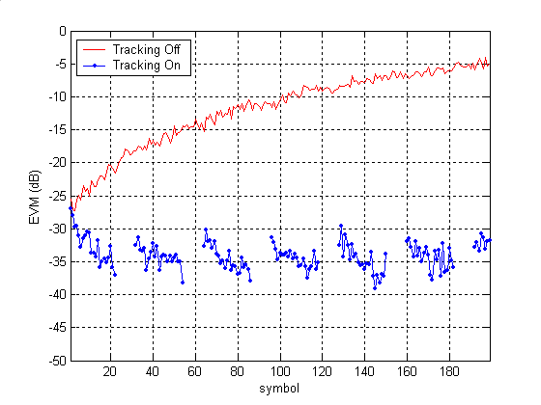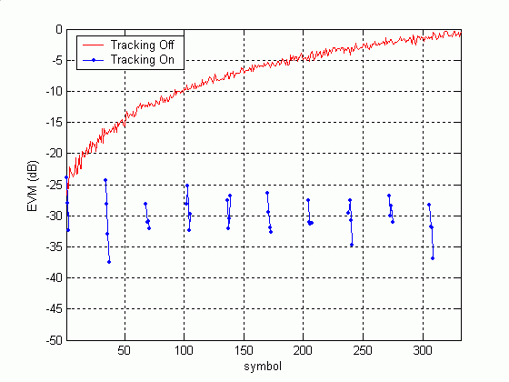
Figure 11 (a) EVM vs time plot for Forward Link (b) EVM vs time plot for Reverse Link

Addressing the Functional Requirements

Number | Name | Requirement | Coverage (Yes/No) | Results Reference
1 | Single Link HT rate supported | Demonstrate at least one set of conditions under which 100 Mbps at the top of the MAC SAP can be achieved. Provide all relevant information to document this. | Yes | See Sections 5.5.3.1, 5.5.4.1 & 5.5.4.2
2 | HT rate supported in 20MHz channel | Proposal supports at least one mode of operation that supports 100Mbps throughput at the top of the MAC SAP in a 20MHz channel.  Provide all relevant information to document this. | Yes | See Sections 5.5.3.1, 5.5.4.1 & 5.5.4.2
3 | Supports 5GHz bands | Protocol supports 5GHz bands (including those supported by .11a) | Yes | See Section 5.1.1
4 | .11a backwards compatibility | Some of the modes of operation defined in the proposal shall be backwards compatible with 802.11a. | Yes | See Section 2.3.1
5 | .11g backwards compatibility | If it supports 2.4 GHz operation, some of the modes of operation defined in the proposal shall be backwards compatible with 802.11g. | Yes | See Section 2.3.2
6 | Control of support for legacy STA from .11n AP | A .11n AP can be configured to reject or accept associations from legacy STA because they are legacy STA. | Yes | No details.
7 | .11e QoS support | The proposal shall permit implementation of the 802.11e ammendment within a .11n STA | Yes | Single or RTS/CTS frame transmision mode can operate within a TXOP.
8 | Spectral Efficiency | The highest throughput mode of the proposal shall achieve a spectral efficiency of at least 3 bps/Hz for the PSDU | Yes | See Section 5.5.3.1.
9 | Compliance to PAR | The proposal complies with all the mandatory requirements of the PAR [6] and 5 Criteria [7] | Yes

Addressing Section 3 of the Comparision Criteria
Sections 4.1 to 4.5 address the additional disclosures as specified by section 3 of 11-03-0814-30-000n.

AD1 – Reference Submissions
- ‘11-04-0020-00-000n-low-pilot-overhead.ppt’, Igor Tolochko & Mike Faulkner , Jan 2004.
- ’11-04-xxxx-00-000n-Eriksson-et-al-proposal.ppt’,

AD2 – TCP Model Parameters
Not Applicable.

AD3 – MAC Simulation Methodology
Not Applicable.

AD4 – MAC Simulation occupied channel width
Not Applicable.

AD5 – Justification of low packet loss rate (PLR) rates achieved
Not Applicable.

Addressing Section 4 of the Comparision Criteria

General

CC2 - Regulatory Compliance
The proposal has no known problems with regulatory compliance in the USA, Japan, Europe, or China.

Marketability

CC3 - List of goodput results for usage models 1,4 and 6.
Not Applicable.

CC6 – PHY complexity

Most baseband processing blocks (e.g. filter, FFT, frequency correction, mapping, demapping) will have a configuration as in 11a. However calculations will be done N times in an N channel system. Thus, assuming N times higher bit-rate, energy per bit for these parts remain constant compared to 11a. This is also true for the Viterbi decoder.
The computational complexity in the channel correction unit grows faster than throughput for MIMO, but its computational complexity is about the same as for FFTs, even for a 3*3 MIMO system.
The calculation needed for generating channel correction coefficients increases rapidly with the number of channels. The increased length of payload, and transmission of frames without preambles keep the power cost for this operation at a reasonable level. The placement of the Sig3 symbol after the last preamble increases available time for computation with one symbol period. This reduces the required complexity of the logic for this function.
In total the digital baseband computational complexity for a 3-layer systems is roughly 4 times that of an 11a system.
The analog front-end grows slower in area and power consumption as some units are reused for all channels. For a 3-layer system the area and power is roughly 2.5 times that of an 11a analog front-end.

CC7 – MAC processing complexity
Not applicable.

Backward Compatibility and Coexistence with Legacy Devices

CC11 – Backward compatability with 802.11-1999 (Rev 2003) and 802.11g
Backward Compatability is ensured by
- Operation within a 20MHz bandwidth with the same 802.11a/g spectral mask.
- Single and RTS/CTS frame transmission modes are fully compatible with legacy 802.11a/g devices, see Section 2.3.

CC15 – Sharing of medium with legacy devices
Not Applicable.

MAC Related
Not applicable except for CC46 and CC47.

CC46 – MAC Compatibility and Parameters
The SIFS parameter is proposed to take a value between 8-16us, meaning that the receiver must be ready to receive after 8us but a transmitter is allowed to wait up to 16us before starting.

CC47 – MAC extensions
In order to ensure the best chance of >100Mbps data throughput at the MAC SAP, then it would be beneficial to provide for frame aggregation such that the MAC efficiency is improved, see Section 7.3. Up to a maximum of 16kbytes is proposed, see Section 2.2.6.4.

PHY related

PHY Rates and Preambles

CC51 - Data Rates
The PHY data rates allowed on a per layer or subgroup basis are defined in Section 2.2.6.1. They can be summarised as:
- 1 to 3 antennas (Mandatory), 4 antennas (optional)
- Bandwidth = 20MHz (Mandatory), 40MHz (Optional)
Table 16: Mandatory Rates
Rate (Mbits/s) | Modulation, Code Rate
6 | BPSK, ½
9 | BPSK, ¾
12 | QPSK, ½
18 | QPSK, ¾
24 | 16QAM, ½
36 | 16QAM, ¾
48 | 64QAM, 2/3
54 | 64QAM, ¾
0 | none
64 | 256QAM, 2/3
72 | 256QAM, ¾
- Adaptive rate can vary from 0Mbit/s through to Ntx*72Mbits/s (216Mbits/s for 3 transmit antennas )

CC42 – Preambles
The preambles are defined in Section . The short and long training sequences are the same as the 802.11a/g defined training sequences with the following modifications:
- Both the STS and LTS sequences have a progressive cyclic delay of 1 sample per antenna applied, see also Appendix A, Section 7.1
- The LTS sequences are also phase loaded on a per antenna basis.
The STS characteristics are summarised in Table 17. In terms of the auto-correlation and cross-correlation the mean sidelobe ratio has a small discrimination ratio with larger number of antennas.
Table 17 : STS Characteristics
 | 1x1 | 2x1 | 3x1 | 4x1
Auto Correlation – mean side lobe (linear) / std of sidelobe (linear) | 0.125 / 0.085 | 0.145 / 0.007 | 0.2416 / 0.023 | 0.3412 / 0.016
Cross Correlation – mean side lobe (linear) / std of sidelobe (linear) | 0.125 / 0.085 | 0.143 / 0.044 | 0.179 / 0.078 | 0.327 / 0.09
Peak to Average Power Ratio/antenna (dB) | 2.1 | 2.1 | 2.1 | 2.1

The LTS characteristics summarised in Table 18. The effect on the Long Training Sequences (LTS) is similar to STS, except that the longer waveform of 64 leads to a much lower sidelobe value. The shape of the peaks is unaffected (same as for STS).
Table 18 : LTS Characteristics
 | 1x1 | 2x1 | 3x1 | 4x1
Auto Correlation – mean side lobe (linear) / std of sidelobe (linear) | 0.0415 / 0.0444 | 0.0328 / 0.0038 | 0.0522 / 0.0127 | 0.068 / 0.0108
Cross Correlation – mean side lobe (linear) / std of sidelobe (linear) | 0.0415 / 0.0444 | 0.0342 / 0.0124 | 0.0472 / 0.0188 | 0.0675 / 0.0225
Peak to Average Power Ratio/antenna (dB) | 3.2 | 3.2 | 3.2 | 3.2

Channelisation

CC51.5 - Channelisation

The PHY uses the 2.4 GHz frequency band (optional) and channelisation plan specified in 18.4.6 and the 5 GHz frequency band and channelisation plan specified in 17.3.8. of IEEE Std 802.11, 1999.

CC52 – Spectral Mask
The transmit spectral mask for the PHY operating in the 2.4 GHz & 5GHz band with OFDM modulation is unchanged as illustrated in Figure 12.
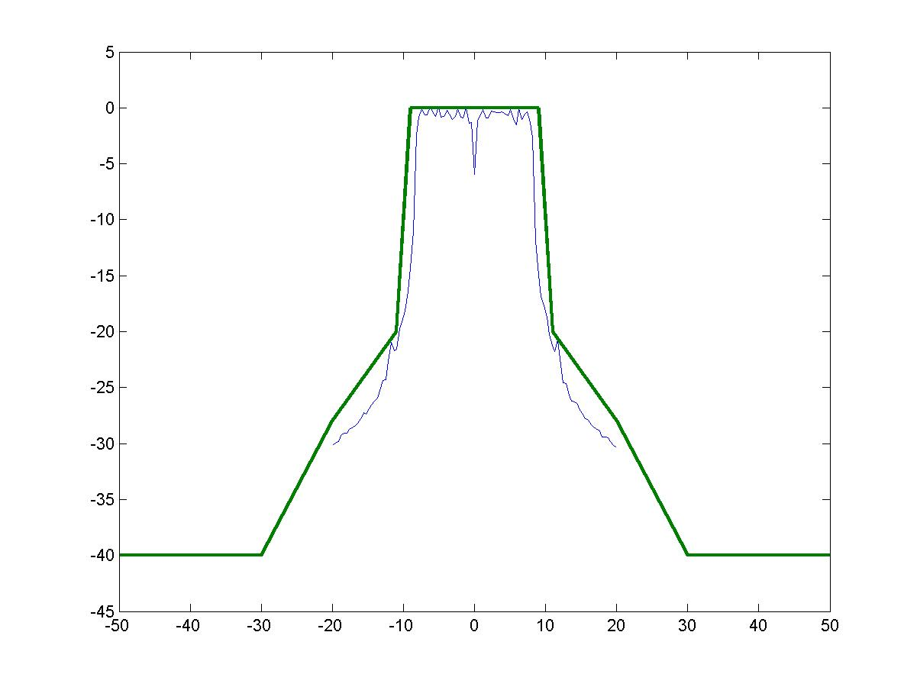
Figure 12: Transmit Spectrum mask and a typical Signal Spectrum modulated with 256QAM with 8dB back-off in the PA

Spectral Efficiency

CC58 – HT spectral Efficiency
Table 19 summarises the results for CC58. The RTS/CTS frame transmission mode achieves a goodput of more than 100Mbps, requiring at least 144Mbps average PHY data rate. That is, the MAC efficiency is approximately 70%.

The single frame transmission mode achieves a maximum goodput of 80Mbps when the average PHY data rate is 288Mbps. The goodput can be increased by at least two known techniques :
- With frame aggregation a 5.5kbyte packet size transmitted at a average PHY data rate of 144Mbps can achieve a goodput of 100Mbps, see Appendix C.
- With channel bonding (optional) the average PHY data rate is increased by a factor 1.8 which would achieve more than 100 Mbps at the MAC SAP, see Appendix E.
Table 19: CC58 Summary
Configuration |  | Average PHY Data rate to achieve Goodput >100Mbps | bps/Hz
2*2 MIMO, Channel B | Single Frame Mode | N.A. | N.A.
2*2 MIMO, Channel B | RTS/CTS Mode | 144 Mbps | 7.2
3*3 MIMO, Channel B | Single Frame Mode | N.A. | N.A.
3*3 MIMO, Channel B | RTS/CTS Mode | 144-216Mbps | 7.2-10.8
4*4 MIMO, Channel B | Single Frame Mode | N.A. | N.A.
4*4 MIMO, Channel B | RTS/CTS Mode | 144-288Mbps | 7.2-14.4
3*3 MIMO, Channel D | Single Frame Mode | N.A. | N.A.
3*3 MIMO, Channel D | RTS/CTS Mode | 144-216Mbps | 7.2-10.8
4*4 MIMO, Channel D | Single Frame Mode | N.A. | N.A.
4*4 MIMO, Channel D | RTS/CTS Mode | 144-288Mbps | 7.2-14.4
Table 20: CC58 Simulation Conditions
Parameter | Parameter value | Comment
Simulation length | Max. 6000 packets, Min 300. | Vary number depending on SNR. PER to 10⁻²
Packet Payload | 1500 bytes
TX architecture | Parallel
Shaping Filters | Transmitter - Interpolation by 5 then 71 tap RRC filter, a=0.2  Receiver - 71 tap RRC filter, a=0.2 followed by decimate by 5
TX/RX antennas | 2/2, 3/3, 4/4(optional)
Rate/layer | Average rate as shown on plots
Interleaver | 802.11a
Channel Model | B, D (with fluorescent effect on) | @ 100MHz
Shadowing variance | 0
Time & Freq. Synchronization | Ideal
Channel Estimation | Ideal
IM1 - PA Model | On | PA backoff at 10dB
IM2 – Carrier frequency offset | 0Hz
IM4 – Phase noise | Off
IM5 – Noise Figure | 10dB
IM6 – Antenna Config. | ½λ at Tx and Rx
TX-RX Spacing | 10m

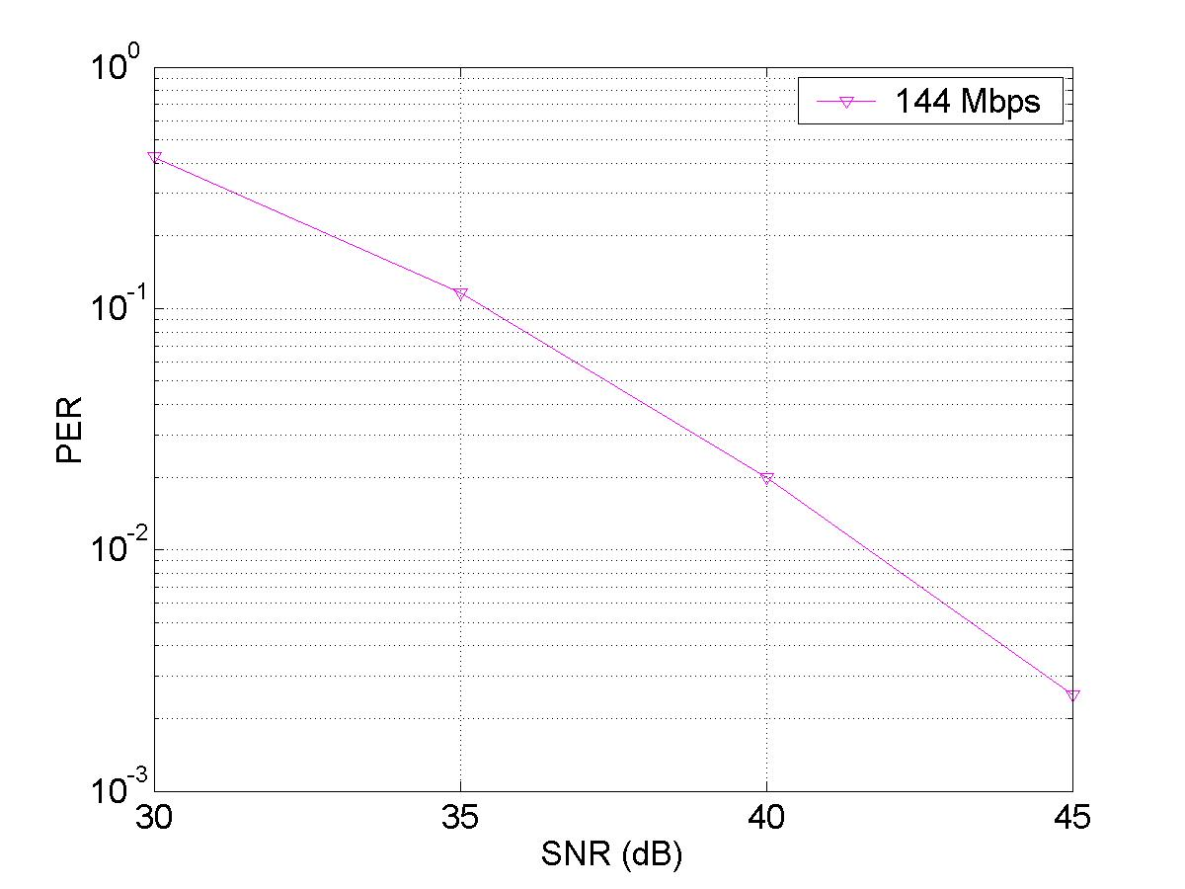 | 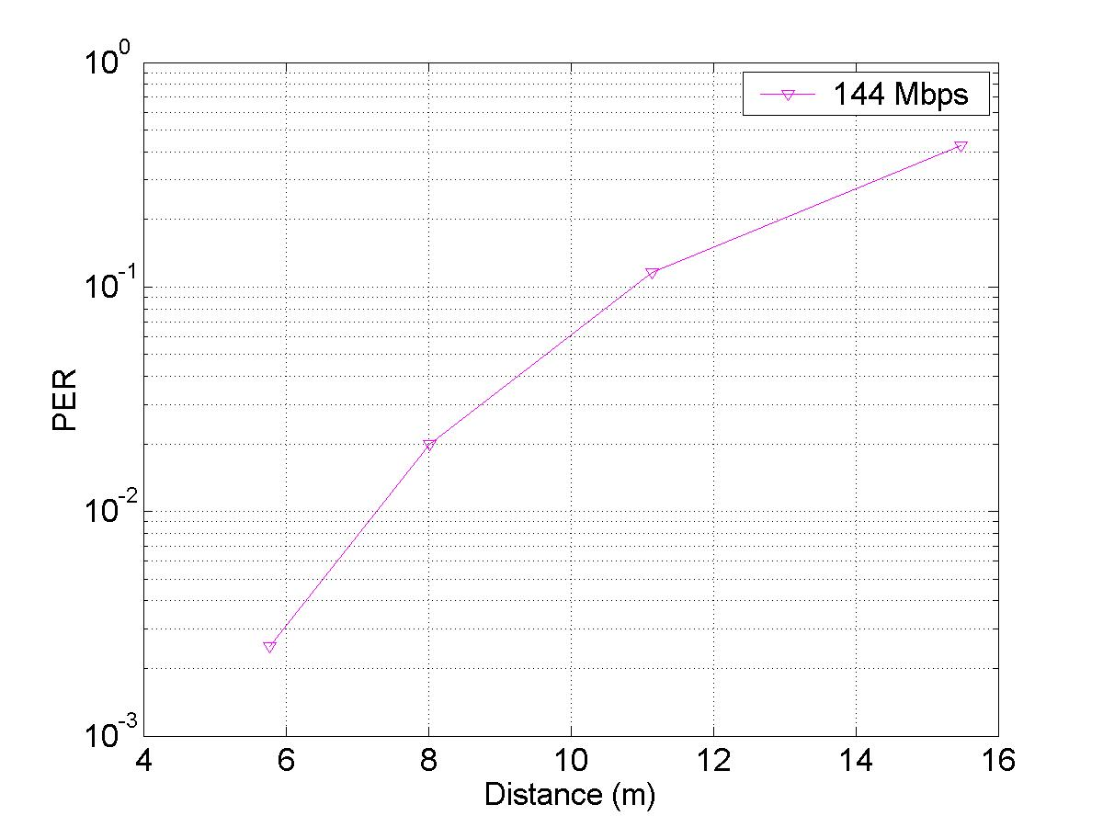
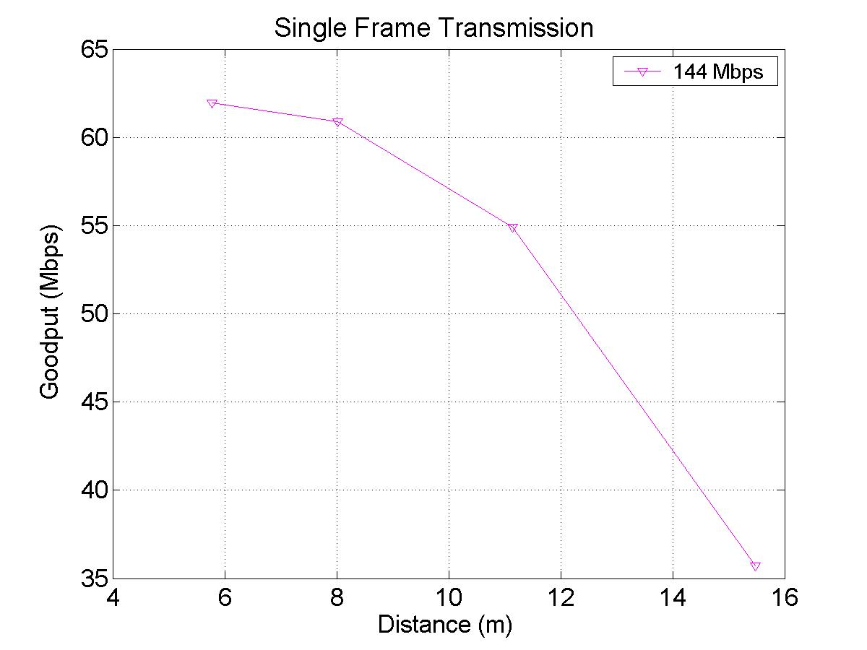 | 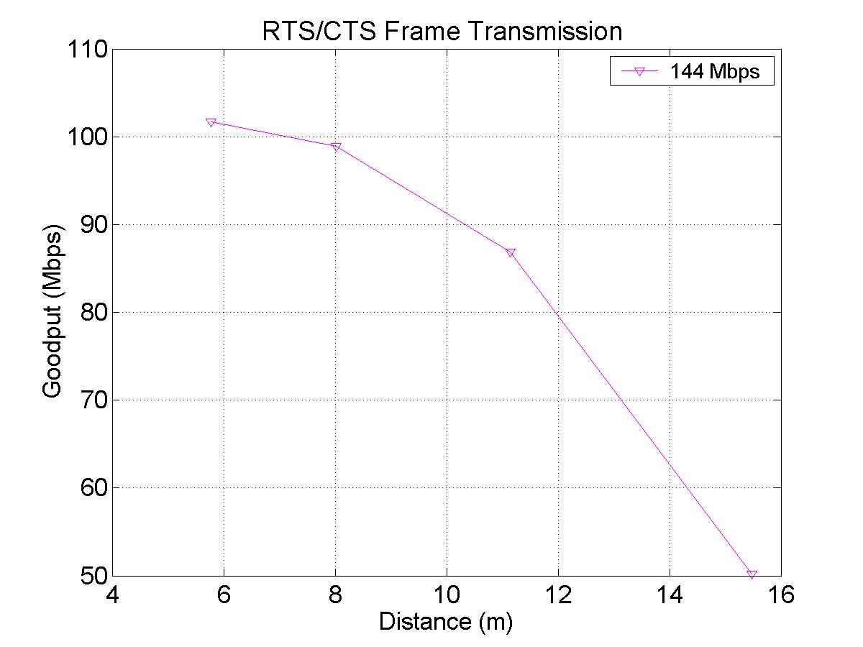
Figure 13: CC58 2*2 MIMO, Channel B
Each curve in the above figures represents an average PHY goodput achieved when adaptive loading is enabled. That is the data rate of each of the two layers varies independently on a packet by packet basis, whilst the sum of the data rate for the two layers is constrained to be constant for each packet.

Please refer to Appendix D, Section 7.4, for a description of the calculation process, which is indicated by the flow of arrows in the above figures.

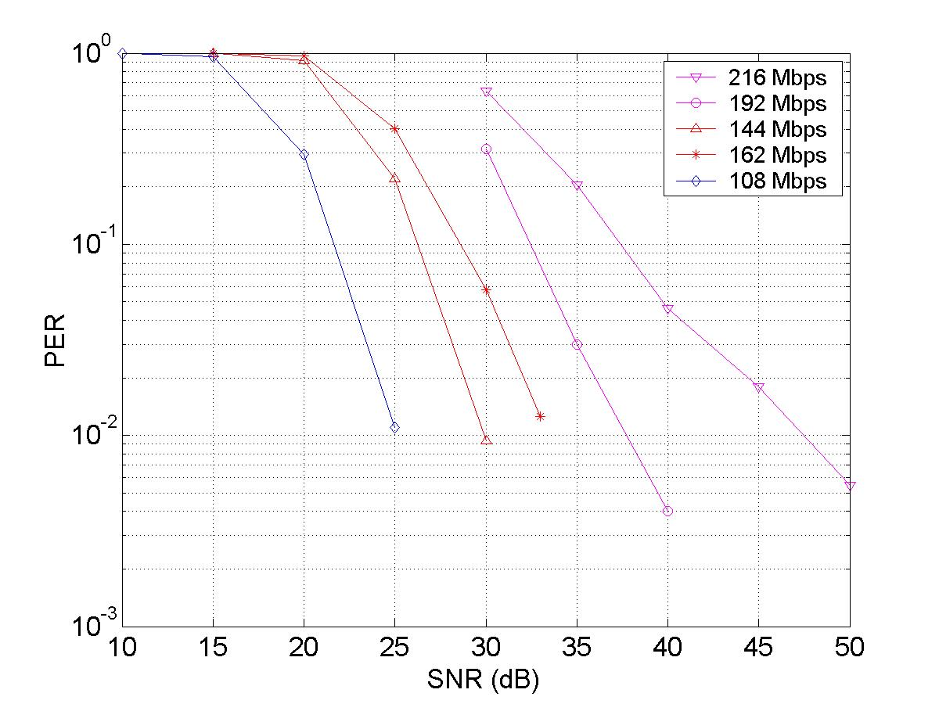 | 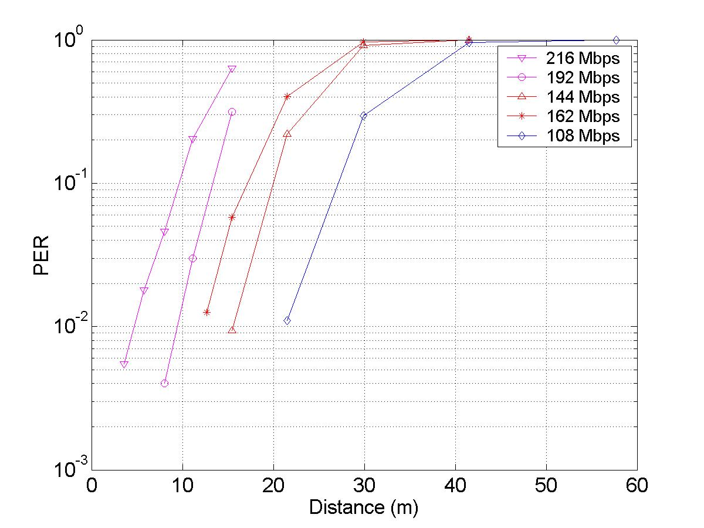
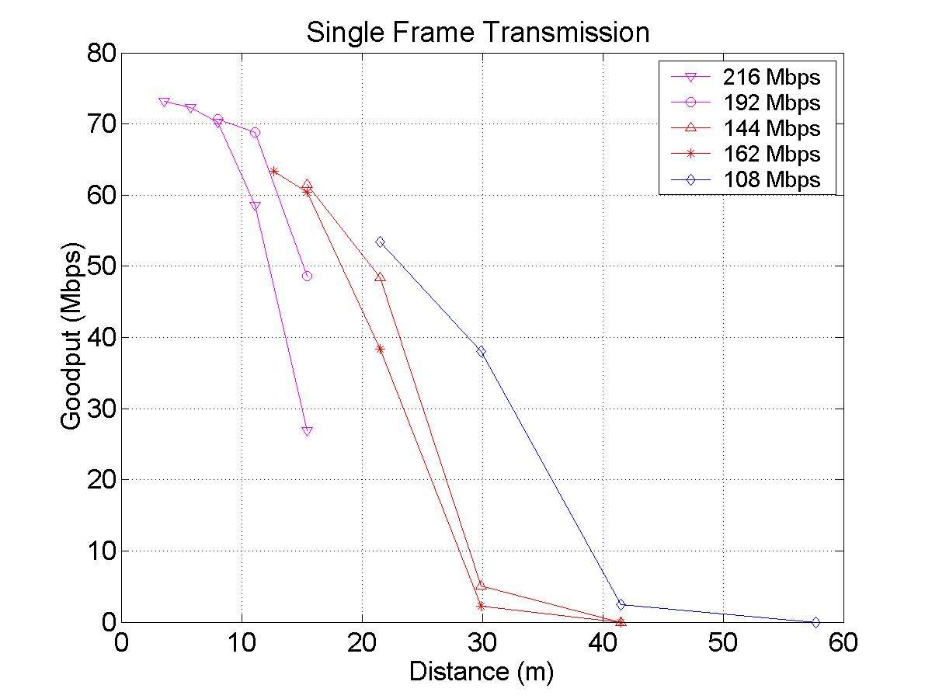 | 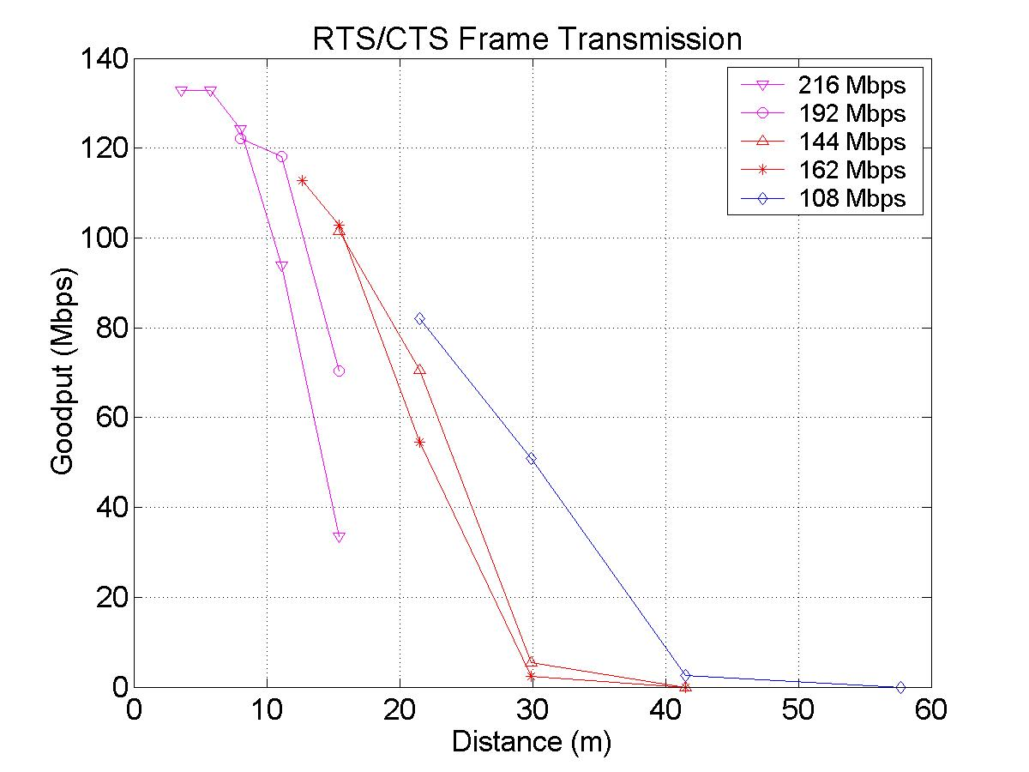
Figure 14: CC58 3*3 MIMO, Channel B

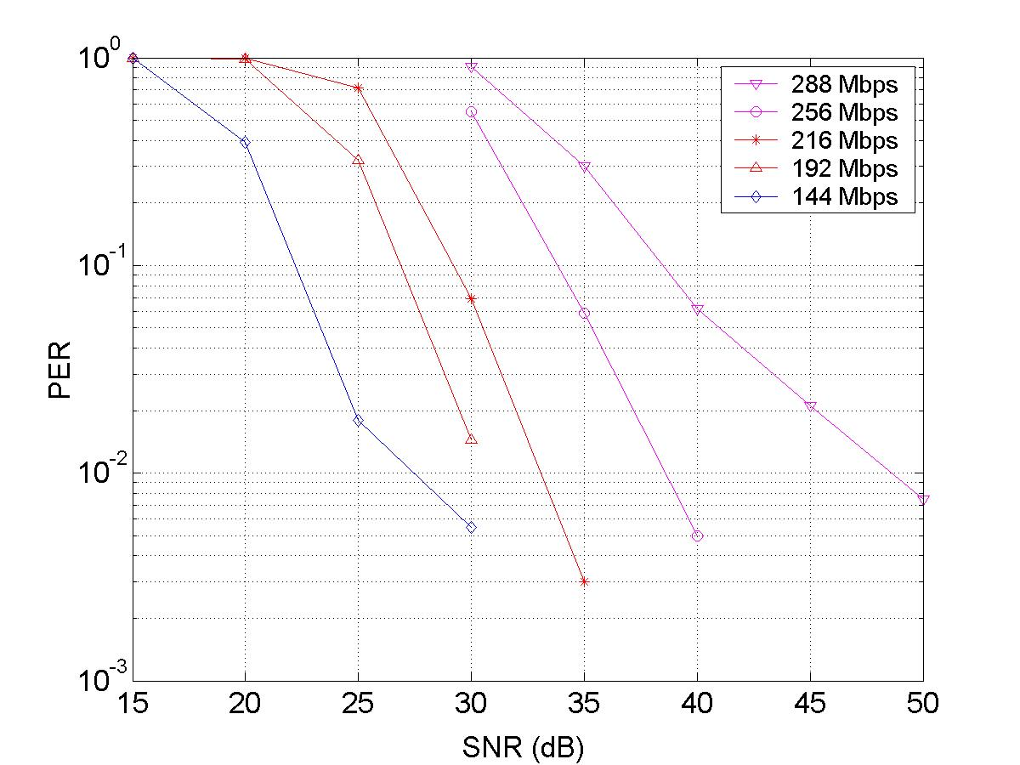 | 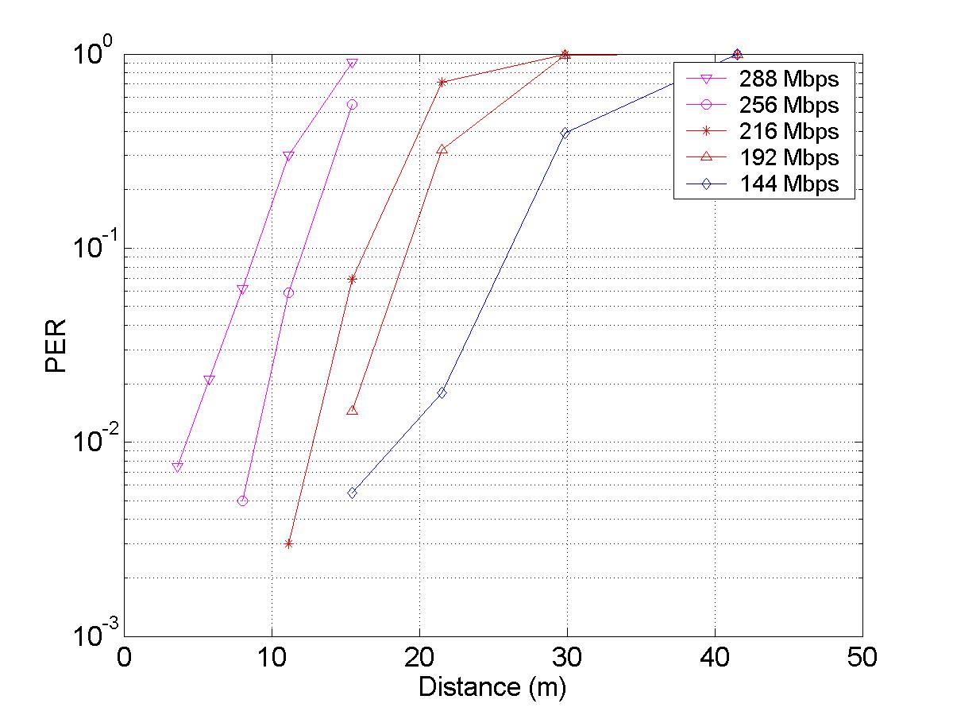
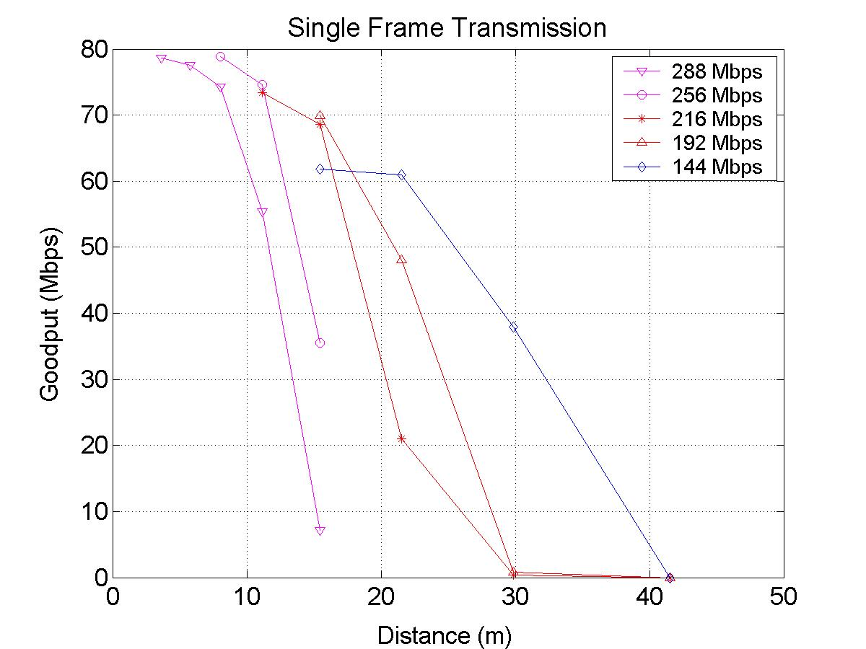 | 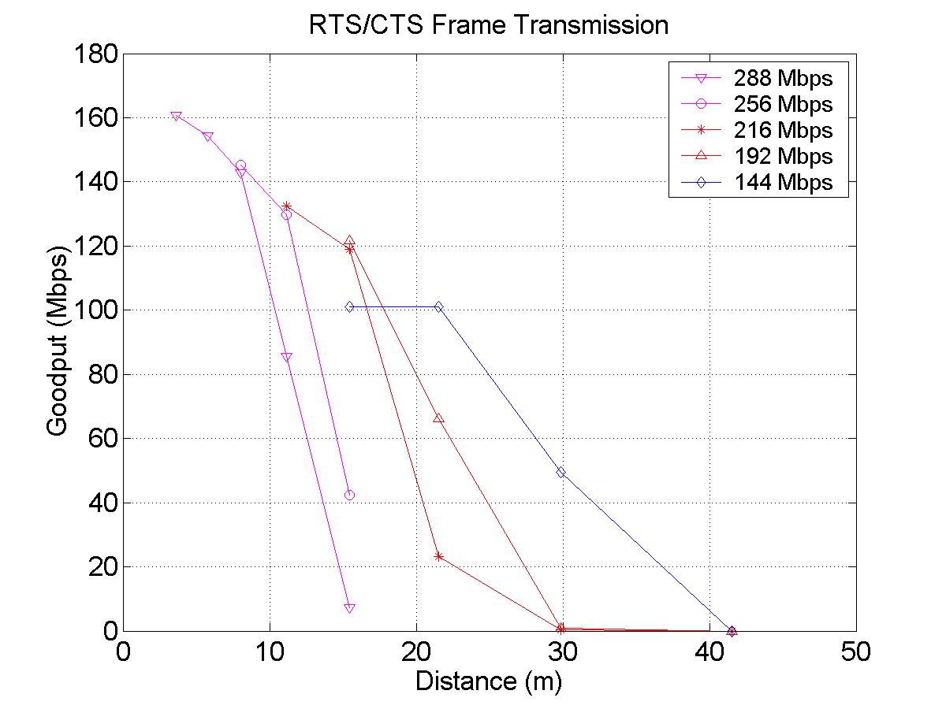
Figure 15: CC58 4*4 MIMO, Channel B (optional mode)

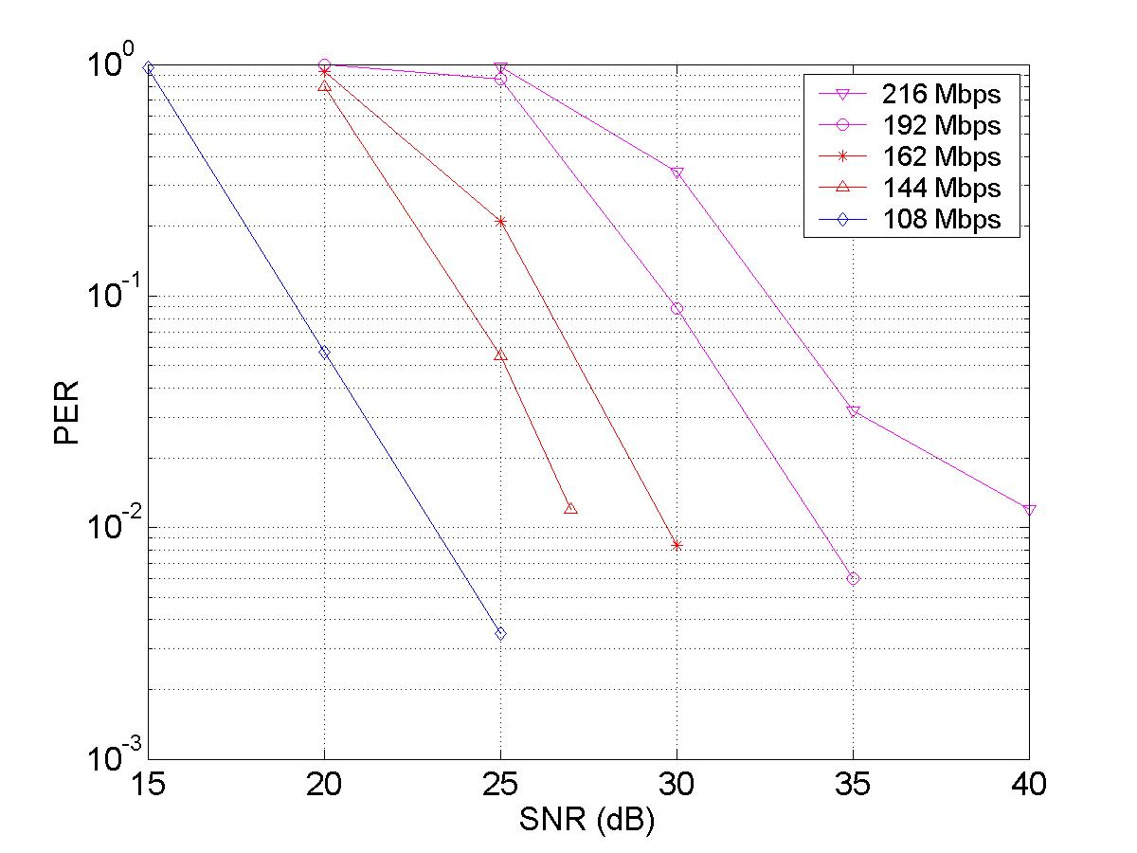 | 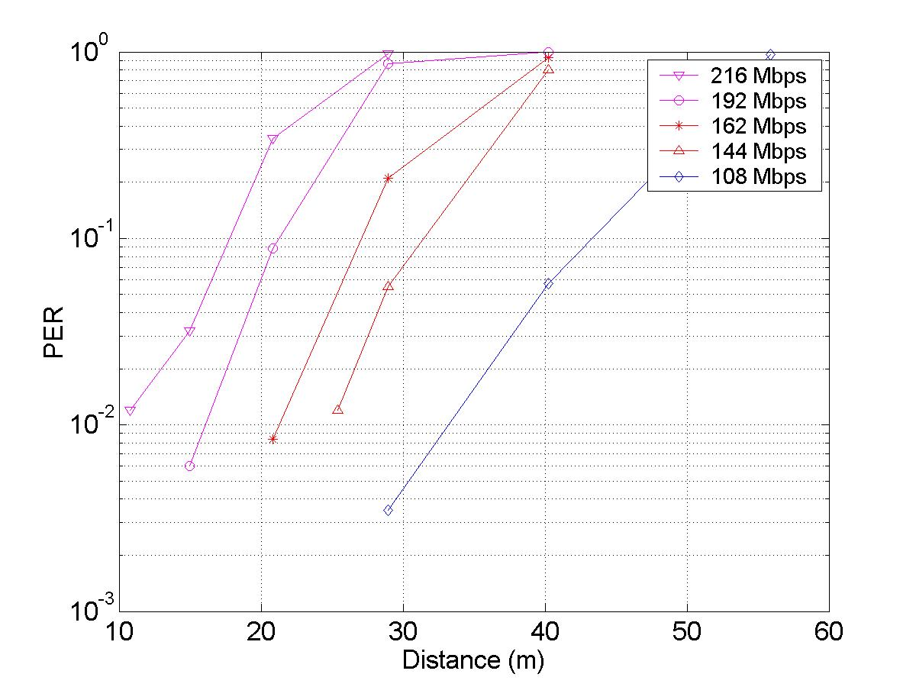
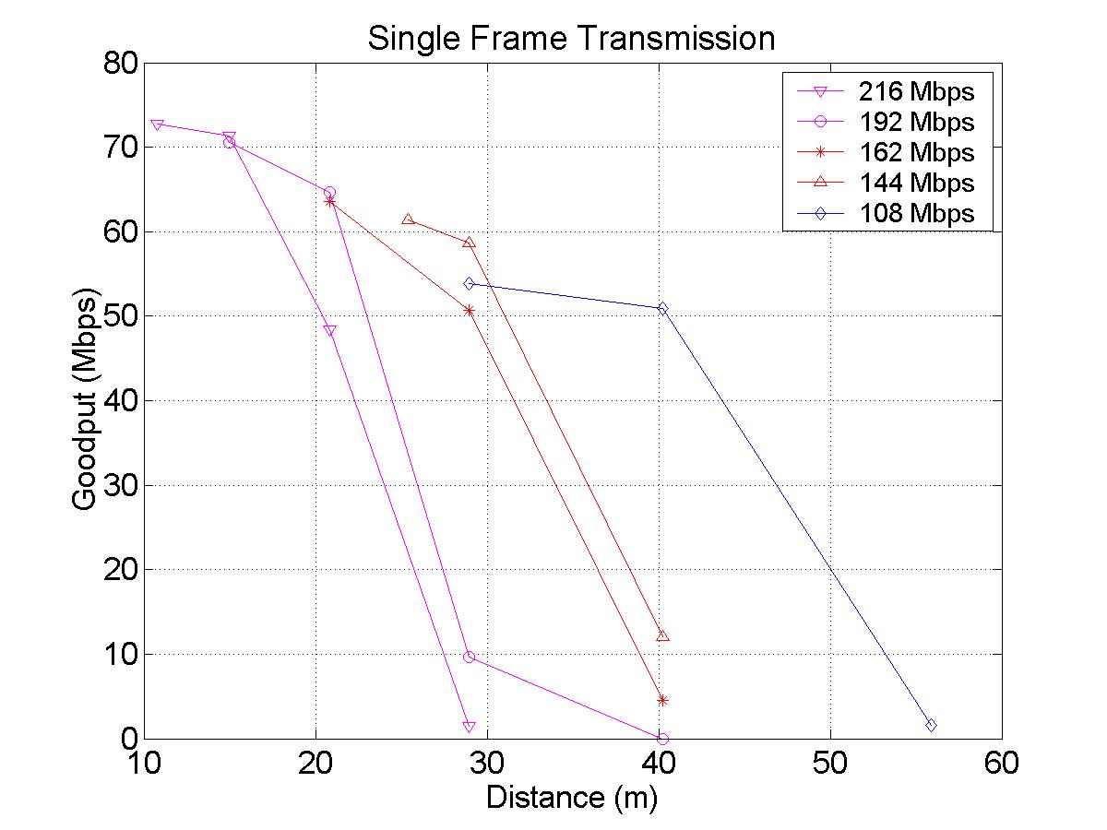 | 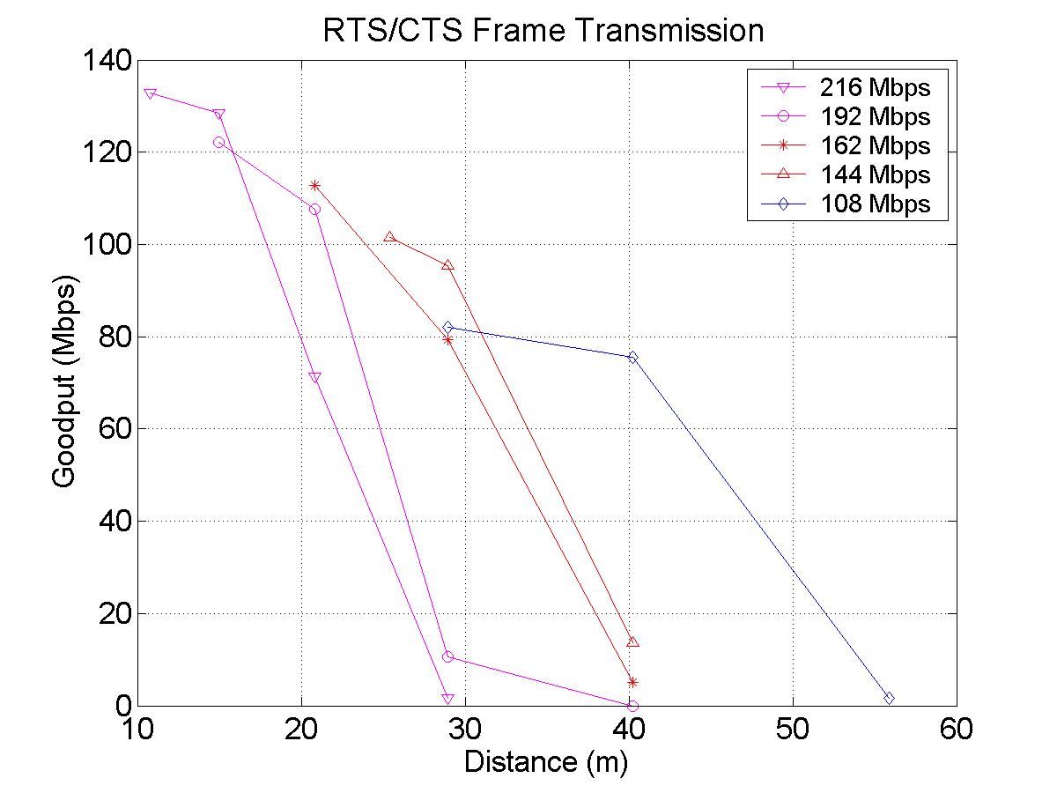
Figure 16: CC58 3*3 MIMO, Channel D

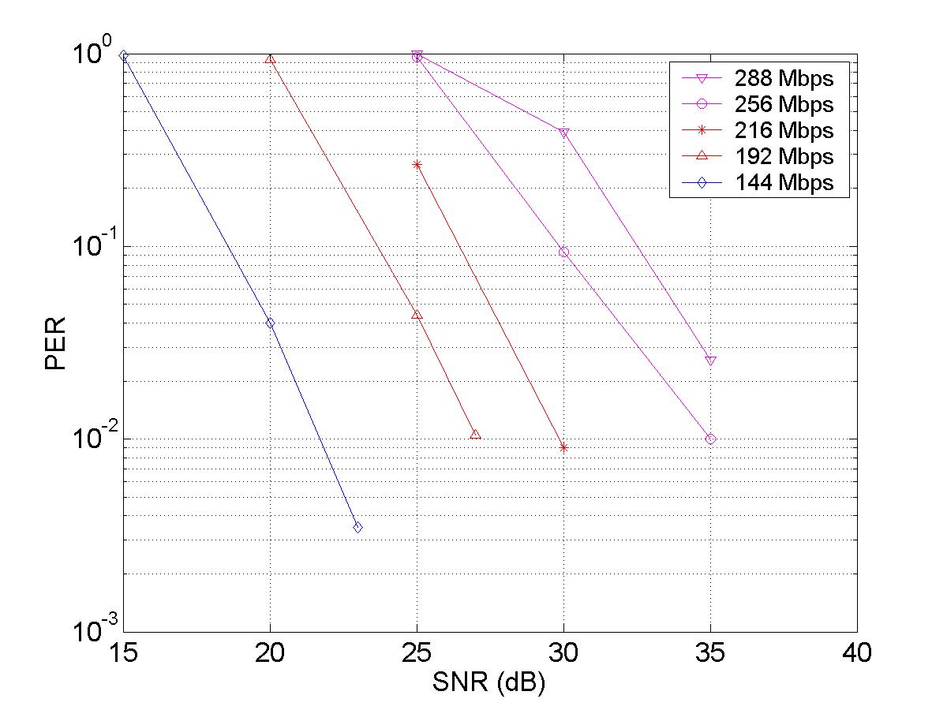 | 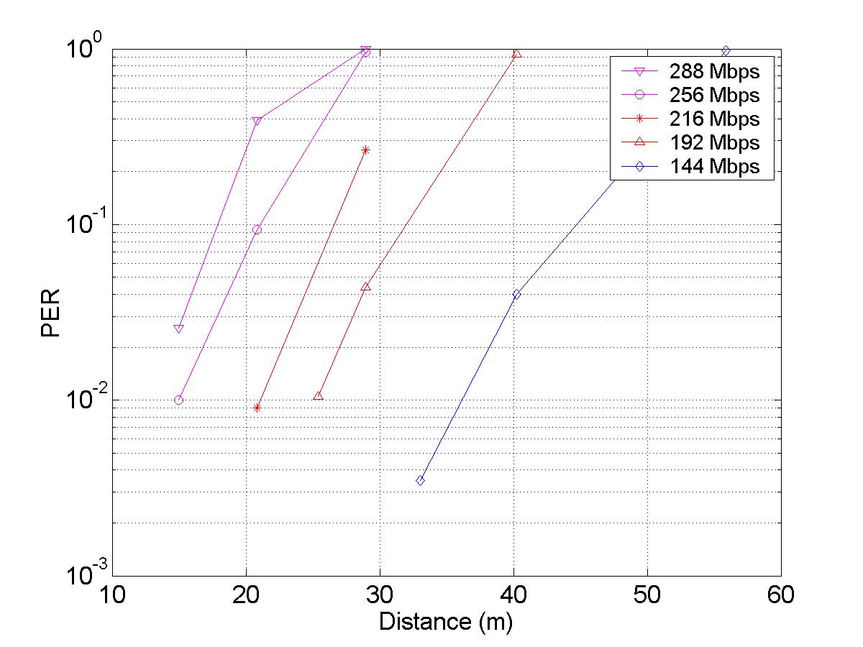
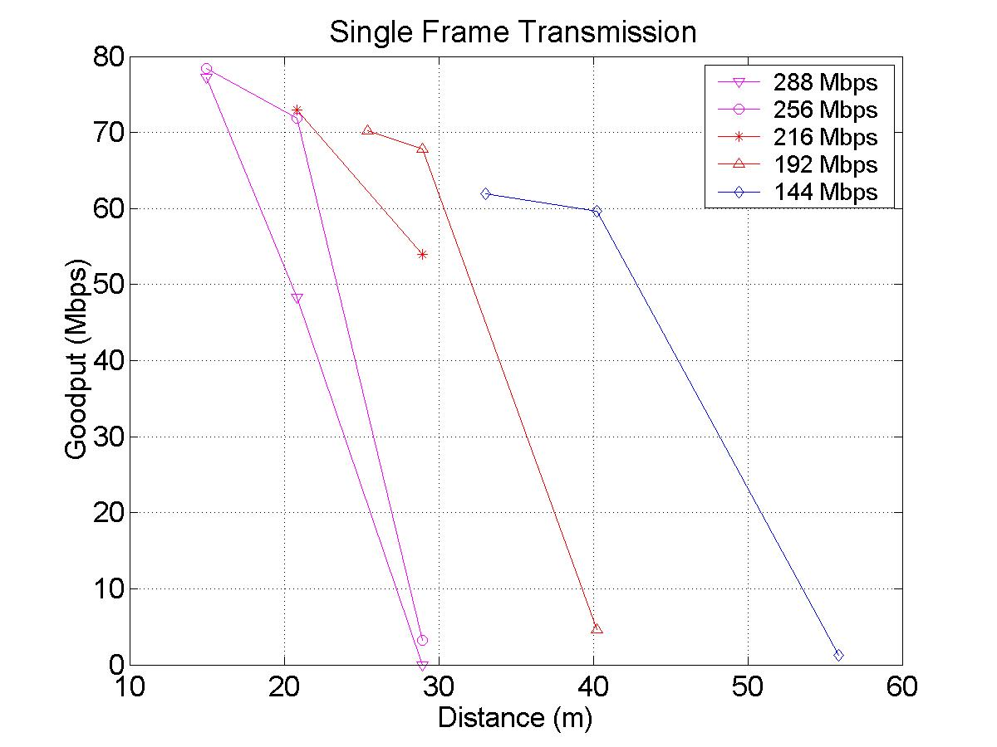 | 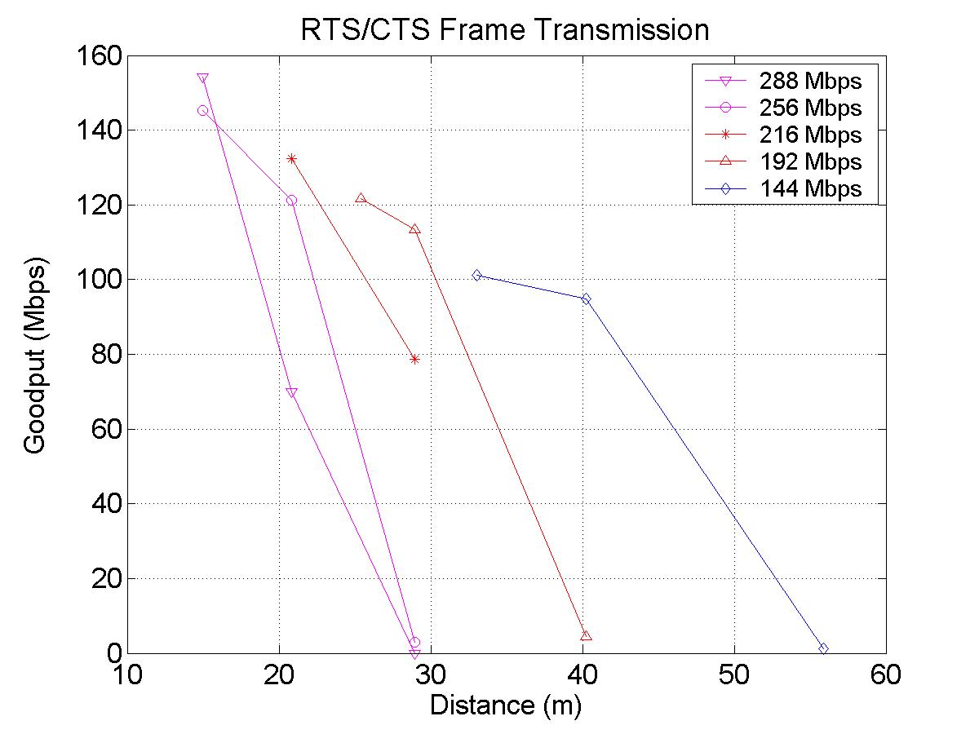
Figure 17: CC58 4*4 MIMO, Channel D (optional mode)

PHY Performance

CC59 – AWGN PER performance

The results for CC59 are illustrated in Figure 18 to Figure 21 for 1*1 to 4*4 configurations respectively. One observation that can be made is that for a AWGN channel the capacity is a linear function of the number of transmit antennas. That is for a PER of 10% the SNR equaled ~17dB for 54Mbps, 108Mbps, 162Mbps and 216Mbps for 1*1, 2*2, 3*3, 4*4 configurations respectively.

It should be noted that in these simulations each layer had the same rate, even if the adaptive loading algorithm was switched on.
Table 21: Simulation conditions
Parameter | Parameter value | Comment
Simulation length | Max. 10000 packets Min 300 | Vary number depending on SNR.
Packet Payload | 1000 bytes
TX architecture | Parallel
Shaping Filters | Transmitter - Interpolation by 5 then 71 tap RRC filter, a=0.2  Receiver - 71 tap RRC filter, a=0.2 followed by decimate by 5
TX/RX antennas | 1/1, 2/2, 3/3, 4/4
Rate/layer | Average rate as shown on plots. Same rate per layer. | .
Interleaver | 802.11a
Channel Model | AWGN | @ 100MHz
Shadowing variance | 0
Time & Freq. Synchronization | Ideal
Channel Estimation | Ideal
IM1 - PA Model | On | PA back-off at 10dB
IM2 – Carrier frequency offset | 0Hz
IM4 – Phase noise | Off
IM5 – Noise Figure | Not Applicable
IM6 – Antenna Config. | ½λ at Tx and Rx
TX-RX Spacing | 10m

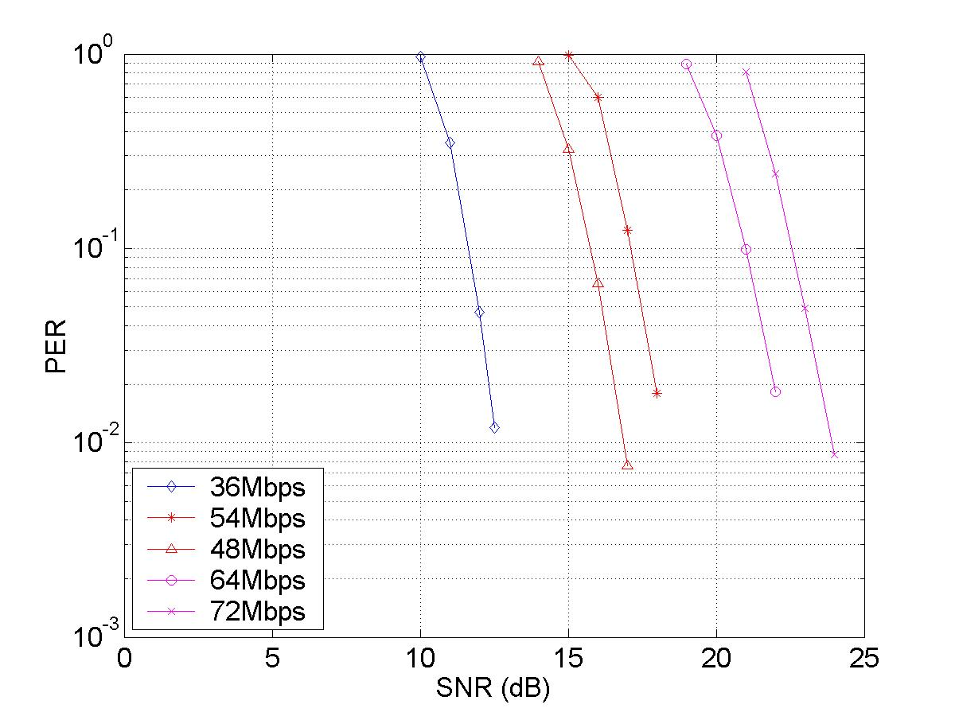
Figure 18: 1x1 AWGN channel

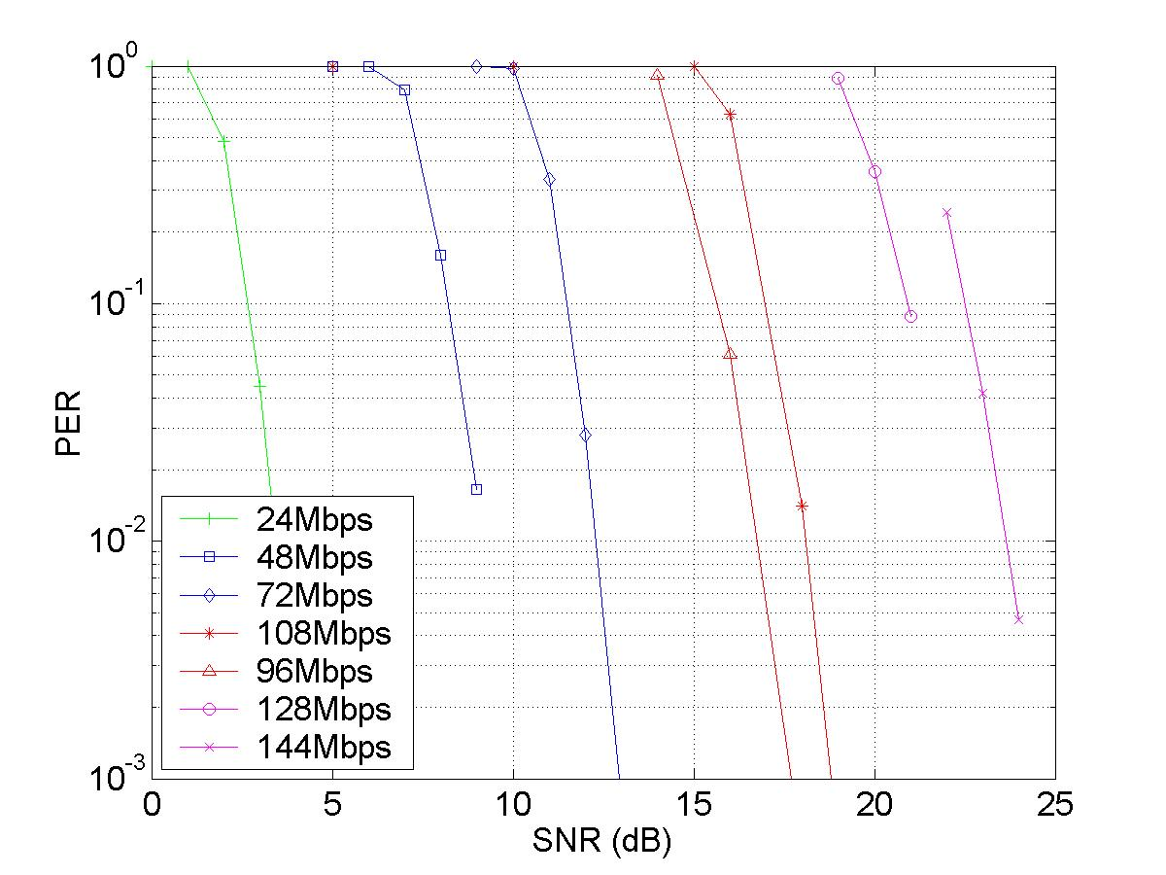
Figure 19: 2x2 AWGN channel

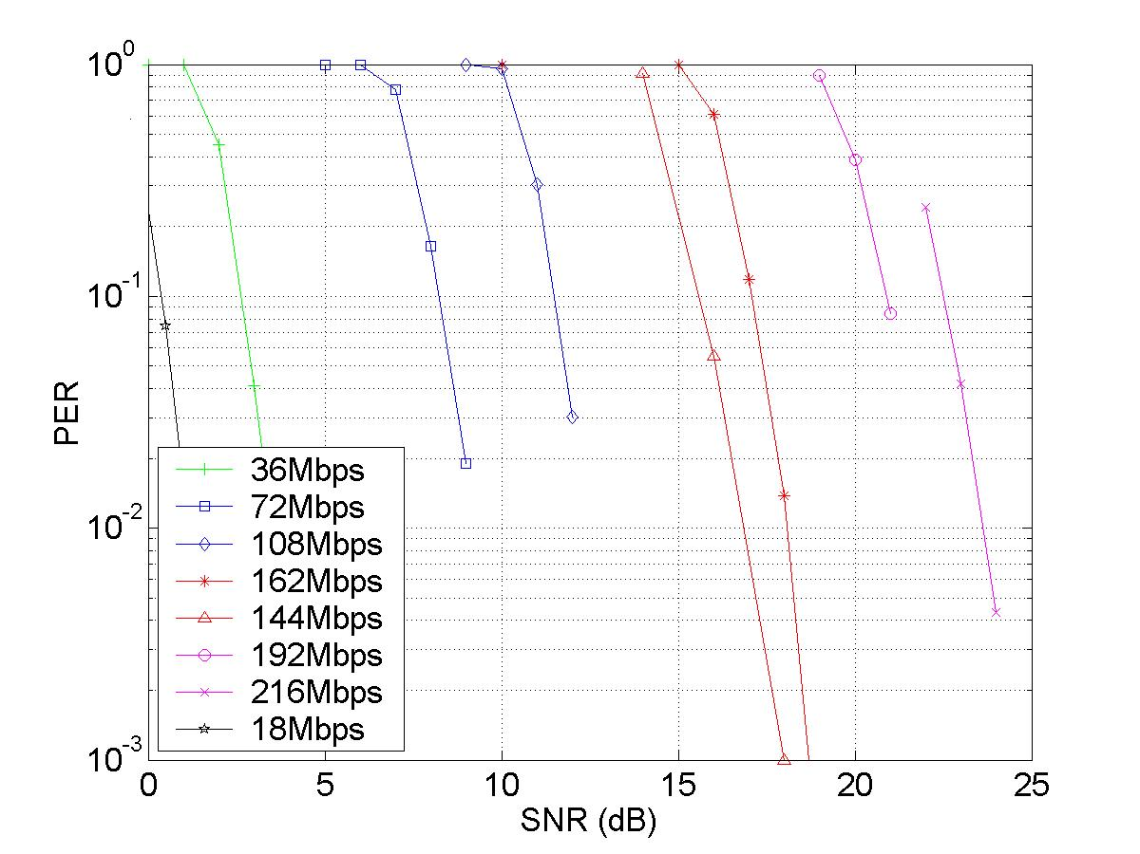
Figure 20: 3x3 AWGN channel

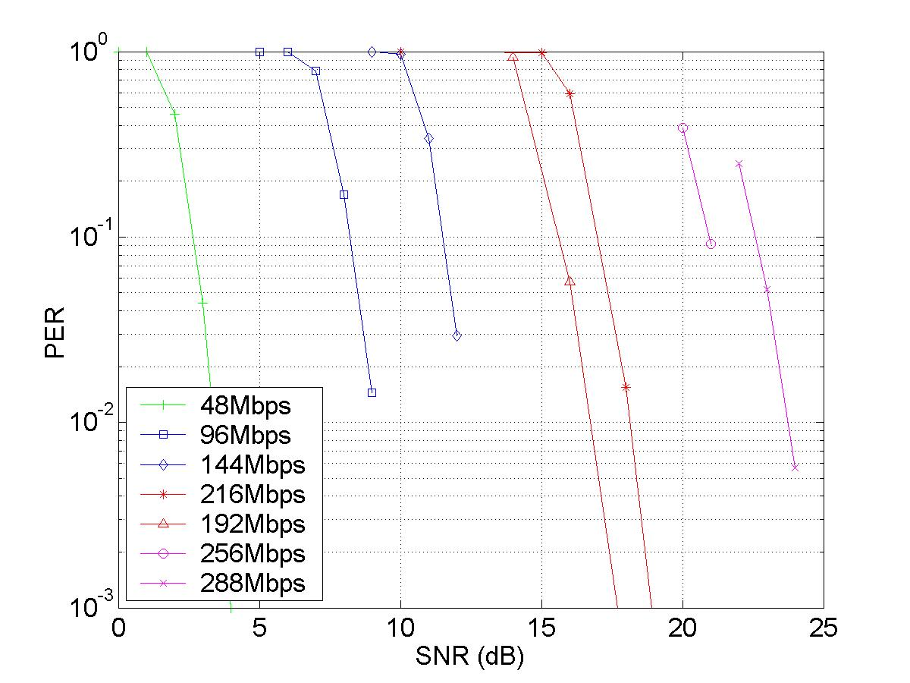
Figure 21: 4x4 AWGN channel

CC67 – PER performance in non AWGN channels

The results for CC67 are illustrated in Figure 22 to Figure 24 for the 3*3 configuration. It should be noted that IM2 (frequency offset) was not activated as this function was not yet supported by the PER simulator. Also, channel D was simulated with the fluorescent effect on and one curve was simulated with it turned off (back to front as was required).

An observation that can be made is that a performance floor is evident for higher rates for all channels. This can be explained by the channel impulse response energy that exceeds the CP length (ISI) for channels E and D and also the phase noise. For channel B it is the phase noise alone that generates the performance floor.

Table 22: Simulation Conditions
Parameter | Parameter value | Comment
Simulation length | Max. 10000 packets Min 300 packets | Vary number depending on SNR.
Packet Payload | 1000 bytes
TX architecture | Parallel
Shaping Filters | Transmitter - Interpolation by 5 then 71 tap RRC filter, a=0.2  Receiver - 71 tap RRC filter, a=0.2 followed by decimate by 5
TX/RX antennas | 3/3
Rate/layer | As illustrated | Adaptive loading on
Interleaver | 802.11a
Channel Model | B, D with fluorescent (one rate without) & E | @ 100MHz
Shadowing variance | 0
Time & Freq. Synchronization | Time Synchronisation Only | No frequency compensation required as IM2 is OFF
Channel Estimation | On
IM1 - PA Model | On | PA back-off at 12dB
IM2 – Carrier frequency offset | 0Hz | Not implemented in version of simulator
IM4 – Phase noise | On
IM5 – Noise Figure | 10dB
IM6 – Antenna Config. | ½λ at Tx and Rx
TX-RX Spacing | 10m

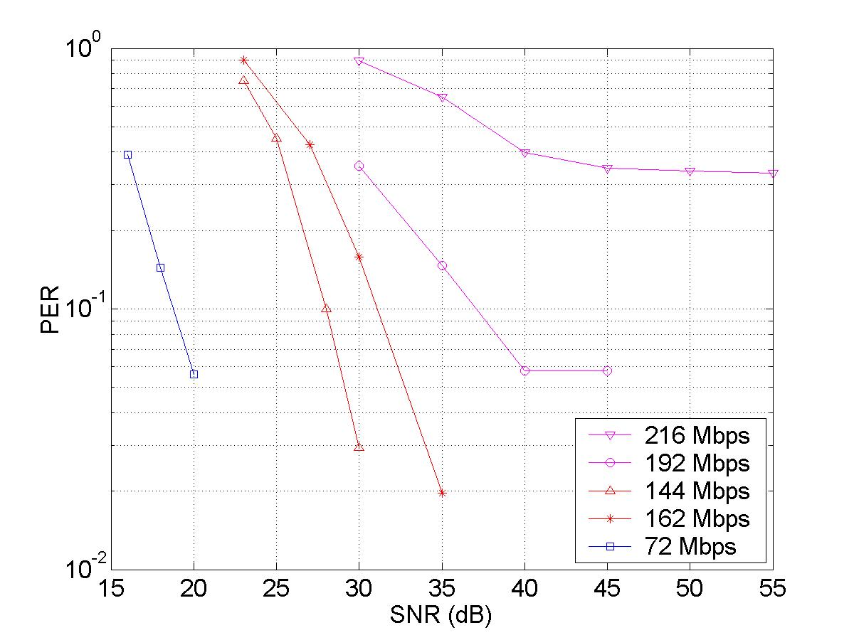 | 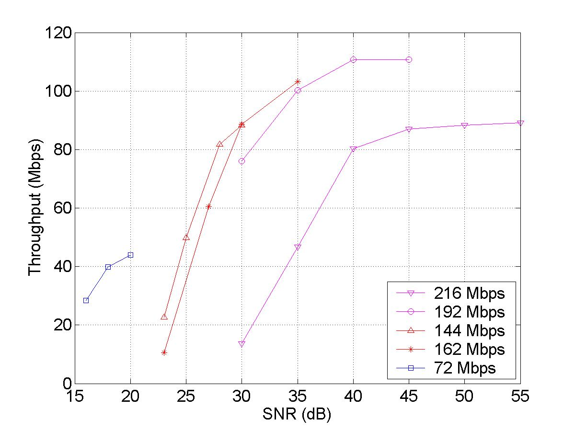

Figure 22: 3x3 Channel B

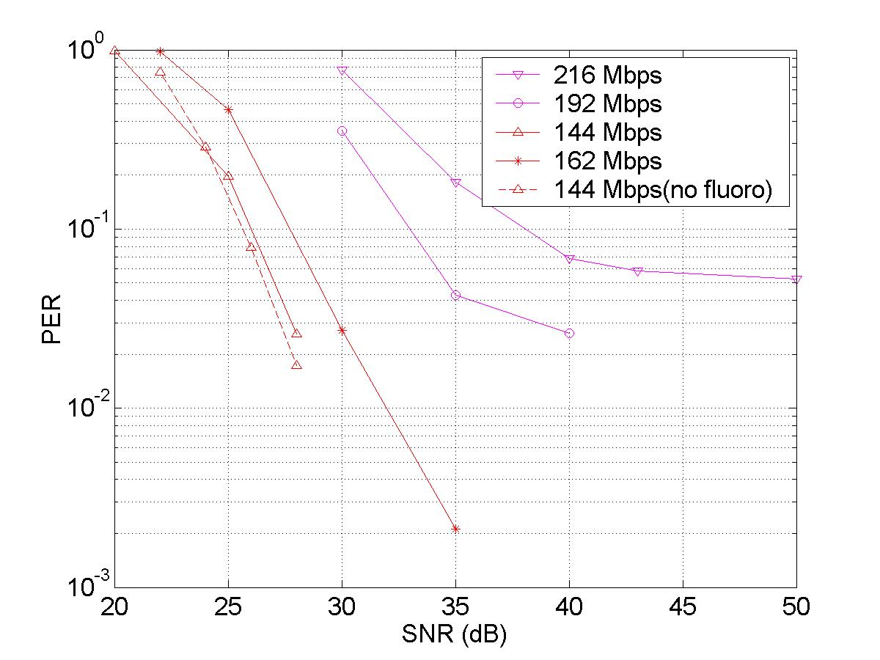 | 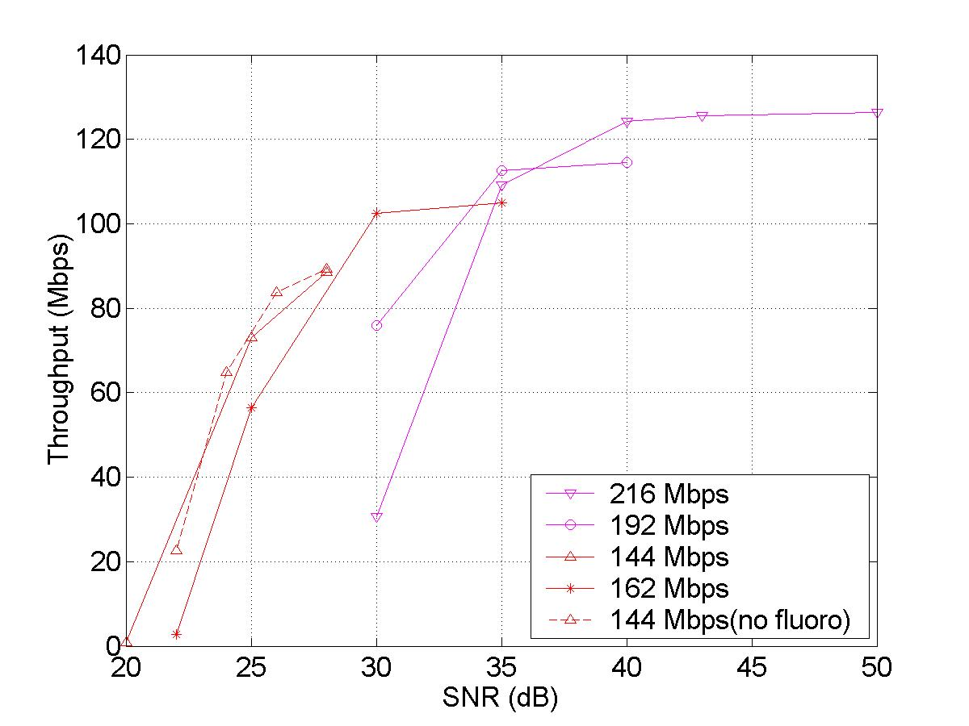

Figure 23: 3x3 Channel D with fluorescent effect (144Mbps rate shown without fluorescent effect)
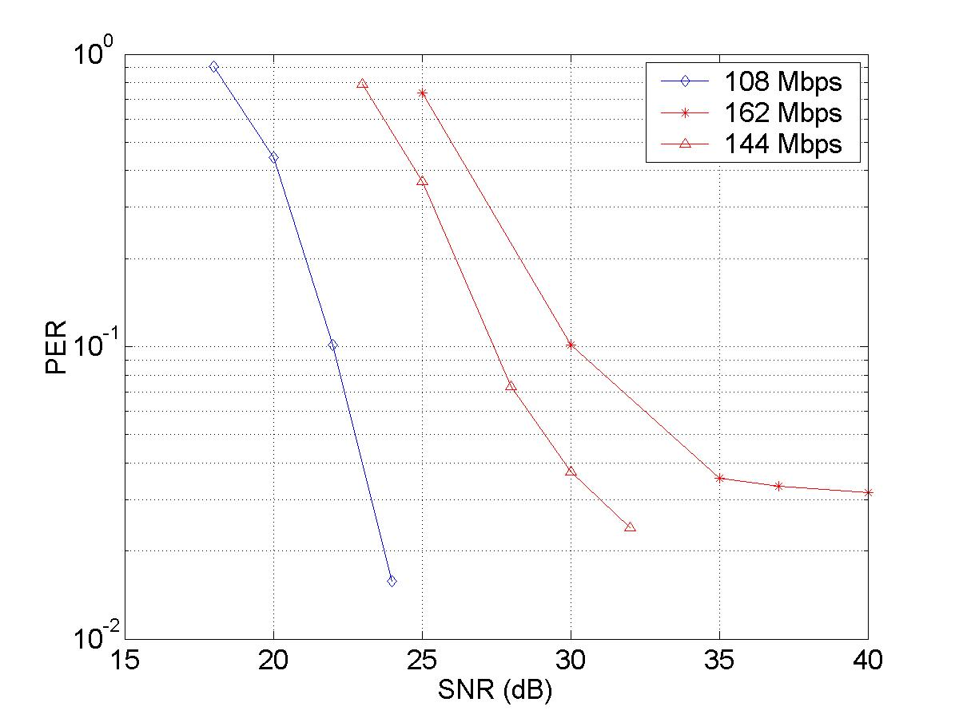 | 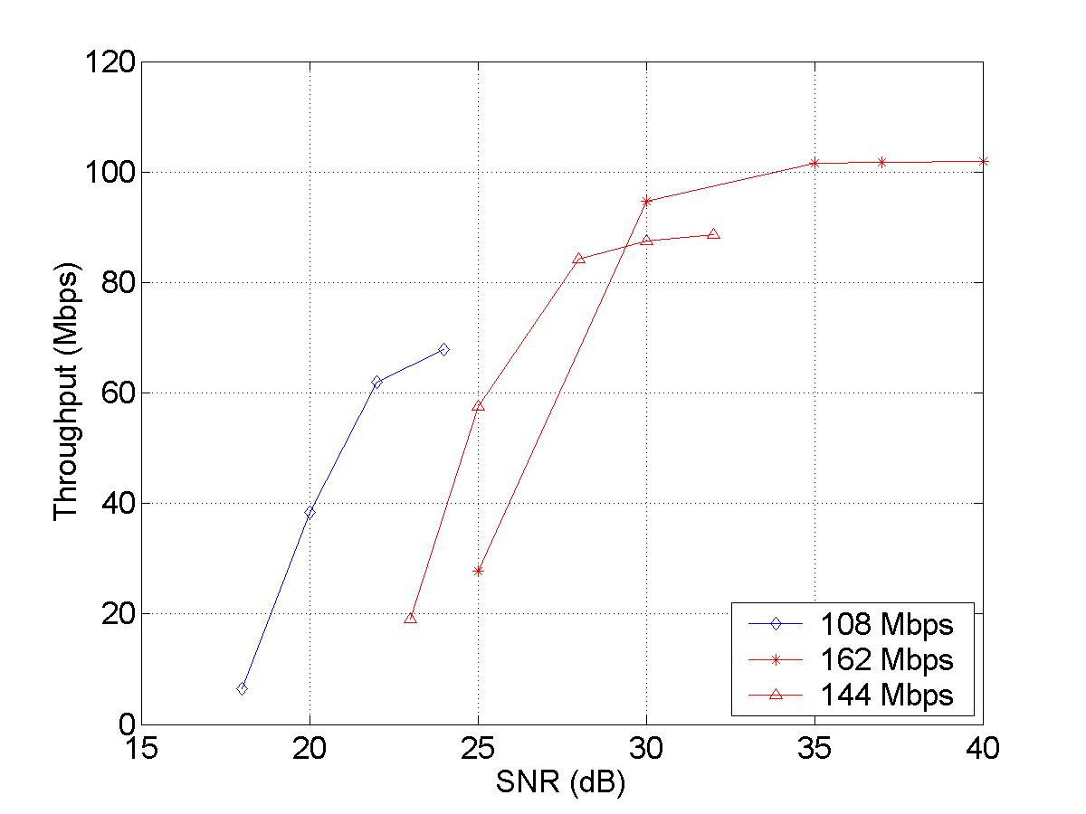

Figure 24: 3x3 Channel E

CC67.2 – Offset Compensation
Not completed as the PER simulator does not yet support reference frequency offset at transmitter and receiver i.e. frequency offset and sampling time offset compensation. However EVM simulations have been shown in Section 2.3.3.2.

PHY Changes

CC80 – Required Changes to 802.11 PHY

The modifications required for a legacy 802.11 PHY are;
- The scalable architecture supports up to 3 (mandatory) or 4 (optional) antennas (although more are possible), see section 2.2.8.1
- The adaptive loading modifies the puncturing and Constellation Mapping on a layer basis, see Section 2.2.5.1. The STA determine the maximum rate per layer (mandatory) or subgroup of carriers (optional) and this is communicated back to the AP, and vice-versa.
- The mapping function has an expanded rate set, see Section 2.2.6.1.
- Cyclic Delay is implemented with a progressive 1 sample delay /per antenna, see Section 7.1.
- The LTS preambles are modified versions of the 802.11a/g defined sequences, see Section 2.2.2.

References

[1] Call for Proposals for 802.11n, IEEE 802.11-03/858r6.
[2] Functional Requirements, IEEE 802.11-03-0813-12-000n
[3] Comparision Criteria, IEEE 802.11-03-0814-30-000n
[4] Usage Models, IEEE 802.11-03-0802-23-000n
[5] Throughput Enhancement via Frame Aggregation – A Sequel, IEEE 802.11-03/567r0
[6] IEEE 802.11-02-798r7, 802.11 HT PAR
[7] IEEE 802.11-02-799r6, 802.11 HT 5 Criteria

Appendices

Appendix A – Background to Cyclic Delay Technique
When one wishes to transmit the same information simultaneously on all Tx antennas in a channel with a dominant LOS characteristic, then there is a problem of the MIMO transmit antennas exhibiting a directional pattern (of both gain and attenuation). For example in Figure 25(a) a lamda/2 array with ideal matched up-conversion, the number of nulls is shown to equal the number of TX antennas minus 1. A 3 antenna system has nulls at 42 degrees and -42 degrees. In the case when the Tx chains have random phase errors, see Figure 25(b), then there is always one direction that gives a null greater than 20dB in the 2Tx antenna case. Also 3Tx and 4Tx antennas can have this problem, but are more likely to have many directions giving over 5dB attenuation.

The implications of this are that in certain directions the AGC will give the wrong setting, the 802.11a Signal and Data symbols transmitted simultaneously on each antenna might not be decoded, even though the MIMO section of the packet can be decoded.
Figure 25: Antenna Array (sp=0.5λ) gain dB vs AOD. (a) Steering coefficients = 1exp(j*0). (b) Steering coefficients = 1exp(j*pi*rand). The single antenna performance (with same Tx power) is at 0dB
One way of circumventing this problem is to introduce a progressive cyclic delay per antenna. The cyclic delay can be implemented by a cyclic shift immediately after the IFFT of 0 samples for the first antenna, 1 sample for the 2nd antenna and 2 samples for the third antenna etc. It should be applied to every symbol.
The Table below illustrates the beneficial effects of introducing the cyclic delay shift. The path loss (dB) has been calculated in the situation when 3Tx antennas are transmitting the same signal to 1 Rx antenna with and without delay diversity. The result is that the average path loss is less with cyclic delay due to the delay diversity effect. It is applicable to channels with a LOS or high level of correlation. It stops these dominant rays from either reinforcing or cancelling (flat fading component). As such it improves the performance of synchronisation when the same information is to be simultaneously sent on all Transmit antennas. In summary;
- Training using phase loaded LTSs will be improved because each LTS will have the same average power.
- AGC levels will be correctly set using the STS.
- It has no effect in non-correlated NLOS channels.
Table 23: Effect of Cyclic Delay on Average Path Loss(dB)
 | LOS (19m,E) Corr(0.5λ) | LOS(19m,E)  Ncorr(10λ) | NLOS(30m,E) + Corr C(0.5λ) | NLOS(30m,E) NonCor(10λ)
Path loss – No cyclic Delay | -75.3 | -68.2 | -83.4 | -78.7 dB
Path Loss – Cyclic Delay | -70.3 | -70.2 | -79.8 | -79.5dB
Improvement | 5dB | -2dB | 3.6dB | -0.8dB

The introduction of cyclic delay effects the cross correlation and auto correlation of the ‘short-training sequences’, by synthetically increasing the delay spread. Synchronisation performance is known to degrade with delay spread.

Figure 26: Cross correlation (top) with the standard 11a STS. Standard-STS(blue curve), delayed-STS(red curve) and (combined) DD-STS(black curve). Auto-correlation (bottom) with standard-STS(blue curve) and DD-STS(black curve) (un-normalised). Correlations are summed over 16 samples.
Figure 26 & Figure 28 shows the two peaks of the cross-correlated waveform of the STS and LTS respectively, representing two signals at the transmit antenna with a progressive cyclic delay of 1 sample per antenna. The auto correlation result shown in Figure 26 & Figure 28 for STS and LTS respectively, shows a broadening of the peak, this will make synchronisation less accurate. , As the number of antennas are increased the synchronisation and channel estimation algorithms will degrade in performance unless they are reconfigured to take advantage of the diversity , this also implies more computation.
Figure 27 : Top: Cross correlation for 3 transmit antennas showing the component parts and composite result. Bottom: Auto correlation for 1x1 (blue),2x1(red),3x1(green),4x1(black) antennas. Note curves will change with the channel.

Figure 28 : Top: Cross correlation for 3 transmit antennas showing the component parts and composite result. Bottom: Auto correlation for 1x1 (blue),2x1(red),3x1(green),4x1(black) antennas. Note curves will change with the channel.

Appendix B – Example of Length Calculation of the Sig3 field

Transmitter to Receiver

Table 24: Calculation of # pad bits
AL | Mode | Sig3R  [Mbps] | Rev CSI field  Length*  [bits] | FWD Rate field  Length  [bits] | Sig3 field length  [bits] | #  OFDM symbols | Pad bits | Total length of Sig3
Same on all layers | 11n; any # of layers | 6 | 4 | 4 | 36+Pad | 2 | 12 | 48
1 rate per layer | 11n; 2 layers | 6 | 4 | 8 | 40+Pad | 2 | 8 | 48
1 rate per layer | 11n; 3 layers | 6 | 4 | 12 | 42+Pad | 2 | 4 | 48
1 rate per layer | 11n; 4 layers | 6 | 4 | 16 | 48+Pad | 2 | 0 | 48
4 sub-groups per layer | 11n; 2 layers | 9 | 4 | 32 | 62+Pad | 2 | 10 | 72
4 sub-groups per layer | 11n; 3 layers | 12 | 4 | 48 | 80+Pad | 2 | 16 | 96
4 sub-groups per layer | 11n; 4 layers | 12 | 4 | 64 | 96+Pad | 2 | 0 | 96
*) The Rev CSI field is empty for the first transmitted frame; the RTS frame.

If we allow the sig3 field to occupy two OFDM-symbols it’s not necessary to go higher than 12 Mbps (QPSK, R=1/2) and yet have 6 reserved bits. Then the number of padbits is between 0 and 16.

Receiver to Transmitter
The length of the Sig3 field in the up-link direction is the same as in the down-link. The difference is that the “FWD Rate” field consists of four bits and the “Rev CSI” field varies in the same manner, See Table 24 above, as the “FWD Rate” field of the previously received frame did in the down-link.

Appendix C – Frame Aggregation
Frame aggregation increases the MAC efficiency and ‘seems to be a good solution to improve throughput when the distance between sender and receiver is relatively short’ [5]. In terms of the frame format proposed in this document the expected MAC throughput rates are illustrated in Figure 29. The techniques and assumptions that are compared are:
- MIMO single frame mode: An average of 144Mbps on Data frame, 12Mbps on ACK frame and an 8us SIFS.
- MIMO RTS/CTS mode : An average of 144Mbps on Type 2 MIMO Data frame, 12Mbps on ACK frame and an 8us SIFS. PER of 10 % and adaptive loading overhead included.

Figure 29(a) illustrates the upper bound which is represented by the MIMO single frame transmissions, where 100Mbps Data throughput rate for payload sizes greater than 5.5kbytes.

Figure 29(a) also illustrates the MAC data throughput considering also the transmission of the RTS/CTS frames given a PER of 10%, MIMO type 3 training frame and adaptive loading overhead. It can be seen that the conditions needed to achieve 100Mbps are that the payload size per frame is greater than 2kbytes, and the transmission length is at least 10kbytes. By increasing the payload size per frame to 9kbytes then the transmission length can be reduced to around 7kbytes, and it obviously has a much increased MAC efficiency over payload sizes of 1500bytes.
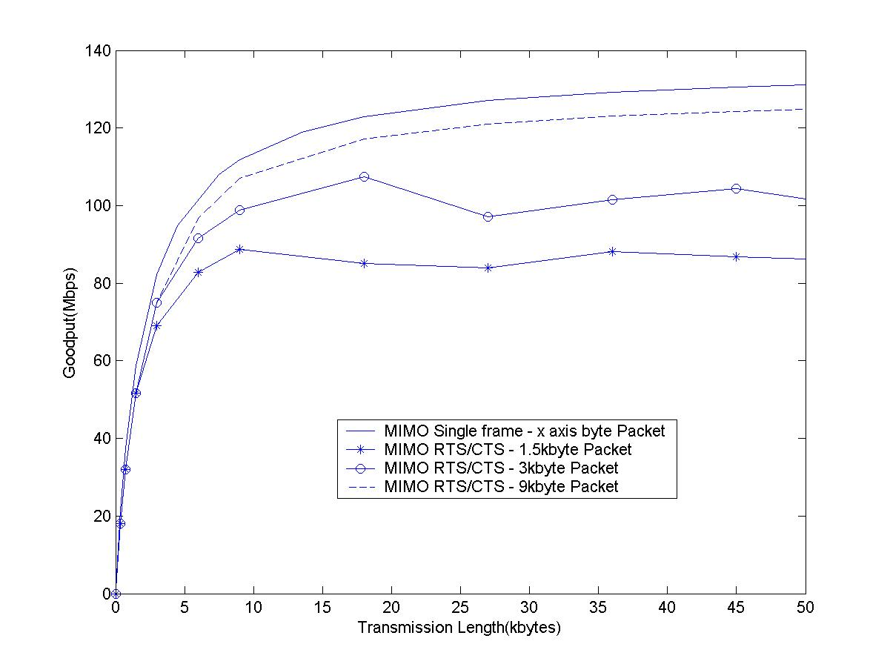
Figure 29: Comparison of MAC data throughputs versus transmission length for different frame format assumes a PER of 10%.

Appendix D - CC58 Calculation Technique and Assumptions

Calculation Assumptions
MSDU = 1500 bytes = 12000 bits
Transmission time per symbol, T_{S} = 4μs

- Calculation Process

  - Generate PER vs SNR curve using adapive loading for a given PHY data rate e.g. Rate_{PHY} = 144Mbps on average using adaptive loading.

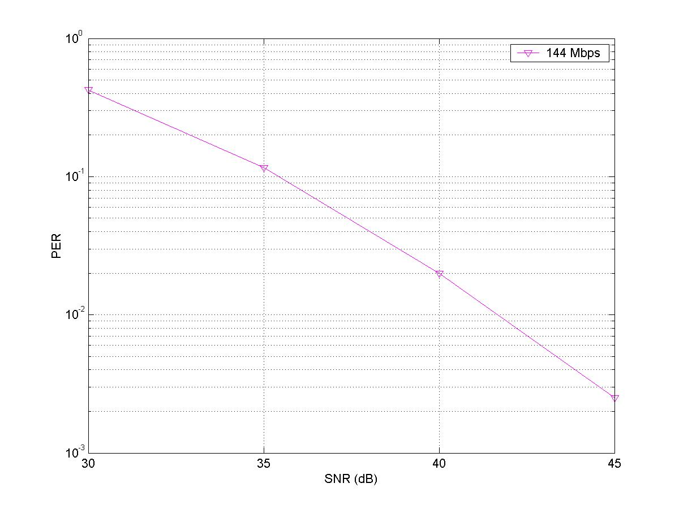

  - Convert SNR axis to distance axis

The relationship between SNR at the receiver and the channel path loss as a function of distance, L(d), can be calculated:
SNR = PTX – L(d) – (-174+10+10log10(BW)) dB
Assuming that
- The transmit power is 17dBm
- The receiver has a noise figure of 10dB
- The channel Bandwidth is 20MHz

Then
SNR = 108 – L(d) dB

From IEEE 802.11 MIMO channel models [3], the path loss model consists of the free space loss L_{FS} (slope of 2) up to a breakpoint distance and slope of 3.5 after the breakpoint distance, which can be expressed as

(4)
Free space loss is given by
dB (A)
where is the distance between transmitter and receiver, is the carrier wavelength. d_{BP} for IEEE channel models A to F are shown below.

 | A | B | C | D | E | F
(m) | 5 | 5 | 5 | 10 | 20 | 30
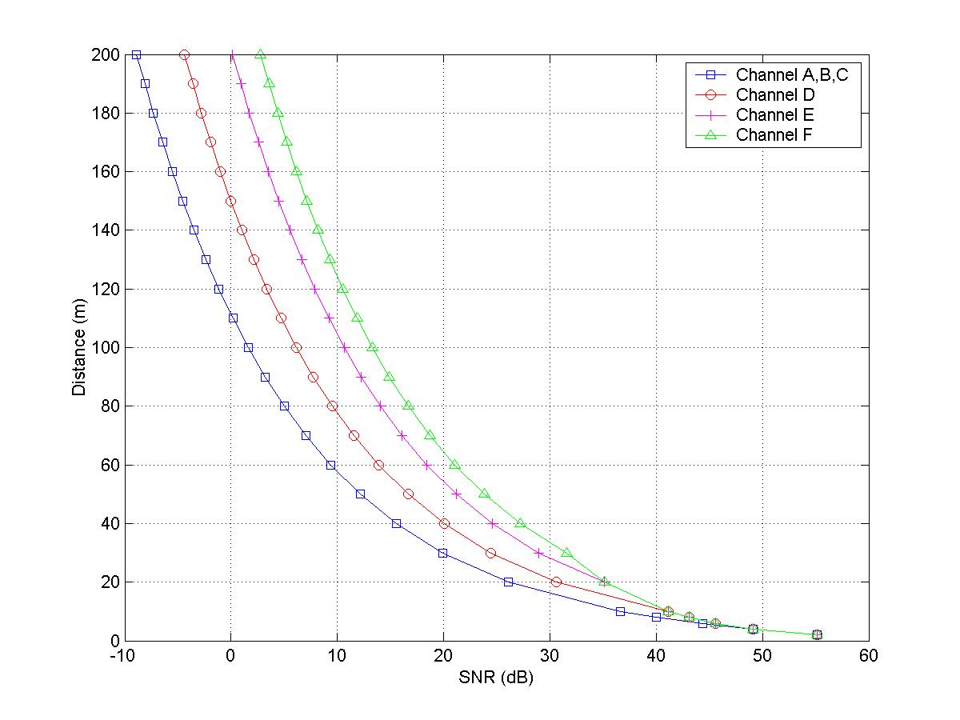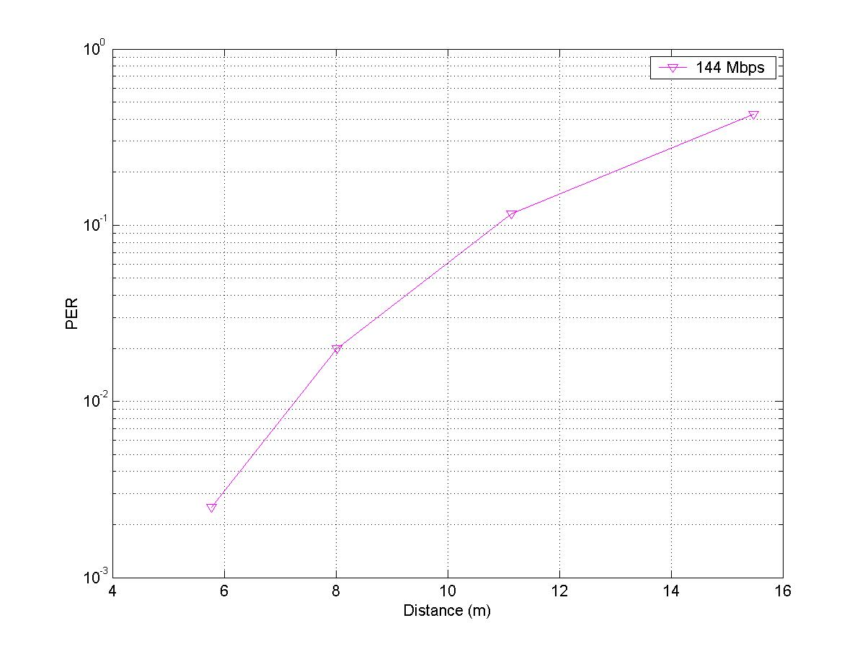
Figure 30: (a) SNR vs Distance for different channel models (b) conversion for model B

  - Convert PER axis to Goodput axis for Single Frame transmission

Goodput takes into account retransmissions and overhead i.e :
- Retransmissions: PER = 10%, 10% retransmissions,
Rate_{goodput} = Rate_{PHY,OH}*(1-PER)………………………………………(1)
- Overhead: Total = N_{P3} = 29 symbols where
  - Type 3 frame overhead = 18 symbols
  - SIFS at 8us = 2 symbols
  - ACK = 7 symbols
  - SIFS = 2 symbols
- Calculate number of data symbols
Average number of data symbols for a 1500 byte payload
Rate_{PHY} | N_{S}
Rate_{PHY} | 2*2 | 3*3 | 4*4
108 |  | 29
144 | 22 | 22 | 22
162 |  | 19 | 19
192 |  | 17 | 17
216 |  | 15 | 15
256 |  |  | 13
288 |  |  | 11
Average PHY data rate = 144 Mbps => N_{S} = 22 data symbols

The PHY rate including the overhead is calculated as:
Rate_{PHY,OH} = Rate_{PHY} * N_{S} /(N_{S} + N_{P3}) = Rate_{PHY} * 22/(22+29)………………………..(2)
Insert (2) into (1) to get

Total Goodput (Single frame Only)= Rate_{goodput}= Rate_{PHY} * 22/(22+29) *(1-PER)

  - Convert PER axis to Goodput axis for RTS/CTS Frame transmission

This is based on the assumption that the time, frequency and Channel Tracking Algorithm performance does not impact performance -

Goodput takes into account retransmissions and overhead. Assume transmiting successfully 50*1500byte packets = 75kbytes of transmission
- Retransmissions: PER = 10%, Total packets re-transmitted = floor(50*PER / (1-(PER)) = 5. Note that a retransmission includes a packet with a training sequence.
- Calculate Average Overhead: assume reserve medium for a transmission of 75kbytes e.g. Ntx = Nrx = 3. Total Overhead = 499 symbols

  - RTS Type 3 frame = 8+2*(Ntx-1)+ 2 symbols = 14
  - CTS Type 3 frame = 8+2*(Nrx-1)+ 1 +2 symbols = 15
  - 50 Type 2 and = (1 + 2)*50 = 150
  - 50 ACK frames = (2 + 2)*50 = 200
  - 5 Type 1 frame and = (5+2*(Ntx-1)+1 +2)*5 = 60
  - 5 Type 1 ACK frame = (5+2*(Nrx-1)+1 +2 )*5 = 60

- Calculate number of data symbols transmitted @ 144Mbps
Total number data symbols in type 2 and type 1 frame= (50+5) * 22= 1210 symbols

- Calculate Goodput
Rate_{goodput} = Total successful bits at MAC / Total Simulation time =
= 50*1500*8 / (4e-6*(1210+499)) = 87.8 Mbps

- Note for CC67: Data throughput excludes the overheads. Assuming the parameters above:
Rate_{throughput} = Total successful bits at MAC / Total Simulation time without overheads =
= 50*1500*8 /(4e-6*(1210)) = 124Mbps

  - From graph choose points that are greater than 100Mbps and calculate bps/Hz = Rate_{PHY} /20MHz

Appendix E – Rate Estimation for Channel Bonding

Apart from using multiple antennas, channel bonding can also increase data rates of OFDM system. Estimation of the rate increase is as follows. First, each OFDM symbol has 48 data carrying subchannels. As a result of channel bonding, the total number of data carrying subchannels is where the extra 12 subchannels are recovered from guard band in the reference SISO-OFDM system. Second, in order to maintain the same transmitted power, the total power per subchannel drops by approximately a half (or 3 dB) which results in increase of BER. One way of maintaining the same bit error rate is to reduce the number of bits per QAM symbol by one.

Therefore, assuming 6 bits on each subchannel in reference SISO system, channel bonding can transmit the total of bits per OFDM symbol, comparing to bits per OFDM symbol without. This represents an increase by a factor of 1.8. This increase factor also applies to the case of MIMO systems.

The value of ranges from 5 to 30 m, depends on the channel models A to F. More details can be found in the reference provided.
We have not included the extra 12 subchannels in the power computation.

