IEEE P802.11
Wireless LANs
Simulation Report for Draft Samsung MAC proposal
Date: August 12, 2004
Authors: Youngsoo Kim (kimyoungsoo@samsung.com)
Kyunghun Jang (khjang@samsung.com)
Jin-Bong Chang (jinb.chang@samsung.com)
Dongjun Lee (djthekid.lee@samsung.com)
Sunghyun Choi (schoi@snu.ac.kr)
Seongkwan Kim (skim@mwnl.snu.ac.kr)
JeongGyun Yu (jgyu@mwnl.snu.ac.kr)

Abstract

This submission reports the simulation results for the Samsung MAC proposal.

Simulation Report
for Draft Samsung MAC proposal

Aug. 12, 2004

Youngsoo Kim (kimyoungsoo@samsung.com)
Kyunghun Jang (khjang@samsung.com)
Jin-Bong Chang (jinb.chang@samsung.com)
Dongjun Lee (djthekid.lee@samsung.com)
Sunghyun Choi (schoi@snu.ac.kr)
Seongkwan Kim (skim@mwnl.snu.ac.kr)
JeongGyun Yu (jgyu@mwnl.snu.ac.kr)

Table of Contents
1. Simulation MAC modes 4
1.1 Mode 1: Periodic MP frame 4
1.2 Mode 2: Aperiodic MP frame 4
2. Simultion Methodology 5
2.1 Summary of PHY Layer Modeling 5
2.2 Higher Layer Assumptions 7
2.3 MAC Layer Parameters 7
2.3.1 Frame Size 7
2.3.2 Frame Aggregation 7
2.3.3 Rate vs. 7
2.3.4 Distance 8
2.3.5 802.11e Support 8
2.3.6 Additional MAC Parameters 9
3. Simulation Scenarios 10
3.1 Residential 10
3.2 Large Enterprise 11
3.3 Hot Spot 13
4. Simulation Results 14

List of Figures
Figure 1 - RxSNR vs. Distance when BW=40MHz, TxPwr=50mW, NF=10dB, Channel B 5
Figure 2 - RxSNR vs. Distance when BW=40MHz, TxPwr=50mW, NF=10dB, Channel D 6
Figure 3 - RxSNR vs. Distance when BW=40MHz, TxPwr=50mW, NF=10dB, Channel E 6

Simulation MAC modes

Mode 1: Periodic MP frame

Mode 2: Aperiodic MP frame

Simultion Methodology

Summary of PHY Layer Modeling
The following physical layer characteristics and parameters are assumed for all of the stations, for this evaluation.

PHY Model Parameters | Parameter
Frequency Channel | 5.25[GHz]
Multi-path fading | Disable
Shadow fading | Disabled
Signal Bandwidth | 40.0[MHz]
Antenna Configuration | 2X2
Transmit Power | 50.0[mW]
Antenna Gain (TX/RX) | 0.0[dBi]
Antenna Pattern (TX/RX) | Omni-Directional
Noise Figure | 10.0[dB]
CCA accuracy (energy detection) | RSSI >= -65[dBm]
CCA accuracy (preamble detection) | SINR >= 3.0[dB]
CCA delay | 6.0[usec]

The Figure 1 shows relationship between Rx. SNR vs. distance between transmitter and receiver, based on channel model B.

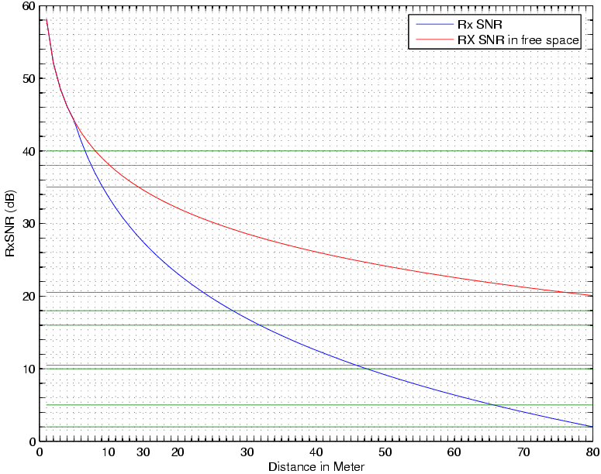
Figure 1 - RxSNR vs. Distance when BW=40MHz, TxPwr=50mW, NF=10dB, Channel B
The green lines show the approximated boundaries between the selections of data rate classes used when Channel Model B is used.

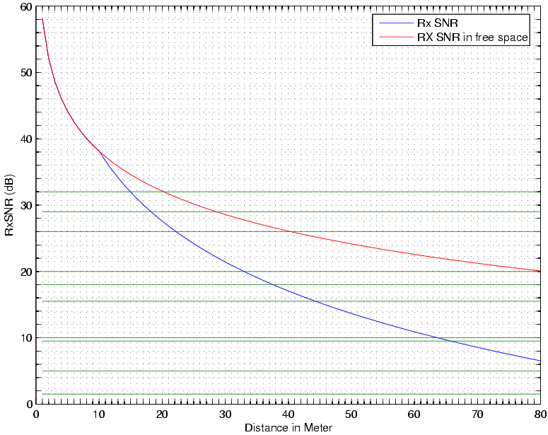
Figure 2 - RxSNR vs. Distance when BW=40MHz, TxPwr=50mW, NF=10dB, Channel D
The Figure 2 shows relationship between Rx. SNR vs. distance between transmitter and receiver, based on channel model D. The green lines show the approximated boundaries between the selections of data rate classes used when Channel Model D is used.

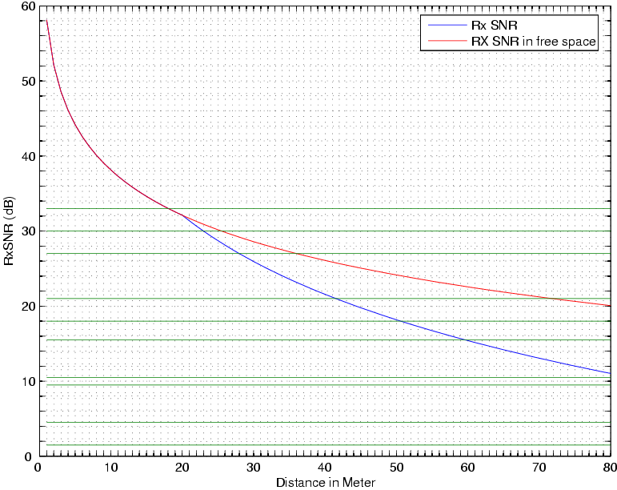
Figure 3 - RxSNR vs. Distance when BW=40MHz, TxPwr=50mW, NF=10dB, Channel E
The Figure 3 shows relationship between Rx. SNR vs. distance between transmitter and receiver, based on channel model E. The green lines show the approximated boundaries between the selections of data rate classes used when Channel Model E is used.

Higher Layer Assumptions
The type and parameter of the TCP model is as follows:

TCP Factor | Parameter
TCP Model | Reno
Duplicate ACK threshold | 3
ACK policy | Delayed ACK
Maximum ACK delay | 200msec

MAC Layer Parameters
The following section describes the MAC layer assumptions used in the simulator.

Frame Size
Frame Sizes are based on the Samsung MAC Specification draft, D.10.0.

Frame Size | Parameter
MP frame (Header + Payload) | 18+(5*n)+(4*m) [Bytes]
Smart Block ACK Request | 22 [Bytes]
Smart Block ACK | 32+(2*l) [Bytes]
MPDU Delimiter | 4 [Bytes]
(* n : the number of the elements of D/L MAP, m : the number of the elements of U/L MAP, l : the number of erroneous MSDUs )

Frame Aggregation
Two-level aggregation is implemented in the simulator. The total size of aggregate PPDU is variable. The PLCP in a PPDU has the Length (12 bits) and Rate (4 bits) field in the legacy SIGNAL field. The Length and Rate fields are virtually set in order to cover the duration of the PPDU. The length of an aggregate PPDU is limited so that its duration may not exceed 5.46 milliseconds, because the maximum duration of the PPDU in 802.11a is about 5.46 millisecond, which can be derived from the maximum length (4096 bytes) divided by the lowest rate (6 Mbps).

Aggregation Factor | Parameter
Frame Aggregation | Two-level
Maximum size of aggregate PPDU | 5msec

Rate vs.

Distance
This predicted rate on each scenario model is determined from the distance between the transmitter and receiver based on channel model. Table 1 presents the relationship between predicted rate and distance based on channel model on each scenario.

Rate (Mbps) | Scenario 1 | Scenario 4 | Scenario 6
Rate (Mbps) | Bound (m) | Bound (m) | Bound (m)
243 | 6.5 | 15 | 18
216 | 7.5 | 18 | 23
162 | 9 | 22 | 28
121.5 | 23.5 | 33 | 41.5
108 | 28 | 37.5 | 50.5
81 | 32 | 44 | 59.5
54 | 46 | 63.5
40.5 | 47 | 65.5
27 | 65.5
13.5 | 80

802.11e Support
Parts of 802.11e are implemented inside the simulator.

802.11e Factor |  | Parameter
Block ACK |  | Not Used
EDCF | AIFS | Incorporated (See Below)
EDCF | CW | Incorporated (See Below)
EDCF | TXOP | Not Used
HCCA |  | Not Used
DLP |  | Not Used

AIFS is used as described below.

Priority | AC | CWmin [Slot Time] | CWmax [Slot Time] | AIFSN
Lowest  ↓  ↓  Highest | AC_BK | aCWmin = 15 | aCWmax= 1023 | 7
Lowest  ↓  ↓  Highest | AC_BE | aCWmin = 15 | aCWmax = 1023 | 3
Lowest  ↓  ↓  Highest | AC_VI | (aCWmin + 1) / 2 – 1 = 7 | ACWmin = 15 | 2
Lowest  ↓  ↓  Highest | AC_VO | (aCWmin + 1) / 4 – 1 = 3 | (aCWmin + 1) / 2 – 1 = 7 | 2
*AIFS[AC] = AIFSN[AC] x aSlotTime + a SIFSTime

Additional MAC Parameters
Additional MAC parameters are as follows.

MAC related parameters | Value
Transmission Buffer Depth | 150[MSDU]
MP frame interval | 10msec [mode 1] / variable [mode 2]
CP duration | variable [mode 1] / 0msec [mode 2]
ASlotTime | 9.0[usec]
Bi-Directional | Enabled
Fragmentation | Disabled
Pair acknowledgment | Enabled
Phase acknowledgment | Disabled
Implicit acknowledgment | Enabled

Simulation Scenarios
This section describes the usage models used in the simulation.

Residential
The Residential model is modeled as follows, with the AP at the center. See the TGn Usage Model document for details.

From | To | Mean Rate [Mbps] | MSDU Size [Bytes] | Access Category | Higher Layer
0 (AP) | 1 | 19.2 | 1500 | AC_VI | UDP
0 | 3 | 24 | 1500 | AC_VI | UDP
0 | 4 | 4 | 1500 | AC_VI | UDP
0 | 4 | 1 | 300 | AC_BE | TCP
0 | 7 | 0.096 | 120 | AC_VI | UDP
0 | 8 | 0.096 | 120 | AC_VI | UDP
0 | 9 | 0.096 | 120 | AC_VI | UDP
0 | 10 | 2 | 512 | AC_VI | UDP
0 | 11 | 0.128 | 418 | AC_VI | UDP
1 | 0 | 0.06 | 64 | AC_VI | UDP
3 | 0 | 0.06 | 64 | AC_VI | UDP
4 | 10 | 30 | 1500 | AC_BE | TCP
5 | 6 | 0.5 | 512 | AC_VI | UDP
6 | 5 | 0.5 | 512 | AC_VI | UDP
7 | 0 | 0.096 | 120 | AC_VI | UDP
8 | 0 | 0.096 | 120 | AC_VI | UDP
9 | 0 | 0.096 | 120 | AC_VI | UDP
10 | 0 | 1 | 512 | AC_VI | UDP
11 | 10 | 0.5 | 50 | AC_VI | UDP

Large Enterprise
The Large Enterprise model is modeled as follows, with the AP at the center. See the TGn Usage Model document for details.

From | To | Mean Rate [Mbps] | MSDU Size [Bytes] | Access Category | Higher Layer
0 (AP) | 1 | 1 | 300 | AC_BE | TCP
0 | 2 | 1 | 300 | AC_BE | TCP
0 | 3 | 1 | 300 | AC_BE | TCP
0 | 4 | 1 | 300 | AC_BE | TCP
0 | 5 | 1 | 300 | AC_BE | TCP
0 | 6 | 10 | 300 | AC_BE | TCP
0 | 7 | 1 | 512 | AC_VI | UDP
0 | 8 | 1 | 512 | AC_VI | UDP
0 | 9 | 2 | 512 | AC_BE | TCP
0 | 10 | 2 | 512 | AC_BE | TCP
0 | 11 | 30 | 1500 | AC_BE | TCP
0 | 12 | 30 | 1500 | AC_BE | TCP
0 | 13 | 30 | 1500 | AC_BE | TCP
0 | 14 | 30 | 1500 | AC_BE | TCP
0 | 15 | 30 | 1500 | AC_BE | TCP
0 | 16 | 30 | 1500 | AC_BE | TCP
0 | 17 | 30 | 1500 | AC_BE | TCP
0 | 18 | 30 | 1500 | AC_BE | TCP
0 | 19 | 30 | 1500 | AC_BE | TCP
0 | 20 | 30 | 1500 | AC_BE | TCP
0 | 25 | 0.096 | 120 | AC_VI | UDP
0 | 26 | 0.096 | 120 | AC_VI | UDP
0 | 27 | 0.096 | 120 | AC_VI | UDP
0 | 28 | 0.096 | 120 | AC_VI | UDP
0 | 29 | 0.096 | 120 | AC_VI | UDP
0 | 30 | 0.096 | 120 | AC_VI | UDP
1 | 0 | 0.256 | 64 | AC_BE | TCP
2 | 0 | 0.256 | 64 | AC_BE | TCP
3 | 0 | 0.256 | 64 | AC_BE | TCP
4 | 0 | 5 | 1000 | AC_BE | TCP
5 | 0 | 10 | 1500 | AC_BE | TCP
6 | 0 | 0.256 | 64 | AC_BE | TCP
7 | 0 | 1 | 512 | AC_VI | UDP
8 | 0 | 1 | 512 | AC_VI | UDP
21 | 0 | 30 | 1500 | AC_BE | TCP
22 | 0 | 30 | 1500 | AC_BE | TCP
23 | 0 | 30 | 1500 | AC_BE | TCP
24 | 0 | 30 | 1500 | AC_BE | TCP
25 | 0 | 0.096 | 120 | AC_VI | UDP
26 | 0 | 0.096 | 120 | AC_VI | UDP
27 | 0 | 0.096 | 120 | AC_VI | UDP
28 | 0 | 0.096 | 120 | AC_VI | UDP
29 | 0 | 0.096 | 120 | AC_VI | UDP
30 | 0 | 0.096 | 120 | AC_VI | UDP

Hot Spot
The Hot Spot model is modeled as follows, with the AP at the center. See the TGn Usage Model document for details.

From | To | Mean Rate [Mbps] | MSDU Size [Bytes] | Access Category | Higher Layer
0 | 1 | 2 | 300 | AC_BE | TCP
0 | 2 | 2 | 300 | AC_BE | TCP
0 | 3 | 2 | 300 | AC_BE | TCP
0 | 4 | 2 | 300 | AC_BE | TCP
0 | 5 | 2 | 300 | AC_BE | TCP
0 | 6 | 2 | 300 | AC_BE | TCP
0 | 7 | 2 | 300 | AC_BE | TCP
0 | 8 | 2 | 300 | AC_BE | TCP
0 | 9 | 2 | 300 | AC_BE | TCP
0 | 10 | 2 | 300 | AC_BE | TCP
0 | 11 | 2 | 512 | AC_VI | UDP
0 | 12 | 2 | 512 | AC_VI | UDP
0 | 13 | 2 | 512 | AC_VI | UDP
0 | 14 | 2 | 512 | AC_VI | UDP
0 | 15 | 2 | 512 | AC_VI | UDP
0 | 16 | 2 | 512 | AC_VI | UDP
0 | 17 | 2 | 512 | AC_VI | UDP
0 | 18 | 5 | 1500 | AC_VI | UDP
0 | 19 | 5 | 1500 | AC_VI | UDP
0 | 20 | 0.096 | 120 | AC_VI | UDP
0 | 21 | 0.096 | 120 | AC_VI | UDP
0 | 22 | 0.096 | 120 | AC_VI | UDP
0 | 23 | 0.096 | 120 | AC_VI | UDP
0 | 24 | 0.096 | 120 | AC_VI | UDP
0 | 25 | 0.096 | 120 | AC_VI | UDP
0 | 26 | 0.096 | 120 | AC_VI | UDP
0 | 27 | 0.096 | 120 | AC_VI | UDP
0 | 28 | 0.096 | 120 | AC_VI | UDP
0 | 29 | 0.096 | 120 | AC_VI | UDP
0 | 30 | 0.096 | 120 | AC_VI | UDP
0 | 31 | 0.096 | 120 | AC_VI | UDP
0 | 32 | 0.096 | 120 | AC_VI | UDP
0 | 33 | 0.096 | 120 | AC_VI | UDP
0 | 34 | 0.096 | 120 | AC_VI | UDP
20 | 0 | 0.096 | 120 | AC_VI | UDP
21 | 0 | 0.096 | 120 | AC_VI | UDP
22 | 0 | 0.096 | 120 | AC_VI | UDP
23 | 0 | 0.096 | 120 | AC_VI | UDP
24 | 0 | 0.096 | 120 | AC_VI | UDP
25 | 0 | 0.096 | 120 | AC_VI | UDP
26 | 0 | 0.096 | 120 | AC_VI | UDP
27 | 0 | 0.096 | 120 | AC_VI | UDP
28 | 0 | 0.096 | 120 | AC_VI | UDP
29 | 0 | 0.096 | 120 | AC_VI | UDP
30 | 0 | 0.096 | 120 | AC_VI | UDP
31 | 0 | 0.096 | 120 | AC_VI | UDP
32 | 0 | 0.096 | 120 | AC_VI | UDP
33 | 0 | 0.096 | 120 | AC_VI | UDP
34 | 0 | 0.096 | 120 | AC_VI | UDP

Simulation Results
Detailed simulation results are presented in a separate “IEEE 802 11-04/921, Samsung MAC Proposal CC Summary” document.

# | Name | Simulation Scenario |  | Mode1:  Periodic MP frame | Mode 2:  Aperiodic MP frame
CC18 | HT Usage Models Supported (non QoS) | SS1  (Mbps/ratio) |  | 9.7/0.31 | 27.4/0.88
CC18 | HT Usage Models Supported (non QoS) | SS4 |  | 124.3/0.28 | 144.3/0.32
CC18 | HT Usage Models Supported (non QoS) | SS6 |  | 14.1/0.7 | 36.9/1.84 *
CC19 | HT Usage Models Supported (QoS) | SS1 |  | 16/16 ** | 16/16 **
CC19 | HT Usage Models Supported (QoS) | SS4 |  | 18/18 | 18/18
CC19 | HT Usage Models Supported (QoS) | SS6 |  | 39/39 | 39/39
CC20 | BSS Aggregate Goodput at the MAC data SAP | SS1 | M1 | 61.7 | 79.4
CC20 | BSS Aggregate Goodput at the MAC data SAP | SS1 | M2 | 61.7 | 79.4
CC20 | BSS Aggregate Goodput at the MAC data SAP | SS1 | M3 | 61.7 | 79.4
CC20 | BSS Aggregate Goodput at the MAC data SAP | SS4 | M1 | 133.5 | 152.5
CC20 | BSS Aggregate Goodput at the MAC data SAP | SS4 | M2 | 133.5 | 152.5
CC20 | BSS Aggregate Goodput at the MAC data SAP | SS4 | M3 | 133.5 | 152.5
CC20 | BSS Aggregate Goodput at the MAC data SAP | SS6 | M1 | 58.9 | 81.8
CC20 | BSS Aggregate Goodput at the MAC data SAP | SS6 | M2 | 58.9 | 81.8
CC20 | BSS Aggregate Goodput at the MAC data SAP | SS6 | M3 | 58.9 | 81.8
CC24 | MAC Efficiency | SS1 |  | 0.40 | 0.51
CC24 | MAC Efficiency | SS4 |  | 0.56 | 0.63
CC24 | MAC Efficiency | SS6 |  | 0.29 | 0.40
* TCP doesn’t have an offered load (limitation) in simulation
** Game control traffic is not used in simulation

