IEEE P802.11
Wireless LANs

Turbo Codes: Partial Proposal for 802.11n - Results
Date: August 12th, 2004
Author: Marie-Helene Hamon, John Benko, Olivier Seller
France Telecom
4, rue du Clos Courtel – BP91226 – 35512 Cesson-Sevigne- France
Phone: 33 299 12 48 73
Fax: 33 299 12 40 98
e-Mail: mhelene.hamon@francetelecom.com

Abstract

This document discloses the results, regarding partial proposal "Turbo Codes", according to the document "IEEE TGn comparison criteria" (IEEE 802.11-03/814r31)
Introduction

This partial proposal "Turbo Codes" is described in the following documents submitted to the IEEE:
- 11-04-0902-00-000n (Turbo Codes Partial Proposal Disclosure)
- 11-04-0903-00-000n (Proposal presentation)
- 11-04-0904-00-000n (Technical specification)

This document addresses each of the comparison criteria relevant to coding, according to the document "IEEE TGn comparison criteria" (IEEE 802.11-03/814r31)

- CC6
In the case of a rate of 100 Mbps, 8 iterations and 5-bit quantization (data and extrinsic information), the decoding complexity can be summarized by:
- Gates: 164000 @ clock = 100 MHz
82000 @ clock = 200 MHz
54000 @ clock = 400 MHz
(for 0.18 μm CMOS)
- RAM: Data Input Buffer + 8.5*k (k represents the blocksize) for extrinsic information + 4000 for sliding window
(example: 72000 bits for 1000-byte block)
- No ROM

- CC11
Backward compatibility with 802.11-99 (Rev 2003) and 802.11g can be achieved if Turbo Coding is an optional coding scheme of the new standard.

- CC51
Turbo Codes can be combined with any kind of modulation technique, number of Tx antennas, bandwidth and any kind of coding rate can be achieved. The list of PHY datarates represented in the simulation results is an example:
- 12 Mbits/s (coding rate ½, QPSK)
- 24 Mbits/s (coding rate ½, 16-QAM)
- 36 Mbits/s (coding rate ¾, 16-QAM)
- 48 Mbits/s (coding rate 2/3, 64-QAM)
- 54 Mbits/s (coding rate ¾, 64-QAM)

This list is non-exhaustive and higher PHY data rates can be achieved with higher coding rates and larger constellations. Possible examples are:
- 60 Mbits/s (coding rate 5/6, 64-QAM)
- 72 Mbits/s (coding rate ¾, 256-QAM)
- …
- CC59
The results were obtained with the Turbo Codes inserted in IEEE802.11a PHY layer, instead of the convolutional code. Perfomance results with the convolutional code are also represented.

The Turbo Code settings are:
- 8-state Duo-Binary Turbo Code, 8 iterations for decoding, Max-Log-MAP

Five data rates are represented:
- 12 Mbits/s: QPSK, R=1/2 24 Mbits/s: 16-QAM, R=1/2
- 36 Mbits/s: 16-QAM, R=3/4 48 Mbits/s: 64-QAM, R=2/3
- 54 Mbits/s: 64-QAM, R=3/4

PSDU length of 1000 bytes were considered. The number of antennas is one at each side (Nr=Nt=1), and at least 100 packet errors were observed. Each packet used an independent channel realization. Perfect channel estimation and synchronization have been assumed.

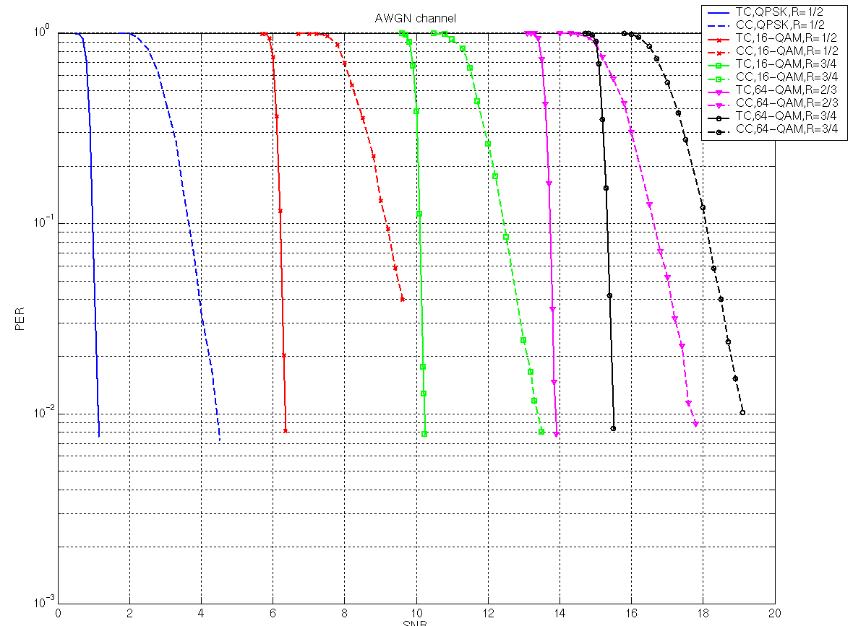

- CC67
Same simulation settings than in the CC above are considered, with the channel models B, D and E. Physical layer impairments have not been implemented. They would create additive noise, but an increased additive noise will not significantly degrade performance (as represented in the figure above).

1) Channel model B
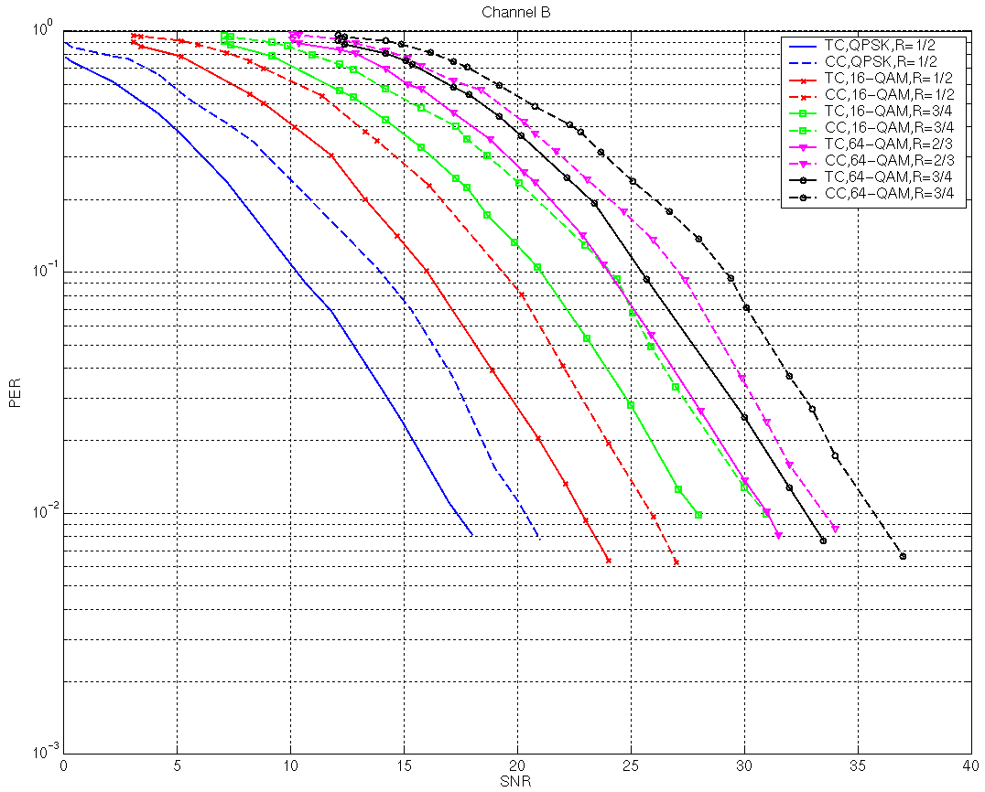

2) Channel model D

The effect of fluorescent effects are also represented on this figure in the last case (R=3/4, 64-QAM).

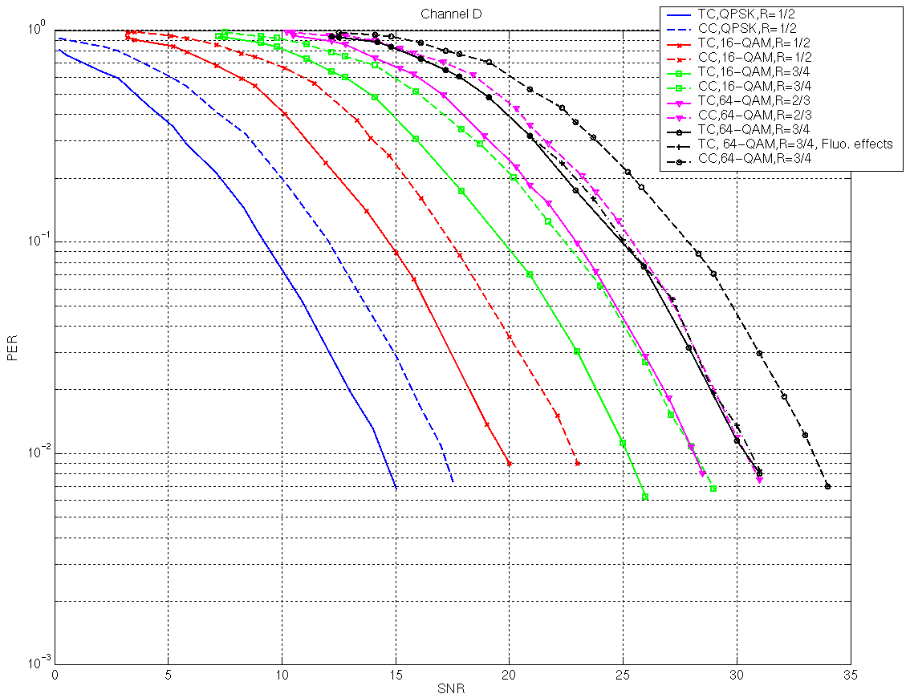

3) Channel model E
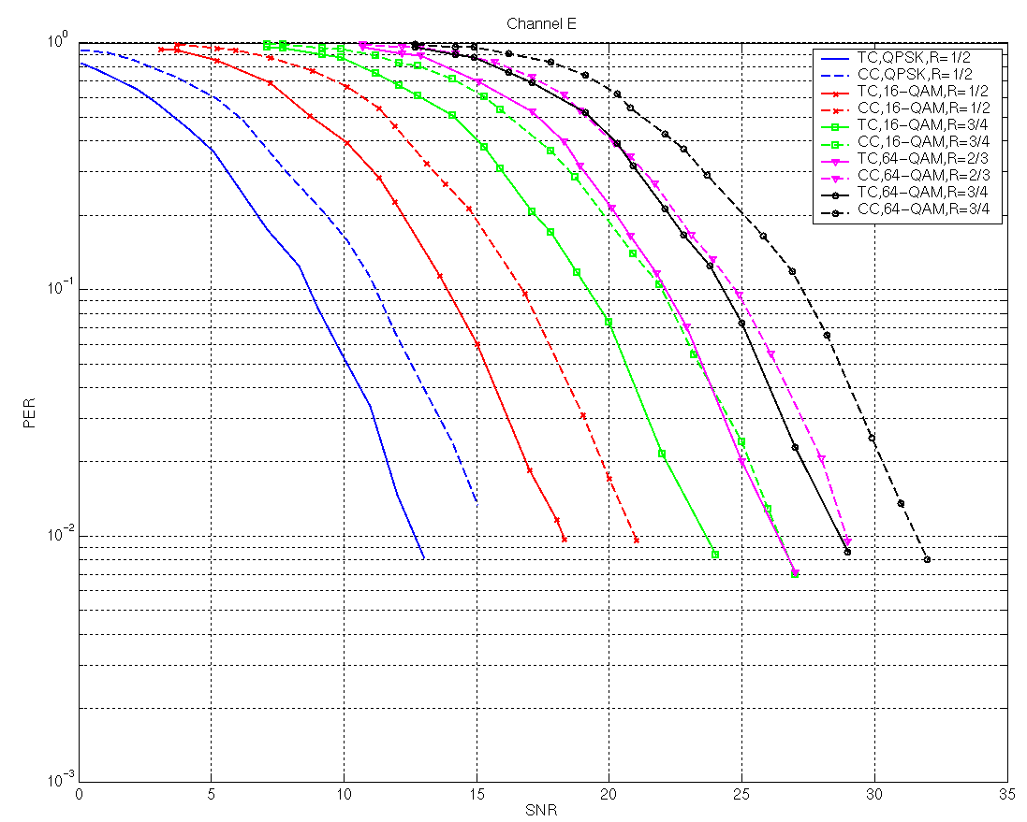

- CC80

The required change to a legacy 802.11 PHY is the implementation of the Turbo Encoder and Decoder. More details are provided in the document 11-04-0904-00-000n "Turbo Code Technical Spec"

