IEEE P802.11
Wireless LANs
TGnSync Proposal PHY Results
Date: 2005-03-14
Author(s):
Name | Company | Address | Phone | email
Syed Aon Mujtaba | Agere Systems | 555 Union Boulevard, Allentown, Pennsylvania 18109, U.S.A. | +1 610 712 6616 | mujtaba@agere.com
Abstract
This document contains simulation results for the TGn Sync proposal. These simulations establish compliance with CC59 and CC67. Additional simulations are provided to highlight the potential performance gains of various features of the TGn Sync proposal.
Notice: This document has been prepared to assist IEEE 802.11. It is offered as a basis for discussion and is not binding on the contributing individual(s) or organization(s). The material in this document is subject to change in form and content after further study. The contributor(s) reserve(s) the right to add, amend or withdraw material contained herein.

Release: The contributor grants a free, irrevocable license to the IEEE to incorporate material contained in this contribution, and any modifications thereof, in the creation of an IEEE Standards publication; to copyright in the IEEE’s name any IEEE Standards publication even though it may include portions of this contribution; and at the IEEE’s sole discretion to permit others to reproduce in whole or in part the resulting IEEE Standards publication. The contributor also acknowledges and accepts that this contribution may be made public by IEEE 802.11.

Patent Policy and Procedures: The contributor is familiar with the IEEE 802 Patent Policy and Procedures <http:// ieee802.org/guides/bylaws/sb-bylaws.pdf>, including the statement "IEEE standards may include the known use of patent(s), including patent applications, provided the IEEE receives assurance from the patent holder or applicant with respect to patents essential for compliance with both mandatory and optional portions of the standard." Early disclosure to the Working Group of patent information that might be relevant to the standard is essential to reduce the possibility for delays in the development process and increase the likelihood that the draft publication will be approved for publication. Please notify the Chair <stuart.kerry@philips.com> as early as possible, in written or electronic form, if patented technology (or technology under patent application) might be incorporated into a draft standard being developed within the IEEE 802.11 Working Group. If you have questions, contact the IEEE Patent Committee Administrator at <patcom@ieee.org>.
Table of Contents
1 Introduction 7
1.1 References 7
1.2 Scope 7
1.3 Simulation updates 7
2 CC59 Smulations 8
2.1 Results for 20 MHz Channels 9
2.2 Results for 40 MHz Channels 11
3 CC67 Simulations 13
3.1 PHY-1 Simulations 14
3.1.1 Supported rates 14
3.1.2 CC67 Simulation parameters 14
3.1.3 Results for CC67 in 20MHz mode 15
3.1.4 Results for CC67 in 40MHz mode 16
3.1.5 CC67.2 Simulation parameters 18
3.1.6 Results for CC67.2 in 20MHz mode 18
3.1.7 CC67.2 Results in 40MHz mode 20
3.1.8 Results for 2x3 configurations 21
3.2 PHY-2 Simulations 24
3.2.1 Simulation parameters 24
3.2.2 Simulation results 24
3.3 PHY-3 Simulations 31
3.4 PHY-4 Simulations 35
3.4.1 Description of Simulator 35
3.4.2 20MHz results 36
3.5 PHY-5 Simulations 40
3.5.1 Simulation parameters 40
3.5.2 CC67 Simulation Results for ABF-MIMO 41
4 PHY Throughput Simulations 42
4.1 PHY throughput for ABF-MIMO 42
4.2 Comparison of PHY Throughput with TGnSync HT-LTF and WWiSE MIMO Training 44
4.3 Comparison of PHY Throughput for 2x1 TGnSync Beamforming and 2x1 WWiSE STBC 46
4.4 PHY Throughput of 4x4 ABF-MIMO with TGnSync Extended MCS and TGnSync Basic MCS vs SS with Basic MCS 47
5 Old PHY Throughput Simulations 48
5.1 Ideal Throughput Simulations 48
5.1.1 Basic MIMO Simulations 49
5.1.2 Beam Forming Simuations 54
5.2 Throughput Simulations for Beamforming with Impairments 60

Table of Figures
Figure 2-1: 20 MHz, 1 spatial stream 9
Figure 2-2: 20 MHz, 2 spatial streams 9
Figure 2-3: 20 MHz, 3 spatial streams 10
Figure 2-4: 20 MHz, 4 spatial streams 10
Figure 2-5: 40 MHz, 1 spatial stream 11
Figure 2-6: 40 MHz, 2 spatial streams 11
Figure 2-7: 40 MHz, 3 spatial streams 12
Figure 2-8: 40 MHz, 4 spatial streams 12
Figure 3-1: Channel Model B, NLOS, 20MHz (with Half GI) 15
Figure 3-2: Channel Model D, NLOS, 20MHz 15
Figure 3-3: Channel Model E, NLOS, 20MHz 16
Figure 3-4: Channel Model B, NLOS, 40MHz (with Half GI) 16
Figure 3-5: Channel Model D, NLOS, 40MHz 17
Figure 3-6: Channel Model E, NLOS, 40MHz 17
Figure 3-7: CC67.2 in 20MHz Mode (E/NLOS) 19
Figure 3-8: CC67.2 in 40MHz Mode (E/NLOS) 20
Figure 9: Model B-NLOS, 1 lambda antenna separation 21
Figure 10: Model D-NLOS, 1 lambda antenna separation 21
Figure 11: Model E-NLOS, 1 lambda antenna separation 22
Figure 12: Model B-NLOS, 0.5 lambda antenna separation 22
Figure 13: Model D-NLOS, 0.5 lambda antenna separation 23
Figure 14: Model E-NLOS, 0.5 lambda antenna separation 23
Figure 3-15: CC67 Channel B-NLOS, 2x2x20MHz, 1000-Byte (Half GI) 25
Figure 3-16: CC67 Channel D-NLOS, 2x2x20MHz, 1000-Byte 26
Figure 3-17: CC67 Channel E-NLOS, 2x2x20MHz, 1000-Byte 27
Figure 3-18: CC67 Channel B-NLOS, 2x3x20MHz, 1000-Byte (Half GI) 28
Figure 3-19: CC67 Channel D-NLOS, 2x3x20MHz, 1000-Byte 29
Figure 3-20: CC67 Channel E-NLOS, 2x3x20MHz, 1000-Byte 30
Figure 3-21: Channel B-NLOS, 20MHz, half GI 31
Figure 3-22: Channel D-NLOS, 20MHz, full GI 32
Figure 3-23: Channel E-NLOS, 20MHz, full GI 32
Figure 3-24: Channel B-NLOS, 40MHz, half GI 33
Figure 3-25: Channel D-NLOS, 40MHz, full GI 33
Figure 3-26: Channel E-NLOS, 40MHz, full GI 34
Figure 27: Channel B-NLOS, 20MHz, (Full GI) 36
Figure 28: Channel D-NLOS, 20MHz, (Full GI) 37
Figure 29: Channel E-NLOS, 20MHz, (Full GI) 37
Figure 30: Channel B-NLOS, 40MHz, (Full GI) 38
Figure 31: Channel D-NLOS, 40MHz, (Full GI) 38
Figure 32: Channel E-NLOS, 40MHz, (Full GI) 39
Figure 33: PER vs SNR in Channel B 41
Figure 34: PER vs SNR in Channel D 41
Figure 35: Average PHY throughput vs SNR in Channel B 42
Figure 36: Average PHY throughput vs SNR in Channel D 43
Figure 37: Average PHY throughput vs SNR in Channel E 43
Figure 38: Average PHY throughput in Channel B 44
Figure 39: Average PHY throughput in Channel D 45
Figure 40: Average PHY throughput in Channel E 45
Figure 41: PHY throughput comparison of TX beamforming with STBC 46
Figure 42: PHY Throughput comparison of Basic MIMO, Basic Beamforming and Advanced Beamforming 47
Figure 5-1: Basic MIMO Throughput Comparison Model B NLOS 50
Figure 5-2: Basic MIMO Throughput Comparison Model D NLOS 50
Figure 5-3: Basic MIMO Throughput Comparison Model E NLOS 51
Figure 5-4: MCS Selection Probabilities for 2x2-20 MHz, Model D NLOS 52
Figure 5-5: MCS Selection Probabilities for 2x3-20 MHz, Model D NLOS 52
Figure 5-6: MCS Selection Probabilities for 4x4-20 MHz, Model D NLOS 53
Figure 5-7: MCS Selection Probabilities for 2x2-40 MHz, Model D NLOS 53
Figure 5-8: Advanced BF vs. Basic Open Loop Comparison, Model B 55
Figure 5-9: Advanced BF vs. Basic Open Loop Comparison, Model D 55
Figure 5-10: Advanced BF vs. Basic Open Loop Comparison, Model E 56
Figure 5-11: Comparison of Basic and Advanced BF, 2x2 - Model B 56
Figure 5-12: Comparison of Basic and Advanced BF, 4x2 - Model B 57
Figure 5-13: Comparison of Basic and Advanced BF, 2x2 - Model D 57
Figure 5-14: Comparison of Basic and Advanced BF, 4x2 - Model D 58
Figure 5-15: Comparison of Basic and Advanced BF, 2x2 - Model E 58
Figure 5-16: Comparison of Basic and Advanced BF, 4x2 - Model E 59
Figure 5-17 : Channel-B (nLOS) Throughput, 2x2 : 2x3 : 3x2 62
Figure 5-18 : Channel-B (nLOS) Throughput, 4x4 62
Figure 5-19 : Channel-D (nLOS) Throughput, 2x2 : 2x3 : 3x2 63
Figure 5-20 : Channel-D (nLOS) Throughput, 4x4 63
Figure 5-21 : Channel-E (nLOS) Throughput, , 2x2 : 2x3 : 3x2 64
Figure 5-22 : Channel-E (nLOS) Throughput, 4x4 64

Introduction

References

[1] Syed (Aon) Mujataba, IEEE802.11-04-0889, “TGn Sync Proposal Technical Specification,”.
[2] Syed (Aon) Mujataba, IEEE802.11-04-0890, “TGn Sync Proposal FRCC Compliance,”.
[3] Adrian Stephens, IEEE802.11-03-0814-r31, “802.11 TGn Comparison Criteria,” July 12 2004.

Scope

This document provides PHY simulation results in support of the TGn Sync proposal for 802.11n as presented in the technical specification [1]. Simulations presented here establish compliance with CC59 (Section 2) and CC67 (Section 3) as defined in [3].

Sections 4 and 5 contain PHY throughput simulations (not required by the CCs) that shed additional light into the efficiency of the TGn Sync proposal and establish the potential gains of the beam forming options of the proposal.

Simulation updates

The results in Sections 2, 3 and 4, have been updated to fully reflect all changes in the latest revision of the technical specification (889r4, March 05).

The results in Section 5 have not been updated. These are based upon the original TGn Sync technical specification (889r0, August 04). However, as the intent of these simulations is to demonstrate the relative performance of optional modes of the proposal, the conclusions are still valid.

CC59 Smulations

CC59 requires ideal AWGN channel simulations with no impairments. In this section we provide PER curves for the full Basic MCS set organized in charts according to the number of spatial streams. In each chart, the number of transmit antennas and the number of receive antennas are the same as the number of spatial streams.

For each SNR, the simulations were run until either least 500 packet errors were observed, or a total of 50,000 packets had been simulated. In call cases of PER ≥ 1%, 500 packet errors were observed, hence exceeding the 100 packet error requirement.

The MCS (modulation coding scheme) definitions and indexing, as defined in [1], for the Basic MIMO set are found in Table 1. The same definitions are used for both 20 and 40 MHz channels. There is one exception. MCS 32 (not listed in the table) is a BPSK rate 1/2 duplicate format transmission mode that provides a 6 Mbps rate for 40 MHz channels. (The data rate for MCS 0 in 40 MHz is 13.5 Mbps.)

Table 1: MCS Definition
MCS Indices  for 1/2/3/4 Spatial Streams | Modulation | FEC Code Rate
0 / 8 / 16 / 24 | BPSK | 1/2
1 / 9 / 17 / 25 | QPSK | 1/2
2 / 10 / 18 / 26 | QPSK | 3/4
3 / 11 / 19 / 27 | 16 QAM | 1/2
4 / 12 / 20 / 28 | 16 QAM | 3/4
5 / 13 / 21 / 29 | 64 QAM | 2/3
6 / 14 / 22 / 30 | 64 QAM | 3/4
7 / 15 / 23 / 31 | 64 QAM | 5/6

Results for 20 MHz Channels

Figure 2-1: 20 MHz, 1 spatial stream

Figure 2-2: 20 MHz, 2 spatial streams

Figure 2-3: 20 MHz, 3 spatial streams

Figure 2-4: 20 MHz, 4 spatial streams

Results for 40 MHz Channels
Figure 2-5: 40 MHz, 1 spatial stream

Figure 2-6: 40 MHz, 2 spatial streams

Figure 2-7: 40 MHz, 3 spatial streams

Figure 2-8: 40 MHz, 4 spatial streams

CC67 Simulations

This section provides CC67 simulations from different simulators. Each simulation was created and managed by different engineering teams, utilising different algorithms for coping with the PHY impairments (e.g. acquisition and channel estimation algorithms) and in some cases introducing different additional blocks such as TX/RX filtering.

In compliance with CC67 we provide “Set 1” CC67 simulation results [3]. We do not provide the optional throughput simulation as specified in “Set 2”.

CC67 simulations are intended to establish the practicality of proposed transmission modes in the presence of impairments and acquisition errors. Clearly various aspects of receiver designs (such as filtering, acquisition algorithms, channel estimation algorithm, etc.) will vary across device manufacturers, so some variation in results is to be expected. Hence, showing results from multiple and disjoint modem engineering efforts only serves to strengthen the conclusions.

Our various simulation efforts have different capabilities, and not all simulators are capabile of fully satisfying all of the CC67 requirements. The table below establishes which CC67 requirements are satisfied by each simulator. Note that in this document revision (r4), only results for PHY-1 and PHY-2 are present – the results from additional simulations will be added shortly in a subsequent revision.

Table 2: CC67 Compliance
CC67 Requirement | PHY-1 | PHY-2 | PHY-3 | PHY-4 | PHY-5
PER for 5 MCSs in 20 MHz | X | X
PER for minimum rate Basic MCS in 20 MHz | X |  | X | X
PER for maximum rate Basic MCS in 20 MHz | X | X | X | X
CC67.2 frequency offset simulations in 20 MHz | X
PER for maximum rate Basic MCS with fluorescent effect in Model D in 20 MHz | X
PER for 5 MCSs in 40 MHz | X
PER for minimum rate Basic MCS in 40 MHz | X |  | X | X
PER for maximum rate Basic MCS in 40 MHz | X |  |  | X
CC67.2 frequency offset simulations in 40 MHz | X
PER for maximum rate Basic MCS with fluorescent effect in Model D in 40 MHz | X
PER for LDPC coding* |  | X
PER for advanced Beamforming Modes* |  |  |  |  | X
* These simulations are not required for CC67 compliance.

PHY-1 Simulations

Supported rates
According to CC67 the following 5 data rates are selected including the maximum and the minimum data rete. The data rates indicated by ( ) means the data rates with Half GI. Half GI is applied only for Channel Model B. Fluorescent effect is added for the maximum rate, 252Mbps in 20MHz mode and 567Mbps in 40MHz mode.

In 6Mbps in 40MHz mode, the duplicate format is applied. The same data is transmitted both in the upper channel and the lower channel.

5 supported data rates in 20MHz mode

- 6.5Mbps (7.2Mbps) : 1x2x20, BPSK, R=1/2 coding
- 78Mbps (87Mbps) : 2x2x20, 16-QAM, R=3/4 coding
- 130Mbps (144Mbps) : 2x2x20, 64-QAM, R=5/6 coding
- 130Mbps (144Mbps) : 2x3x20, 64-QAM, R=5/6 coding
- 260Mbps (289Mbps) : 4x6x20, 64-QAM, R=5/6 coding

5 supported data rates in 40MHz mode

- 6Mbps (6.67Mbps) : 1x2x40, BPSK, R=1/2 coding, Duplicated Format
- 108Mbps (120Mbps) : 2x2x40, 16-QAM, R=1/2 coding
- 243Mbps (270Mbps) : 2x2x40, 64-QAM, R=3/4 coding
- 243Mbps (270Mbps) : 2x3x40, 64-QAM, R=3/4 coding
- 540Mbps (600Mbps) : 4x6x40, 64-QAM, R=5/6 coding

CC67 Simulation parameters

Table 3 Simulation Conditions for CC67
Sampling Rate | 80MHz in 20MHz mode  160MHz in 40MHz mode
Receiver Type | MMSE
PPDU Length | 1,000Bytes
Channel Model | B(NLOS), D(NLOS), E(NLOS)
Half GI | Applied only for Model B
Channel Estimation | Per tone estimation (no smoothing)
Timing Acquisition | Matched filtering by L-STF
Offset Compensation | Using L-LTF and pilot tones
Impairments in CC | IM1,2,4,5,6 (Output Back Off=8dB in IM1)

Results for CC67 in 20MHz mode
The following figures show the results of CC67.Figure 3-9, Figure 3-10 and Figure 3-11 show the results for Channel Model B, D and E, respectively. Half GI is applied only for Channel Model B.

Figure 3-9: Channel Model B, NLOS, 20MHz (with Half GI)

Figure 3-10: Channel Model D, NLOS, 20MHz

Figure 3-11: Channel Model E, NLOS, 20MHz

Results for CC67 in 40MHz mode
Figure 3-12, Figure 3-13 and Figure 3-14 show the results for Channel Model B, D and E, respectively. Same as 20MHz mode, Half GI is applied only for Channel Model B.

Figure 3-12: Channel Model B, NLOS, 40MHz (with Half GI)

Figure 3-13: Channel Model D, NLOS, 40MHz

Figure 3-14: Channel Model E, NLOS, 40MHz

CC67.2 Simulation parameters
According to CC67.2, the simulation conditions are same as CC67. Therefore, the 10 data rates shown in Section 3.1.1.1 and Section 3.1.1.2 are used.
Table 4 Simulation Conditions for CC67.2
Sampling Rate | 80MHz in 20MHz mode  160MHz in 40MHz mode
Receiver Type | MMSE
PPDU Length | 1,000Bytes
Channel Model | E(LOS/NLOS)
Half GI | Not applied
Channel Estimation | Per tone estimation (no smoothing)
Timing Acquisition | Matched filtering by L-STF
Offset Compensation | Using L-LTF and pilot tones
Impairments in CC | IM1,4,5,6 (Output Back Off=8dB in IM1)

Results for CC67.2 in 20MHz mode
Table 5 shows the result of CC67.2 in Channel Model E/NLOS case. At first, the simulations in no offset (0ppm) are done to find SNR values below PER=1%. The SNR values in the forth column represents these and PERs are shown in the fifth column. Once SNR values are found, the simulations in +-40ppm are done and PERs are shown in the sixth and seventh column.

Table 5 Results of CC67.2 in 20MHz Mode (E/NLOS)
No | Rate (Mbps) | Mode | SNR | PER (-13.675ppm) | PER (0ppm)
1 | 6.5 | 1x2x20, BPSK, R=1/2 | 5 | 4.21E-02 | 4.19E-02
2 | 78 | 2x2x20, 16QAM, R=3/4 | 27 | 6.10E-02 | 6.10E-02
3 | 130 | 2x2x20, 64QAM, R=5/6 | 37 | 8.62E-02 | 8.58E-02
4 | 130 | 2x3x20, 64QAM, R=5/6 | 29 | 5.03E-02 | 4.98E-02
5 | 260 | 4x6x20, 64QAM, R=5/6 | 30 | 6.50E-02 | 6.47E-02

Figure 3-15: CC67.2 in 20MHz Mode (E/NLOS)

Table 6 shows the results of LOS case. In this case, SNR=50dB and PERs are shown. 0ppm means no offset is added.

Table 6 Results of CC67.2 in 20MHz Mode (E/LOS)
No | Rate (Mbps) | Mode | SNR | PER (+40ppm) | PER  (-40ppm)
3 | 130 | 2x2x20, 64QAM, R=5/6 | 50 | 1.82E-02 | 1.73E-02

CC67.2 Results in 40MHz mode
Same as in 20MHz mode, at first, the simulations in no offset (0ppm) are done to find SNR values below PER=1%. As shown in Table 7, the SNR values in the forth column represents them and PERs are shown in the fifth column. Once SNR values are found, the simulations in +-40ppm are done and PERs are shown in the sixth and seventh column.
Table 7 Results of CC67.2 in 40MHz Mode (E/NLOS)
No | Rate (Mbps) | Mode | SNR | PER  (-13.675ppm) | PER  (0ppm)
1 | 6 | 1x2x40, BPSK, R=1/2 | 2 | 6.16E-02 | 6.18E-02
2 | 108 | 2x2x40, 16QAM, R=1/2 | 20 | 9.04E-02 | 8.97E-02
3 | 243 | 2x2x40, 64QAM, R=3/4 | 32 | 6.49E-02 | 6.51E-02
4 | 243 | 2x3x40, 64QAM, R=3/4 | 26 | 6.20E-02 | 6.20E-02
5 | 540 | 4x6x40, 64QAM, R=5/6 | 30 | 3.28E-02 | 3.23E-02

Figure 3-16: CC67.2 in 40MHz Mode (E/NLOS)

Table 8 shows the results of LOS case. In this case, SNR=50dB and PERs are shown. 0ppm means no offset is added.
Table 8 Results of CC67.2 in 40MHz Mode (E/LOS)
No | Rate (Mbps) | Mode | SNR | PER (+40ppm) | PER  (-40ppm)
3 | 243 | 2x2x40, 64QAM, R=3/4 | 50 | 5.00E-04 | 4.00E-04

Results for 2x3 configurations
The following results are fully complient with the impairments specified for CC67, with the exception of the use of 1 lambda antenna separation for some simulations.
Figure 17: Model B-NLOS, 1 lambda antenna separation

Figure 18: Model D-NLOS, 1 lambda antenna separation

Figure 19: Model E-NLOS, 1 lambda antenna separation

Figure 20: Model B-NLOS, 0.5 lambda antenna separation

Figure 21: Model D-NLOS, 0.5 lambda antenna separation

Figure 22: Model E-NLOS, 0.5 lambda antenna separation

PHY-2 Simulations

Simulation parameters

- Simulator format: Simulink (20MHz)
- Simulation parameters:
  - RF impairment (PA nonlinearity, phase noise, frequency offset )
  - MMSE decoder (No successive cancellation)
  - Per-tone channel estimation (No smoothing)
  - Viterbi trace back length of 128 with 12-bit quantization for the input soft metrics
  - 11n Channel model B, D, E non-LOS
  - PPDU length is 1000 bytes, as CC specified
  - SNR is calculated as ensemble averaged SNR
  - 10000 packets are simulated for each SNR value.
  - Short GI only applied to channel model B
  - Channel coding:
    - Convolutional codes
    - Advanced LDPC codes:
      - Min-sum with one term correction decoding algorithm:

      - Maximum iteration = 50
      - No channel interleaver
  - No CDD or Walsh+CDD
- Remark: MCS 15 is 64QAM with 5/6 code

Simulation results

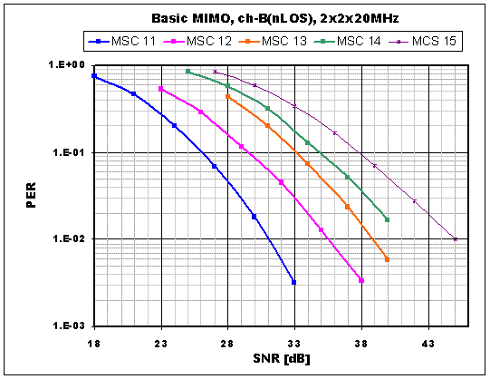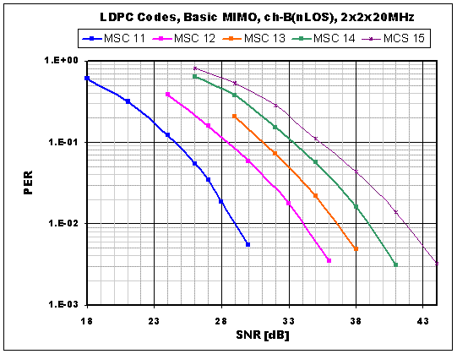

Figure 3-23: CC67 Channel B-NLOS, 2x2x20MHz, 1000-Byte (Half GI)
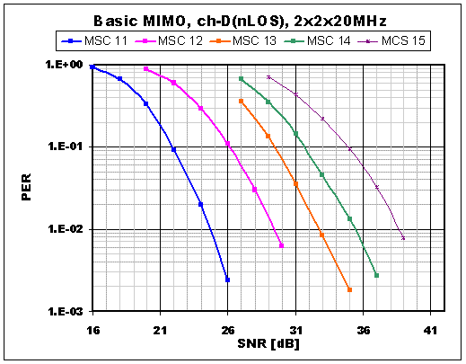
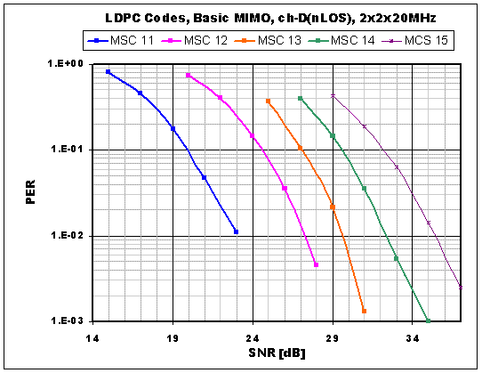

Figure 3-24: CC67 Channel D-NLOS, 2x2x20MHz, 1000-Byte
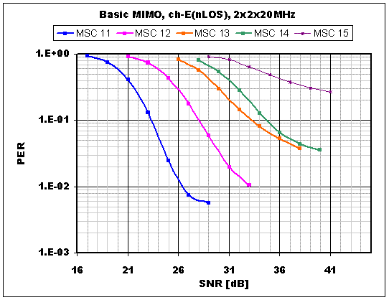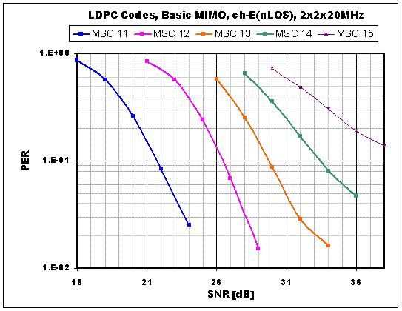

Figure 3-25: CC67 Channel E-NLOS, 2x2x20MHz, 1000-Byte
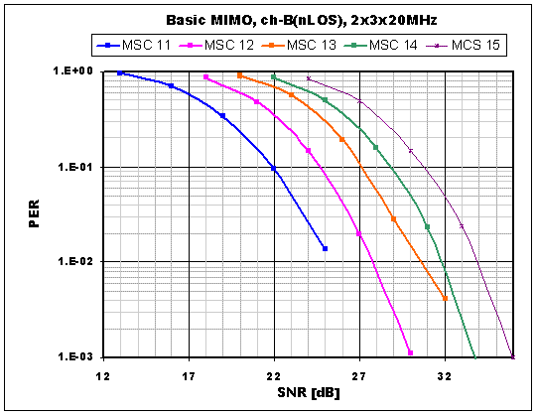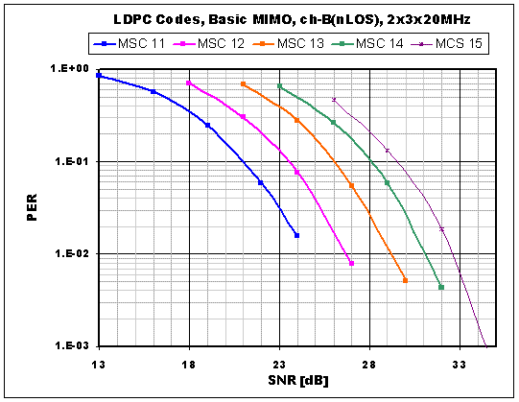

Figure 3-26: CC67 Channel B-NLOS, 2x3x20MHz, 1000-Byte (Half GI)
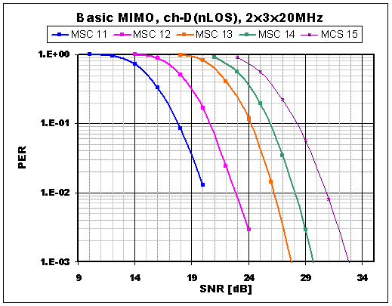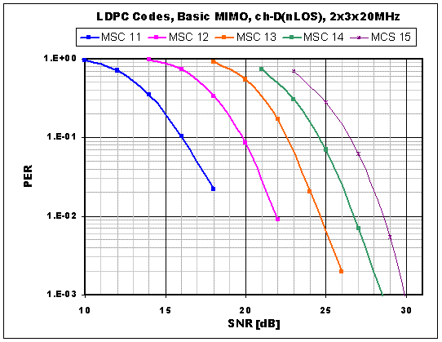

Figure 3-27: CC67 Channel D-NLOS, 2x3x20MHz, 1000-Byte
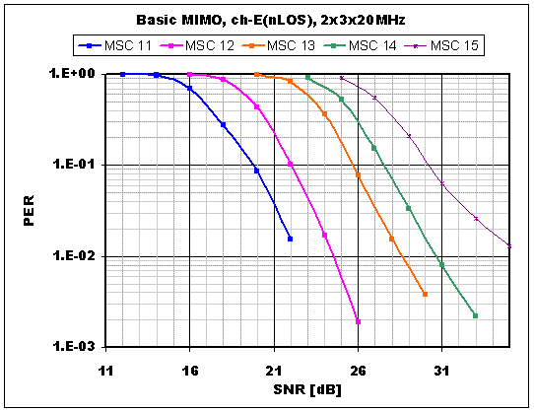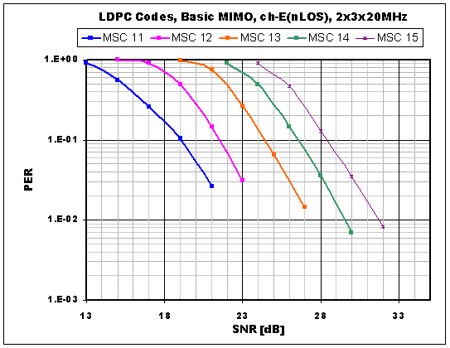

Figure 3-28: CC67 Channel E-NLOS, 2x3x20MHz, 1000-Byte

PHY-3 Simulations

This subsection provides the simulation results for CC 67. The performance is evaluated for B, D and E-NLOS channels and the results are presented in average Packet-Error-Rate (PER) versus Signal-to-Noise Ratio (SNR). The simulation set-up is given below:

- RF impairment: PA non-linearity (IM 1), carrier-frequency offset (IM 2), phase noise (IM 4) and antenna configuration (IM 6).
- PSDU length is 1000 bytes.
- Half guard interval (GI) for B-NLOS channel.
- Symbol and carrier frequency synchronization performed.
- Simple per tone channel estimation.
- No cyclic delay diversity (CDD).

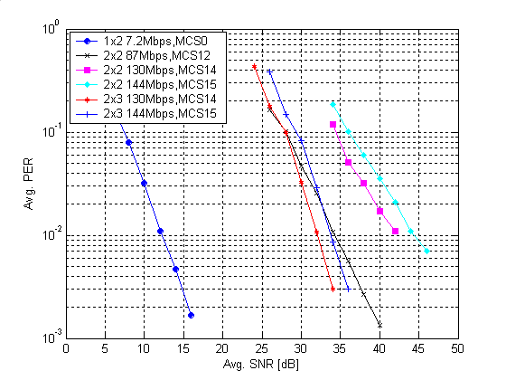

Figure 3-29: Channel B-NLOS, 20MHz, half GI

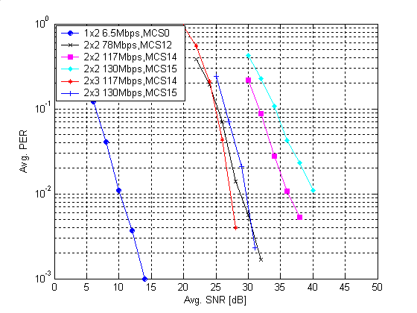
Figure 3-30: Channel D-NLOS, 20MHz, full GI

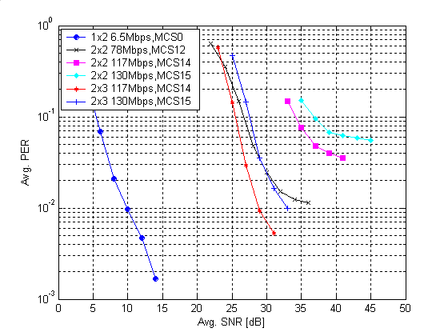
Figure 3-31: Channel E-NLOS, 20MHz, full GI
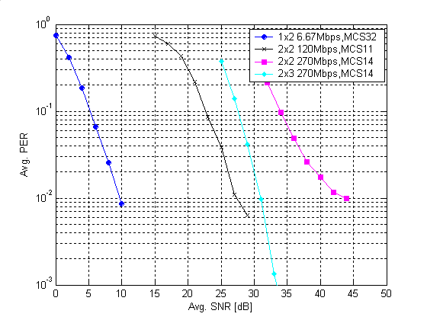
Figure 3-32: Channel B-NLOS, 40MHz, half GI

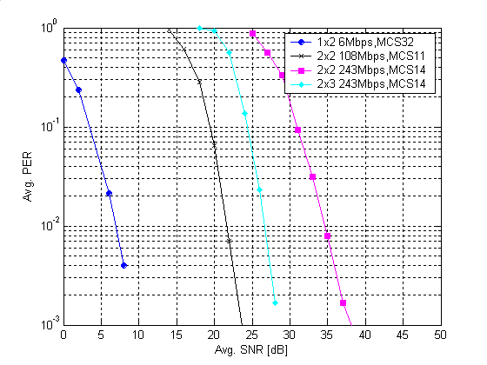
Figure 3-33: Channel D-NLOS, 40MHz, full GI
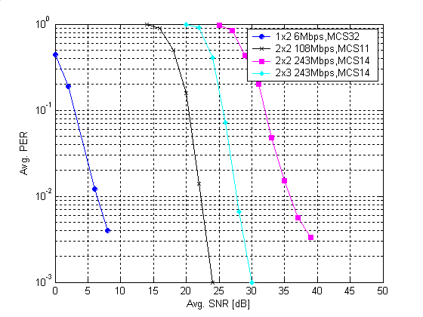
Figure 3-34: Channel E-NLOS, 40MHz, full GI

PHY-4 Simulations

This subsection provides CC67 simulation results for Basic MIMO. After here, when we write m x n, “m” is the number of Tx antennas (and it is identical to the number of spatial stream in basic MIMO case), and “n” is the number of Rx antennas.

Description of Simulator

Our simulator is fully CC compliant. Impairments include
- IM1 (PA non-linearity) is included. P=3 and OBO=8dB. Sampling clock is 200MHz for this module.
- IM2 (Carrier frequency offset) is included. Offset value is –13.675ppm, and sampling clock offset is also added. Actual timing acquisition is implemented.
- IM4 (Phase Noise) is included.
- IM6 (Antenna Configuration) is set to what IM6 of CC required, i.e., antenna configuration is linear array and distance between adjacent two antennas is a half λ.

Regarding channel model, we used the latest TGn Matlab code as it is.
- channel mode- B, D, and E.
- non-LOS models are used.
- Channel is varying during packet.
- Please note that our results don’t include fluorescent effect at the highest rate in channel-D

Other simulator descriptions are as follows;
- Our simulator includes
  - Analog filter model and other FIR filter at each sampling clock converting stage.
  - Packet detection without prior knowledge.
  - Frequency offset compensation and its tracking.
  - Time-of-arrival estimation, and sampling clock offset compensation and its tracking.
  - Actual channel estimation at receiver side (MMSE, without any successive cancellation).
  - Almost ideal AGC at L-STF and HT-STF.
- Our simulator doesn’t include
  - short GI
  - any advanced coding.
  - Walsh +CDD (spatial spreading)
- Other parameters
  - Floating calculation
  - T₀=600[nsec] (From OFDM symbol edge to FFT window starting point)
  - Trace-back length of Viterbi decoder is 128.
  - No smoothing filter for channel estimation.
  - PPDU length is 1000 bytes, as CC specified.
  - SNR is calculated as ensemble averaged SNR.
  - When the number of packet error reaches to 100, then quit from this loop.
  - 10,000 seeds of channel realization are used

20MHz results

Note that in contrast to other results in this document, the simulation results for Model-B presented here use the full GI and not the optional half GI. Additionally, the simulations for MCS31 reported here are for a 4TX, 4RX confiuration, whilst those reported in other sections are for a 4TX, 6RX configuration.

Figure 35: Channel B-NLOS, 20MHz, (Full GI)

Figure 36: Channel D-NLOS, 20MHz, (Full GI)

Figure 37: Channel E-NLOS, 20MHz, (Full GI)
Figure 38: Channel B-NLOS, 40MHz, (Full GI)

Figure 39: Channel D-NLOS, 40MHz, (Full GI)
Figure 40: Channel E-NLOS, 40MHz, (Full GI)

PHY-5 Simulations

Simulation parameters
- 4x4 and 2x2 system configurations
- 802.11n Channel models B, D, E
- 5.25 GHz
- All impairments (PA nonlinearity, phase noise, frequency offset, timing offset)
- Channel estimation and acquisition per packet
- PPDU length: 1000 bytes
- Extended MCS set (126 combinations with equal code rate, variable modulation per stream)
- Min. 100 packet errors per point
- HT-LTF MIMO training
- 52 data subcarriers, 4 tracking pilots, full GI

MCS 1 | 2x2 | 13 Mbps
MCS 5 | 2x2 | 52 Mbps
MCS 33 | 2x2 | 78 Mbps
MCS 41 | 2x2 | 117 Mbps
MCS 1 | 4x4 | 13 Mbps
MCS 38 | 4x4 | 78 Mbps
MCS 65 | 4x4 | 156 Mbps
MCS 112 | 4x4 | 195 Mbps

CC67 Simulation Results for ABF-MIMO

Figure 41: PER vs SNR in Channel B
Figure 42: PER vs SNR in Channel D

PHY Throughput Simulations

PHY throughput for ABF-MIMO

- 4x4 and 2x2 system configurations
- 802.11n Channel models B, D, E
- 5.25 GHz
- All impairments (PA nonlinearity, phase noise, frequency offset, timing offset)
- Channel estimation and acquisition per packet
- PPDU length: 1000 bytes
- Extended MCS set (126 combinations with equal code rate, variable modulation per stream)
- 100 channel realizations
- 50 packets per realization
- HT-LTF MIMO training
- 52 data subcarriers, 4 tracking pilots, full GI

Figure 43: Average PHY throughput vs SNR in Channel B

Figure 44: Average PHY throughput vs SNR in Channel D

Figure 45: Average PHY throughput vs SNR in Channel E

Comparison of PHY Throughput with TGnSync HT-LTF and WWiSE MIMO Training

- Basic MIMO mode (2x2)
- TGnSync Basic MCS (identical to WWiSE rates with the exception of BPSK, R=3/4, which we ignored)
- 52 data subcarriers, 4 tracking pilots, full GI
- Identical rate control parameters
- No impairments
- 802.11n Channels B, D, E
- Channel estimation and acquisition per packet
- PPDU length: 1000 bytes
- 100 channel realizations
- 50 packets per realization

Figure 46: Average PHY throughput in Channel B

Figure 47: Average PHY throughput in Channel D

Figure 48: Average PHY throughput in Channel E

Comparison of PHY Throughput for 2x1 TGnSync Beamforming and 2x1 WWiSE STBC

Simulation results using perfect channel estimates and 52 data subcarriers for both approaches. ABF-MIMO uses all the 1-stream rates in the Extended MCS set (max data rate 78 Mbps). STBC uses the WWiSE rate set, except BPSK, R=3/4 (max data rate 65 Mbps). Otherwise all rate control parameters are identical. Approximately 3 dB difference.

Figure 49: PHY throughput comparison of TX beamforming with STBC

PHY Throughput of 4x4 ABF-MIMO with TGnSync Extended MCS and TGnSync Basic MCS vs SS with Basic MCS

- 802.11n Channel model B
- 5.25 GHz
- All impairments (PA nonlinearity, phase noise, frequency offset, timing offset)
- Channel estimation and acquisition per packet
- PPDU length: 1000 bytes
- Extended MCS set (126 combinations with equal code rate, variable modulation per stream)
- Basic MCS set (8 combinations with equal code rate and modulation)
- HT-LTF MIMO training
- 52 data subcarriers, 4 tracking pilots, full GI
- 1000 channel realizations, 10 packets per real.

Figure 50: PHY Throughput comparison of Basic MIMO, Basic Beamforming
and Advanced Beamforming

Old PHY Throughput Simulations

The simulations presented in this section are not required by the comparison criteria.

In this section we define PHY Throughput to be the total number of bits delivered divided by the transmission time of the data portions of the transmitted PPDUs. This throughput does not include PLCP header overheads, or MAC overheads such as inter-frame space or contension time.

Ideal Throughput Simulations

The simulations presented in this subsection are “ideal” simulations because
- there are no impairments, and
- an ideal MCS selection algorithm is employed.

All of the simulations in this subsection use the MMSE receiver.

One purpose of these simulations is to investigate the potential throughput gains that are achievable using some of the optional features of the proposal; specifically, advanced coding and beam forming. Throughput simulations are particularly well suited for this purpose. When comparing different coding scheme, the data rates of the MCSs between to two systems to be compaired may not match.

Throughput depends on MCS selection algorithms. As is well know, SNR measurment alone is not a good predictor of PER. It is highly likely that practical MCS selection algorithm will need to be tuned to the particular air interface technology. Thus, our use of an ideal MCS selection algorithm provides a fair comparison between technologies; that is, one of the candidates is not given an unfair advantage via the particular algorithm employed.

The ideal throughput simulation is described as follows:
- Generate a channel realization H
- For each MCS, simulate 200 packet transmissions.
  - Estimate PER(H,MCS) given the number of error observed in the 200 simulations
  - Calculate TP(H,MCS) = (1 - PER(H,MCS)) * rate(MCS)
- Calculate per channel statistics
  - TP(H) = max_{MCS} TP(H,MCS)
  - PER(H) = max_{MCS} PER(H,MCS*) where MCS* = arg max_{MCS} TP(H,MCS)

The plotted simulation results are then averaged over 100 channel realizations H.

On a practical note, not all MCSs are actually simulated in step 2. There are obvious tricks to minimize the amount of simulation. For example, if the data rate of a given MCS* is less than the max TP(H,MCS) for the MCSs already simulated, then there is no point to simulate MCS*. By starting with the best MCS from the previous H, this eliminates many of the lower rate MCSs. Likewise, as the algorithm searches higher rate MCSs and TP(H,MCS) falls below, say, half the current best TP(H,MCS), then we can stop simulating. The program search parameters were tuned so that there was no difference in results between the reduced MCS search algorithm and exhaustive search.

Basic MIMO Simulations

Note: These simulations have not yet been updated to reflect the current TGnSync technical specification, however they remain here as they still serve a useful role to demonstrate the relative benefits of different modes of operation.

Figure 5-51, Figure 5-52 and Figure 5-53 show the throughput results of a comparison of four MIMO configuration, respectively, for Model B, Model D and Model E. These Basic MIMO simulation utilize MCS 0-15 for the 2x2 and 2x3 cases, and MCS 0-31 for the 4x4 case.

These figures show the “sweet spot” of 140 Mbps. If we assume a MAC efficiency of 70%, 140 Mbps is the required PHY throughput to reach the 100 Mbps top-of-MAC goal.

It is seen that the 2x2-40 MHz TGn Sync solution has a significant SNR advantage over the 20 MHz configuration.

It must be noted that if these curves were translated to throughput vs. range charts there would be a 3 dB plealty applied to the 40 MHz system due to the fact that the total transmit power is the same for both cases. After this shift 3 dB, it is clear that 2x2-40 MHz is roughly comparable in performance to 4x4-20 MHz.

However, it is still appropriate to compare throughput on the SNR scale for a very important reason. All else equal, High SNR implies high RF cost and power consumption. High SNR requires additional PA back-off, additional bits in data converters, additional dynamic range, less I/Q imbalance and highly linear analog circuits. These factors drive RF and analog cost and power consumption across the transmit and receive RF chains.

It is therefore clear that the 2x2 40 MHz configuration provides an extremely cost effective solution to achieve the 100 Mbps top-of-MAC throughput goal of 802.11n.

Figure 5-51: Basic MIMO Throughput Comparison Model B NLOS

Figure 5-52: Basic MIMO Throughput Comparison Model D NLOS

Figure 5-53: Basic MIMO Throughput Comparison Model E NLOS

In addition to throughput (and PER) statistics, the simulation algorithm can also collect MCS selection statistics to allow us to examine the relative frequency that various MCSs are selected. These results are shown in the following figures for Model D NLOS.

Compare the 2x2 and 2x3 20 MHz cases of Figure 5-54 and Figure 5-55. We see in the 2x2 case when the receiver can choose between MCSs of approximately the same rate but different numbers of spatial steams (1 or 2), that the lowner number of spatial streams generally wins. This is because in the 2x2 case, 2 spatial stream transmissions lacks diversity. Moving to the 2x3 chart, we clearly see the impact of the additional diversity in that the lower rate 2 spatial stream cases are chosen more often. The same trend is evident in 4x4 case in Figure 5-56, where we see a predominance of 3 spatial streams, and very little occurance of 4 spatial streams.

Figure 5-57 shows the 2x2-40 MHz case. These selection probability curves are quite similar to the 2x2-20 MHz case.

Figure 5-54: MCS Selection Probabilities for 2x2-20 MHz, Model D NLOS

Figure 5-55: MCS Selection Probabilities for 2x3-20 MHz, Model D NLOS

Figure 5-56: MCS Selection Probabilities for 4x4-20 MHz, Model D NLOS

Figure 5-57: MCS Selection Probabilities for 2x2-40 MHz, Model D NLOS

Beam Forming Simuations

Note: These simulations have not yet been updated to reflect the current TGnSync technical specification, however they remain here as they still serve a useful role to demonstrate the relative benefits of different modes of operation.

This subsection examines the impact of beam forming on throughput. We shall show results for both the ABF (Advanced Beam Forming) and much simpler BBF (Basic Beam Forming). In both cases we shall show that tremendous gains are achievable.

All of the Beam Forming calculations in this section were preformed using the SVD method.

ABF differs from BBF in two primary ways. ABF utilizes an extended MCS set, and it allows for variable power loading across spatial streams.

The extended MCS set includes MCSs having different code rates and different modulations across the spatial streams. Additionaly, the extended MCS set includes 256 QAM. Normally, 256 QAM would be difficult to support due to the high SNR requirement. However, beam forming gains allow these high data rate modes to operate with substantially lower SNRs, which potentially brings 256 QAM into the realm of possibility.

Figure 5-58, Figure 5-59 and Figure 5-60 show a comparison of 2x2, 3x2 and 4x2 the Advanced BF to 2x2 and 3x2 open loop. We see that the 3x2 advanced BF is generally several dB better than the 2x3 solution.
TGn Sync believes that the logical application for beam forming transmission is for very high throughput traffic with stringent QoS requirement; specifically streaming video such has HDTV. The technology makes sense because high costs and power consumption are contained in the media server, which could be a set-top box AP or a multi-media PC. Power consumption is not such a problem as these devices are pluged into the wall. One media server device, however, can serve high rate media to several low cost, low power (battery operated) clients.

Given the deployment secenario just described, the sweet spot configuration is that of the 4 transmit antenna media server device serving 2 receive antenna clients. The results of Figure 5-58, Figure 5-59 and Figure 5-60 indicate a consistent 10 dB gain relative to the 2x2 baseline. Of course, for the same configuration, one might argue that there are open loop transmit diversity methods that also provide gain. However, these will not achieve 10 dB diversity gain.

Next, Figure 5-61 through Figure 5-66 compare what is achievable with substantially less complexity than full advanced BF. We compare advance to two version of basic BF. Both basic BF are restricted to MCS 0-15, which do not include 256 QAM, and hence, the peak rate is the same as Basic open loop MIMO. The two variants are with and without variable power loading across spatial streams.

We see in the 2x2 cases that power loading and the extended MCS set do provide some reasonable gains. For the 4x2 cases, the simplest Basic BF without variable spatial stream power loading provides nearly as much throughput as the full advanced BF.

Figure 5-58: Advanced BF vs. Basic Open Loop Comparison, Model B

Figure 5-59: Advanced BF vs. Basic Open Loop Comparison, Model D

Figure 5-60: Advanced BF vs. Basic Open Loop Comparison, Model E

Figure 5-61: Comparison of Basic and Advanced BF, 2x2 - Model B

Figure 5-62: Comparison of Basic and Advanced BF, 4x2 - Model B

Figure 5-63: Comparison of Basic and Advanced BF, 2x2 - Model D

Figure 5-64: Comparison of Basic and Advanced BF, 4x2 - Model D

Figure 5-65: Comparison of Basic and Advanced BF, 2x2 - Model E

Figure 5-66: Comparison of Basic and Advanced BF, 4x2 - Model E

Throughput Simulations for Beamforming with Impairments

Note: These simulations have not yet been updated to reflect the current TGnSync technical specification, however they remain here as they still serve a useful role to demonstrate the relative benefits of different modes of operation.

This subsection provides additional throughput simulations to compare advanced beamforming with Basic MIMO. These are not CC67 compliant simulation from the point of required packets number.

- IM1 (PA non-linearity) is included. Rapp p = 3 and output back-off = 8dB. Sampling clock is 200 Msps.
- IM2 (carrier frequency offset) is included. Offset value is -13.675 ppm, and sampling clock offset is also added. Actual timing acquisition is implemented.
- IM4 (phase noise) is included.
- IM6 (antenna configuration) set to CC67 requirement of ½ wavelength antenna spacing.
- Packet detection, frequency offset compensation, and timing offset compression are implemented.
- Link adaptation algorithm
  - We implemented our original link adaptation algorithm.
  - It is not ideal one. It could be used in actual implementation.
  - Link adaptation uses the MCS set shown in Table 9, without restriction, as far as the number of spatial streams is equal to or less than the number of Tx antennas, in ABF mode.
  - In basic MIMO mode, N_{SS} is restricted to be the same as N_{Tx}. As a result, throughput at low SNR regions becomes low compared to the case of employing Walsh+CDD to map one spatial stream to two or more Tx antennas.
- Channel Seed
  - We used 100x100 PPDUs for showing rough comparison, fewer than required by CC67.
- Other remarks
  - We did not use 1 spatial stream Walsh+CDD for basic MIMO simulations.

Table 9: MCS Set
ID# | Stream  Count | Stream ID vs Modulation&Coding |  |  |  | Full GI
ID# | Stream  Count | stream 1 | stream 2 | stream 3 | stream 4 | Rate in  20MHz
0 | 1 | BPSK, 1/2 | N/A | N/A | N/A | 6
1 | 1 | QPSK, 1/2 | N/A | N/A | N/A | 12
2 | 1 | QPSK, 3/4 | N/A | N/A | N/A | 18
3 | 1 | 16QAM, 1/2 | N/A | N/A | N/A | 24
4 | 1 | 16QAM, 3/4 | N/A | N/A | N/A | 36
5 | 1 | 64QAM, 2/3 | N/A | N/A | N/A | 48
6 | 1 | 64QAM, 3/4 | N/A | N/A | N/A | 54
8 | 2 | BPSK, 1/2 | BPSK, 1/2 | N/A | N/A | 12
9 | 2 | QPSK, 1/2 | QPSK, 1/2 | N/A | N/A | 24
10 | 2 | QPSK, 3/4 | QPSK, 3/4 | N/A | N/A | 36
11 | 2 | 16QAM, 1/2 | 16QAM, 1/2 | N/A | N/A | 48
12 | 2 | 16QAM, 3/4 | 16QAM, 3/4 | N/A | N/A | 72
13 | 2 | 64QAM, 2/3 | 64QAM, 2/3 | N/A | N/A | 96
14 | 2 | 64QAM, 3/4 | 64QAM, 3/4 | N/A | N/A | 108
16 | 3 | BPSK, 1/2 | BPSK, 1/2 | BPSK, 1/2 | N/A | 18
17 | 3 | QPSK, 1/2 | QPSK, 1/2 | QPSK, 1/2 | N/A | 36
18 | 3 | QPSK, 3/4 | QPSK, 3/4 | QPSK, 3/4 | N/A | 54
19 | 3 | 16QAM, 1/2 | 16QAM, 1/2 | 16QAM, 1/2 | N/A | 72
20 | 3 | 16QAM, 3/4 | 16QAM, 3/4 | 16QAM, 3/4 | N/A | 108
21 | 3 | 64QAM, 2/3 | 64QAM, 2/3 | 64QAM, 2/3 | N/A | 144
22 | 3 | 64QAM, 3/4 | 64QAM, 3/4 | 64QAM, 3/4 | N/A | 162
24 | 4 | BPSK, 1/2 | BPSK, 1/2 | BPSK, 1/2 | BPSK, 1/2 | 24
25 | 4 | QPSK, 1/2 | QPSK, 1/2 | QPSK, 1/2 | QPSK, 1/2 | 48
26 | 4 | QPSK, 3/4 | QPSK, 3/4 | QPSK, 3/4 | QPSK, 3/4 | 72
27 | 4 | 16QAM, 1/2 | 16QAM, 1/2 | 16QAM, 1/2 | 16QAM, 1/2 | 96
28 | 4 | 16QAM, 3/4 | 16QAM, 3/4 | 16QAM, 3/4 | 16QAM, 3/4 | 144
29 | 4 | 64QAM, 2/3 | 64QAM, 2/3 | 64QAM, 2/3 | 64QAM, 2/3 | 192
30 | 4 | 64QAM, 3/4 | 64QAM, 3/4 | 64QAM, 3/4 | 64QAM, 3/4 | 216
33 | 1 | 256QAM, 3/4 | N/A | N/A | N/A | 72
34 | 2 | QPSK, 3/4 | BPSK, 1/2 | N/A | N/A | 24
35 | 2 | QPSK, 3/4 | BPSK, 3/4 | N/A | N/A | 27
36 | 2 | 16QAM, 1/2 | QPSK, 1/2 | N/A | N/A | 36
37 | 2 | 16QAM, 3/4 | QPSK, 1/2 | N/A | N/A | 48
38 | 2 | 16QAM, 3/4 | QPSK, 3/4 | N/A | N/A | 54
39 | 2 | 64QAM, 2/3 | BPSK, 1/2 | N/A | N/A | 54
40 | 2 | 64QAM, 3/4 | QPSK, 3/4 | N/A | N/A | 72
41 | 2 | 64QAM, 2/3 | 16QAM, 1/2 | N/A | N/A | 72
42 | 2 | 256QAM, 3/4 | 16QAM, 1/2 | N/A | N/A | 96
43 | 2 | 256QAM, 3/4 | 16QAM, 3/4 | N/A | N/A | 108
44 | 2 | 256QAM, 3/4 | 256QAM, 3/4 | N/A | N/A | 144
45 | 3 | 16QAM, 3/4 | 16QAM, 1/2 | QPSK, 1/2 | N/A | 72
46 | 3 | 64QAM, 2/3 | QPSK, 3/4 | BPSK, 1/2 | N/A | 72
47 | 3 | 64QAM, 3/4 | 16QAM, 1/2 | QPSK 3/4 | N/A | 96
48 | 3 | 64QAM, 3/4 | 16QAM, 3/4 | QPSK, 3/4 | N/A | 108
49 | 3 | 64QAM, 3/4 | 64QAM, 2/3 | BPSK, 1/2 | N/A | 108
50 | 3 | 64QAM, 3/4 | 64QAM, 3/4 | 16QAM, 3/4 | N/A | 144
51 | 3 | 256QAM, 3/4 | 64QAM, 2/3 | 16QAM, 1/2 | N/A | 144
52 | 3 | 256QAM, 3/4 | 64QAM, 3/4 | QPSK 3/4 | N/A | 144
53 | 3 | 256QAM, 3/4 | 64QAM, 3/4 | 16QAM, 3/4 | N/A | 162
54 | 3 | 256QAM, 3/4 | 256QAM, 3/4 | QPSK 3/4 | N/A | 162
55 | 3 | 256QAM, 3/4 | 256QAM, 3/4 | 64QAM, 2/3 | N/A | 192
56 | 4 | 64QAM, 2/3 | 16QAM, 3/4 | BPSK, 1/2 | BPSK, 1/2 | 96
57 | 4 | 64QAM, 3/4 | 64QAM, 3/4 | 16QAM, 1/2 | QPSK, 1/2 | 144
58 | 4 | 256QAM, 3/4 | 64QAM, 3/4 | 64QAM, 2/3 | QPSK, 3/4 | 192
59 | 4 | 256QAM, 3/4 | 64QAM, 3/4 | 64QAM, 3/4 | QPSK, 1/2 | 192
60 | 4 | 256QAM, 3/4 | 256QAM, 3/4 | 16QAM, 3/4 | QPSK, 1/2 | 192
61 | 4 | 256QAM, 3/4 | 256QAM, 3/4 | 64QAM, 2/3 | 16QAM, 1/2 | 216
62 | 4 | 256QAM, 3/4 | 256QAM, 3/4 | 64QAM, 3/4 | QPSK, 3/4 | 216

Figure 5-67 : Channel-B (nLOS) Throughput, 2x2 : 2x3 : 3x2

Figure 5-68 : Channel-B (nLOS) Throughput, 4x4
Figure 5-69 : Channel-D (nLOS) Throughput, 2x2 : 2x3 : 3x2

Figure 5-70 : Channel-D (nLOS) Throughput, 4x4

Figure 5-71 : Channel-E (nLOS) Throughput, , 2x2 : 2x3 : 3x2

Figure 5-72 : Channel-E (nLOS) Throughput, 4x4

