IEEE P802.11
Wireless LANs
Structured LDPC Codes as an Advanced Coding Scheme for 802.11n
Date: August 13, 2004
Authors: Aleksandar Purkovic, Sergey Sukobok, Nina Burns, Levent Demirekler, Zhaoyun Huang
Nortel Networks
20410 Century Blvd., Germantown, MD 20874, USA
Phone: 1-301-528-3230
Fax: 1-301-528-3298
e-Mail: apurkovi@nortelnetworks.com

Abstract
This document describes a partial proposal being submitted to the TGn of the 802.11 Working Group. A particular family of structured Low-Density Parity-Check (LDPC) codes was described, which we believe fully addresses the requirements presented before the 802.11n PHY layer. It has been recognized that advanced coding schemes exhibit significant coding gain over the existing convolutional codes especially for large information block sizes and when low Forward Error Correction (FEC) overhead is desirable (high coding rates). We believe that LDPC codes offer a good compromise in terms of performance and complexity. Furthermore, structured LDPC codes, described in this document, allow additional benefits for practical implementation, such as simple encoder, wire routing task for the decoder with reasonable complexity, etc.

Introduction

This document describes a partial proposal being submitted to the TGn of the 802.11 Working Group. A particular family of structured Low-Density Parity-Check (LDPC) codes was described, which we believe fully addresses the requirements presented before the 802.11n PHY layer. It has been recognized that advanced coding schemes exhibit significant coding gain over the existing convolutional codes especially for large information block sizes and when low Forward Error Correction (FEC) overhead is desirable (high coding rates). We believe that LDPC codes offer a good compromise in terms of performance and complexity. Furthermore, structured LDPC codes, described in this document, allow additional benefits for practical implementation, such as simple encoder, wire routing task for the decoder with reasonable complexity, etc.

Section 2. describes construction of structured LDPC parity check matrix as well as how a base parity check matrix can be expanded to suite a range of information block lengths. In Section 3. the encoding process is outlined. Definition of the particular parity check matrix, corresponding performance results, and comparison with the existing convolutional codes are presented in Section 4. Section 5. addresses some of the implementation issues including a short discussion on the latency. Finally, Section 6. covers the summary and conclusions.

Construction of the structured LDPC parity check matrix based on π–rotation

This parity check matrix H construction involves two steps. In the first step, a “base” parity check matrix is constructed for the highest required code rate. This construction is based on the π–rotation method [1]. Next, the base matrix is expanded in order to best fit requested information block size (K) and the code rate (R=K/N) combination, where N equals the codeword length.

Base parity check matrix construction

The base LDPC parity check matrix of the size MxN (M – number of parity check bits, M=N-K), constructed this way can be represented in the following general form:

H = [H_{d,q}|…|H_{d,3}|H_{d,2}|H_{d,1}|H_{p}] = [H_{d}|H_{p}]

All of the component sub-matrices, H_{p}, H_{d,1}, H_{d,2},…, H_{d,q} are square matrices of the size MxM. Code rate of the base parity check matrix is given by: R = q/(q+1).

Combined H_{d,i}, (i=1,2,…,q) matrices form an MxK matrix, H_{d}, which corresponds to the “data” bits of the codeword. The design of this matrix ensures high coding gain and will be described in more details later on.

H_{p} is an MxM “dual diagonal” matrix, which corresponds to the “parity” bits of the codeword. It can be represented as:

$$H_{p}=\begin{aligned}\left[\text{1 0 0 0 }\text{.}\text{.}\text{.}\text{ 0 0} | \right]\left[\text{1 1 0 0 }\text{.}\text{.}\text{.}\text{ 0 0} | \right]\left[\text{0 1 1 0 0 }\text{.}\text{.}\text{.}\text{ 0} | \right]\left[ \text{.}\text{.}\text{.}\text{.}\text{.}\text{.}\text{.}\text{.}\text{.}\text{.}\text{.} | \right]\left[ \text{.}\text{.}\text{.}\text{.}\text{.}\text{.}\text{.}\text{.}\text{.}\text{.}\text{.} | \right]\left[\text{0 }\text{.}\text{.}\text{.}\text{ 0 1 1 0 0} | \right]\left[\text{0 0 }\text{.}\text{.}\text{.}\text{ 0 1 1 0} | \right] \\ \end{aligned}$$

Code rates lower than the maximum, q/(q+1), can be achieved by “shortening”, i.e. by using only some portion of the matrix H_{d}. Examples bellow show how the shortening is done. Only highlighted portion of the parity check matrix H is used.

H = [H_{d,q}|…|H_{d,3}|H_{d,2}|H_{d,1}|H_{p}] → for R=1/2

H = [H_{d,q}|…|H_{d,3}|H_{d,2}|H_{d,1}|H_{p}] → for R=2/3

H = [H_{d,q}|…|H_{d,3}|H_{d,2}|H_{d,1}|H_{p}] → for R=3/4

…

H = [H_{d,q}|…|H_{d,3}|H_{d,2}|H_{d,1}|H_{p}] → for R=q/(q+1)

In general, the shortened H matrix doesn’t have to include integral number of H_{d,i} matrices, in which case obtained code rates lie in between those outlined above.
Matrices H_{d,i}, (i=1,2,…,q) are constructed by using modified π-rotation technique, originally described in [1]. Each of the matrices H_{d,i} can be represented in the following form:

$$H_{\text{d,i}}=\begin{aligned}\left[π_{A,i}π_{B,i}π_{C,i}π_{D,i} | \right]\left[π_{B,i}π_{C,i}π_{D,i}π_{A,i} | \right]\left[π_{C,i}π_{D,i}π_{A,i}π_{B,i} | \right] \\ \end{aligned}$$

$π_{A,i}$is an mxm permutation matrix, whereas $π_{B,i},π_{C,i},$ and $π_{D,i}$are obtained by 90º, 180º, and 270º counterclockwise rotations of the permutation matrix $π_{A,i}$, respectively. Permutation matrix is defined as the matrix in which each row and column have weight equal to one (row/column weight are defined as the number of 1’s in a row/column, respectively). An example of such permutation matrices is shown below for m = 6.

$π_{A,i}=$$\begin{aligned}\left[\text{0 0 0 0 1 0} | \right]\left[\text{0 0 0 0 0 1} | \right]\left[\text{1 0 0 0 0 0} | \right]\left[\text{0 0 1 0 0 0} | \right]\left[\text{0 1 0 0 0 0} | \right] \\ \end{aligned}$ $π_{D,i}=$$\begin{aligned}\left[\text{0 0 0 1 0 0} | \right]\left[\text{0 1 0 0 0 0} | \right]\left[\text{0 0 1 0 0 0} | \right]\left[\text{1 0 0 0 0 0} | \right]\left[\text{0 0 0 0 0 1} | \right] \\ \end{aligned}$

$π_{B,i}=$$\begin{aligned}\left[\text{0 1 0 0 0 0} | \right]\left[\text{1 0 0 0 0 0} | \right]\left[\text{0 0 0 0 0 1} | \right]\left[\text{0 0 0 1 0 0} | \right]\left[\text{0 0 0 0 1 0} | \right] \\ \end{aligned}$ $π_{C,i}=$$\begin{aligned}\left[\text{0 0 1 0 0 0} | \right]\left[\text{0 0 0 0 1 0} | \right]\left[\text{0 0 0 1 0 0} | \right]\left[\text{0 0 0 0 0 1} | \right]\left[\text{1 0 0 0 0 0} | \right] \\ \end{aligned}$

Each component permutation matrix $π_{A,i}$ is completely specified by a length-m permutation vector v_{A,i} = [v_{A,i,1}, v_{A,i,2},…,v_{A,i,m}]. Permutation vector can be generated by first selecting a pair of small seed numbers (a_{i},b_{i}) and then by applying a simple algorithm which converts pair (a_{i},b_{i}) into corresponding vector v_{A,i}. Vector v_{A,i}. defines positions of 1’s in $π_{A,i}$, in the following fashion: v_{A,i,1} specifies the position of a “1” in the first column of $π_{A,i}$, (counting from the bottom), v_{A,i,2} specifies the position of a “1” in the second column of $π_{A,i}$, and so on. For the previous example for m=6, $π_{A,i}$ is completely specified by the permutation vector v_{A,i}=[4, 2, 3, 1, 6, 5]. This example permutation vector could have been created by selecting a pair of small numbers (a, b) = (5, 3) and applying the following algorithm:

Initialization:
s₀ = 0, s₁ = 1, …, s_{m-1} = m-1
u = m

Algorithm:
for j = 1 to m
k = (a∗j+b)mod(m+1-j)
v_{A,i}(j) = m–s_{k}
for n = k to u
s_{n} = s_{n+1}
n = n+1
end
u = u–1
j = j+1
end

This way a base matrix designed for rate R=q/(q+1) is completely specified by 2q+1 numbers only:

m, a₁, b₁, a₂, b₂, …, a_{q}, b_{q}

In terms of the row and column weights, this base parity check matrix has the following properties. Last (rightmost) column has weight 1, other columns in H_{p} have weight 2, whereas all the columns in H_{d} portion of the parity check matrix have weight 4. First (top) row has weight 4q+1, whereas all other rows have weight 4q+2. In other words, H_{d} portion of the parity check matrix is both column and row regular: column weight is fixed to 4 and row weight is fixed to 4q.

This particular parity check matrix construction allows very compact specification and various implementation optimizations and tradeoffs, which will be addressed in Section 5.

The matrix generation process is performed by the “divide and conquer” technique. First, search is performed to find rate 1/2 matrix. The key criteria used during the search are large minimum distance, which guarantees acceptable performance bound, and good girth distribution (the girth of a graph is defined as the smallest cycle length that exists in the graph), which is important for the effectiveness of the decoding by the Sum Product Algorithm (SPA). This way H_{d,1} is determined. With H_{d,1} fixed, the search process continues in order to find H_{d,2}, and so on.

Expansion of the base parity check matrix

If there is a need to accommodate a larger block size, base parity check matrix may be expanded by an integer factor L, from the base MxN = 4mx4m(q+1) matrix to a 4mLx4mL(q+1) matrix. Factor L should be chosen to be a small integer number in order to keep the hardware complexity at a reasonable level. The expansion of H_{p} and H_{d,i} component sub-matrices, is performed differently, however.

Expansion of H_{p} is done by replacing each “0” element by an LxL zero matrix, 0_{LxL}, and each “1” element by an LxL identity matrix, I_{LxL}.

Expansion of H_{d,i} is done by replacing each “0” element by an LxL zero matrix, 0_{LxL}, and each “1” element by a rotated version of an LxL identity matrix, I_{LxL}. The rotation order, s (number of circular shifts to the right, for example) can be determined, for example, by using a simple rule: s = (r x c)_{mod L}, where r and c correspond to the row and column index of the particular “1” element, respectively.

Encoding

Described structure of the LDPC parity check matrix enables a simple encoding algorithm. In general, by the definition of the parity check matrix, the following holds:

H_{MxN}c_{Nx1} = 0_{Mx1} ,

where H is the parity check matrix, 0_{Mx1} is an all-zero Mx1 vector, and c is the codeword vector given by:

c = [d₁,d₂,…,d_{K},p₁,p₂,…,p_{M}]^{T} = $\left[\frac{d}{p}\right]$

In the expression above vector d =[d₁,d₂,…,d_{K} ]^{T} represents information bits (systematic part), whereas vector p = [p₁,p₂,…,p_{M}]^{T} represents parity bits (redundancy part). Due to the dual diagonal structure of the sub-matrix H_{p}, parity bits can be computed recursively as:

$p_{1}=\sum_{n=1}^{k_{1}}{h_{1,i_{n}^{1}}d_{i_{n}^{1}}},$where $i_{n}^{1}$ is the index of the column in which row 1 contains a “1”

$p_{2}=p_{1}+\sum_{n=1}^{k_{2}}{h_{2,i_{n}^{2}}d_{i_{n}^{2}}},$ where $i_{n}^{2}$ is the index of the column in which row 2 contains a “1”

…

$p_{M}=p_{M−1}+\sum_{n=1}^{k_{M}}{h_{M,i_{n}^{M}}d_{i_{n}^{M}}},$ where $i_{n}^{M}$ is the index of the column in which row M contains a “1”

In these recursive expressions h_{r,c} are non zero elements (=1) of the used (highlighted in the examples above) portion of the “data” part of the parity check matrix, H_{d}. Number of these non-zero elements in rows 1,2,…,M, is represented by k₁, k₂,…, k_{M}, respectively. In the particular case, when (w) H_{d,i} , (i=1,2,..,w) matrices are used and the achieved code rate is exactly w/(w+1), the “data” part of the parity check matrix is row regular and therefore, k₁=k₂=…=k_{M}=const=4w.

Therefore, the encoding operation can be performed efficiently by applying above recursions. It requires only simple AND and XOR circuits.

For the cases when the information block size is above a specified threshold, concatenation of the codewords is employed. The reason behind this approach is that we believe it represents a reasonable complexity and performance trade-off. Namely, it has been argued in various publications that designing a code for the codeword size of 2000-3000 bits represents a “sweet spot” considering the level of current technology and the anticipated requirements to be set for the 802.11n devices (please refer to [2], for example).

Parity check matrix definition and performance evaluation

In this section a particular matrix is proposed for the 802.11n application for coding rates ≤7/8 and performance results are provided for the information packet length of K = 1000 bytes.

Parity check matrix definition

Base matrix of the size (MxN)=(332x2656), corresponding to the maximum code rate of 7/8, is completely specified by the following set of parameters:

[m, a₁, b₁, a₂, b₂, a₃, b₃, a₄, b₄, a₅, b₅, a₆, b₆, a₇, b₇] = [83,5,8,2,48,7,51,3,30,3,23,17,16,9,8]

These parameters are used in conjunction with the algorithm described in 2.1. in order to compute permutation vectors v_{A,i} , which in turn define permutation matrices $π_{A,i}$, i = 1,2,…, 7. The whole matrix is symbolically represented below:

Figure 1. Parity check matrix for rate 7/8

As it was explained in 2.1., $π_{B,i},π_{C,i},$and $π_{D,i}$are obtained by 90º, 180º, and 270º counterclockwise rotations of the permutation matrix $π_{A,i}$, respectively. Alternatively, one may choose to compute permutation vectors v_{B,i} , v_{C,i} , and v_{D,i} , corresponding to $π_{B,i},π_{C,i},$and $π_{D,i}$, respectively, by applying the following algebraic expressions:

For j = 1, 2, …, m (m=83):

v_{B,i}[m+1- v_{A,i}(j)] = j, v_{C,i}(j) = m+1- v_{A,i}(m+1-j), v_{D,i}(j) = m+1- v_{B,i}(m+1-j).

A range of code rates and information block sizes is made possible by shortening (using only part of H_{d}), expansion by a factor L (small integer), and concatenation. For example, if the information block of size of 1000bytes (8000bits) needs to be encoded with code rates of 1/2, 2/3, 3/4, and 7/8, the following table lists expansion factors and number of concatenated codewords. It also shows achieved effective code rates.

Code rate | Expansion factor (L) | Number of codewords | Effective code rate
R = 1/2 = 0.5 | L = 4 | 6 | R_{eff} = 0.501
R = 2/3 = 0.667 | L = 4 | 3 | R_{eff} = 0.667
R = 3/4 = 0.75 | L = 4 | 2 | R_{eff} = 0.751
R = 7/8 = 0.875 | L = 2 | 2 | R_{eff} = 0.858

Performance evaluation

Guidelines specified in the Comparison Criteria document, CC59 and CC67 were partially followed. Impairments other than Gaussian noise and fading channel (modelled according to the Channel Models document, [5]) were not implemented in order to have FEC code performance evaluated independently of other receiver modules and adaptive algorithms as much as possible. Channel interleaver according to the 802.11a specification was applied to the convolutional code case only. In the case of LDPC codes interleaver was not needed.

Packet Error Rate (PER) results provided below for 1000 byte packet are based on the floating point Sum-Product algorithm with 20 iterations. Figure 2 and Figure 3 correspond to AWGN and Channel Model D, respectively.

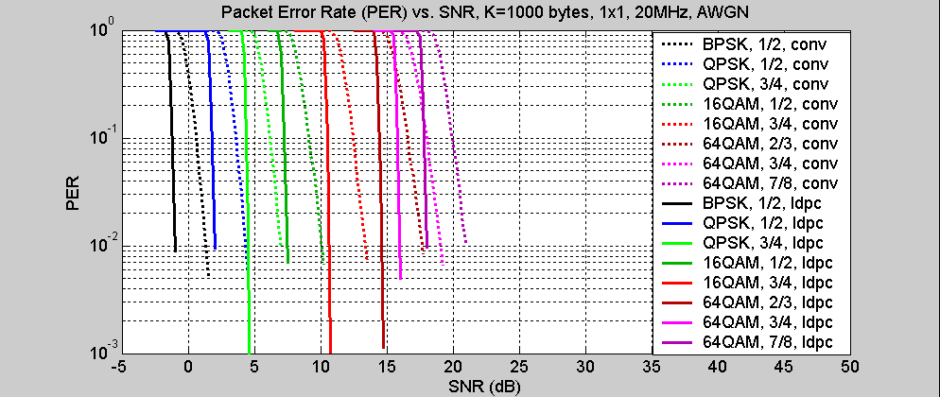
Figure 2. Packet error rate, AWGN channel

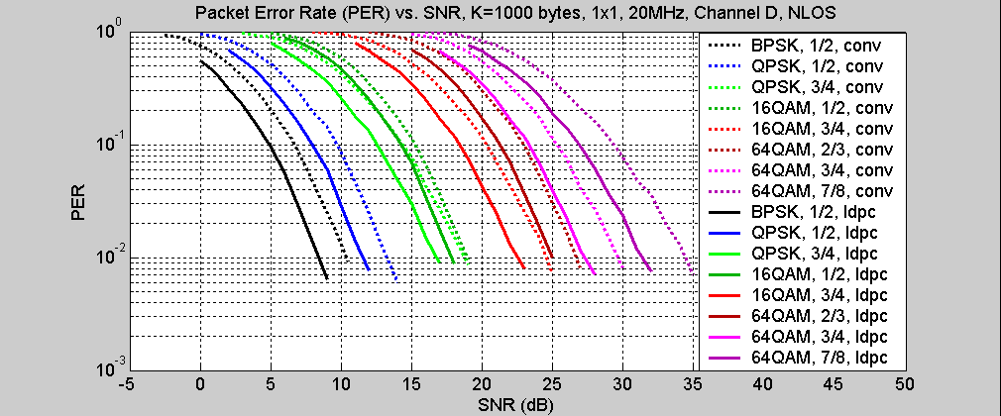
Figure 3. Packet error rate, channel model D

Implementation issues and latency

The main reason behind choosing the path leading towards a structured parity check matrix was because of ever present complexity concerns. We believe that this particular parity matrix construction offers advantage of considerable coding gain over the existing convolutional codes and at the same time enables efficient hardware implementations.

Encoding
It was shown in Section 3. that dual diagonal structure of the matrix H_{p} enables efficient recursive encoding. In this section we elaborate more on how the structure of matrices H_{d,i} can be exploited to further reduce complexity of the encoder. An alternative approach is to first compute the “projection vector”, $υ$. Namely, from:

$\text{Hc}=[H_{d}|H_{p}]\left[\frac{d}{p}\right]=0$ we have: $H_{d}d=H_{p}p=υ$. Parity check bits (vector p) can be therefore calculated in two steps:

Step 1: Calculate projection vector $υ$ from: $υ=H_{d}d$
Step 2: Calculate parity vector p from: $[H_{p}]^{−1}υ=L_{p}υ$, where $L_{p}$is a convenient lower-triangular matrix (due to the dual-diagonal structure of $H_{p}$)

Projection vector can be now efficiently calculated by employing π-rotation structure of H_{d}. Each segment of $υ$, $υ_{i}$, corresponding to the square matrix H_{d,i}, is further divided into four parts of length m, the size of the permutation matrix. Now, we can use the following expression:

$$υ_{i}=H_{\text{d,i}}d_{i}→\begin{aligned}\left[υ_{i,1} | \right]\left[υ_{i,2} | \right]\left[υ_{i,3} | \right] \\ \end{aligned}$$

This matrix equation can be converted into a set of linear equations as follows:

$$υ_{i,1}=π_{A,i}d_{i,1}+π_{B,i}d_{i,2}+π_{C,i}d_{i,3}+π_{D,i}d_{i,4}$$
$$υ_{i,2}=π_{B,i}d_{i,1}+π_{C,i}d_{i,2}+π_{D,i}d_{i,3}+π_{A,i}d_{i,4}$$
$$υ_{i,3}=π_{C,i}d_{i,1}+π_{D,i}d_{i,2}+π_{A,i}d_{i,3}+π_{B,i}d_{i,4}$$
$$υ_{i,4}=π_{D,i}d_{i,1}+π_{A,i}d_{i,2}+π_{B,i}d_{i,3}+π_{C,i}d_{i,4}$$

It can be seen that permutation matrices $π_{A,i},π_{B,i},π_{C,i},π_{D,i}$need to be instantiated in hardware only once. They can then be reused. Figure 4 below shows symbolically how this may be accomplished by “rotating” m-long data segments $d_{i,1},d_{i,2},d_{i,3},d_{i,4}$around.
Figure 4. Projection vector computation by hardware reuse
More details on this approach can be found in [3].

Decoding

Although codes proposed here can be decoded by using generic architectures implementing SPA or Min-Sum (SPA approximation) algorithms, this parity check matrix is of the structure that can be exploited in practical implementations for various optimisations. This fact greatly reduces the problem generally associated with the highly irregular hardware interconnectivity, which is normally associated with LDPC codes. Codes constructed this way can be considered to be created by an “architecture aware” code design, with the advantages thoroughly elaborated in [4].

With respect to the finite precision implementation, regularity in column weight (Section 2.1.) potentially offers benefits over irregular constructions.

Latency

At this time we cannot offer some concrete estimates since the decoder was not implemented in VLSI. However, some general statements can be made. Tradeoffs between the hardware complexity and the latency are possible. It is indicated in [2] that latency as low as 1μs can be practically achieved with the parity check matrices of similar size.

Summary and conclusions

We have described a family of structured LDPC codes designed for the 802.11n application. During the code design we adhered to the following design objectives:

- Considerable coding gain over existing convolutional codes
- Simple encoding algorithm
- Coverage of the required range of information block lengths and code rates
- Support for the additional code rates above the current maximum (3/4)
- Enable efficient decoder hardware implementations

Preliminary performance results and complexity analysis qualify these codes as good candidates for the advanced coding for 802.11n. It is important to point out that these codes can be further refined to better fit the 802.11n standard as it shapes up, especially considering various MIMO schemes.

References

[1] R. Echard, S. Chang, “The π-rotation low-density parity check codes,” In Proc. GLOBECOM 2001, pp. 980-984, Nov. 2001.
[2] IEEE 802.11-03/865r1, “LDPC FEC for IEEE 802.11n Applications,” Eric Jacobsen, Intel, November 2003.
[3] Rich Echard, On the Construction of Some Deterministic Low-Density Parity Check Codes,” PhD thesis, George Mason University, 2002
[4] M.M.Mansour and N.R.Shanbhag, “High-Throughput LDPC Decoders,” IEEE Trans. On VLSI Systems, vol. 11, No 6, pp. 976-996, December 2003
[5] IEEE 802.11-03/940r4, “TGn Channel Models”, TGn Channel Models Special Committee, May 2004.

