IEEE P802.11
Wireless LANs
Action Ethertype
Date: July 9, 2004
Author: Tim Moore
Microsoft
1 Microsoft Way, Redmond, WA
Phone: 425-703-9861
Fax:
e-mail:timmoore@microsoft.com
Abstract

SME-Infomaion frames are sent by the SME and received by the SME. The information when received by the SME is inserted in one or more MIB and so is available to everyone. Since in 802.11k the SME initiates the measurement requests, this document describes a proposal to use a new Ethertype frame format to send measurement and site requests and to send measurement and site reports. This document uses the new Ethertype frame formation for both protected and unprotected frames. These Ethertype frames can be protected via the data frame protection since they are data frames.
When a SME Radio measurement entity wants to request for a measurement report, it sends a measurement request using SME-Information frame formats, the receiving SME uses the MLME-MEASURE primitive to make the measurements and then sends a measurement report response containing the measurements.
SME-Information frames are sent and received by the the Radio Measurement entity within the SME.

Requestor SME Requestee MAC Requestee SME
-----------------------------------------------------------------------------------------------------------------------------------------------------------→
Measurement Request
←------------------------------------
MLME-MEASURE.Request

------------------------------------→
MLME-MEASURE.Confirm
←----------------------------------------------------------------------------------------------------------------------------------------------------------
Measurement Report

Delete section 5.7.8, 5.7.9 from 11k

Delete section 7.4.2 from 11k

Change Figure 11 (11i) to

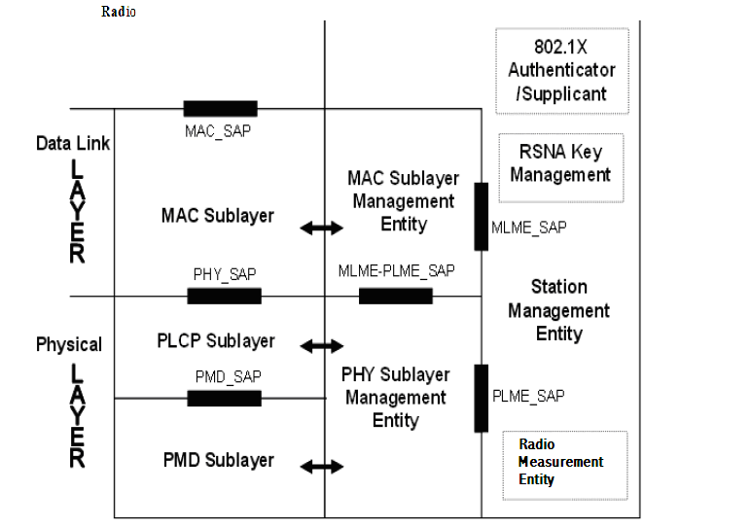

Insert new section 11.4

11.4 SME-Information Frame
When the SME initiates the measurement or site requests, the SME sends a SME-Information frame to the peer SME Radio Measurement entity Since these frames are data frames they are protected via the normal data protection mechanism. The format of the SME-Information frame is as follows:

Fields | Octets
SME-Information Ethertype | 1-2
SME-Information Version | 3
SME-Information Type | 4
SME-Information Length | 5-6
SME-Information Body | 7-N
Figure 97 – SME-Information frame format

The SME-Information Type field is XX-XX.

Informational Note: XX-XX is an EtherType to be allocated by IEEE RAC during sponsor ballot and this note is to be removed once allocated.

The SME-Information Version field is 1.

The SME-Information Type field is defined in Table 20h:

Table 20h – SME-Information Type values

SME-Information Type Value | Description
255 | Action

SME-Information Length field contains the length of the SME-Infomation Body. This field is two octets in length, taken to represent an unsigned binary number. The value of this field defines the length in octets of the SME-Information Body field; a value of 0 indicates that there is no SME-Information Body field present.

11.4.1 SME-Information Action
The SME-Information body format for a frame with the SME-Information Type of Action is defined as:

Category | Action | Dialog Token | IEs
1 Octet | 1 Octet | 1 Octet | 0-N Octets
Figure 97 – SME-Information Action frame format

Category shall be set according to Table 19a.
Action shall be set according to Table 20f.
Dialog Token shall be as defined in clause 7.4.1.1.

11.4.1.1 Radio Measurement Action Details
Five Action frame formats are defined for Radio Measurement purposes. An Action field, in the octet field immediately after the Category field, differentiates the five formats. The Action field values associated with each frame format are defined in Table 20f.
Table 20f—Radio Measurement Action field values
Action field value | Description
0 | Measurement Request
1 | Measurement Report
2 | Reserved
3 | Reserved
4 | Site Report Request
5 | Site Report Response
6-255 | Reserved

11.4.1.1.1 Measurement Request SME-Information Action frame format
The Measurement Request frame uses the SME-Information Action frame body format and is transmitted by a STA requesting another STA to measure one or more channels. The format of the SME-Information Action frame body shall be as defined in 7.4.1.1.
The Category field shall be set to indicate the Radio Measurement category according to Table 19a.
The Action field shall be set to indicate a Measurement Request according to Table 20f.
The Dialog Token and Measurement Request Elements fields shall be as defined in clause 7.4.1.1.

11.4.1.1.2 Measurement Report SME-Information Action frame format
The Measurement Report frame uses the SME-Information Action frame body format and is transmitted by a STA in response to a Measurement Request frame or by a STA autonomously providing measurement information. The format of the SME-Information Action frame body shall be as defined in 7.4.1.2.
The Category field shall be set to indicate the Radio Measurement category according to Table 19a.
The Action field shall be set to indicate a Measurement Report according to Table 20f.
The Dialog Token and Measurement Request Elements fields shall be as defined in clause 7.4.1.2.

11.4.1.1.3 Site Report Request SME-Information Action frame format
The Site Report Request frame uses the SME-Information Action frame body format and is transmitted by a STA requesting the DS related information in the Site Report about neighboring AP’s. The format of the Site Report Request SME-Information Action frame body is shown in Figure 0-4.

 | Category | Action | Dialog Token | SSID IE
Octets: | 1 | 1 | 1 | variable
Figure 0-4 – Site Report Request frame body format
The Category field shall be set equal to the value indicating the Radio Measurement category, as specified in Table 1 in 7.3.11.
The Action field shall be set equal to the value indicating Site Report Request, as specified in Table 5 in 7.4.1.
The Dialog Token field shall be set equal to a non-zero value chosen by the STA sending the measurement request to identify the request/report transaction.
The SSID element specifies the ESS of which the STA is interested in getting the site report. If the field is omitted, the Site Report Response will contain the Site Report element for the current SSID the STA is associated with. If the SSID is present in the Site Report Request, the Site Report Response will contain the Site Report for the SSID requested.

11.4.1.1.4 Site Report Response SME-Information Action frame format
The Site Report Response frame uses the SME-Information Action frame body format and is transmitted by a STA in response to a Site Report Request SME-Information Action frame or by a STA autonomously providing Site Report information. The format of the Site Report Response SME-Information Action frame body is shown in Figure 0-5.
 | Category | Action | Dialog Token | Site Report Elements
Octets: | 1 | 1 | 1 | variable
Figure 0-5 - Site Report Response frame body format
The Category field shall be set equal to the value indicating the Radio Measurement category, as specified in Table 1 in 7.3.11.
The Action field shall be set equal to the value indicating Site Report Response, as specified in Table 5 in 7.4.1.
The Dialog Token field shall be set equal to the value in any corresponding Site Report Request frame. If the Site Report Response frame is not being transmitted in response to a Site Report Request frame then the Dialog token shall be set equal to zero.

The Site Report Elements field shall contain the Site Report elements described in 7.3.2.22. If the STA has no information in response to the Site Report Request, the Site Report element will be omitted.

11.4.1.1.5 TPC Request SME-Information Action frame format
The TPC Request frame uses the SME-Information Action frame body format and is transmitted by a STA requesting another STA for transmit power and link margin information. The format of the SME-Information Action frame body shall be as defined in 7.4.1.3.
The Category field shall be set to indicate the Radio Measurement category according to Table 19a.
The Action field shall be set to indicate a Measurement Report according to Table 20f.
The Dialog Token and Measurement Request Elements fields shall be as defined in clause 7.4.1.2.

11.4.1.1.6 TPC Report SME-Information Action frame format
The TPC Report frame uses the SME-Information Action frame body format and is transmitted by a STA in response to a TPC Request frame or by a STA autonomously providing TPC information. The format of the SME-Information Action frame body shall be as defined in 7.4.1.4.
The Category field shall be set to indicate the Radio Measurement category according to Table 19a.
The Action field shall be set to indicate a Measurement Report according to Table 20f.
The Dialog Token and Measurement Request Elements fields shall be as defined in clause 7.4.1.2.

Delete section 10.3.12, 10.3.14 (11k)

