IEEE P802.11p/D1.0,TBD_ 2004
(Draft Amendment to IEEE Std 802.11®, 1999, Reaff2003)

Draft Amendment to STANDARD FOR Information technology – Telecommunications and information exchange between systems -
LAN/MAN Specific Requirements -
Part 11: Wireless LAN Medium Access Control (MAC) and physical layer (PHY) specifications: Wireless Access in Vehicular Environments (WAVE)
Sponsored by the
IEEE 802 Committee
of the
IEEE Computer Society

Copyright © 2004 by the Institute of Electrical and Electronics Engineers, Inc.
Three Park Avenue
New York, New York 10016-5997, USA
All rights reserved.
This document is an unapproved draft of a proposed IEEE Standard. As such, this document is subject to change. USE AT YOUR OWN RISK! Because this is an unapproved draft, this document must not be utilized for any conformance/compliance purposes. Permission is hereby granted for IEEE Standards Committee participants to reproduce this document for purposes of IEEE standardization activities only. Prior to submitting this document to another standards development organization for standardization activities, permission must first be obtained from the Manager, Standards Licensing and Contracts, IEEE Standards Activities Department. Other entities seeking permission to reproduce this document, in whole or in part, must obtain permission from the Manager, Standards Licensing and Contracts, IEEE Standards Activities Department.
IEEE Standards Activities Department
Standards Licensing and Contracts
445 Hoes Lane, P.O. Box 1331
Piscataway, NJ 08855-1331, USA

Abstract:
Change the abstract to specify five radio units, and adding operation in 5.850-5.925 GHz:
This standard contains five physical layer units: four radio units, operating in the 2400–2500 MHz band and in the bands comprising 5.15–5.25 GHz, 5.25–5.35 GHz, and 5.725–5.825 GHz, 5.850-5.925 GHz, and one baseband infrared (IR) unit.

Introduction
(This introduction is not part of IEEE P802.11p, Draft Amendment to STANDARD FOR
Wireless Access in Vehicular Environments (WAVE) – LAN/MAN Specific Requirements -
Part 11: Wireless Medium Access Control (MAC) and physical layer (PHY) specifications:
5.850 – 5.925 GHz Operation)
The purpose of this specification is to define requirements for WAVE devices to provide wireless communications over short distances between information sources and transactions stations on the roadside and mobile radio units, between mobile units, and between portable units and mobile units. The communications generally occur over line-of-sight distances of less than 1000 m between roadside units and stopped or moving vehicles. The communications can also occur between high-speed vehicles. This specification also offers regulatory bodies a means of standardizing access to the 5.9 GHz frequency band for the purpose of interoperable communications to and between vehicles at line-of-sight distances on the roadway.
This specification accomplishes the following:
- Describes the functions and services required by a WAVE and IEEE 802.11 compliant device to operate in a high-speed mobile environment
- Refers to IEEE 802.11 MAC procedures
- Defines the 5.9 GHz WAVE signaling technique and interface functions that are controlled by the IEEE 802.11 MAC
- Permits the operation of a WAVE conformant device within a WAVE communications zone that may coexist with multiple overlapping WAV E communication zones
- Describes the requirements and procedures to provide privacy of user information being transferred over the wireless medium and authentication of the WAVE or IEEE 802.11 conformant devices

At the time this amendment to the standard was submitted to Sponsor Ballot, the working group had the following membership:

Stuart J. Kerry, Chair Al Petrick and Harry Worstell, Vice Chairs
Tim Godfrey, Secretary

Lee Armstrong, Chair Task Group p
Wayne Fisher, Editor, 802.11p

This list to be added upon conclusion of the sponsor ballot.

Major contributions were received from the following individuals:

Lee Armstrong
Broady Cash
Tim Godfrey
Ken Cook
Daniel Jiang
Carl Kain
Sheung Li
Justin McNew
Roger O’Connor
Ed Ring
Robert Soranno
Filip Weytjens
Jeffery Zhu

The following persons were on the balloting committee: (To be provided by IEEE editor at time of publication.)
TBD

Contents

Introduction ii
2. Normative references 1
3. Definitions 1
4. Abbreviations and acronyms 2
5. General Description of the Architecture 3
5.1.2 How WAVE Systems are Different 3
5.1.2.1 Communications with High-speed Vehicles 3
5.1.2.2 High Velocity Communications 3
5.1.2.3 OBUs and RSUs 3
5.1.2.4 Channel Access Strategy 3
5.1.2.5 Control Channel and Service Channels 3
5.1.2.6 Priority Transmissions 4
5.1.2.7 Power Control 4
5.1.2.8 Unique Ad Hoc Mode 4
5.1.2.9 Standard Reference Location 4
5.9 Implementation of WAVE 4
7. Frame formats 8
7.1 MAC frame formats 8
7.1.2 General frame format 8
7.1.4 WAVE ad hoc mode 8
7.3 Management frame body components 9
7.3.1.11 WAVE action field 9
7.4 Management actions 10
7.4.1 WAVE management actions 10
7.4.1.1 Regenerate_MAC_Address WAVE Action frame format 10
7.4.1.2 Nearby_Station_request WAVE Action frame format 10
7.4.1.3 Nearby_Station_response WAVE Action frame format 11
9. MAC sublayer functional description 11
9.10 WAVE Ad Hoc Mode 11
11. MLME 11
11.1 Synchronization 11
11.1.6 WAVE Ad Hoc Mode 11
11.1.7 Dynamic MAC Address 12
12.3.4.2 PHY-SAP sublayer-to-sublayer service primative 12
12.3.5 PHY-SAP detailed service specification 12
12.3.5.13 PHY-HRRSSI.request 13
12.3.5.14 PHY-HRRSSI.confirm 13
12.3.5.15 PHY-RANDOMMAC.request 14
17. Orthogonal frequency division multiplexing (OFDM) PHY specification for the 5 GHz band 14
17.1 Introduction 14
17.2 OFDM PHY specific service parameter list 14
17.2.2 TXVECTOR parameters 14
17.2.2.2 TXVECTOR DATARATE 15
17.2.3 RXVECTOR parameters 15
17.2.3.2 RXVECTOR RSSI 16
17.2.3.3 DATARATE 16
17.3.2.2 RATE-dependent parameters 16
17.3.2.3 Timing related parameters 17
17.3.3 PLCP preamble (SYNC) 17
Figure 114a–OFDM training structure 17
17.3.4 SIGNAL field 18
17.3.4.1 RATE field 18
17.3.7 PLCP data modulation and modulation rate change 19
17.3.8.1 Outline description 19
17.3.8.2 Regulatory requirements 20
17.3.8.3 Operating channel frequencies 21
17.3.8.3.1 Operating frequency range 21
17.3.8.3.3 Channelization 21
17.3.8.6 Slot time 22
17.3.8.7 Transmit and receive antenna port impedance 22
17.3.8.7 Transmit and receive antenna requirements 23
17.3.8.8 Transmit and receive operating temperature range 23
17.3.9.1 Transmit power levels 23
17.3.9.2 Transmit spectrum mask 25
17.3.9.4 Transmit center frequency tolerance 29
17.3.9.5 Symbol clock frequency tolerance 29
17.3.9.6.3 Transmitter constellation flatness 29
Table 96–Allowed relative constellation error versus data rate 30
17.3.9.7 Transmit modulation accuracy test 30
17.3.10 PMD receiver specifications 30
17.3.10.1 Receiver minimum input level sensitivity 30
Table 97–Receiver performance requirements 30
17.3.10.2 Adjacent channel rejection 31
17.3.10.3 Nonadjacent channel rejection 32
17.3.10.5 CCA sensitivity 32
17.3.10 PMD receiver specifications 32
17.3.10.6 Multi-path delay spread (For WAVE) 32
17.3.10.7 Doppler spread (For WAVE) 32
17.3.10.8 Amplitude variation (For WAVE) 32
17.3.10.9 Rician channel variation (For WAVE) 32
17.4.1 PLME_SAP sublayer management primitives 33
17.4.2 OFDM PHY MIB 33
17.4.4 OFDM PHY characteristics 36
17.5.4.3 PMD_SAP service primitive parameters 37
Annex A 38
Protocol Implementation Conformance Statement (PICS) proforma 38
A.4 PCIS proforma—IEEE Std 802.11—1999 (Reaff 2003) 38
A.4.3 IUT Configuration 38
A.4.4.4 MAC Addressing function 38
A.4.8 OFDM PHY function 38
Annex B 40
Hopping sequences 40
Annex C 40
Formal description of MAC operation 40
Annex D 40
ASN.1 encoding of the MAC and PHY MIB 40
Annex E 43
Bibliography 43
Annex F 43
High Rate PHY/FH interoperability 43
Annex G 43
An example of encoding a frame for OFDM PHY 43
Annex H 43
Initial equipment state for WAVE operations 43
Annex J 44
RSSI Calibration factors 44

Figures
Figure 11a—RSU Communicating With an OBU 5
Figure 11b—Basic Service Sets With RSUs and OBUs 5
Figure 11c—Basic Service Sets With OBUs Only 6
Figure 11d—Connecting OBUs to Wide-Area Networks 6
Figure 11e—Connecting an OBU to an In-vehicle Network 7
Figure 11f—BSS Connects Onboard Computer Through the WAN to the ITS Application 7
Figure 11g—Connecting a Remote ITS Application to Onboard Systems 8
Figure 33a—WAVE Action Field 9
Figure 114a--OFDM Training Structure for WAVE 18
Figure 123a—OFDM PHY WAVE frequency channel plan for North America 22
Figure 124a–WAVE Class A Transmit Spectrum Mask 26
Figure 124b–WAVE Class B Transmit Spectrum Mask 27
Figure 124c–WAVE Class C Transmit Spectrum Mask 28
Figure 124d–WAVE Class D Transmit Spectrum Mask 29

Tables
Table 19a—WAVE category codes 9
Table 20a—WAVE Action field values 10
Table 28 PHY-SAP sublayer-to-sublayer service primatives 12
Table 82 TXVECTOR parameters 14
Table 83 RXVECTOR parameters 15
Table 84 Rate-dependent parameters 16
Table 85 Timing-related parameters 17
Table 86–Contents of the Signal field 19
Table 92–Major parameters of the OFDM PHY 19
Table 93–Regulatory requirement list 20
Table 94–Valid operating channel numbers by regulatory domain and band 21
Table 95a–WAVE Transmitter Power Limits for Public Safety 23
Table 95b–WAVE Transmitter Power Limits for Private Usage 24
Table 95c–WAVE Device Classes and Transmit Power Levels 24
Table 95d–WAVE Spectrum Mask 25
Table 96–Allowed relative constellation error versus data rate 30
Table 97a–WAVE Type 1 Receiver Performance Requirements 31
Table 97b–WAVE Type 2 Receiver Performance Requirements 31
Table 98–MIB attribute default values/ranges 33
Table 99–OFDM PHY characteristics 36
Table 102–List of parameters for the PMD primitives 37

Draft Amendment to STANDARD FOR Information technology – Telecommunications and information exchange between systems -
LAN/MAN Specific Requirements -
Part 11: Wireless LAN Medium Access Control (MAC) and physical layer (PHY) specifications:

Wireless Access in Vehicular Environments (WAVE)
[This amendment is based on the current edition of IEEE Std 802.11, 1999, reaffirm 2003 Edition.
NOTE—The editing instructions contained in this supplement define how to merge the material contained herein into the existing base standard to form the new comprehensive standard as created by the addition of IEEE Std 802.11-1999 reaff 2003.
The editing instructions are shown in bold italic. Three editing instructions are used: change, delete, and insert. Change is used to make small corrections in existing text or tables. The editing instruction specifies the location of the change and describes what is being changed either by using strikethrough (to remove old material) or underscore (to add new material). Delete removes existing material. Insert adds new material with-out disturbing the existing material. Insertions may require renumbering. If so, renumbering instructions are given in the editing instruction. Editorial notes will not be carried over into future editions.

2. Normative references
Insert the following new reference at the appropriate locations in clause 2:
CFR 47 Title 47 on Telecommunication

3. Definitions
Insert the following new definitions at the appropriate locations in clause 3, renumbering as necessary:
3.51 onboard unit (OBU): An onboard unit (OBU) is a WAVE transceiver that is normally mounted in or on a vehicle, but which in some instances may be a portable unit. An OBU can be operational while a vehicle or person is either mobile or stationary. OBUs receive and contend for time to transmit on one or more RF channels. Except where specifically excluded, OBU operation is permitted wherever vehicle operation or human passage is permitted. OBUs mounted in vehicles are licensed by rule and communicate with roadside units (RSUs) and other OBUs. Portable OBUs are also licensed by rule. OBU operations in the U-NII Bands follow the rules in those bands.
3.52 roadside unit (RSU): A roadside unit is a WAVE transceiver that is mounted along a road or pedestrian passageway. An RSU may also be mounted on a vehicle or is hand carried, but it shall only be operated when the vehicle or hand-carried unit is stationary. Furthermore, an RSU operating under CFR 47 Part 90 rules is restricted to the location where it is licensed to operate. However, portable or hand-held RSUs are permitted to operate on the Control Channel and Service channels where they do not interfere with a site-licensed operation. A RSU broadcasts data to OBUs or exchanges data with OBUs in its communications zone. An RSU also provides channel assignments and operating instructions to OBUs in its communications zone, when required.
3.53 private (application): Implementation of a WAVE service to transfer data to and from individual or business-owned devices to enable business or user data transactions or to improve the efficiency of business data transactions.
3.54 public safety (application): Implementation of a WAVE service by a government or government-sponsored activity as defined in CFR 47 USC section 309(j).

4. Abbreviations and acronyms
Insert the following new abbreviations and acronyms at the appropriate locations in clause 4:
BPSK binary phase shift keying
C-MPDU coded MPDU
DSRC dedicated short-range communications
EIRP effective isotropic radiated power
FCC Federal Communications Commission
FFT Fast Fourier Transform
GI guard interval
HVMC high velocity mobile communications
IFFT inverse Fast Fourier Transform
ITS-RS Intelligent Transportation Systems Radio Service
MLME MAC sublayer management entity
OBU onboard unit
OFDM orthogonal frequency division multiplexing
PER packet error rate
PLME PHY management entity
QAM quadrature amplitude modulation
QPSK quadrature phase shift keying
RSU roadside unit
U-NII unlicensed national information infrastructure
WAVE wireless access in vehicular environment

5. General Description of the Architecture
Insert a new paragraph as follows:

5.1.2 How WAVE Systems are Different

5.1.2.1 Communications with High-speed Vehicles
This specification defines a medium access control and air interface that enable accurate and valid message delivery with communication units mounted in high-speed moving vehicles. These communications may occur with other units that are: (1) fixed along the roadside or above the roadway; (2) mounted in other high-speed moving vehicles; (3) mounted in stationary vehicles; or (4) portable or hand-held. Communications may also occur between stationary or low-speed mobile units and fixed or portable units on the roadside or off-the-road, in private or public areas. Currently, IEEE 802.11 addresses communications between stationary units or mobile units moving at low speeds. High-speeds are considered those achieved by the general public and emergency vehicles on North American highways. Low-speeds are considered as walking to running paces.

5.1.2.2 High Velocity Communications
WAVE devices must be capable of transferring messages to and from vehicles each traveling at speeds up to 137 km/h with a Packet Error Rate (PER) of less than 10% for PSDU lengths of 1000 bytes and to and from vehicles at speeds up to a minimum of 200 km/h with a PER of less than 10 % for PSDU lengths of 64 bytes.

5.1.2.3 OBUs and RSUs
Units designed for mobile operations are called onboard units (OBUs). Communication units fixed along the roadside, over the road on gantries or poles, or off the road in private or public areas are called roadside units (RSUs). The WAVE RSUs may function as stations or as access points (APs) and WAVE OBUs only have functions consistent with those of stations (STAs). The common function between all RSUs is that these stationary units control access to the RF medium for OBUs in their communication zones or relinquish control to broadcast data only.

5.1.2.4 Channel Access Strategy
In order to accommodate the more dynamic environment with essentially the same radio technology and provide priority to public safety communications, WAVE uses a different channel access strategy than IEEE 802.11 units and employs additional operating rules. This additional System Management strategy is described primarily in the IEEE Control Channel and Service Channel Standard (under development) Number TBD.

5.1.2.5 Control Channel and Service Channels
The essence of this strategy is the identification of a control channel and service channels, a system of priority access, and mandatory service channel data transfer time limits while in motion.

5.1.2.6 Priority Transmissions
WAVE transmissions will give priority to the transmission of safety-related messages to travelers. This implementation will follow the implementation developed in IEEE Std 802.11e.

5.1.2.7 Power Control
WAVE transmissions shall adhere to a power control scheme in which the transmitted power allowed is determined by the purpose of the transmission and the range required to ensure a viable transmission. The public safety communications will be allowed higher powered transmissions compared to private applications using WAVE communications. The transmit power limits for Public Safety and Private applications is defined in clause 17.3.9. For extended communications the transmit power is further limited to the actual power needed to maintain a communications link with an acceptable bit error rate.

5.1.2.8 Unique Ad Hoc Mode
WAVE uses a unique Ad Hoc mode. The WAVE Ad Hoc mode is used on all WAVE channels as the default mode of operation. However, it is the only mode of operation on the control channel. In this mode the BSSID is all zeros and there is no distributed beaconing mechanism. An OBU nominally listens on the control channel for messages or application announcements and a data exchange channel assignment, but does not scan. The IEEE Std 802.11-1999 management frames are received and acknowledged but not acted upon in the WAVE Ad Hoc mode.

5.1.2.9 Standard Reference Location
RF power, sensitivity, and antenna pattern are intended to be referenced to a standard location on the vehicle. This standard location is intended to be the front bumper of a passenger vehicle or the equivalent on a commercial vehicle. Annex J describes the power and antenna calibration factors.

5.9 Implementation of WAVE
The WAVE communications are conducted either between RSUs and OBUs, as shown in Figures 11a and 11b, or only between OBUs, as shown in Figure 11c. The WAVE communications may be routed from or into wide area networks by portals from RSUs, as shown in Figure 11d. The WAVE communications may be routed between wide area networks and invehicle networks by portals from OBUs and RSUs, as shown in Figures 11e to 11g. WAVE devices shall implement a WAVE Ad-Hoc mode and initialize to the settings defined in Annex H to operate in the Intelligent Transportation Systems Radio Service (ITS-RS) band of 5.850-5.925 GHz as allocated by the Federal Communications Commission (FCC).

PLACE FIGURE 11a HERE

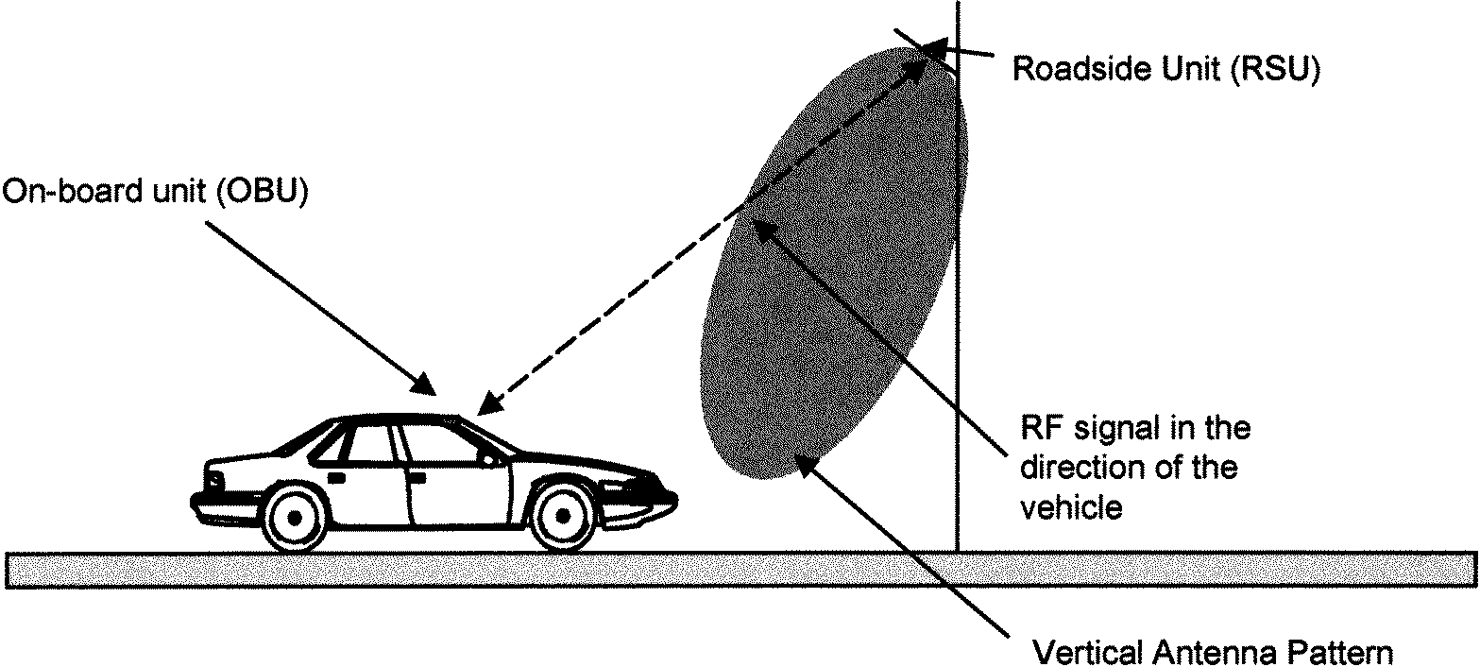
OBU Antenna Reference Point

Figure 11a—RSU Communicating With an OBU

PLACE FIGURE 11b HERE

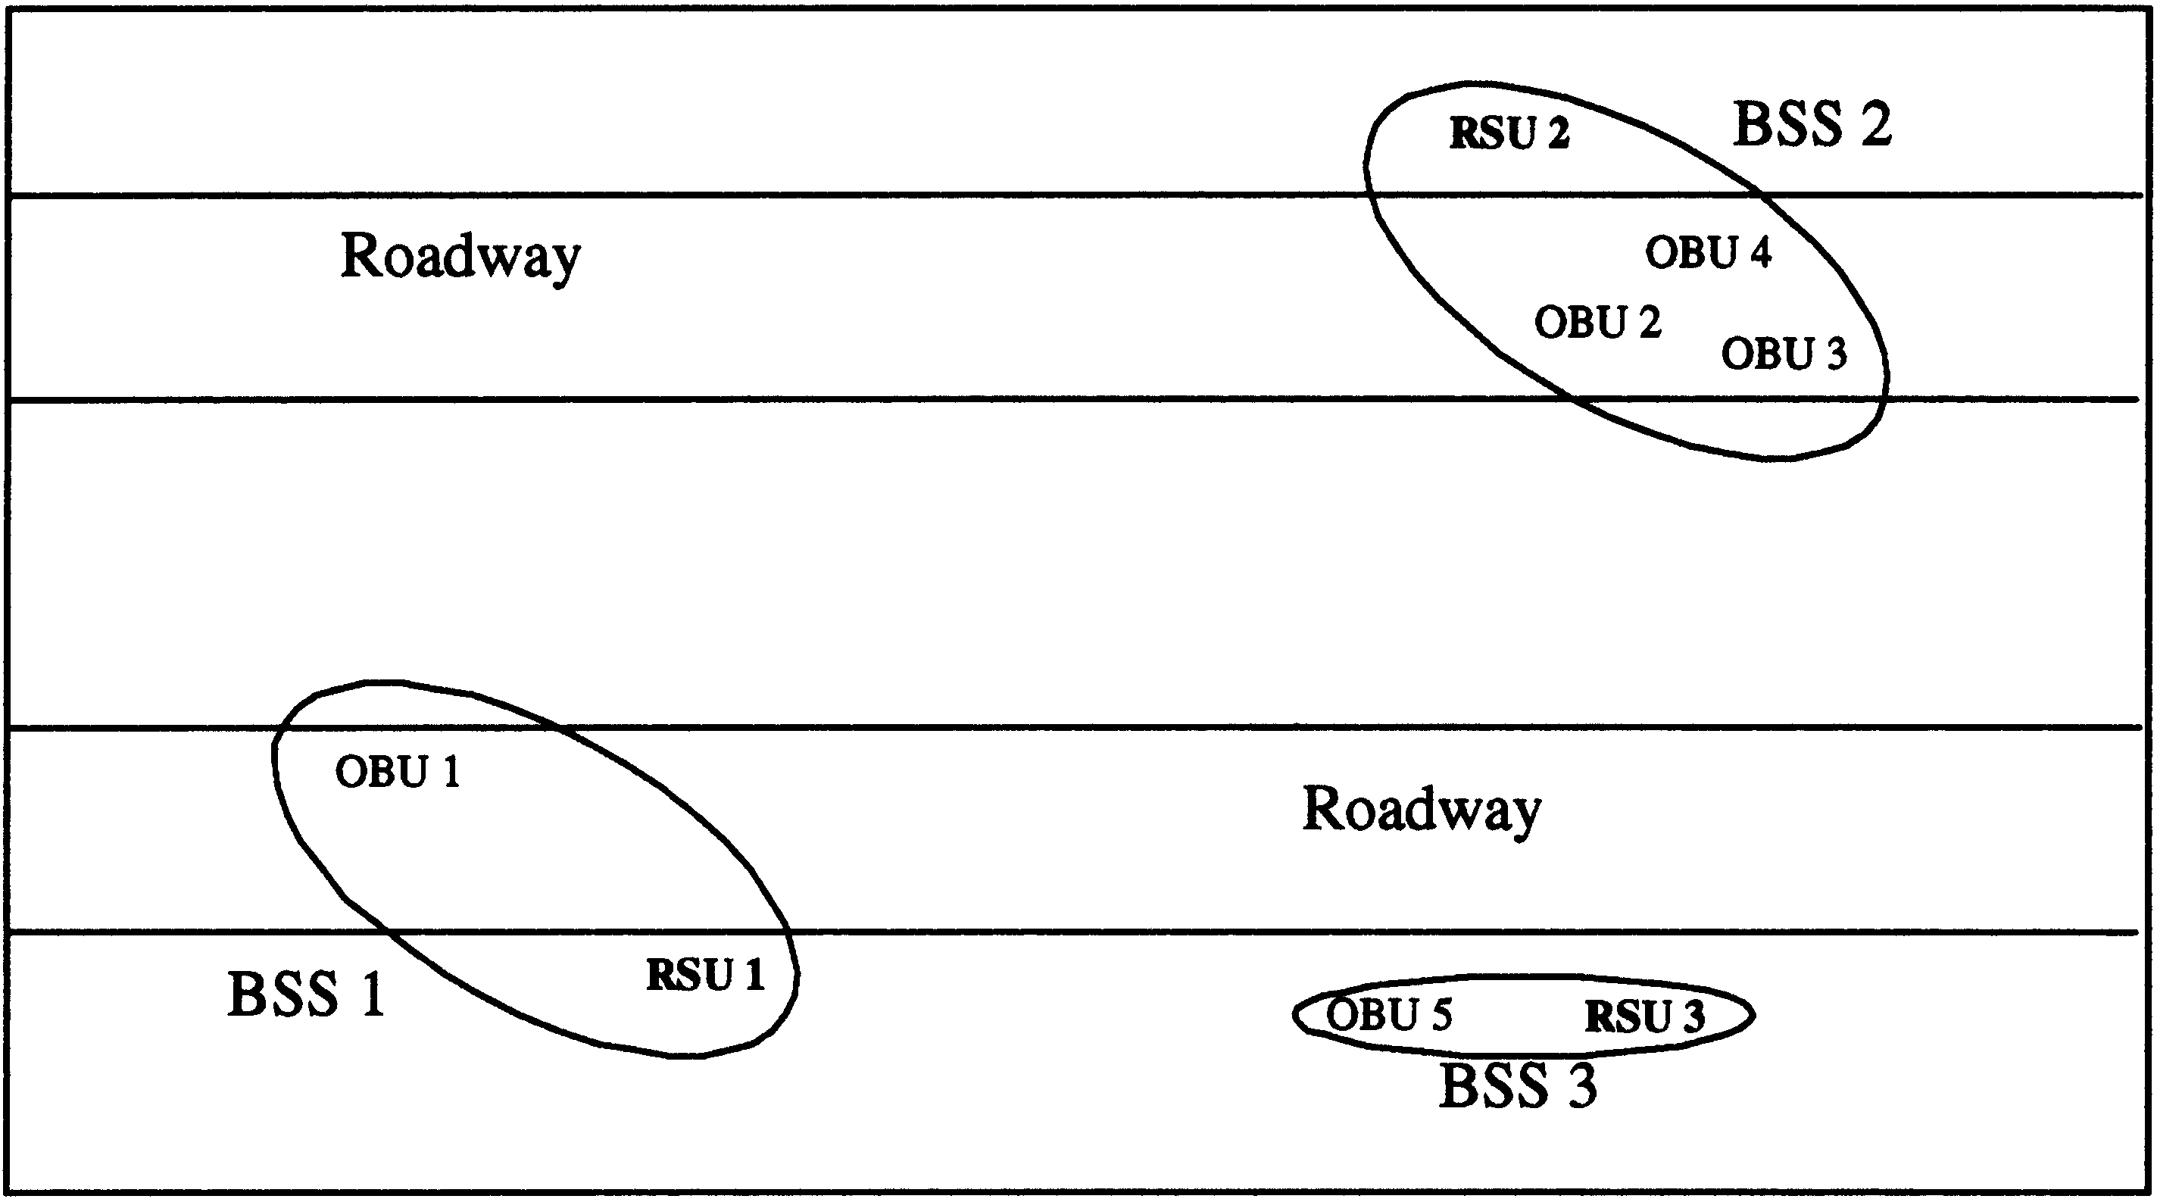

Figure 11b—Basic Service Sets With RSUs and OBUs

PLACE FIGURE 11c HERE

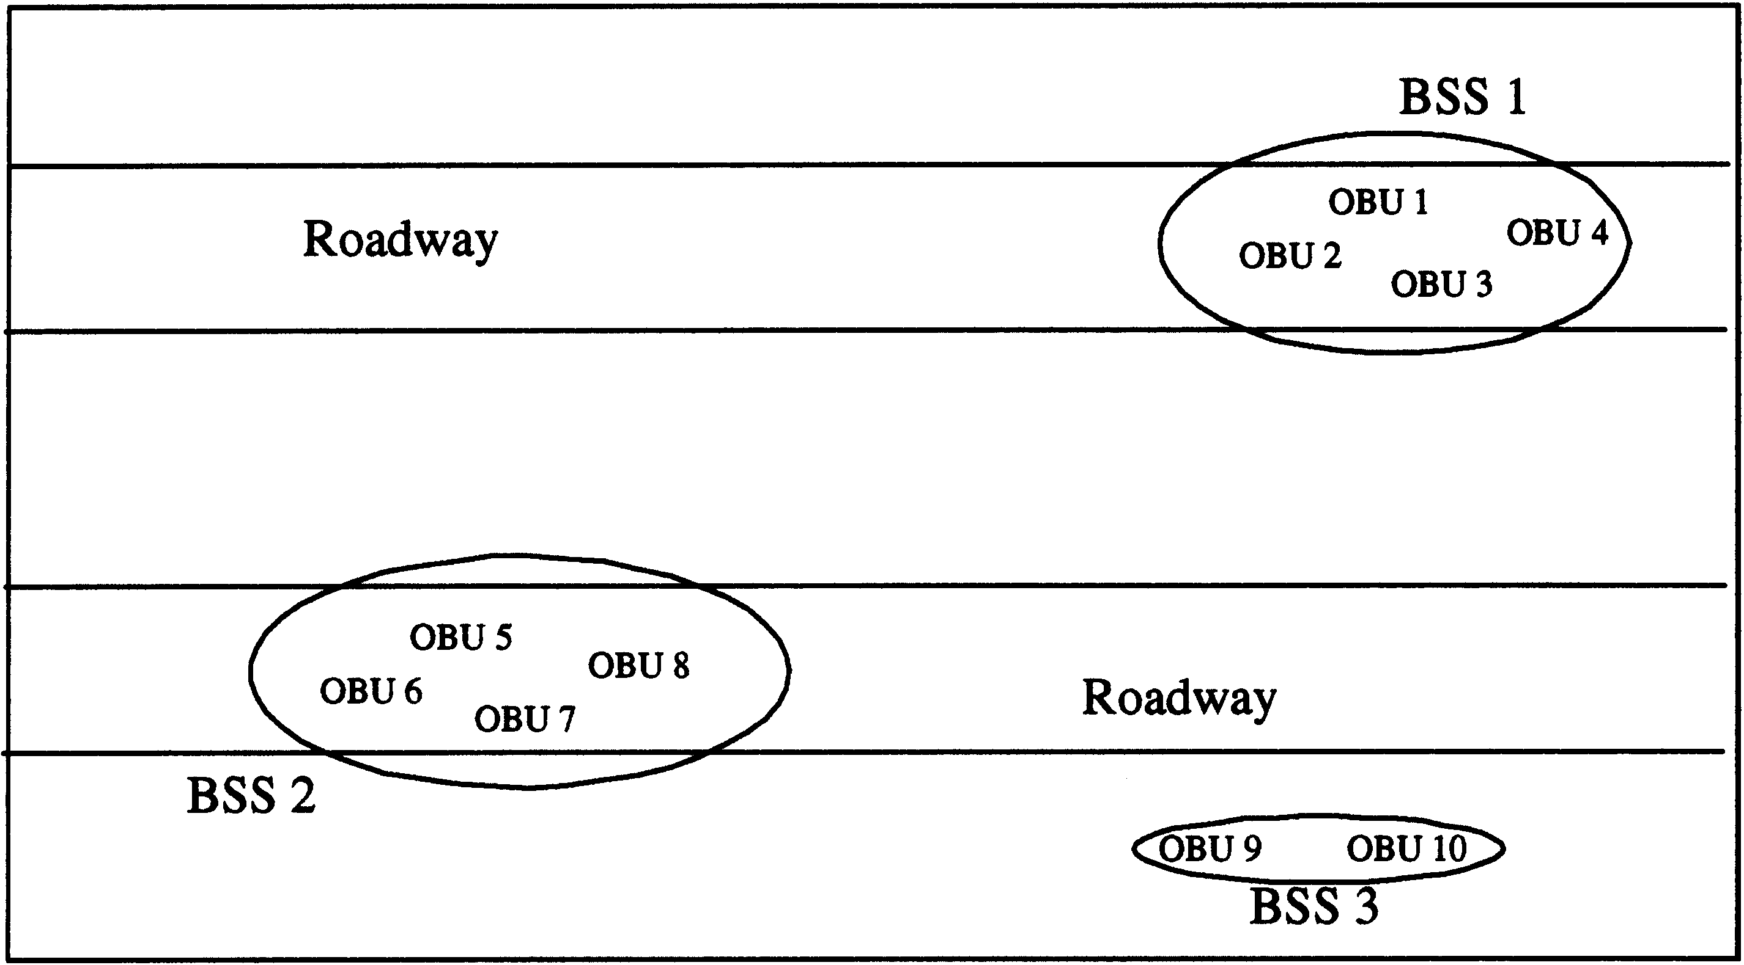

Figure 11c—Basic Service Sets With OBUs Only

PLACE FIGURE11d HERE

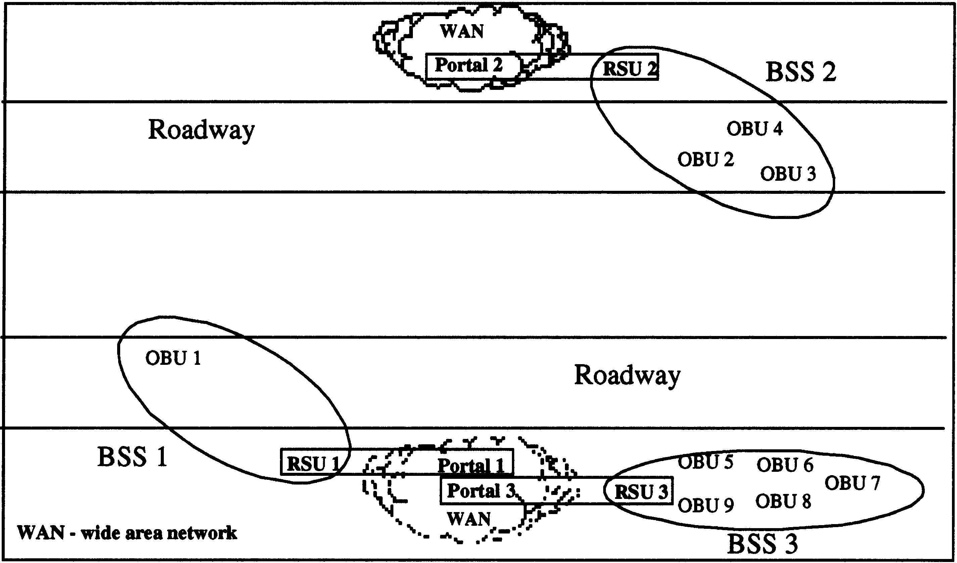

Figure 11d—Connecting OBUs to Wide-Area Networks

PLACE FIGURE 11e HERE

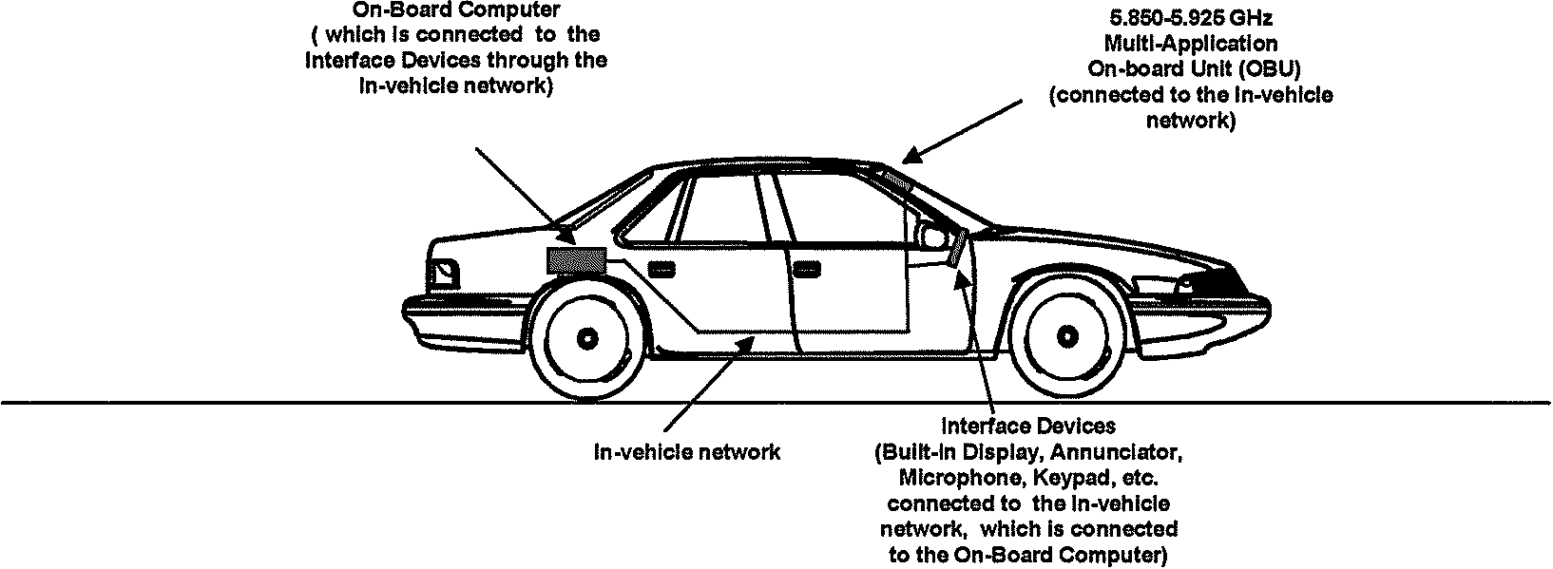

Figure 11e—Connecting an OBU to an In-vehicle Network

PLACE FIGURE 11f HERE

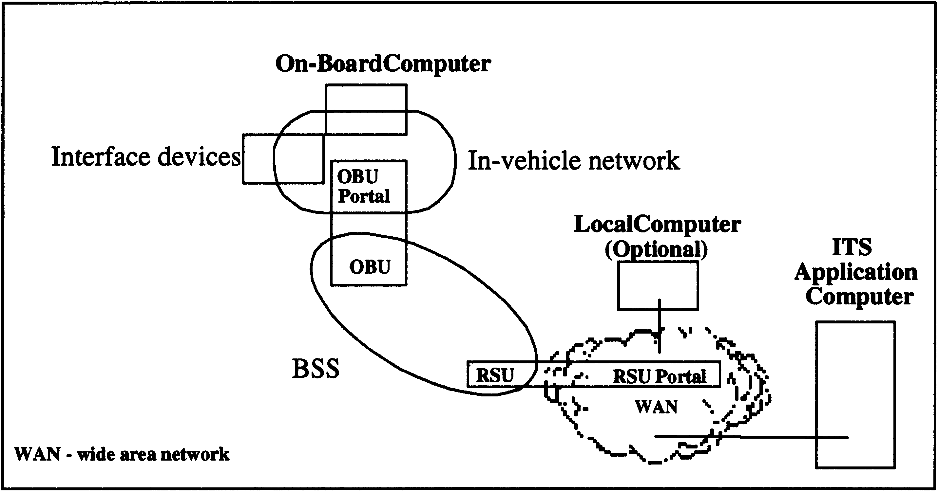

Figure 11f—BSS Connects Onboard Computer Through the WAN to the ITS Application

PLACE FIGURE 11g HERE

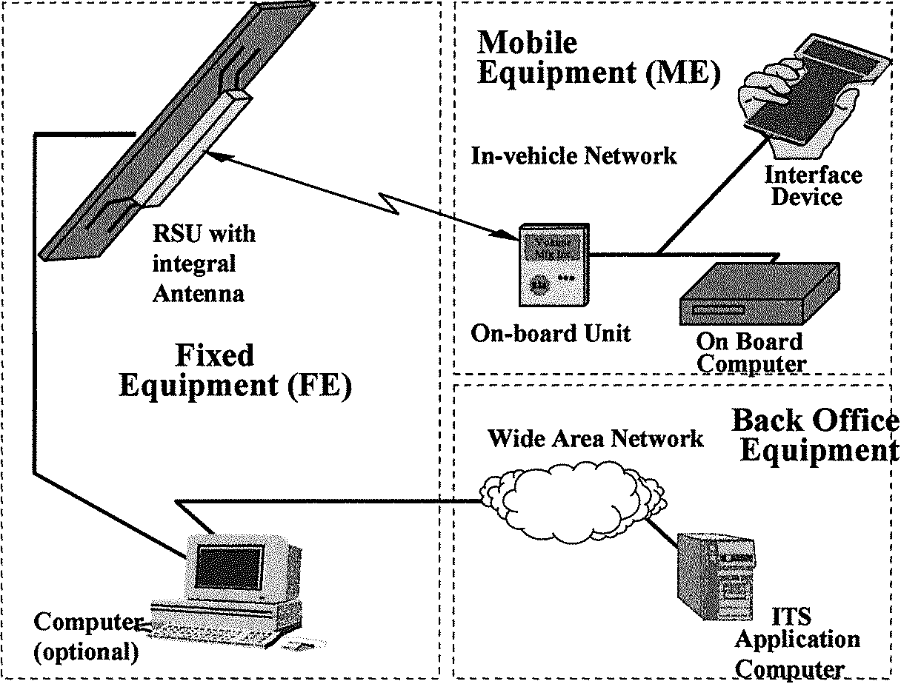

Figure 11g—Connecting a Remote ITS Application to Onboard Systems

7. Frame formats

7.1 MAC frame formats

7.1.2 General frame format
Insert the following text at the end of subclause 7.1.2:
For WAVE implementation the QoS Control field shall be used as defined in IEEE 802.11e. The power management frame control field shall be the same as defined in IEEE 802.11h.

Insert following 7.1.3.6 the following subclause:

7.1.4 WAVE ad hoc mode
WAVE devices shall implement a WAVE Ad Hoc mode of operation. In this mode only the Control, Data, and Management type fields are used. (See Table 1) Within the Control type field only the RTS, CTS, and ACK subtypes are used. Within the Data type field only the basic data subtype is used. RTS and CTS shall not be used in the control channel.

7.3 Management frame body components
Insert following 7.3.1.10 the following subclause and figure, renumbering subclauses and figures as necessary:

7.3.1.11 WAVE action field
The Action field provides a mechanism for specifying extended management actions. The format of the Action field is shown in Figure 33a.

 | Category | Action Details
Octets: | 1 | variable
Figure 33a—WAVE Action Field
The Category field shall be set to one of the non-reserved values shown in Table 19a. Action frames of a given category are referred to as <category name> Action frames. For example, frames in the "WAVE" category are called "WAVE Action frames". If a device receives a unicast Action frame with an unrecognized Category field or some other syntactic error and the most significant bit of the Category field is set to a code defined in Table 19a, then the device shall return the entire Action frame to the source without change except that the most significant bit of the Category field shall be set equal to 1.
The Action Details field contains the details of the action. The details of the actions allowed in each category are described in the appropriate paragraph referenced in Table 19a.

Table 19a—WAVE category codes
Code | Meaning | See Paragraph
0-2 | Assigned to other uses in 802.11
3 | WAVE management | 7.4.1
4-127 | Reserved
128-255 | Error

Insert a final paragraph to clause 7 as follows with figures and tables included, renumbering as necessary:

7.4 Management actions

7.4.1 WAVE management actions
Three Action frame formats are defined for WAVE Management purposes. An Action field, in the octet field immediately after the Category field, differentiates the formats. The Action field values associated with each frame format within the WAVE Category are defined in Table 20a.

Table 20a—WAVE Action field values
Action field value | Meaning
0 | Regenerate MAC Address
1 | Reserved
2 | Nearby Station request
3 | Nearby Station response
4– 255 | Reserved

7.4.1.1 Regenerate_MAC_Address WAVE Action frame format
The action body of a Regenerate_MAC_Address request WAVE Action frame may either be null, or may contain a single, 4-octet Random Value field. The values of the Activation Delay and Dialog Token fields shall be set to zero in transmitted Regenerate_MAC_Address frames and ignored in received Regenerate_MAC_Address frames. A station that receives a unicast action frame with the WAVE Category and the Regenerate_MAC_Address action code with no action-specific octets in the action body shall invoke its random MAC address generation procedure. A station that receives a unicast action frame with the WAVE Category and the Regenerate_MAC_Address action code with the 4-octet Random Value field in the action body shall only invoke its random MAC address generation procedure if the received random value is equal to the last random value transmitted by this station in a recent Nearby_Station_response WAVE action frame. If the received random value is not equal to the most recent transmitted random value, or if the receiving station has not generated a random value for a Nearby_Station_response within the number of TU specified by the dot11AuthenticationResponseTimeout, the Regenerate_MAC_Address WAVE action is ignored.

7.4.1.2 Nearby_Station_request WAVE Action frame format
The action body of a Nearby_Station_request WAVE Action frame format is null. No action-specific octets are required, and the value of the Activation Delay field shall be set to zero in transmitted Nearby_Station_request frames and ignored in received Nearby_Station_request frames. However, receipt of a Nearby_Station_request frame with one or more information elements in the action request body shall not be considered to constitute an invalid request, although the receiving station should ignore any such elements that may be present. The sending station shall place an arbitrary value in the Dialog Token field, and each receiving station that generates a corresponding Nearby_Station_response frame shall copy the value of the received Dialog Token into the Dialog Token field of its response. Stations should send successive Nearby_Station_request frames using distinct Dialog Token values. Nearby_Station_request frames shall be sent using a broadcast destination address. Receipt of an action frame with the WAVE Category and the Nearby_Station_request action code shall cause the receiving station to respond with a Nearby_Station_response action frame unless that station has been configured by the station management entity to ignore such requests..

Nearby_Station_response WAVE Action frame format

The action body of a Nearby_Station_response WAVE Action frame contains a single, 4-octet Random Value field. Each station generating a Nearby_Station_response frame shall place into this field a 32-bit pseudo-random value, generated for this frame and no other purpose from a uniform distribution over the interval [0,232-1]. The sending station shall retain this pseudo-random value, for possible matching against a subsequent Regnerate_MAC_Address frame, for at least the duration specified by the current value of dot11AuthenticationResponseTimeout. Implementers are advised that for proper operation of this protocol it is necessary for the pseudo-random sequences generated at each station to be statistically independent. The status code field shall always be transmitted as zero, and the dialog token field shall always contain the value from the Nearby_Station_request frame that caused generation of this Nearby_Station_response frame.

9. MAC sublayer functional description
Insert a final paragraph as follows:

9.10 WAVE Ad Hoc Mode
In the WAVE Ad Hoc mode of operation only three Frame Exchange Sequences ,"Data", "Mgmt", and "{RTS – CTS-}[Freq – ACK -] Last – ACK" are used (See Table 21)

11. MLME

11.1 Synchronization
Insert two final paragraph as follows:

11.1.6 WAVE Ad Hoc Mode
In the WAVE Ad Hoc mode of operation the BSSID shall be all zeros. There shall be no distributed beaconing mechanism. WAVE devices do not implement the 802.11 scanning function. WAVE devices use the default channel of operation as defined by the management primitives. The management frames are received and acknowledged but not acted upon .

11.1.7 Dynamic MAC Address
WAVE OBU devices shall implement a mechanism to dynamically generate a random MAC address to be used to control WAVE network access and confidentiality. The MAC address shall be a randomly generated number that minimizes the probability of OBUs generating the same number, even when those OBUs are subjected to the same initial conditions. The new random MAC address shall be generated upon start-up of the device.
In the 48 bit MAC address the individual/group bit shall be set as needed and the Global/Local bit shall be set to local. The remaining 46 bits shall receive the randomized address. The random algorithm shall generate an uncorrelated value. If an OBU ever receives a frame with its own address as the source address, the receiving OBU shall select a new MAC address. Duplicate address detection is done during association. If a station that is already associated attempts to reassociate, assume it is a duplicate. A “regenerate MAC address” command shall be sent.
Only those random number generators capable of generating a FIPS-approved, truly pseudorandom distribution are permitted. The current list of tested and approved random number generators includes:
FIPS 186 (DSS) Appendix 3.1 or Appendix 3.2; ANSI X9.31 Appendix A.2.4; or ANSI X9.62-1998 Annex A.4.

12.3.4.2 PHY-SAP sublayer-to-sublayer service primative
Insert primitives to Table 28 as follows:
Table 28 PHY-SAP sublayer-to-sublayer service primatives
Insert the rows in the table as shown:
Primative | Request | Indicate | Confirm
PHY-HRRSSI | X |  | X
PHY-RANDOMMAC | X

12.3.5 PHY-SAP detailed service specification
Insert three final paragraphs as follows:

12.3.5.13 PHY-HRRSSI.request

12.3.5.13.1 Function

This primitive is a request by the MAC sublayer to the local PHY entity to lock the AGC and get ready for high resolution RSSI mode.

12.3.5.13.2 Semantics of the service primitive

The primitive provides the following parameters:

PHY-HRRSSI.request (SWITCH)

SWITCH is a parameter that has two values: ON and OFF. When the value is ON, the MAC sublayer requests the PHY entity to enter the high resolution RSSI mode and when the value is OFF, the MAC sublayer request the PHY entity to exit the high resolution RSSI mode.

12.3.5.13.3 When generated

This primitive will be issued by the MAC sublayer to the PHY entity whenever the MAC sublayer needs to enter or exit the high resolution RSSI mode.

12.3.5.13.4 Effect of receipt

The effect of receipt of this primitive by the PHY entity will be to lock the AGC and enter the high resolution RSSI mode or unlock the AGC and exit the high resolution RSSI mode..

12.3.5.14 PHY-HRRSSI.confirm

12.3.5.14.1 Function

This primitive is issued by the PHY sublayer to the local MAC entity to confirm the entering or exiting of the high resolution RSSI mode.

12.3.5.14.2 Semantics of the service primitive

The semantics of the primitive are as follows:

PHY-HRRSSI.confirm

There are no parameters associated with this primitive.

12.3.5.14.3 When generated

This primitive will be issued by the PHY sublayer to the MAC entity whenever the PHY has received a PHY-HRRSSI.request from the MAC entity and is ready for high resolution RSSI measurement or is out of the high resolution RSSI mode.

12.3.5.14.4 Effect of receipt

The receipt of this primitive by the MAC entity shall cause the MAC to indicate the received RSSI as a high resolution RSSI or as a normal resolution RSSI.

12.3.5.15 PHY-RANDOMMAC.request

12.3.5.15.1 Function

This primitive is a request by the MAC sublayer to the local PHY entity to generate a random MAC address using a FIPS or ANSI random number generator.

12.3.5.15.2 Semantics of the service primitive

The primitive provides the following parameters:

PHY-RANDOMMAC.request

12.3.5.15.3 When generated

This primitive shall be issued by the MAC sublayer to the PHY entity during start-up or whenever the MAC sublayer needs to request that the PHY entity regenerate a MAC address.

12.3.5.15.4 Effect of receipt

The effect of receipt of this primitive by the PHY entity will be to generate an uncorrelated random MAC address.

17. Orthogonal frequency division multiplexing (OFDM) PHY specification for the 5 GHz band

17.1 Introduction
Insert the following text at the end of clause 17.1:
The RF LAN system is extended to include 5.850 – 5.925 GHz for WAVE. The WAVE radio frequency system occupies a licensed ITS Radio Services Band, as regulated in the United States by the Code of Federal Regulations, Title 47, Part 90. The OFDM system provides WAVE with data payload communication capabilities of 3, 4.5, 6, 9, 12, 18, 24, and 27 Mbit/s in 10 MHz channels. In addition data payload capabilities of 6, 9, 12, 18, 24, 36, 48, and 54 Mbit/s can be supported using optional 20 MHz channel combinations.

17.2 OFDM PHY specific service parameter list

17.2.2 TXVECTOR parameters

Table 82 TXVECTOR parameters
Insert the values in the table as shown:
Parameter | Associate primitive | Value
LENGTH | PHY-TXSTART.request (TXVECTOR) | 1-4095
DATARATE  (DATARATE for WAVE Implementation) | PHY-TXSTART.request (TXVECTOR) | 6, 9, 12, 18, 24, 36, 48, and 54  (Support of 6, 12, and 24 datarates is mandatory)  3, 4.5, 6, 9, 12, 18, 24, and 54  (Support for 3, 6, and 12 are mandatory for WAVE)
SERVICE | PHY-TXSTART.request (TXVECTOR) | Scrambler initialization; 7 null bits +9 reserved null bits
TXPWR_LEVEL | PHY-TXSTART.request (TXVECTOR) | 1-8  (1-64 for WAVE)

17.2.2.2 TXVECTOR DATARATE

Change the last sentence as shown
Data rates of 6, 12, and 24 shall be supported (3, 6, and 12 for WAVE). Other rates may also be supported.

17.2.3 RXVECTOR parameters

Table 83 RXVECTOR parameters
Insert the values in the rows as shown:
Parameter | Associate primitive | Value
LENGTH | PHY-RXSTART.indicate | 1-4095
RSSI | PHY-RXSTART.indicate (RXVECTOR) | 0-RSSI maximum
DATARATE  DATARATE for WAVE Implementation | PHY-RXSTART.request (RXVECTOR) | 6 ,9 ,12, 18,24, 36, 48, and 54  3, 4.5, 6, 9, 12, 18, 24, and 27
SERVICE | PHY-RXSTART.request (RXVECTOR) | Null

17.2.3.2 RXVECTOR RSSI
Insert the following text at the end of the clause:
For WAVE operations, subsequent to a period of no less than 2 ms after an alert signal, the minimum RSSI resolution should be less than or equal to 0.2 dB and must be accurate to ± 1 dB across the entire operating temperature range within -60 to -30 dBm of the receiving signal range.

17.2.3.3 DATARATE
Insert the following text at the end of the clause:
For WAVE implementations using 10 MHz channels, the allowed values of the DATARATE are 3, 4.5, 6, 9, 12, 18, 24, or 27 Mbps.

17.3.2.2 RATE-dependent parameters
Insert the following text at the end of the clause:
The modulation parameters for WAVE devices are the same except the data rates are reduced by one half as shown in the second column of Table 84.
Table 84 Rate-dependent parameters
Insert the column of values in the table as shown:

Data Rate, Mbits/s | Data Rate, Mbits/s for WAVE* | Modula-tion | Coding Rate, (R) | Coded Bits per Subcarrier, (N_{BPSC}) | Coded Bits per OFDM Symbol, (N_{CBPS}) | Data Bits per OFDM Symbol, (N_{DBPS})
6 | 3 | BPSK | 1/2 | 1 | 48 | 24
9 | 4.5 | BPSK | 3/4 | 1 | 48 | 36
12 | 6 | QPSK | 1/2 | 2 | 96 | 48
18 | 9 | QPSK | 3/4 | 2 | 96 | 72
24 | 12 | 16-QAM | 1/2 | 4 | 192 | 96
36 | 18 | 16-QAM | 3/4 | 4 | 192 | 144
48 | 24 | 64-QAM | 2/3 | 6 | 288 | 192
54 | 27 | 64-QAM | 3/4 | 6 | 288 | 216
* Data rates for WAVE operations in a 10 MHz bandwidth operation. For WAVE operations using 20 MHz bandwidth channels, column 1 data rates apply.

17.3.2.3 Timing related parameters

Table 85 Timing-related parameters
Insert a column in the table as shown:

Parameter | Value | Values for WAVE
N_{SD}: Number of data subcarriers | 48 | 48
N_{SP}: Number of pilot subcarriers | 4 | 4
N_{ST}: Number of subcarriers, total | 52 (N_{SD} + N_{SP}) | 52 (N_{SD} + N_{SP})
Δ_{F}: Subcarrier frequency spacing | 0.3125 MHz (=20 MHz/64) | 0.15625 MHz (=10 MHz/64)
T_{FFT}: Inverse Fast Fourier Transform (IFFT)/Fast Fourier Transform (FFT) period | 3.2 μs (1/ΔF) | 6.4 μs (1/ΔF)
T_{PREAMBLE}: PLCP preamble duration | 16 μs (T_{SHORT} + T_{LONG}) | 32 μs (T_{SHORT} + T_{LONG})
T_{SIGNAL}: Duration of the SIGNAL BPSK-OFDM symbol | 4.0 μs (T_{GI} + T_{FFT}) | 8.0 μs (T_{GI} + T_{FFT})
T_{GI}: GI duration | 0.8 μs (T_{FFT}/4) | 1.6 μs (T_{FFT}/4)
T_{GI2}: Training symbol GI duration | 1.6 μs (T_{FFT}/2) | 3.2 μs (T_{FFT}/2)
T_{SYM}: Symbol interval | 4 μs (T_{GI} + T_{FFT}) | 8 μs (T_{GI} + T_{FFT})
T_{SHORT}: Short training sequence duration | 8 μs (10 × T_{FFT}/4) | 16 μs (10 × T_{FFT}/4)
T_{LONG}: Long training sequence duration | 8 μs (T_{GI2} + 2 × T_{FFT}) | 16 μs (T_{GI2} + 2 × T_{FFT})

17.3.3 PLCP preamble (SYNC)

Figure 114a–OFDM training structure
Insert the new Figure 114a with time changes as shown. Renumber as needed:

PLACE FIGURE 114a HERE

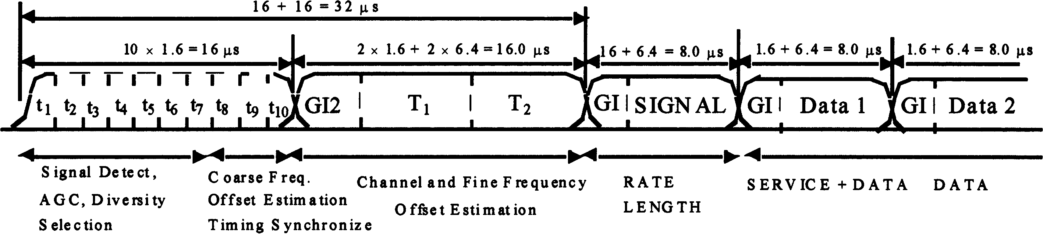

Figure 114a--OFDM Training Structure for WAVE

Change the clause as follows:
The PLCP preamble is followed by the SIGNAL field and DATA. The total training length is 16 µs. For WAVE implementation using 10 MHz channels the total training length is 32 µs. The dashed boundaries in the figure denote repetitions due to the periodicity of the inverse Fourier transform.
Also Change the clause as follows:
The fact that only spectral lines of S–_{26:26} with indices that are a multiple of 4 have nonzero amplitude results in a periodicity of T_{FFT}/4 = 0.8 μs. The interval TSHORT is equal to ten 0.8 μs periods (that is, 8 μs). For WAVE the periodicity of T_{FFT}/4 = 1.6 μs and the interval TSHORT is ten 1.6 μs periods (16 μs).

Also Change the clause as follows:
where:
T_{G12} = 1.6 μs.
Two periods of the long sequence are transmitted for improved channel estimation accuracy, yielding T_{LONG} = 1.6 + 2*3.2 = 8 μs. For WAVE, T_{G12} = 3.2 μs and T_{LONG} = 3.2 + 2*6.4 = 16 μs.

17.3.4 SIGNAL field
Change the clause as follows:
The encoding procedure, which includes convolutional encoding, interleaving, modulation mapping processes, pilot insertion, and OFDM modulation, follows the steps described in 17.3.5.5, 17.3.5.6, and 17.3.5.8, as used for transmission of data at a 6 Mbit/s rate (3 Mbit/s rate for WAVE when using 10 MHz channels).

17.3.4.1 RATE field
Insert the following text at the end of the clause:
The four bits encoding the RATE for WAVE devices are the same except the data rates are reduced by one half as shown in the second column of Table 86.

Table 86–Contents of the Signal field
Insert the column of values in the table as shown:
Rate, Mbits/s | Rate Field for WAVE, Mbits/s | R1-R4
6 | 3 | 1101
9 | 4.5 | 1111
12 | 6 | 0101
18 | 9 | 0111
24 | 12 | 1001
36 | 18 | 1011
48 | 24 | 0001
54 | 27 | 0011

17.3.7 PLCP data modulation and modulation rate change
Change the clause as follows:
The PLCP preamble shall be transmitted using an OFDM modulated fixed waveform. The IEEE 802.11® SIGNAL field, BPSK-OFDM modulated at 6 Mbit/s (3 Mbit/s for WAVE when using 10 MHz channels), shall indicate the modulation and coding rate that shall be used to transmit the MPDU.

17.3.8.1 Outline description
Change the clause as follows:
The general block diagram of the transmitter and receiver for the OFDM PHY is shown in Figure 122. Major specifications for the OFDM PHY are listed in Table 92. Parameters to implement WAVE have been added to Table 92. The data rates are reduced by one half and the symbol duration, GI, and bandwidth are changed.

Table 92–Major parameters of the OFDM PHY
Insert the values into the table as shown:

Information Data Rate | 6, 9, 12, 18, 24, 36, 48, and 54 Mbit/s  (6, 12, and 24 Mbit/s are Mandatory)
Information Data Rate for WAVE | 3, 4.5, 6, 9, 12, 18, 24, and 27 Mbit/s  (3, 6, and 12 Mbit/s are Mandatory)
Modulation | BPSK OFDM  QPSK OFDM  16-QAM OFDM  64-QAM OFDM
Error correcting code | K = 7 (64 states) convolutional code
Coding rate | 1/2, 2/3, 3/4
Number of subcarriers | 52
OFDM symbol duration | 4.0 μs (8.0 µs for WAVE)
Guard interval | 0.8 μsª (T_{GI}) (1.6 µs for WAVE)
Occupied bandwidth | 16.6 MHz (8.3 MHz for WAVE)
ª Refer to 17.3.2.4.

17.3.8.2 Regulatory requirements

Table 93–Regulatory requirement list
Change the information in the table as shown:
Geographic area | Approval standards | Documents | Approval authority
United States | Federal Communications  Commission (FCC) | CFR47[B6], Part 15, Sections 15.205, 15.209, and 15.247; Subpart E, Sections 15.401-15.407; and Part 90, Subparts I and M | FCC
Japan | Ministry of Post and Telecommunication (MPT) | MPT Ordinance for Reg-ulating Radio Equipment, Article 49.20 | MPT

17.3.8.3 Operating channel frequencies

17.3.8.3.1 Operating frequency range
Change the last sentence in the first paragraph as shown:
In the United States, the FCC is the agency responsible for the allocation of the 5 GHz U-NII and ITS Radio Service Bands.
.

17.3.8.3.3 Channelization

Table 94–Valid operating channel numbers by regulatory domain and band
Insert information in the table as shown:
Regulatory domain | Band (GHz) | Operating channel numbers | Channel center frequencies (MHz)
United States | U-NII lower band (5.15-5.25) | 36  40  44  48 | 5180  5200  5220  5240
United States | U-NII middle band (5.25-5.35) | 52  56  60  64 | 5260  5280  5300  5320
United States | U-NII upper band (5.725-5.825) | 149  153  157  161 | 5745  5765  5785  5805
United States  and Canada | ITS-RS  (5.850-5.925) | 172  174  175  176  178  180  181  182  184 | 5860  5870  5875  5880  5890  5900  5905  5910  5920

Insert the following paragraph at the end of the clause:
Figure 123a shows the channelization scheme which shall be used with the FCC Intelligent Transportation Systems Radio Services (ITS-RS) allocation and the Industry Canada ITS-RS allocation. The U.S. and Canadian ITS-RS Band accommodates seven channels in a total bandwidth of 75-MHz. Channels 175 and 181 are designated for WAVE equipment operating with 20-MHz bandwidth. When operating in 20 MHz channels WAVE devices operate in compliance with the PHY layer requirements of IEEE Standard 802.11-1999 (Reaff2003), except that the channel center frequencies and power limits are designated by this amendment. In addition, the MAC shall continue to operate in compliance with this amendment including implementing the default WAVE Ad-hoc mode as described herein.

Insert the new Figure 123a with channel changes. Renumber Figures as appropriate:

PLACE FIGURE 123a HERE

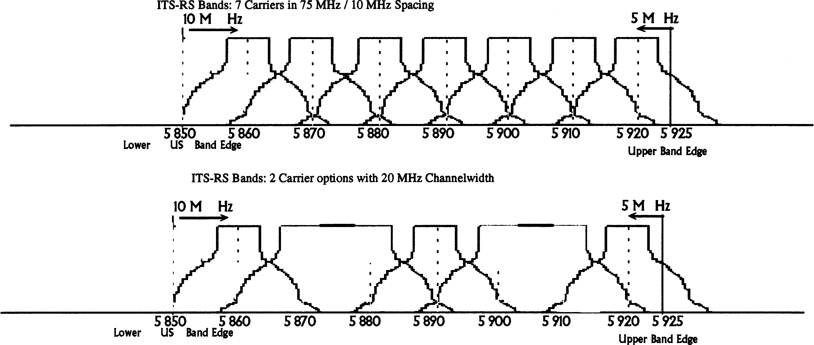
Figure 123a—OFDM PHY WAVE frequency channel plan for North America

17.3.8.6 Slot time
Change the text in the clause as shown:
The slot time for the OFDM PHY shall be 9µs, which is the sum of the RX-to-TX turnaround time, MAC processing delay, and CCA detect time (<4 μs). The propagation delay shall be regarded as being included in the CCA detect time. The slot time for the OFDM PHY for WAVE shall be 16 µs and the CCA detect time shall be <8 µs.

17.3.8.7 Transmit and receive antenna port impedance
Change the title and Insert text to the clause as shown:

17.3.8.7 Transmit and receive antenna requirements

The transmit and receive antenna port(s) impedance shall be 50 Ω if the port is exposed. For WAVE the transmit and receive antennas shall be either right hand circularly or vertically polarized.

17.3.8.8 Transmit and receive operating temperature range
Insert the following text at the end of the clause:
A fourth temperature range is added for WAVE operation. Type 4, defined as from –40 to 85°C, is designated for automotive environments.

17.3.9.1 Transmit power levels
Insert the following text at the end of the clause:
For WAVE devices the maximum allowable Effective Isotropic Radiated Power (EIRP) in accordance with FCC regulations is 44.8 dBm (30 W). Device output power is limited by class as defined in Table 95c. The maximum output power for a device is 28.8 dBm (750 mW). A device is allowed to transmit more power than this limit to overcome cable losses to the antenna as long as the antenna input power does not exceed 28.8 dBm and the EIRP does not exceed 44.8 dBm. However, specific channels and categories of uses have additional limitations. The transmit power limits of WAVE devices for Public Safety applications are defined in Table 95a. The transmit power limits for Private Usage are defined in Table 95b. Four classes of operation are specified for WAVE devices in the 5.850 to 5.925 GHz band and are shown in Table 95c.

Insert the following tables at the end of the clause and renumber Tables:
Table 95a–WAVE Transmitter Power Limits for Public Safety

WAVE Channel | Frequency (GHz) | RSU |  | OBU
WAVE Channel | Frequency (GHz) | Max Antenna input Pwr (dBm) | Max EIRP (dBm) | Max Antenna input Pwr (dBm) | Max EIRP (dBm)
172 | 5.860 | 28.8 | 33.0 | 28.8 | 33.0
174 | 5.870 | 28.8 | 33.0 | 28.8 | 33.0
175 | 5.875 | 10.0 | 23.0 | 10.0 | 23.0
176 | 8.880 | 28.8 | 33.0 | 28.8 | 33.0
178 | 5.890 | 28.8 | 44.8 | 28.8 | 44.8
180 | 5.900 | 10.0 | 23.0 | 20.0 | 23.0
181 | 5.905 | 10.0 | 23.0 | 20.0 | 23.0
182 | 5.910 | 10.0 | 23.0 | 20.0 | 23.0
184 | 5.920 | 28.8 | 40.0 | 28.8 | 40.0

Table 95b–WAVE Transmitter Power Limits for Private Usage

WAVE Channel | Frequency (GHz) | RSU |  | OBU
WAVE Channel | Frequency (GHz) | Max Antenna input Pwr (dBm) | Max EIRP (dBm) | Max Antenna input Pwr (dBm) | Max EIRP (dBm)
172 | 5.860 | 28.81 | 33.01 | 28.8 | 33.0
174 | 5.870 | 28.8 | 33.0 | 28.8 | 33.0
175 | 5.875 | 10.0 | 23.0 | 10.0 | 23.0
176 | 8.880 | 28.8 | 33.0 | 28.8 | 33.0
178 | 5.890 | 28.8 | 33.0 | 28.8 | 33.0
180 | 5.900 | 10.0 | 23.0 | 20.0 | 23.0
181 | 5.905 | 10.0 | 23.0 | 20.0 | 23.0
182 | 5.910 | 10.0 | 23.0 | 20.0 | 23.0
184 | 5.920 | 28.8 | 33.0 | 28.8 | 33.0

Table 95c–WAVE Device Classes and Transmit Power Levels

Device Class | Maximum Device Output Power,  dBm
A | 0
B | 10
C | 20
D | 28.8 or more

17.3.9.2 Transmit spectrum mask
Insert the following text at the end of the clause:
For WAVE the transmitted spectrum mask is relative to the device class of operation. The power in the transmitted spectrum for all WAVE devices shall be –25 dBm or less within 100 kHz outside all channel and band edges. This will be accomplished by attenuating the transmitted signal 100 kHz outside the channel and band edges by 55 + 10log(P) dB, where P is the total transmitted power in watts. The transmitted spectral density of the transmitted signal for all devices shall fall within the spectral mask, as detailed in Table 95d. The measurements shall be made using a 100 kHz resolution bandwidth and a 30 kHz video bandwidth.
The transmitted spectral mask for class A, B, C, and D devices are shown in Figures. 124a, 124b, 124c, and 124d. In addition, all WAVE site installations shall limit the EIRP in the transmitted spectrum to –25 dBm or less in the 100 kHz of bandwidth at the channel edges and the band edges. Additional filtering that supplements the filtering provided by the transmitter may be needed for some antenna/transmitter combinations.

Insert the following table at the end of the clause and renumber Tables:
Table 95d–WAVE Spectrum Mask

Device Class | ± 4.5-MHz Offset | ± 5.0-MHz Offset | ± 5.5-MHz Offset | ± 10-MHz Offset | ± 15-MHz Offset
Class A | 0 | -10 | -20 | -28 | -40
Class B | 0 | -16 | -20 | -28 | -40
Class C | 0 | -26 | -32 | -40 | -50
Class D | 0 | -35 | -45 | -55 | -65
Reduction in Power Spectral Density, dBr

Insert the following four figures at the end of the clause and renumber Figures:

PLACE FIGURE 124a HERE

Figure 124a–WAVE Class A Transmit Spectrum Mask

PLACE FIGURE 124b HERE

Figure 124b–WAVE Class B Transmit Spectrum Mask

PLACE FIGURE 124c HERE

Figure 124c–WAVE Class C Transmit Spectrum Mask

PLACE FIGURE 124d HERE

Figure 124d–WAVE Class D Transmit Spectrum Mask

17.3.9.4 Transmit center frequency tolerance
Change the clause as follows:
The transmitted center frequency tolerance shall be ±20 ppm maximum. For all WAVE devices using 10 MHz channels, the transmitted center frequency tolerance shall be ±10 ppm maximum. The transmit center frequency and the symbol clock frequency shall be derived from the same reference oscillator.

17.3.9.5 Symbol clock frequency tolerance
Change the clause as follows:
The symbol clock frequency tolerance shall be ±20 ppm maximum. For all WAVE devices using 10 MHz channels, the symbol clock frequency tolerance shall be ±10 ppm maximum. The transmit center frequency and the symbol clock frequency shall be derived from the same reference oscillator.

17.3.9.6.3 Transmitter constellation flatness
Insert the following text at the end of the clause:
The allowed relative constellation errors for WAVE devices are the same except the data rates are reduced by one half as shown in the second column of Table 96.

Table 96–Allowed relative constellation error versus data rate
Insert the column of values in the table as shown:
Table 96–Allowed relative constellation error versus data rate

Data Rate (Mbits/s) | Data Rates for WAVE (Mbits/s) | Relative constellation error (db)
6 | 3 | -5
9 | 4.5 | -8
12 | 6 | -10
18 | 9 | -13
24 | 12 | -16
36 | 18 | -19
48 | 24 | -22
54 | 27 | -25

17.3.9.7 Transmit modulation accuracy test
Change the clause as follows:
The transmit modulation accuracy test shall be performed by instrumentation capable of converting the transmitted signal into a stream of complex samples at 20 Msamples/s or more (10 Msamples/s or more for WAVE devices using 10 MHz channels), with sufficient accuracy in terms of I/Q arm amplitude and phase balance, dc offsets, phase noise, etc.

17.3.10 PMD receiver specifications

17.3.10.1 Receiver minimum input level sensitivity
Insert the following text at the end of the clause:
For WAVE devices using 10 MHz channels, the data rates are reduced by one half and, accordingly, the receiver performance requirements are adjusted and defined in Table 97a and Table 97b. Two categories of adjacent channel rejection capability will be allowed to accommodate operating in a higher power environment. The categories are designated as Type 1 and Type 2. The receiver performance requirements for Type 1 are specified in Table 97a. The Type 2 requirements are specified in Table 97b.

Table 97–Receiver performance requirements
Insert the following tables at the end of the clause and renumber Tables:
Table 97a–WAVE Type 1 Receiver Performance Requirements

Data rate  (Mbits/s) | Minimum  sensitivity (dBm) | Adjacent channel  rejection (dB) | Alternate adjacent  channel rejection (dB)
3 | -85 | 18 | 34
4.5 | -84 | 17 | 33
6 | -82 | 16 | 32
9 | -80 | 15 | 31
12 | -77 | 13 | 29
18 | -70 | 11 | 27
24 | -69 | 8 | 24
27 | -67 | 4 | 20

Table 97b–WAVE Type 2 Receiver Performance Requirements

Data rate (Mbits/s) | Minimum sensitivity (dBm) | Adjacent channel rejection (dB) | Alternate adjacent channel rejection (dB)
3 | -85 | 37 | 44
4.5 | -84 | 36 | 43
6 | -82 | 35 | 42
9 | -80 | 34 | 41
12 | -77 | 32 | 39
18 | -70 | 30 | 37
24 | -69 | 27 | 34
27 | -67 | 23 | 30

17.3.10.2 Adjacent channel rejection
Insert the following text at the end of the clause:
For a WAVE-compliant OFDM PHY, the corresponding rejection shall be no less than that specified in Table 97a for a Type 1 WAVE device and Table 97b for a Type 2 WAVE device. The interfering WAVE signal in the adjacent channel shall be an OFDM signal conforming to a WAVE Class A spectral mask.

17.3.10.3 Nonadjacent channel rejection
Insert the following text at the end of the clause:
For a WAVE-compliant OFDM PHY, the corresponding rejection shall be no less than that specified in Table 97a for a Type 1 WAVE device and Table 97b for a Type 2 WAVE device. The interfering WAVE signal in the nonadjacent channel shall be an OFDM signal conforming to a WAVE Class A spectral mask.

17.3.10.5 CCA sensitivity
Insert the following text at the end of the clause:
For WAVE the start of a valid OFDM transmission at a receive level equal to or greater than the minimum 3 Mbit/s (–85 dBm) sensitivity shall cause CCA to indicate busy with a probability >90 % within 8 μs. If the preamble portion was missed, the receiver shall hold the CS signal busy for any signal 20 dB above the minimum 3 Mbit/s sensitivity (–65 dBm).

17.3.10 PMD receiver specifications
Insert new paragraphs after clause 17.3.10.5 as follows:

17.3.10.6 Multi-path delay spread (For WAVE)
The packet error rate (PER) shall be less than 10% for PSDU lengths of 1000 bytes for the same signal arriving at the receiver with a time delay of 400ns rms from the direct path signal over a period of 5 seconds for 3, 6, and 12 Mbps data rates.

17.3.10.7 Doppler spread (For WAVE)
The packet error rate (PER) shall be less than 10% for PSDU length of 1000 bytes for signals arriving at the receiver with a maximum Doppler shift of ± 2100 Hz over a period of 5 seconds for 3, 6, and 12 Mbps data rates.

17.3.10.8 Amplitude variation (For WAVE)
The packet error rate (PER) shall be less than 10% for PSDU length of 1000 bytes for signals arriving at the receiver with amplitude variations of 10 dB at a rate of 100 Hz over a period of 5 seconds for 3, 6, and 12 Mbps data rates. A 15 dB link margin over the minimum sensitivity shall be used for these evaluations.

17.3.10.9 Rician channel variation (For WAVE)
The packet error rate (PER) shall be less than 10% for PSDU length of 1000 bytes for signals arriving at the receiver in a simulated Rician channel with K=10 for 3, 6, and 12 Mbps data rates. A 10 dB link margin over the minimum sensitivity shall be used for these evaluations.

17.4.1 PLME_SAP sublayer management primitives
Change the text in the clause as follows:
Table 98 lists the MIB attributes that may be accessed by the PHY entities and the intralayer of higher level LMEs. These attributes are accessed via the PLME-GET, PLME-SET, PLME-RESET, and PLME-CHARACTERISTICS primitives for U-NII and WAVE band operations, as defined in 10.4.

17.4.2 OFDM PHY MIB
Insert the following text at the end of the clause:
For WAVE implementation the specific MIB attributes and values are defined in Table 98a. For WAVE the dot11 PHY Operation Table PHY type is WAVE-5. (05).

Insert the following into Table 98:
Table 98–MIB attribute default values/ranges

Managed Object | Default Value/Range | Operational Semantics
dot11 PHY Operation Table
dot11 PHY type | OFDM-5. (04)  WAVE-5. (05) | Static  dynamic
dot11 current reg domain | implementation dependent | static
dot11 current frequency band | implementation dependent | static
dot11 temp type | implementation dependent | static
dot11 device class | implementation dependent | dynamic
dot11 ACR type | implementation dependent | dynamic
dot11 PHY Antenna Table
dot11 current Tx antenna | implementation dependent | dynamic
dot11 diversity support | implementation dependent | static
dot11 current Rx antenna | implementation dependent | dynamic
dot11 PHY Tx Power Table
dot11 number supported power levels | implementation dependent | static
dot11 Tx power Level 1 | implementation dependent | static
dot11 Tx power Level 2 | implementation dependent | static
dot11 Tx power Level 3 | implementation dependent | static
dot11 Tx power Level 4 | implementation dependent | static
dot11 Tx power Level 5 | implementation dependent | static
dot11 Tx power Level 6 | implementation dependent | static
dot11 Tx power Level 7 | implementation dependent | static
dot11 Tx power Level 8 | implementation dependent | static
dot11 Tx power Level 9 | implementation dependent | static
dot11 Tx power Level 10 | implementation dependent | static
dot11 Tx power Level 11 | implementation dependent | static
dot11 Tx power Level 12 | implementation dependent | static
dot11 Tx power Level 13 | implementation dependent | static
dot11 Tx power Level 14 | implementation dependent | static
dot11 Tx power Level 15 | implementation dependent | static
dot11 Tx power Level 16 | implementation dependent | static
dot11 Tx power Level 17 | implementation dependent | static
dot11 Tx power Level 18 | implementation dependent | static
dot11 Tx power Level 19 | implementation dependent | static
dot11 Tx power Level 20 | implementation dependent | static
dot11 Tx power Level 21 | implementation dependent | static
dot11 Tx power Level 22 | implementation dependent | static
dot11 Tx power Level 23 | implementation dependent | static
dot11 Tx power Level 24 | implementation dependent | static
dot11 Tx power Level 25 | implementation dependent | static
dot11 Tx power Level 26 | implementation dependent | static
dot11 Tx power Level 27 | implementation dependent | static
dot11 Tx power Level 28 | implementation dependent | static
dot11 Tx power Level 29 | implementation dependent | static
dot11 Tx power Level 30 | implementation dependent | static
dot11 Tx power Level 31 | implementation dependent | static
dot11 Tx power Level 32 | implementation dependent | static
dot11 Tx power Level 33 | implementation dependent | static
dot11 Tx power Level 34 | implementation dependent | static
dot11 Tx power Level 35 | implementation dependent | static
dot11 Tx power Level 36 | implementation dependent | static
dot11 Tx power Level 37 | implementation dependent | static
dot11 Tx power Level 38 | implementation dependent | static
dot11 Tx power Level 39 | implementation dependent | static
dot11 Tx power Level 40 | implementation dependent | static
dot11 Tx power Level 41 | implementation dependent | static
dot11 Tx power Level 42 | implementation dependent | static
dot11 Tx power Level 43 | implementation dependent | static
dot11 Tx power Level 44 | implementation dependent | static
dot11 Tx power Level 45 | implementation dependent | static
dot11 Tx power Level 46 | implementation dependent | static
dot11 Tx power Level 47 | implementation dependent | static
dot11 Tx power Level 48 | implementation dependent | static
dot11 Tx power Level 49 | implementation dependent | static
dot11 Tx power Level 50 | implementation dependent | static
dot11 Tx power Level 51 | implementation dependent | static
dot11 Tx power Level 52 | implementation dependent | static
dot11 Tx power Level 53 | implementation dependent | static
dot11 Tx power Level 54 | implementation dependent | static
dot11 Tx power Level 55 | implementation dependent | static
dot11 Tx power Level 56 | implementation dependent | static
dot11 Tx power Level 57 | implementation dependent | static
dot11 Tx power Level 58 | implementation dependent | static
dot11 Tx power Level 59 | implementation dependent | static
dot11 Tx power Level 60 | implementation dependent | static
dot11 Tx power Level 61 | implementation dependent | static
dot11 Tx power Level 62 | implementation dependent | static
dot11 Tx power Level 63 | implementation dependent | static
dot11 Tx power Level 64 | implementation dependent | static
dot11 current Tx power level | implementation dependent | dynamic
dot11 Reg Domains supported Table
dot11 reg domains supported | implementation dependent | static
dot11 frequency bands supported | implementation dependent | static
dot11 PHY Antennas List Table
dot 11 supported Tx antenna | implementation dependent | static
dot11 supported Rx antenna | implementation dependent | static
dot 11 diversity selection Rx | implementation dependent | dynamic
dot11 supported Data Rates Tx Table
dot11 supported data rates Tx value | 3, 4.5, 6, 9, 12, 18, 24, 27, 36, 48, and 54 Mbit/s  Mandatory Rates: 6, 12,and 24  Mandatory Rates for WAVE:  3, 6, and 12 | static
dot11supportedDataRatesRxTable
dot11 supported data rates Rx value | 3, 4.5, 6, 9, 12, 18, 24, 27, 36, 48, and 54 Mbit/s  Mandatory Rates: 6, 12, and 24  Mandatory Rates for WAVE:  3, 6, and 12 | Static
dot11 PHY OFDM Table
dot11 current frequency | implementation dependent | Dynamic
dot11 TI threshold | implementation dependent | Dynamic

17.4.4 OFDM PHY characteristics
Insert the following text at the end of the clause:
The WAVE channel switching time (aChSwitchTime) of less than 2 ms is added to Table 99. The values of other OFDM PHY characteristics are changed to implement WAVE as specified in the column for WAVE in Table 99.

Table 99–OFDM PHY characteristics
Insert the values in the table as shown:
Characteristics | Value | Values for WAVE
aSlotTime | 9 μs | 16 μs
aSIFSTime | 16 μs | 32 μs
aCCATime | < 4 μs | < 8 μs
aRxTxTurnaroundTime | < 2 μs | < 2 μs
aTxPLCPDelay | Implementation dependent | Implementation dependent
aRxPLCPDelay | Implementation dependent | Implementation dependent
aRxTxSwitchTime | << 1 μs | << 1 μs
aCHSwitchTime | N/A | < 2 ms
aTxRampOnTime | Implementation dependent | Implementation dependent
aTxRampOffTime | Implementation dependent | Implementation dependent
aTxRFDelay | Implementation dependent | Implementation dependent
aRxRFDelay | Implementation dependent | Implementation dependent
aAirPropagationTime | << 1 μs | < 4 μs
aMACProcessing Delay | < 2 μs | < 2 μs
aPreambleLength | 20 μs | 40 μs
aPLCPHeaderLength | 4 μs | 8 μs
aMPDUMaxLength | 4095 | 4095
aCWmin | 15 | 15
aCWmax | 1023 | 1023

17.5.4.3 PMD_SAP service primitive parameters
Insert the following text at the end of the clause:
The values of TXPWR_LEVEL and RATE are expanded to implement WAVE.

Table 102–List of parameters for the PMD primitives
Change the values in the table as shown:
Parameter | Associate Primitive | Value
TXD_UNIT | PMD_DATA.request | One(1),Zero(0): one OFDM symbol value
RXD_UNIT | PMD_DATA.indicate | One(1), Zero(0): one OFDM symbol value
TXPWR_LEVEL | PMD_TXPWRLVL.request | 1-64 (max of 64 levels)
RATE | PMD_RATE.request | 12 Mbit/s (for BPSK) 24 Mbit/s (for QPSK) 48 Mbit/s (for 16-QAM) 72 Mbit/s (for 64-QAM)
WAVE_RATE | PMD_RATE.request | 6 Mbit/s (for BPSK) 12 Mbit/s (for QPSK) 24 Mbit/s (for 16-QAM) 36 Mbit/s (for 64-QAM)
RSSI | PMD_RSSI.indicate | 0-8 bits of RSSI

Annex A
(normative)

Protocol Implementation Conformance Statement (PICS) proforma

A.4 PCIS proforma—IEEE Std 802.11—1999 (Reaff 2003)

A.4.3 IUT Configuration
Insert the following into A.4.3, numbering as appropriate
Item | Feature | References | Status | Support
*CF6a | WAVE PHY for the 5 GHz band | -- | O.2 | Yes □ No □

A.4.4.4 MAC Addressing function
Insert the following into A.4.4.4, numbering as appropriate
Item | MAC Address function | References | Status | Support
AD4 | Random MAC Address | 7.1.3.3 | M | Yes □ No □

A.4.8 OFDM PHY function
Insert the following into A.4.8, numbering as appropriate
Item | OFDM PHY function | References | Status | Support
OF1: OFDM PHY Specific Service Parameters
OF1.2.1a | DATARATE = 3.0 Mbit/s | 17.2.2.2 | M | Yes □ No □
*OF1.2.2a | DATARATE = 4.5 Mbit/s | 17.2.2.2 | O | Yes □ No □
*OF1.2.8a | DATARATE = 27.0 Mbit/s | 17.2.2.2 | O | Yes □ No □
OF3: PMD Operating Specification General
*OF3.3.4 | ITS-RS band (5.850-5.925 GHz) | 17.3.8.3 | O.1 | Yes □ No □
OF3.10.4 | Type 4 (40 °C to 85 °C) | 17.3.8.3 | O | Yes □ No □
OF4: PMD Transmit Specification
OF4.1.4 | Class A device Power Level (5.850-5.925 GHz) | 17.3.9.1 | OF3.3.4:M | Yes □ No □
OF4.1.5 | Class B device Power Level (5.850-5.925 GHz) | 17.3.9.1 | OF3.3.4:M | Yes □ No □
OF4.1.6 | Class C device Power Level (5.850-5.925 GHz) | 17.3.9.1 | OF3.3.4:M | Yes □ No □
OF4.1.7 | Class D device Power Level (5.850-5.925 GHz) | 17.3.9.1 | OF3.3.4:M | Yes □ No □
OF4.2.1 | Class A device Spectrum Mask (5.850- 5.925 GHz) | 17.3.9.1 | OF3.3.4:M | Yes □ No □
OF4.2.2 | Class B device Spectrum Mask (5.850- 5.925 GHz) | 17.3.9.1 | OF3.3.4:M | Yes □ No □
OF4.2.3 | Class C device Spectrum Mask (5.850- 5.925 GHz) | 17.3.9.1 | OF3.3.4:M | Yes □ No □
OF4.2.4 | Class D device Spectrum Mask (5.850- 5.925 GHz) | 17.3.9.1 | OF3.3.4:M | Yes □ No □
OF5: PMD Receiver Specifications
OF5.1.1 | -85 dBm for 3 Mbit/s | 17.3.10.1 | M | Yes □ No □
OF5.1.2 | -84 dBm for 4.5 Mbit/s | 17.3.10.1 | OF1.2.2:M | Yes □ No □
OF5.1.3 | -82 dBm for 6 Mbit/s | 17.3.10.1 | O | Yes □ No □
OF5.1.4 | -80 dBm for 9 Mbit/s | 17.3.10.1 | OF1.2.4:M | Yes □ No □
OF5.1.5 | -77 dBm for 12 Mbit/s | 17.3.10.1 | O | Yes □ No □
OF5.1.6 | -70 dBm for18Mbit/s | 17.3.10.1 | OF1.2.6:M | Yes □ No □
OF5.1.7 | -69 dBm for 24 Mbit/s | 17.3.10.1 | OF1.2.7:M | Yes □ No □
OF5.1.8 | -67 dBm for 27 Mbit/s | 17.3.10.1 | OF1.2.8:M | Yes □ No □
OF5.2.1 | Type 1 (802.11a compliant) | 17.3.10.2 | M | Yes □ No □
OF5.2.2 | Type 2 (WAVE enhanced) | 17.3.10.2 | O | Yes □ No □
OF5.3.1 | Type 1 (802.11a compliant) | 17.3.10.3 | M | Yes □ No □
OF5.3.2 | Type 2 (WAVE enhanced) | 17.3.10.3 | O | Yes □ No □
OF5.7 | Doppler Spread | 17.3.10.7 | M | Yes □ No □
OF5.8 | Amplitude Variation | 17.3.10.8 | M | Yes □ No □
OF5.9 | Rician Channel Variation | 17.3.10.9 | M | Yes □ No □
OF9: OFDM PMD Sublayer
OF9.3.4a | Parameter: RATE (3 Mbit/s) | 17.5.4.3 | M | Yes □ No □
OF9.3.5a | Parameter: RATE (6 Mbit/s) | 17.5.4.3 | M | Yes □ No □

Annex B
(informative)

Hopping sequences

Annex C
(normative)

Formal description of MAC operation

Annex D
(normative)

ASN.1 encoding of the MAC and PHY MIB
Insert the following variables to the PHY MIB:
In “dot11PhyOperation TABLE”, change “dot11PHYType attribute” as follows:
“dot11PHYType OBJECT-TYPE
SYNTAX INTEGER fhss(1), dsss(2), irbaseband(3), ofdm(4), hrdsss(5), WAVE (6)
MAX-ACCESS read-only
STATUS current
DESCRIPTION”
“This is an 8-bit integer value that identifies the PHY type
supported by the attached PLCP and PMD. currently defined
values and their corresponding PHY types are:
FHSS 2.4 GHz = 01, DSSS 2.4 GHz = 02, IR Baseband = 03,
OFDM 5 GHz = 04, HRDSSS = 05, WAVE 5 GHz = 6”
::= dot11PhyOperationEntry 1

Change the following text at the end of “dot11supportedDataRateRx TABLE” section:
dot11FrequencyBandssupported
SYNTAX INTEGER (1..31)
MAX-ACCESS read-only
STATUS current
DESCRIPTION
“The capability of the OFDM PHY implementation to operate in the three U-NII
bands and the WAVE band. Coded as an integer value of a three bit field as follows:

bit 0 .. capable of operating in the lower (5.15-5.25 GHz) U-NII band
bit 1 .. capable of operating in the middle (5.25-5.35 GHz) U-NII band
bit 2 .. capable of operating in the upper (5.725-5.825 GHz) U-NII band
bit 3 .. capable of operating in the (5.850-5.925 GHz) ITS-RS band
For example, for an implementation capable of operating in the lower and mid
bands this attribute would take the value 3.”
::= dot11PhyOFDMEntry 3

dot11deviceType OBJECT-TYPE
SYNTAX INTEGER (1..4)
MAX-ACCESS read-write
STATUS current
DESCRIPTION
“The device power Level: Class A=1, Class B=2, Class C=3, Class D=4.”
::= dot11PhyOFDMEntry 4
dot11ACRType OBJECT-TYPE
SYNTAX INTEGER (1..2)
MAX-ACCESS read-write
STATUS current
DESCRIPTION
“The Adjacent/Alternate Channel Rejection type.”
::= dot11PhyOFDMEntry 5

Insert the following at the end of the “compliance statements” section:
GROUP dot11PhyWAVEComplianceGroup
DESCRIPTION
“implementation of this group is required when object
dot11PHYType has the value of WAVE. This group is
mutually exclusive with the groups dot11PhyIRComplianceGroup
and dot11PhyFHSSComplianceGroup, but is compatible
with dot11PhyOFDMComplianceGroup and
dot11PhyDSSSComplianceGroup”

In “Groups - units of conformance” section, insert the following text to the end of
the section

“dot11PhyWAVEComplianceGroup OBJECT-GROUP
OBJECTS
dot11currentFrequency,
dot11TIThreshold,
dot11FrequencyBandssupported,
dot11deviceType,
dot11ACRType
STATUS current
DESCRIPTION
“Attributes that configure the OFDM for WAVE.”
::= dot11Groups 18”

Annex E
(informative)

Bibliography

Annex F
(informative)

High Rate PHY/FH interoperability

Annex G
(informative)

An example of encoding a frame for OFDM PHY

Annex H
(normative)

Initial equipment state for WAVE operations

H1. RSUs and OBUs shall implement a WAVE Ad-Hoc mode and the following settings on power-up to operate in the ITS-RS band. The RSU or OBU shall listen for incoming messages or internal commands in this state until commanded otherwise.
a. Beacon scan shall be disabled.
b. The channel shall be set to 178.
c. The data rate shall be set to 6 Mbps.
d. The unit shall be able to receive at any mandatory data rate.

TABLE H1—Example Registry Settings for a typical WAVE device (Non-Mandatory)

Characteristics | Value or Condition
bkScanEnable | 0
bssType | 3
rateCtrlEnable | 1
SmeEnable | 0
TransmitRate | 0

Insert the following Annex, renumber as appropriate:

Annex J
(normative)

RSSI Calibration factors
J1. The WAVE standards make provision for accurately calibrating receiver sensitivity, vehicle RF attenuation parameters, and providing offset parameters for antenna centroids. These parameters are mandatory in order to support vehicle location by tracking of RSSI measurements. This provides an important mechanism for many applications that require knowledge of the vehicle position in close range applications. The applications that use this capability will specify the use of the RSSI, RSSI vs. RF Power conversion table, calibration factors, and physical offsets.
The purpose of this Annex is to establish common reference information to be used with the standard when using RSSI for RF location.
J2. RSSI conversion table:
For any WAVE Radio it must be possible to create a calibrated RSSI vs. RF Power conversion table as part of the receiver data that permits the user to specify an exact receive power level for the device which is translated from a corresponding RSSI value for that receiver. This table should be created by the transponder manufacturer as part of the product and made available to the applications.
The RSSI vs. RF Power conversion table is defined by measurements made under controlled conditions and consist of sufficient data points to provide ±1 dBm accuracy over the receiver sensitivity specified in Section 17.3.10 of this document
J3. Transponder RSSI calibration factors
The RSSI values that are measured by the PHY layer, may be calibrated for specific applications with additional Transponder RSSI calibration factors. It is the responsibility of the application provider to perform this calibration and ensure that each transponder can carry this calibration factor in the application information.
J4. Antenna Position Calibration
Applications that depend on a specific physical location of the radio antenna on the vehicle need to know how much this location is displaced from the expected location. The expected location of the radio antenna is to be referenced to the centre of the front bumper of the vehicle, at a height of 0.25m from the ground.
Consequently, the mounted transponder, or the vehicle equipped with a transponder may be capable of providing these parameters to the RSU to enable proper correlation between antenna and vehicle position. When provided, antenna position calibration is specified as three values:
J4.1 Antenna Position Axial (APA) variation. The distance that the antenna is rearward of the front bumper. Range 0 to 12.7 meters in 0.1meter increments
J4.2 Antenna Position Width (APW) variation. The distance that the antenna is left or right of the vehicle center. Range -3.1 to +3.1 meters in 0.1meter increments, default value=0.
J4.3 Antenna Position Height (APH) variation. The distance that the antenna is above the nominal bumper height of 0.25 meter. Value in 0.1meter increments

Available from U.S. Government Printing Office Superintendent of Documents, 732 N. Capitol St., NW, Mail Stop: SDE, Washington, DC 20401.

