IEEE P802.11
Wireless LANs
MAC architecture
Date: June 17, 2002
Author: Srinivas Kandala (Sharp Laboratories)
Adrian P. Stephens (Mobilian Corporation)
Matt Sherman (AT&T Labs)
Sunghyun Choi (Philips Research Laboratories)
Duncan Kitchin (Intel Corporation)
Paul Lambert (Woodside Networks)
Contact: srini@sharplabs.com
Abstract

This contribution attempts to add text in explaining the MAC architecture and is for the consideration of IEEE 802.11 Tge for inclusion in the next draft.

Editorial notes appear in bold italic Times New Roman font. Changes to existing text in current standard are shown underlined and in red for additions and red with strikethrough for deletions.
_____________________________________________________________________________________________

Instruct the editor to add the following text and figure at the end of clause 6.1.3:

6.1.4 MAC Data service architecture
The MAC data plane architecuture (i.e. those process that involve transport of all or part of an MSDU) is shown in Figure 11.1. During transmission an MSDU goes through some or all of the following processes in order: Power Save defer queuing, fragmentation, encryption, FEC and MPDU formatting. At some point the Data MPDUs that contain all or part of the MSDU are queued per access category/TS. This queuing may be at any of the three points indicated above.
During reception, a received Data MPDU goes through processes of MPDU header + CRC validation, FEC decoding, duplicate removal, possible reordering if Burst Ack mechanism is used, decryption, and defragmentation. The only queing explicitly introduced by this standard is to perform the defragmentation process. After reassembly, the MSDU may be relayed within the BSS or indicated through the LLC interface.
Figure 11.1 - MAC Data-Plane Architecture

Instruct the editor to make the following changes and update figure 47 in clause 9.1

MAC architecture

The MAC architecture can be described as shown in Figure 47 as providing the PCF and HCF through the services of the (E)DCF.

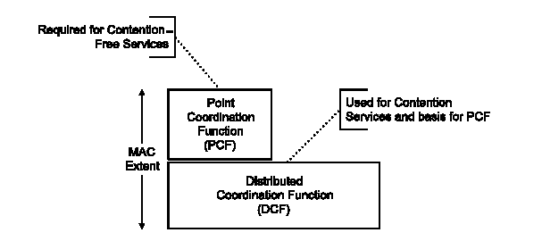

Figure 47 – MAC architecture

The MAC control plane architecuture is shown in Figure 47.1 and should be interpreted as described here. The PCF is formed from the following parts: CFP Scheduler, CF-Poll and CF-Delivery. The HCF is formed from all the parts in Figure 47.1 except DCF.
DCF can operate in a fully distributed fashion, without any explicit management. This is the case for an IBSS or a AP without a PC. When a PC is present, the DCF respects this by setting the NAV to protect scheduled CFPs.
The PC uses the CFP to deliver individual CF-Polls to CF-pollable STAs and to deliver its own Data.
EDCF operates as DCF, honoring scheduled CFPs, but also subject to global parameters that control its operation.
An HC can use EDCF to gain CAPs, or can schedule them within its CFP. Within the CAP it can deliver data and polled TXOPs to QSTAs or schedule CC/RR periods.
The HC can also deliver individual CF-Polls to STAs (although this is deprecated) and it can use the CFP for delivery of its own (downlink) data. The delivery of the downlink multicast data is according to the rules in 11.2.1.4 and 11.2.1.5.

Figure 47.1 - Mac Control-Plane Architecture

