IEEE P802.11
Wireless LANs
Title
Date: April 22 and 23, 2002
Author: Jon Rosdahl
Micro Linear
11734 South Election Road Suite 200 Draper, UT 84003
Phone: 801-617-2508
Fax: 801-617-2501
e-Mail: jrosdahl@ieee.org
Abstract
Minutes from the Interim Meeting held in San Mateo, CA, April 22 and 23, 2002.

Registered Attendees:
David Bagby, Bob O’Hara, Paramesh Gopi, Kevin Hayes, Stuart Kerry, Justin McCann,
Robert Moskowitz, Richard Paine, Indu Prakash, Jon Rosdahl, John Volbrecht, Liwen Wu,
Bill Selmeier

Meeting Called to order 9:05 AM by David Bagby.

Review the Proposed Agenda
2 days: 9-5
Review purpose
Address Administrative stuff
Process Comments from letter ballot

MOTION: Moved to approve Agenda
Moved: Richard P. 2nd: Kevin Vote: Unanimous.

Review status and decision Flow.

Admin Stuff
Approve Minutes from March Mtg
Moved: Kevin 2nd Bob O. Vote: Unanimous

Meeting Fees $25.00:
Collected from attendees:

Comment Resolution Work:
Draft 3.0b was sent out.
Editorials and previous approved

MOTION: Moved to adopt 3.0b per184/R12 and Draft 3.0b which reflects those resolutions:
Moved: Richard P. 2nd Jon R. Vote: Unanimous

New Editorial Comments from Robert M. was reviewed for corrections to corrections in Draft 3.0b.
Reviewed an editorial correction from Justin. (Punctuation of one sentence)
Comment file R12 was the starting point of our processing, and then Bob will create R13.

About 100 Comments are left.

Comment: 395: Declined: Key length has already been changed, although not as long as requested.
Discussion: was on some other key length issues.
Disposition: Declined -- Unanimous

Comment 396:
Discussion: Unsure on what he is really asking for. The comment change is not clear as to what he wants to happen, and the comment is on 5.2, and it doesn’t make sense for what he is asking for.
Disposition: Declined Comment was not well presented.
Unanimous

Comment 421:
Discussion: Why is it necessary for RADIUS? A discussion on the history of why it was chosen was given. Since AP’s has to support 802.1X, it must be able to support RADIUS services. The concern was in the static IP address configuration of each AP in a deployment scenario. Section 5.2 is not trying to say how to set-up RADIUS. The comment is really about the scope of definition.
Disposition: Declined: Answer to question is No.
Unanimous

Comment 239:
Discussion: RADIUS was selected, although it was not required, and yes it does require that the addresses of the AP get exchanged and communicated. The request of the commenter is to remove all References to RADIUS, and does not tell us what to replace the text with. Although the comment change could be done, it would leave the draft in a state that is unacceptable. The comment should be declined.

Disposition: Declined: Processing of many other comments have brought the task group to include RADIUS for this, and other purposes. Elimination of RADIUS for IP address discovery leaves the IAPP non-functional.
Unanimous

Comment 253: Comment had been accepted, but the text didn’t arrive until this meeting.
Discussion: Reviewed doc from Robert M. to extract the specific text for placing into the new draft. Robert then explained the process and how the change is supposed to be used. The timeout of the key and the exchange is the current outstanding problem. The idea of how to change keys across the board has not been defined. The ADD.Notify can be sent from any place in the network, and should be protected. Model is that at Boot time it gets the key and when the lifetime of the key expires, it needs to get a new key. We need to allow reception on 2 keys, but only transmit one. (old versus new). Since at IAPP registration point, the RADIUS can update the IP address. There was a concern that there should be two keys kept around , one old and on new (current). The AP should be able to receive both old and new. A request for having a reject message was rejected as providing a Denial of Service attack mode. Concern that we are adding more complexity than is needed. What is the real issue of our discussion? If you have one key, there is a point where some of the ADD.Notify Messagees will be dropped. This is caused by not having all keys updated at the same instant in time. Protection of the ADD.Notify is optional. Pulling the discussion back to look at the specific changes and review them. Sections 4.1.4,
Concern was expressed on the way the text from Robert has been brought. Discussion on how to make progress proceeded. We need to understand the proposed changes and having Robert go through the changes and explain them was determined to be the best method.

A Break was taken 10:50.
And discussion resumed at 11:00.

Resume discussion by Robert M. to explain paragraph 5.5.2 changes. Concern was expressed that he may have problems with the scheme, but in reality it was possibly a problem of using the wrong RADIUS term. The Access Point is both a RADIUS client and a RADIUS user. 5.3.1 through 5.3.3 packets that will need to be used are defined. ……….. A number of scenarios were described, or rather may be described, but will not go through them all at this time…… Registration process was described, as a side benefit to having these new packets in the sequence. ……… The key is a shared secret. By configuring the secret in the Access Point, the stations do not have to have any knowledge of the RADIUS secrets. There was some voters that wanted to discuss at length the changes and to clarify several points off-line. There must be a way to make more progress by holding the discussion over lunch. If we go back to line 171, and then try to get 75% of the total comments without needing to accept the text at this point.

Comment 12: Comment Declined, This is a recommend practice that recommends the preferred implementation…..
Unanimous

Comment 13:
Discussion: There is a new Section 1.4 that provides the details for a risk assessment.
Disposition: The requested change does not follow from any justification in the text of the comment. There is a threat discussion in section 1.4 that describes the Threat Model for the IAPP.
Unanimous

Comment 240: same as comment 239: Declined.
Comment 347: Same as comment 13: Declined.

Comment 144:
Discussion: How does an AP get the information about the Old AP from the RADIUS Server. The AP uses it’s BSSID security secret to get the information. It is the server that would provide the information only to a client with an authenticated access.
Disposition: Comment is satisfied with current draft as a result of processing earlier comments….
Unanimous

Comment 60: Comment Accepted, and previous done.
Comment 175: Skipped for now, it is not a no vote, and from a non-voter.
Comment 194: Comment has been addressed.
Comment 201: Comment had been addressed.
Comment 297: Comment has been addressed.
Comment 397: Skipped for the time being and will return later.

Comment 461: Comment Declined. The Detail required to use IPSec is provided in the relevant RFICs.
Unanimous

Comment 462:
Discussion: Is the block extensible? Yes from the IAPP stand point, but the owners define the Blocks themselves. It is not designed for propriety information.
Disposition: Comment Declined. The Block is defined as it is defined. It is not up to the implementer to add arbitrary bits and pieces to the security Blocks.
Unanimous

Comment 61:
Discussion: The intent was to say the contents, but the group determined that the sentence needs to be removed.
Disposition: Accepted, Sentence was removed.
Unanimous

Comment 422: Comment Declined.
Unanimous

Comment 122: Comment Accepted,
Discussion: The title and some text will be modified to be more general. This will help allow the use of other contexts to be passed in the future. We need to add a sentence to provide a more general explanation. We will not add the specific context descriptions. The question is that the context block needs to be encrypted by the ones that need it. Concern was expressed that the last sentence is still possibly confusing. The group felt that it was not.
Unanimous

Comment 241:
Discussion: This is a potential problem, but it is not our scope to do it.
Disposition: Comment Declined. Authentication of the 802.11 frames is the responsibility of the 802.11 MAC, should such authentication be required. The IAPP is an independent entity that responds to service requests from the APME, not from the 802.11 MLME.

Comment 398:
Discussion: The roaming was invented to short-circuit multiple associations. The need to do a reauthenticate is still a need whether it is roaming or not. By forcing him to reauthenticate you cannot preclude him from getting the access that is being tried to prevent it from happening.
Disposition: Comment Declined:
Unanimous

Final accounting of meeting fees.
Break for Lunch 12:00:

Meeting Reconvened at 12:45
Editor is absent for a time, and so Secretary will keep up the Comment Resolution, Chair will do the Editing of the Draft as needed till he returns.

Line 197: Comment 17:
Disposition: Comment Accepted. "Security Contexts" was not found in the current draft.
Unanimous

Line 198: Comment 62:
Disposition: Comment declined: See 4th paragraph in the named section.
Unanimous

Line 199: Comment 145:
Disposition: Commenter is satisfied with Draft 3.0b.
Unanimous

Line 200: Comment 146 :
Disposition: Comment accepted.
Unanimous

Line 201: Comment 176:
Disposition: We will add a threat model to the draft to explain the reasons for using IPsec. It is the opinion of the task group that the bilateral security association of IPsec is sufficient to secure the IAPP communications between APs, which is all that IAPP is attempting to accomplish. The commenter’s statement that IAPP involves a 3-party handoff of authorization is not supported by the content of the draft. If some other standard is planning to make use of the facilities provided by IAPP to perform such a 3-party handoff, it is the responsibility of that other standard to ensure that the handoff is performed securely. The requested change is declined.
Unanimous

Line 202: Comment 195:
Disposition: Comment Accepted: Now lower case.
Unanimous

Line 203: Comment 242:
Disposition: Comment accepted. The issuance of the Layer 2 Update frame has been moved to occur after the MOVE-response packet is received with Status=SUCCESSUL. Regarding the Rogue Station, it must be handled by 802.11 MAC protocol.
Unanimous

Line 204: Comment 399:
Disposition: Comment declined. No specific Change requested. However other change requests have caused the update to be made after the association response.
Unanimous

Line 205: Comment 400:
Disposition: Comment declined: No specific change requested. The SPI is the pointer into the security info table for the AP. IPSec requires the SPI to be unique at each receiver, and the draft satisfies this requirement.
Unanimous

Line 206: Comment 401:
Disposition: Comment Accepted: "Password" has been changed to "secret", and consistent use of secret and key applied.
Unanimous

Line 207: Comment 402:
Disposition: Comment Accepted: See new section 1.4.
Unanimous

Line 208: Comment 403:
Disposition: Comment Declined: Since the move is done via TCP, delivery is guaranteed by the delivery mechanism.
Unanimous

Line 209: Comment 463:
Disposition: Comment is Invalid and non-responsive.
Unanimous

Line 210: Comment 464:
Disposition: Comment Accepted. Text was clarified. Please refer to new draft.
Unanimous

Line 211: Comment 63:
Disposition: Comment Accepted. Text was clarified. Values are dependant on Cypher Suite.
Unanimous

Line 212: Comment 14:
Line 213: Comment 64:
Skip for text from Robert M.

Line 214: Comment 243:
Disposition: Comment Accepted. See new Draft. See comment 114.
Unanimous
Break at 1:55

Reconvened at 2:05.

Comment 464 : Comment Accepted.
We returned and added term to a table 6 and table 14 in the draft.

Comment 255: Prior to the break, we accepted the comment, and now will look at the text to change.
A slide presentation on IP to MAC multicast was shown to explain how the mapping takes place. More work is needed and so we need to go on, and rethink this more tomorrow.

Lines 214-217 were deferred.

Line 218, Comment 404: Comment Declined. The TG decided that ADD-Notify is required as part of the recommended practice to allow the continued use of Legacy STAs that do not properly implement the 802.11 standard by making constant use of Associate Request rather than the proper use of the Reassociation Request.

Line 219, Comment 330:
Disposition: Comment Declined. Te text in 5.6 is purely descriptive of the fact that there is a MIB. The MIB is defined in Annex A, where the word “Normative” is used.
Unanimous

Line 220, Comment 65:
Discussion: The AP’s use Radius to find the old AP not to find the STA. So the comment is probably correct, and the phrase removed.

Disposition: Comment Accept, Phrase removed.
Unanimous

Line 221, Comment 405:
Disposition: Comment Declined. The task group believes that the enforcement of a single association is a reasonable and attainable goal for this recommended practice.
Unanimous

Line 222, Comment 123 &
Line 223, comment 310:
Disposition: Comment Accepted, “The TBD will be replaced as soon as it is assigned. It has been ordered.” Will be added as a footnote to the draft. Stuart is to get the port number ordered.
Unanimous

Line 224, Comment 423:
Disposition: Comment Declined. The location once fixed means it is irrelevant.
Unanimous

“Premature optimisation is the root of all Evil”

Line 225, Comment 124:
Discussion: should an AP be allowed to support certain versions of the protocol or not.
Disposition: Comment accepted. Text modified, similar to the comment change request.
Unanimous

Line 226, Comment 331:
Discussion: if we remove short, we need to define the span. The text is a duplicate of what is in the RADIUS Spec. The identifier field is the subject that could be moved to reword the sentence. It was argued that the changing of the wording would meet the needs of the commenter, but there is no description of what is to be placed in the identifier field. The values to be placed in the field are dependant on implementation. The value should be unique. With respect to other outstanding packets when sent, except when that packet is a response to another IAPP packet.
Discussion on how to make the previous sentence complete was taken. The concern was to be explicit in defining the what goes in the identifier field for both request and response.

Disposition: Comment Accepted, Text modified to eliminate the use of the word “short”.
Unanimous

Line 227, Comment 196:
Disposition: This is defined to allow the future use of 64-bit addresses, already being allocated by the IEEE.
Unanimous

Line 228, Comment 197: Comment Declined.
Unanimous

Line 229, Comment 257: Comment resolved same as 5.5.2.
Unanimous

Line 230, Comment : comment deferred.
Line 231: Comment : Comment Declined. UDP is sufficient for this packet.
Unanimous

Line 232: Comment186:
Comment Declined. The task group does not desire to add the complexity of a universal time base to the requirements for implementing an ESS utilizing IAPP.
Unanimous

Line 233: Comment 64:
Comment declined. This is defined to allow the future use of 64-bit Addresses, already being allocated.
Unanimous

Line 234 Comment 67: comment response: To provide 16-bit alignment to the MAC address.
Unanimous
Line 235: Comment 68: Comment Accepted: Text modified.
Unanimous
Line 236: Comment 244: Comment Accepted (from March Meeting).

Line 238 and Line 239: Comment 407 and 408: Comments were invalidated as non-responsive.
Unanimous
Line 240: Comment 2:
Discussion: The RFC that we reference recommends DES, but we have not recommended 3Des. It is unclear whether we need to recommend one or not. Is AES something that can be done in general? Yes, it can, but the comment is looking to the comment, it is asking for a recommendation, there is one made in the referenced RFC. If we decline the comment, then we may have more comments in the future. We have a concern for recommending a choice that is still in a draft form. We could recommend the minimum of DES and then an implementer can then add more stringent types in the future. The referenced RFC’s can be the minimum, and as the RFIC is updated, so will our recommended practice. It was determined that 2406 defines DES as the minimum Required transform level. Text was added to reflect this point in section 6.8.
Disposition: Comment Accepted. The reference to the appropriate RFC is included as a reference and a minimum set is defined.

Line 241: Comment 27:
Comment declined. The protocol is as simple as a the task group can create and meet the functional requirements and to satisfy the comments received in prior letter ballots.

Line 242: Comment 69: deferred.
Line 243, 244: Comment Accepted: refer to the new draft.
Line 245: deferred.
Line 246: Comment Declined.
Line 247: Comment Declined.
Line 248: Comment Declined.
Line 249: Comment deferred.
Line 250: Comment invalid and non-responsive.
Line 242, 245:
Discussion on changes to the text for correcting the issue proceeded in to editing the text.
Disposition:
Line 185, 200: Comment Accepted.

Changes to 6.6 required some consistency changes to 6.7 to make it consistent. The New-AP-ACK-Authenticator definition needed to be consistently used in both 6.6. And 6.7. Figure 12 needed to update to reflect the changes.

Line 249: Comment:
Discussion: Is the commenter asking for extra text, or is he not understanding the section, and need to have clarification added? Section 5 is where the function is defined, and section 6 is where the Packet format is described.
Disposition: Comment is declined. Section 5 is for function definition and Section 6 is for Packet format description.

Line 251: Comment 70:
Disposition: Comment Accepted. Figure is corrected, and the last paragraph is corrected to be consistent and correct.
Unanimous

Line 252: Comment: Commenter is satisfied with text changes made as a result of processing other comments.

Line 252: Comment:
Disposition: Comment Declined: There is insufficient information to determine a change that will satisfy the requirements.
Line 253: Comment accepted. The Text has been rewritten.
Line 254: Comment: Duplicate Comment.
Line 256: Comment:
Discussion: Bummer that the commenter didn’t provide requested changes.
Disposition: Comment Accepted. All requested changes have been implemented exactly as requested by the commenter.

Line 257: Comment 19: Discussion: We need to understand the issue. Skip to next comment.
Line 258: Comment 106: Comment Accepted, There are no requirements for 802.1X for support of roaming.
Line 259: Comment 107: Comment declined. Many previous comments have requested secure IAPP operation.

Line 260: Comment 333:
Discussion: We talked this over, and decided that it was editorial, and the name doesn’t need to change.
Disposition: Comment Declined. This is an editorial comment.

Line 261: Comment 20:
Discussion : We have a comment that will completely remove Annex B, and another one that will completely replace B, and so we need to determine if we need to keep Annex B or not. It sounds like it Annex B is a draft RFC anyway, and so we need to determine its need. The Annex B was made as a draft to look at in CMOBIUS. We determined that Annex B.
Disposition: Annex B was removed. Comment Accepted.
Unanimous

So All Comments on annex B are hereby resolved. Disposition for those are comment moot due to removal of Annex B.
Vote: Unanimous

Note: The following text was submitted as a clarification of the issue discussed in Line 261, Comment 20. It was provided on May 2, 2002 by Bernard Aboba [aboba@internaut.com]

“> > Annex B (Context Transfer in IEEE 802) was written specifically for IEEE
> > 802.11 TgF. It was published in IETF draft form to get feedback on
> > on the ideas contained within it. The feedback (relating to RADIUS
> > processing rules and attributes appropriate for context transfer) has been
> > incorporated into the latest revision of the document, which is available
> > at http://www.ietf.org/internet-drafts/draft-aboba-802-context-02.txt.
> >
> > Annext B was never submitted to SEAMOBY as an individual submission
> > or WG work item (indeed, it is not labelled as such within the IETF draft
> > naming system which requires that individual submissions be named
> > draft-aboba-seamoby-XXXX if that were the case). Because it deals
> > only with context transfer between IEEE 802 media, it is not relevant to
> > that group, whose charter focusses on layer 3 context transfer, and
> > it has never been presented to SEAMOBY.”

The Port numbers that need to be requested are asking for a description of what the port number is to be used. The Chair can give the IANA with the draft text. We can then apply for the port number.

The Meeting then broke into two groups at 5:06pm.
One group to discuss Robert M.’s Text, and the other to process the “General” Comments.
The groups continued their discussions for about an hour then everyone left.
Meeting Reconvened at 9:04 AM Tuesday April 23rd.
Congrats to Bob who Shaved.
Review the progress made by the sub-groups.

Line 268: Comment declined. See Minutes of prior meetings.
Unanimous

Line 269: Commenter requested no changes.
Unanimous

Line 270: Comment declined. The security requirements of the IAPP are independent of those for TGi and must be dealt with in IAPP.
Unanimous

Line 271: Comment: Comment Declined.
Unanimous

Line 272: Comment: Comment Declined. The API of a standard or recommended practice is the service acess point (SAP). This is defined in clause 4.
Unanimous

Line 273: Comment: Comment declined. Mutual authentication of STA and AP is a function defined by the 802.11 MAC Management protocol, not the IAPP. The IAPP defines a mechanism that may be used by APs to perform this authentication. But it is not defining the authentication, itself.
Unanimous

Line 274: Comment: Comment declined. A specific recommendation has been made. An exhaustive list of all possibilities is outside the scope of the recommended practice.
Unanimous

Line 276: Comment 182:
Disposition: no change requested
Unanimous

Line 277: Comment 187:
Disposition: No change requested. RADIUS met the requirements of the IAPP. RADIUS has a much larger existing user base and supplier base than the other identified protocols.
Unanimous

Line 279: Comment 216:
Disposition: Comment declined. The functional requirements were adopted and defined the scope of the solution. There was no need seen for a generic message between APs.
Unanimous

Line 280: Comment 251:
Disposition: Comment declined. The requirement for the development of the IAPP is to support 802.11-1999, not some potential, undefined standard.
Unanimous

Line 281: Comment 252:
Disposition: Comment accepted. The revised draft implements changes that are believed to implement the requested changes
Unanimous

Line 282: Comment 311:
Disposition: No Change Requested. This is a recommended practise not a draft amendment.
Unanimous

Line 283: Comment 335: Comment accepted.
Unanimous

Line 284: Comment 33: The third column is to identify the Element IDs. Comment accepted.
Unanimous

Line 285: Comment 34: ID numbers have been assigned and entered in the table. Comment accepted.
Unanimous

Line 286: Comment 453:
Disposition: This comment is considered by the TGF group to be a non-responsive comment. The draft was offered for review to the entire 802.11 WG - this includes all members of Tgi. Additionally, the comment asks for no draft changes and does not meet the requirement of being sufficiently detailed to specify changes required to the TGF draft to satisfy the voter. Simply having the opinion that there should be more discussion is not sufficient to support a technical "no" vote.
Unanimous

Line 331: Editorial comment 337:
Disposition: Other Commenters have found significant value in this diagram. If Additional information would be useful to this commenter from an MSC, the commenter is solicited to provide one.
Unanimous

Line 332: Editorial Comment 338: Same as Line 331.
Unanimous

Line 341: Comment 222: comment was “Same as 15” should be the same for resolution.
Editorial Comments are missing description and change request.
Disposition: Comment does not provide sufficient
Unanimous

Line 346: Comment 223: &
Line 348: Comment 340: &
Line 350: Comment 225: &
Editorial Comments Missing description and change request.
Disposition: Comment does not provide sufficient
Unanimous

Line 409: Comment 4:
Discussion: Look to see if the words used in the paragraph need to be rearranged or not. No problem could be identified in the current rendition, and so no further changes are needed.
Disposition: The clause has been edited as a result of processing other comments. The commenter is solicited to re-examine the text to see if its meaning is clearer.
Unanimous

Line 411: Comment 5:
Same as Line 409, Comment 4.
Unanimous

Line 413: Comment 440:
The resolution was changed as we have removed the sentence in question.
Disposition: The referenced sentence has been deleted.
Unanimous

Line 419: Comment 361:
Same as line 409.
Unanimous

Line 425:Comment #: The language is correct and precise. See IEEE Std. 802.2
Unanimous

Line 433: Comment #:
Discussion: a review of ESP Identifier was checked. ESP XXX “number” was changed to ESP XXX “identifier” as needed.

Disposition: Comment Accepted. Table was changed.
Line 443: comment #:
Line 444: Comment #:
Line 446: Comment #:
Same as 409:
Unanimous

Line 449: Comment #:
Discussion: reviewed the table entry in Annex A.
Disposition: Comment Accepted. Relevant text changed.
Unanimous

Line 450 – 457: refer to Annex B. As Annex B has been deleted, these are now moot.
Unanimous

Line 469: Comment #: Comment declined. The commenter is solicited to provide such a new diagram, if such would be helpful.
Unanimous

Line 472: Disposition: The language is correct according
Unanimous

Line 473:
Disposition: There is no occurrence of the text cited by the commenter in the draft as balloted.
Unanimous

Line 136: comment:
Discussion: The group believes the handshake is sufficient.
Disposition: Comment Declined. The task group believes that the handshake is sufficient to securely transfer the keying material. If the commenter is not convinced, he is solicited to provide a concrete description of a successful attack against the exchange.
Unanimous

Line 153: Comment: This comment is dealt with by the new section 1.4.
Disposition: A New Clause 1.4 was added…..
Unanimous

Line 179: Comment #:
Discussion: This is a comment that the information going into the RADIUS server was from the STA, which it isn’t. The commenter did not understand the process. We then reviewed the text to try to make it clearer. The section has been changed already, and should satisfy the commenter.

Disposition:
Unanimous

Line 189: Comment #
Discussion: Robert has this in a section of text that he provided prior to the meeting that meets issue #1 and 2. Issue #3 is not certain that it is complete, but #4 is also been taken care of.
While parts are done, we will come back to this.

Discussion: We need an Attribute Number from IANA for the RADIUS. This is unclear as to what the number is for and while 802.11 has a MIB 10036 value for the member-body. The RADIUS did not provide the entire arc in the identifier of its attributes. The number that is needed IANA Private Enterprise number. And the person that can get it is the Chair of 802.11, Stuart. Http://www.iana.org/cgi-bin/enterprise.pl is the web site to get the number.

Line 257: Comment #:
Disposition: Comment declined. There is not an active RADIUS body with which to liase. The definitions of the extensions to the RADIUS operation are accomplished in a RADIUS plug-in, a standard practice of RADIUS vendors.
Unanimous

Line 278: Comment #:
Discussion: Could an Add Notify be replayed later and have it cause a disruption. There is a sequence number from the station that was given before, but that is not necessarily the issue the commenter is specifying. The ESP sequence number prevents the replay attack from happening.
This comment will be revisited when we look at the text from Robert.

Break: 10:20 am.

Meeting Resumed at 10:35 am.

Robert M. had a nifty White board program to lead the discussion.
The discussion was on the rouge attack of ADD.Notify, and how ESP protects us from this attack.
The IAPP-Init RADIUS Access provides Registration of BSSID table for MOVE RADIUS Access
Also Provides a General Registration of AP in ESS for management sort of stuff.
Why do we have to type all sorts of things that have to be typed in to configuring AP, but we can eliminate the need to manually enter this by using RADIUS access to prevent us from having to type these into APs. With Registration with the RADIUS, you don’t have hand enter all the data. The Table is stored in the RADIUS Server, and the BSS key can be used as the RADIUS secret password. Which is a more standard RADIUS packet, than what was there before.
Probably also supports DHCP address assignment to AP.
DHCP address change has to trigger IAPP-Initiate clear out All IAPP info.
The comments ask for the ADD.Notify to be made secure. This requires some global key that is manually installed, or some dynamic way to get the shared key. RADIUS allows you to get this dynamically. All comments on the Security are to get a central repository to administrate the keys.
The question is relating to the text, is it in sufficient shape to apply to the draft.
It is easier to have the text in a separate state and apply to the current draft.
In order to resolve the comments, we may have to add text that may cause more comments in the future.
The message to get registered with the RADIUS will provide the Shared key back to the AP.
We need to make the change to make the Recommended Practice more meaningful.
The change is to make ADD_Notify secure.

White Board pictures from the discussion:
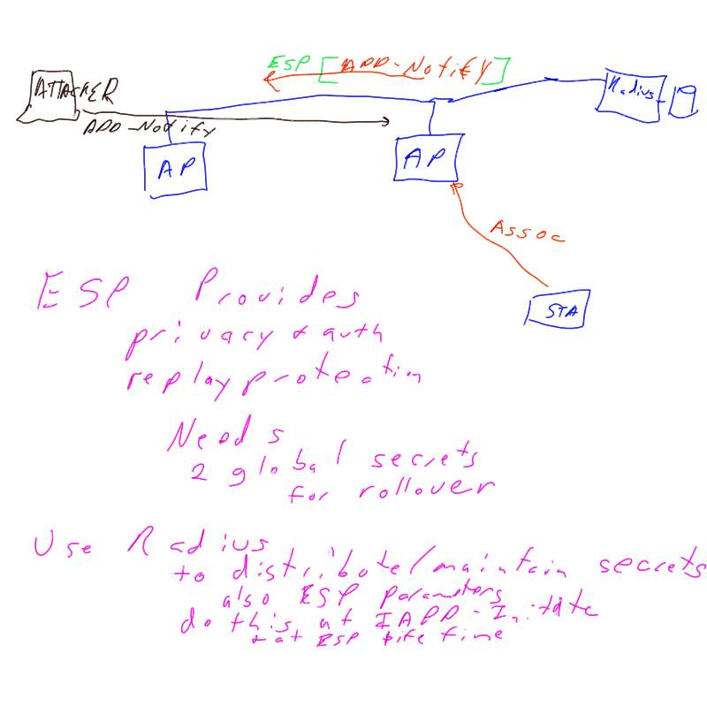

Second Page of discussion Notes:
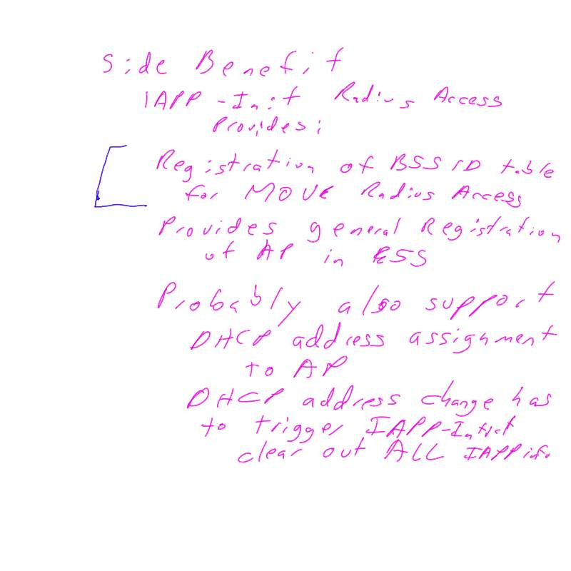

The meeting broke into sub-groups to get the text crafted correctly. 11:05 am.
Lunch was provided at 12:30 pm, and the groups kept working.
Stuart ordered Numbers for the Private Enterprise Identifier from IANA.
He also got the information for the Port Numbers that were needed ordered.

Meeting called to order at 2:15 after the sub-groups were prepared to report.

Motion: To Adopt the proposed text to secure ADD-Notify MSG
Moved: Robert M. 2nd John V. Vote: Unanimous

Discussion: The Text was for section 5.3.1 and 5.3.2

New Text was provided for changing the Broadcast to Multicast packet usage.

It was pointed out that we will need a Well-defined Multicast Address. Stuart took the AI to get it assigned.

The editor made some name changes to Robert M. Proposed text to be more descriptive. (i.e. Multicast changed to IAPP IP Multicast).

Motion:
Moved to accept the text as modified by Bob O. from Robert M that changes the Broadcast to Multicast address usage for ADD-Notify.
Moved: John V. 2nd Richard P. Vote: Unanimous

The previous Motions and comment resolution resolve the following Comments:
Line 142:
Line 163:
Line 189:
Line 210:
Line 212:
Line 213:
Line 215: Comment accepted, but the change was different than what was asked for.
Line 216:
Line 217:
Line 230:
Line 242:
Line 278: Comment Accepted, but the change was different than the specific requested change.
Vote: Unanimous that all the previous comments had been addressed.

At this point we believe that all comments have been addressed.
We have 2 outstanding Action items.
R17 has the comment resolutions up to this point.
Draft 3.0f is the draft that includes all the comment resolutions in R17

The drafts and R17 were distributed to attendees.

Remaining Open issues that are needed:
1. When you register, you get a session key, and then you need to get a new session key, so do we need to describe the need for a timer? No we don’t actually tell you the pieces that you need to build the AP. The Recommended practice describes the functionality. The concern was that we need to consider having the timer description. John withdrew his concern.

- We need to have a section that describes the overview of the consequences of not having the Security pieces.
- Section 5.5.2 had some edit that are missing.
- 97, 212, 213, 381 Comments needed to have the resolution added to the comment file.
  - 381 The answer is yes,
  - 212 and 213 missed the edit of their resolution: Comment Accepted.
  - 97 missed from the Add-Notify list of resolutions.
- A Table with element entries without descriptions.
- Vendor Attributes Table Caption and description.

Resolution of the open issues:
4. The Secretary will update the comment file and create an R18 and place back in the share area.
Now all the comments have a resolution.

3. Section 5.5.2 text was prepared and presented for consideration.
After review and a minor modification, the group unanimously accepted the changes.

Break at 3:05 pm.

Meeting reconvened at 3:12 pm.

Resolution of the open issues continued:
5. Caption for the tables and a description of the table itself was added. “ Table 6 contains a list of the vendor-specific RADIUS attributes used by the IAPP. The IEEE 802.11 vendor code is XXXXX (Number has been ordered, and noted in the footnotes.)

- The descriptions of these entries needs to be added, but we don’t have them defined as of now. If we don’t do it, we will get back comments that all these elements need definitions, and we will loose the opportunity for going to sponsor ballot in July.

The group split back into sub-groups to create the descriptions for the table entries at 3:25 pm.

Bill volunteered to type as someone else spoke, but it was determined that it would be faster to just let those speaking type.

Meeting reconvened at 4:15
The proposed text for 6.8 was added, and reviewed. There was a concern that the Date/Time Stamp was specified in UNIX format.

MOTION: Adopt the changes in 5.2 and 6.8 with the word UNIX replaced with the correct RFC reference.
Moved: Richard P. 2nd John V. Vote: Unanimous

The text for 5.3.5 and 5.3.7 was proposed, and a new acronym added to the list of acronyms.

MOTION: Adopt the changes to sections 5.3.5 and 5.3.7.
Moved: Richard P. 2nd Bob O Vote: Unanimous

Text changes for 6.6 and 6.7 were then discussed.

NTP time for the Date/Time field has the RFC 1305 that defines its usage.

References to 1112 and 1305 added to the reference list.

MOTION: Adopt the changes to sections 6.6 and 6.7 and the additions to the reference list.
Moved: Liwen. 2nd Stuart K. Vote: Unanimous

Document was then saved as Draft 3.0i to the share area.
The Editor will create Draft 3.1 from 3.0i after performing a last editor’s pass.

Goals for May 2002 for the report.
TGf is not meeting as the letter ballot is tentatively open.

Goals for July 2002
TGf will review the results of LB 37 & 38 & Start a sponsor ballot with either draft 3.0 or 3.1.
TGf anticipates a lighter meeting schedule in July.

Sponsor ballot must be announced 30 days prior to the SEC meeting.
A review of the motion that was made in March was done to ensure sufficient time to review and still meet the deadlines.
7th of June is the deadline to notify the SEC of a pending Sponsor Letter ballot for the July Plenary.

So this means that Letter Ballot 38 will need to be completed prior to that.

The Final Comment Doc is R18.
The Minutes will be 293, and report is 284.
The minutes and reports go to Tim G.
The Draft goes to Harry W. for private posting.
The comment resolution goes to Harry W for public posting.
Meeting Adjourned 5:00 PM

