IEEE P802.11
Wireless LANs
Integrity check for Disassociate
Date: March 04, 2002
Authors: Tim Moore
Microsoft
One Microsoft Way, Redmond, WA 98052-6399
Phone: +1 425-703-9861
E-mail: timmoore@microsoft.com

Abstract
This paper suggests text for inclusion in the TGi draft to enable the disassociate message to be integrity checked.

7.2.3.3 Disassociate: In RSNs should be handled as a data packet for encrypted and integrity purposes but it is allowed to be sent in the clear when no keys are available.
Add section with text:
In an RSN association, a disassociate frame should be encrypted and integrity checked as a data packet when a temporal key is available. When no temporal key is available the packet shall still be sent.
In an RSN association, reception of a disassociate frame is valid if it was correctly decrypted and integrity checked or if no temporal key is available for the association.
Support encrypted frame body in management frame for disassociation frame. Create a data frame of the format and calculate the MIC using TKIP:

DA | SA | Reason code | MIC

When encapsulated in a MPDU the format is
802.11 Hdr | IV | Reason code | MIC | ICV | FCS

Data frame format
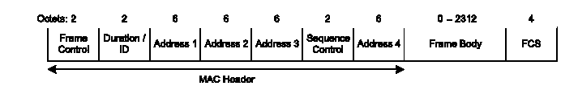

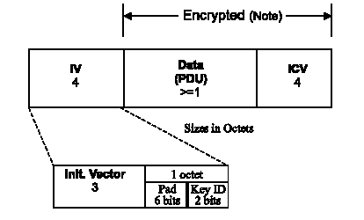

Management frame format
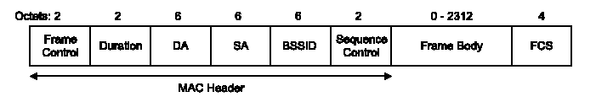

Disassociation frame format
The frame body of a management frame of subtype Disassociation contains the reason code information. This Reason Code field is used to indicate the reason that an unsolicited notification management frame of type Disassociation was generated. The length of the Reason Code field is 2 octets.

