IEEE P802.11
Wireless LANs
Explicit Loss Notification Mechanism in 802.11 Data Networks for Reliable Transport
Date: November 8, 2001
Authors:
Xia Gao Suhas N. Diggavi
University of Illinois, AT&T Labs – Research
Urbana-Champaign, IL 61801 Florham Park, NJ 07932
(217)-244-8473 (973)3608492
xiagao@crhc.uiuc.edu suhas@research.att.com

S. Muthukrishnan Matthew Sherman
AT&T Labs – Research AT&T Labs – Research
Florham Park, NJ 07932 Florham Park, NJ 07932
(973)3607212 (973) 236-6925
muthu@research.att.com mjsherman@att.com

Abstract
TCP is a reliable transport mechanism that has been enormously successful in wireline networks. Hybrid (wireline and wireless) networks pose new challenges for TCP. In particular, TCP must react differently to packet losses in the wired versus wireless links since they occur for different reasons. This issue has been well documented in the literature (see [1], and references therein). In [8], a method has been proposed for modifying TCP to work efficiently in hybrid networks; this involves link layer support to provide Explicit Loss Notification (ELN). In this contribution, we identify modifications required to support ELN within 802.11 standards and provide data demonstrating ELN’s value.

Reliable Transport Problem in 802.11
The technical challenge in meeting the goal of reliable transport over hybrid (wireline/wireless) networks is to localize the source of packet losses, namely, whether the packet losses are due to congestion in the wireline network or due to losses in the wireless link. This is because TCP attributes packet losses to congestion in the wireline network and takes corrective measures: Adjusting congestion windows and dropping data rates, which ultimately degrades performance in wired/wireless networks when packet losses due to wireless links dominate. In WLANs with 802.11 link layer technology, packet losses due to wireless links are significant, eg., due to prevailing channel transmission conditions, and interference from other users and radio sources, etc. Making TCP effective over hybrid networks with wireless characteristics of 802.11 (and other WLAN, WAN) technology is a challenge (see [2, 3, 4, 6, 7, 5] and references therein).

Overview of Solution
In [8], an endtoend solution is proposed for modifying TCP to be effective over hybrid networks. It relies on the Explicit Loss Notification [8, 1] mechanism to separately identify wireless linklosses from the wireline congestion losses. The particular ELN method in [8] is based on a very simple principle: if the header packet is received correctly by the mobile terminal, even if the IP packet is in error, the receiver would know that there was a wireless link loss. This information can then be conveyed back to the sender using a special acknowledgment (ACK) which is done at the transport layer. Note that this ACK mechanism is different and separate from the MAC layer ACK of the 802.11 specification. The method in [8] works by protecting the IPlayer header, that is, ensuring that the header be reliably transmitted; this is done by using an ARQ mechanism. More details are in [8].

Implementing the ELN Method from [8] in 802.11
In 802.11 networks, the IP packet is received by the MAC layer and translated into MAC service data units (MSDUs). If an MSDU is larger than the dot11FragmentationThreshold, it is partitioned (see Section 9.1.4 of [9]) in to several MAC protocol data units (MPDUs) at the sender. Each MPDU has a unique fragment number. The MAC protocol transmits MPDUs in increasing order of the fragment number. When a MPDU is transmitted, the MAC protocol waits an ACKTimeout period of time for the ACK. If the ACK is not received, the transmission is assumed lost and is retransmitted again. This procedure continues until either the whole MSDU is successfully transmitted or the transmission is stopped and the MSDU is discarded. The transmission can be stopped when, say, aMaxTransmitMSDULifetime is reached or the number of retransmissions exceeds dot11ShortRetryLimit or dot11LongRetryLimit. The receiver keeps a similar timer for each MSDU, aMaxReceiveLifetime. The timer of aMaxReceiveLifetime begins when receiving the first MPDU of the MSDU. At the receiver, when all the MPDUs comprising a MSDU are received, the MAC protocol delivers it to the higher layers. When the timer reaches aMaxReceiveLifetime, if the whole MSDU is still not completely received, the previously received MPDUs are discarded without reporting them to the higher layers.
The ELN mechanism in [8] can be implemented if the MAC protocol is modified at the receiver so that partially successful MSDUs are delivered to the higher layers. In addition, by appropriately using the number of retry attempts (dot11ShortRetryLimit or dot11LongRetryLimit), and the MSDU timetolive (aMaxTransmitMS DULifetime) the ELN mechanism in [8] can be implemented.
The specific change to be made in 802.11 is to add an entry in the 802.11 MIB that can be called ``dot11PartialUpload'' in the Dot11OperationEntry (given in Annex D of [9]). The syntax of the new object is given in Table 1.

dot11PartialUpload  SYNTAX  MAXACCESS  STATUS | OBJECTTYPE  TruthValue  readwrite  current
Table 1) Syntax of the ''dot11PartialUpload'' entry
When dot11PartialUpload is set to TRUE, even when all the MAC protocol data units (MPDUs) of one MAC service data unit (MSDU) are not completely received, the successfully received MPDUs may be forwarded to the upper layers of the IP protocol stack. Note that if the MPDU counter at the receiver is not started, this means that no MPDU (fragment) has reached the receiver and hence there is no need to do a partial upload. When ParitialUpload is set to FALSE, the successfully received MPDUs will be discarded if the whole MSDU is not completely transmitted. This is the default behavior of the current 802.11 standard.

The MSDU packet gets fragmented if it exceeds the dot11FragmentationThreshold which is between 256 octets and 2346 octets (see the MIB specification on page 483-484 of [9]). Say we use the smallest fragmentation size of 256 octets for an MPDU. It follows that 256 octets of LLC data will fit in an MPDU (Section 9.4] of [9]). After subtracting the LLC overhead of 4 octets (Section 3.2 of [10]), 252 octets of network layer data can fit in one MPDU. The IP and TCP headers are between 20 and 60 octets in size each, which will comfortably fit into one MPDU. Thus a single MPDU fragment can completely contain the IP packet header information. Since the IP header occurs at the beginning of an MPDU, it will be contained in the first MPDU, which will have the smallest fragment number, and hence will be transmitted first. Using the changes suggested in this contribution for the MAC protocol in 802.11, any partially successful MSDU is delivered to the higher layer; any such delivery will contain the first fragment, and hence, will contain the IP packet header information. The transport mechanism in [8] examines the IP packet header and can identify the flow associated with the IP packet. Therefore, even if the MSDU was not completely delivered, i.e. the entire IP packet was not correctly delivered; the receiver knows that the packet reached the 802.11 Access Point and that the loss occurred in the wireless link. Therefore, as the receiver knows that this loss did not occur due to congestion in the wireless link, it generates [8] a special ACK for the sender thereby implementing the ELN mechanism.

Details of implementation
In order to properly represent the partial upload feature, the functions in upload blocks of the formal description of the MAC layer state machine (described in Annex C of [9]) need to be modified. The three blocks to focus on are in the upload path and are the “Reception” block, “Protocol_Control_STA” block and the “MAC_Data_Service” block. The logical path for the packet from the physical layer to the LLC is as shown below:

Packet from PHY layer → Defragment → Rx_Coordination → MSDU_TO_LLC → LLC.

The “Defragment” sub-block is in the “Reception” block, the “Rx_Coordination” sub-block lies in the “Protocol_Control_STA” block, and, the MSDU_TO_LLC sub-block occurs in the “MAC_Data_Service” block. The “Defragment” sub-block assembles the partially received MSDU and puts it into an array. If it receives a complete MSDU it will upload it to the “Rx_Coordination” sub-block, which in turn will pass it up to the MSDU_TO_LLC sub-block and finally the MSDU_TO_LLC passes the MSDU to the LLC. In order to represent the partial upload feature, changes need to be made to these sub-blocks, so that they pass a partially successful MSDU to the LLC. The following mechanism is suggested to implement this feature.

The data structure for assembling the MSDU in the formal description is through an array where the partial MSDU is stored along with the time when the first fragment (MPDU) of the MSDU was put in. Currently, the “Defragment” block discards a partially successful MSDU when aMaxReceiveLifeTime is reached. This is implemented using the function ArAge() which compares the current time to the time when the first MPDU of the particular MSDU was put into the array meant for reassembling the MSDUs. Therefore, if the time for a particular MSDU has expired the “Defragment” sub-block marks the part of the array occupied by that partial MSDU as unused and therefore, the MSDU is discarded. The proposed change is that once it is determined through the ArAge() function that a particular partially assembled MSDU has expired, a modification to the Rx_Indicate() function is used to upload the partial MSDU to the next sub-block. Currently the Rx_Indicate() function has four arguments, Frame, Reception end time, Reception start time, and Rate. It is proposed that one more argument be added called “Partial” which allows the “Defragment” sub-block to mark an incomplete MSDU being uploaded. Hence the function call Rx_Indicate (Frame, Reception end time, Reception start time, Rate, Partial) sets “Partial” to 0 if the MSDU was completely successful and “Partial” to 1 if the MSDU was only partially successful. The “Frame” contains the partially assembled MSDU, if it was not completely successful.

Next, the “Rx_Coordination” sub-block receives the Rx_Indicate() function call from the “Defragment” sub-block. It calls the Msdu_Indicate() function to pass the MSDU up to the MSDU_TO_LLC sub-block. The “Rx_Coordination” sub-block needs to check the value of the variable “Partial” in the modified function Rx_Indicate(), and use that in the function Msdu_Indicate which needs to be modified in the following manner. Currently the Msdu_Indicate() function uses parameters Frame, and CfPriority. This would be modified to Msdu_Indicate(Frame,CfPriority,Partial) with the “Partial” variable passed on from that received from the Rx_Indicate() function.

Finally the “MSDU_TO_LLC” sub-block uses the Msdu_Indicate() call from the “Rx_Coordinate” sub-block and calls the function To_LLC() which transfers the MSDU block to the LLC. Therefore, in this sub-block a modified Msdu_Indicate() function is used which has the variable “Partial” to update the MA-UNITDATA.indication primitive (see Section 6.2.1.2.2 of [9]). Here, if the dot11PartialUpload is enabled, and if the MSDU was partially received (as indicated by the “Partial” variable) the “rx_success” value is set to “fail/partial”. This is a modification to the variable “rx_success” which controls the “reception status” parameter of the MA-UNITDATA.indication. Currently, the rx_success variable can only be successful as the failed/partial MSDUs are discarded. If dot11PartialUpload is enabled, it allows for the variable “rx_success” to take its logically alternate value, i.e., “fail/partial” which indicates to the MA-UNITDATA.indication primitive that the “reception status” is “fail/partial”. By examining this entry in the primitive, the LLC can distinguish between partially successful and fully successful MSDUs.

Numerical results
To demonstrate the utility of the proposed changes, simulation results are presented for a one-hop scenario using the ns-2 simulator (version 2.1b7a) with the following wireless link parameters. The raw data rate is 1 Mb/s with a maximal delay of 2msec. Each IP packet has a fixed size of 1500 bytes and the fragment size is 256 bytes. All other NS related parameters were set to their default values. For this scenario, the 802.11 FER ranged from 0.0% to 1%. This translates to an IP layer packet error rate of 0% to 7%. The IP packet error rate can be directly related to the FER because, given the default retry and transmit life time limits, if any fragment (frame) is lost even once the entire IP packet is lost. The throughput of the ELN mechanism was compared for different versions of TCP. In Figure 1 below the throughput improvement that can be achieved by implementing ELN through link layer partial upload is shown, as the Channel error rate (FER) increases from 0% to 1%. The “No ELN” scheme used for comparison is TCP-Reno, which is the dominant TCP implementation currently. More details about these schemes and the setup can be found in [8]. As the FER increases from 0% to 1%, the throughput improvement at the IP layer varies between 0% and 37%. At a 1% transport layer loss rate (0.15% FER), the throughput improvement using the ELN mechanism (denoted as LHP in the figure) is 10%. And, for a FER of 1%, which is well within the operating region of 802.11 and translates to a transport layer packet loss rate of 7%, the throughput increase is 37% using the ELN mechanism.

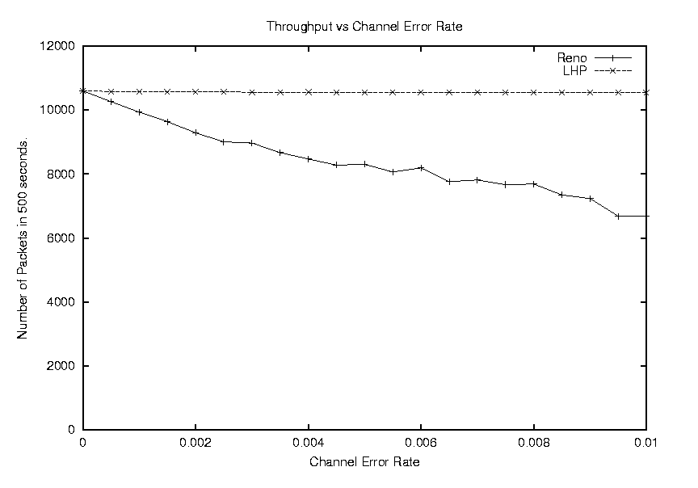
Figure 1: Comparison of throughput with and without ELN mechanism

References
[1] Hari Balakrishnan, Venkata N. Padmanabhan, Srinivasan Seshan, and Randy H. Katz, ``A comparison of mechanisms for improving tcp performance over wireless links,'' IEEE/ACM Transactions on Networking, vol. 5, no. 6, pp. 756--769, December 1997.
[2] E. Ayanoglu, S. Paul, T. F. LaPorta, K. K. Sabnani, and R. D. Gitlin, ``AIRMAIL: A linklayer protocol for wireless networks ,'' in ACM Wireless Network, vol. 1, pp. 4760, February 1995.
[3] A. Bakre and B. R. Badrinath, ``ITCP: Indirect TCP for mobile hosts,'' in Proc. 15th Int. Conf. Distributed Computing System (ICDCS), May 1995.
[4] H. Balakrishnan, S. Seshan and R. H. Katz, ``Improving reliable transport and handoff performance in cellular wireless networks,'' in ACM Wireless Networks, vol. 1, no. 4, December 1995.
[5] A. DeSimone, M. C. Chuah, and O. C. Yue, ``Throughput performance of transportlayer protocols over wireless LANs,'' in Proc. of Globecom, December 1993.
[6] K. Brown and S. Singh, ``MTCP: TCP for mobile cellular networks,'' in ACM Computer Comm. Rev. (CCR), vol. 27, no. 5, 1997.
[7] R. K. Balan, B. P. Lee, K. R. R. Kumar, L. Jacob, W. K. G. Seah and A. L. Ananda, ``TCP HACK: TCP header checksum option to improve performance over lossy links,'' in Proc. IEEE INFOCOM'2001, 2001.
[8] Xia Gao, Suhas N. Diggavi and S. Muthukrishnan, ``To Serve and to Protect: Reliable Transport Mechanisms for Wireless Data Networks,'' in ``AT&T Technical report # TD4ZTNZN,'' July 2001.
[9] ANSI/IEEE Standard 802.11, Part 11: Wireless LAN Medium Access Control (MAC) and Physical layer (PHY) specifications.
[10] ANSI/IEEE Standard 802.2, Part 2: Logical Link Control specifications.

