IEEE P802.11
Wireless LANs
CCK-OFDM Proposed Normative Text
Date: July 10 2001
Author:
Keith Baldwin, Intersil Corporation, kbaldwin@intersil.com
Mark Webster, Intersil Corporation, mwebster@intersil.com
Steve Halford, Intersil Corporation, 321-729-5130, shalford@intersil.com
Jim Zyren, Intersil Corporation, jzyren@intersil.com

Abstract

Our proposed high-rate standard merges the legacy 2.4 GHz IEEE 802.11 and 802.11b networks to 5 GHz IEEE 802.11a standard, which drastically increases data rates by employing orthogonal frequency division (OFDM) modulation. Thus, the combined benefits of an advanced multipath tolerant waveform and extended rates to 54 Mbit/s are achieved within any existing 802.11 or 802.11b compliant network.

Compatibility is ensured through use of legacy 802.11b long and optionally short preambles and inclusion of a signal extension field to accommodate a modest increase in latency. This design ensures existing clear channel assessment (CCA) and short interframe spacing interval (SIFS) function properly when new and legacy devices interoperate. In addition, an ultrashort preamble option is provided that, while not necessarily backwards compliant, does enable 802.11g capable networks to switch to a higher throughput option. The ultrashort preamble option is identical to 802.11a modulation in every way except RF center frequency.

Draft IEEE Std 802.11g-2001
(supplement to
ANSI/IEEE Std 802.11and 802.11b, 1999 Edition)

Supplement to IEEE Standard for
Information technology –
Telecommunications and information exchange
Between systems –
Local and metropolitan area networks –
Specific Requirements –

Part 11: Wireless LAN Medium Access Control
(MAC) and Physical Layer (PHY) specifications:

Further Speed Extension to the 2.4 GHz Band Physical Layer

Sponsor

LAN/MAN Standards Committee
of the
IEEE Computer Society

Not yet approved

IEEE-SA Standards Board

Abstract: Changes and additions to IEEE Std 802.11 and IEEE Std 802.11b, 1999 Edition are provided to support even higher date rate physical layer (PHY) operation in the 2.4 GHz band.
Keywords: 2.4 GHz, high speed, local area network (LAN), radio frequency (RF), wireless

_______________

The Institute of Electrical and Electronic Engineers, Inc.
3 Park Avenue, New York, NY 10016-5997, USA

Copyright © 2001 by the Institute of Electrical and Electronic Engineers, Inc.

Print: ISBN X-XXXX-XXXX-X
PDF: ISBN X-XXXX-XXXX-X

No part of this publication may be reproduced in any form, in an electronic retrieval system or otherwise, without the prior written permission of the publisher.
IEEE Standards documents are developed within the IEEE Societies and the Standards Coordinating Committees of the IEEE Standards Association (IEEE-SA) Standards Board. Members of the committees serve voluntarily and without compensation. They are not necessarily members of the Institute. The standards developed within IEEE represent a consensus of the broad expertise on the subject within the Institute as well as those activities outside of IEEE that have expressed an interest in participating in the development of the standard.

Use of an IEEE Standard is wholly voluntary. The existence of an IEEE Standard does not imply that there
are no other ways to produce, test, measure, purchase, market, or provide other goods and services related to the scope of the IEEE Standard. Furthermore, the viewpoint expressed at the time a standard is approved and issued is subject to change brought about through developments in the state of the art and comments
received from users of the standard. Every IEEE Standard is subjected to review at least every five years for revision or reaffirmation. When a document is more than five years old and has not been reaffirmed, it is reasonable to conclude that its contents, although still of some value, do not wholly reflect the present state of the art. Users are cautioned to check to determine that they have the latest edition of any IEEE Standard.

Comments for revision of IEEE Standards are welcome from any interested party, regardless of membership affiliation with IEEE. Suggestions for changes in documents should be in the form of a proposed change of text, together with appropriate supporting comments.

Interpretations: Occasionally questions may arise regarding the meaning of portions of standards as they
relate to specific applications. When the need for interpretations is brought to the attention of IEEE, the
Institute will initiate action to prepare appropriate responses. Since IEEE Standards represent a consensus of all concerned interests, it is important to ensure that any interpretation has also received the concurrence of a balance of interests. For this reason, IEEE and the members of its societies and Standards Coordinating
Committees are not able to provide an instant response to interpretation requests except in those cases where the matter has previously received formal consideration.

Comments on standards and requests for interpretations should be addressed to:

Secretary, IEEE-SA Standards Board
445 Hoes Lane
P.O. Box 1331
Piscataway, NJ 08855-1331
USA

Note: Attention is called to the possibility that implementation of this standard may
require use of subject matter covered by patent rights. By publication of this standard,
no position is taken with respect to the existence or validity of any patent rights in
connection therewith. The IEEE shall not be responsible for identifying patents for
which a license may be required by an IEEE standard or for conducting inquiries into
the legal validity or scope of those patents that are brought to its attention.

Authorization to photocopy portions of any individual standard for internal or personal use is granted by the Institute of Electrical and Electronics Engineers, Inc., provided that the appropriate fee is paid to Copyright Clearance Center. To arrange for payment of licensing fee, please contact Copyright Clearance Center, Customer Service, 222 Rosewood Drive, Danvers, MA 01923 USA; (978) 750-8400. Permission to photocopy portions of any individual standard for educational classroom use can also be obtained through the Copy-right Clearance Center.
Introduction

[This introduction is not part of IEEE Std 802.11b-1999, Supplement to IEEE Standard for Information technology—
Telecommunications and information exchange between systems—Local and metropolitan area networks—Specific
requirements—Part 11: Wireless LAN Medium Access Control (MAC) and Physical Layer (PHY) specifications:
Higher-Speed Physical Layer Extension in the 2.4 GHz Band.]

This standard is part of a family of standards for local and metropolitan area networks. The relationship
between the standard and other members of the family is shown below. (The numbers in the figure refer to
IEEE standard numbers.)

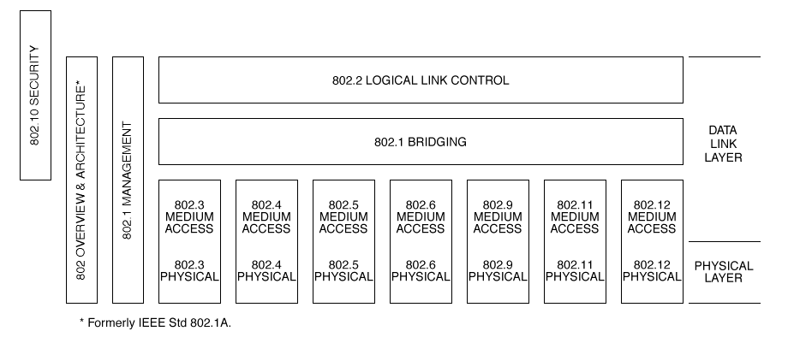
{Note to the editor: This figure needs to be updated with .15, .16, & .17}
This family of standards deals with the Physical and Data Link layers as defined by the International Organization for Standardization (ISO) Open Systems Interconnection (OSI) Basic Reference Model (ISO/IEC 7498-1:1994). The access standards define seven types of medium access technologies and associated physical media, each appropriate for particular applications or system objectives. Other types are under investigation.

The standards defining the access technologies are as follows:

IEEE Std 802 Overview and Architecture. This standard provides an overview to the
family of IEEE 802 Standards.

ANSI/IEEE Std 802.1B LAN/MAN Management. Defines an OSI management-compatible architec-
and 802.1k ture, and services and protocol elements for use in a LAN/MAN environment
[ISO/IEC 15802-2] for performing remote management.

ANSI/IEEE Std 802.1D Media Access Control (MAC) Bridges. Specifies an architecture and protocol
[ISO/IEC 15802-3] for the interconnection of IEEE 802 LANs below the MAC service boundary.

ANSI/IEEE Std 802.1E System Load Protocol. Specifies a set of services and protocol for those
[ISO/IEC 15802-4] aspects of management concerned with the loading of systems on IEEE 802
LANs.

IEEE Std 802.1F Common Definitions and Procedures for IEEE 802 Management Information

ANSI/IEEE Std 802.1G Remote Media Access Control Bridging. Specifies extensions for the intercon-
[ISO/IEC 15802-5] nection, using non-LAN communication technologies, of geographically sepa-
rated IEEE 802 LANs below the level of the logical link control protocol.

Copyright © 2000 IEEE. All rights reserved. iii
ANSI/IEEE Std 802.2 Logical Link Control
[ISO/IEC 8802-2]

ANSI/IEEE Std 802.3 CSMA/CD Access Method and Physical Layer Specifications
[ISO/IEC 8802-3]

ANSI/IEEE Std 802.4 Token Passing Bus Access Method and Physical Layer Specifications
[ISO/IEC 8802-4]

ANSI/IEEE Std 802.5 Token Ring Access Method and Physical Layer Specifications
[ISO/IEC 8802-5]

ANSI/IEEE Std 802.6 Distributed Queue Dual Bus Access Method and Physical Layer Specifica-
[ISO/IEC 8802-6] tions

ANSI/IEEE Std 802.9 Integrated Services (IS) LAN Interface at the Medium Access Control and
[ISO/IEC 8802-9] Physical Layers

ANSI/IEEE Std 802.10 Interoperable LAN/MAN Security

IEEE Std 802.11 Wireless LAN Medium Access Control and Physical Layer Specifications
[ISO/IEC DIS 8802-11]

IEEE Std 802.11b Wireless LAN Medium Access Control and Physical Layer Specifications:
Higher-Speed Physical Layer Extension in the 2.4 GHz Band

IEEE Std 802.11a Wireless LAN Medium Access Control and Physical Layer Specifications:
High Speed Physical Layer in the 5 GHz Band

ANSI/IEEE Std 802.12 Demand Priority Access Method, Physical Layer and Repeater Specifica-
[ISO/IEC DIS 8802-12] tions

In addition to the family of standards, the following is a recommended practice for a common Physical
Layer technology:

IEEE Std 802.7 IEEE Recommended Practice for Broadband Local Area Networks

The following additional working groups have authorized standards projects under development:

IEEE 802.14 Standard Protocol for Cable-TV Based Broadband Communication Network

IEEE 802.15 Wireless Personal Area Networks Access Method and Physical Layer
Specifications

IEEE 802.16 Broadband Wireless Access Method and Physical Layer Specifications

iv Copyright © 2000 IEEE. All rights reserved
Participants

At the time this standard was balloted, the 802.11 Working Group had the following membership:

, Chair
, Vice Chair
, Co-Vice Chair
, Secretary

, Chair and editor, 802.11-rev
, State-diagram editor
, State-diagram editor
, Chair PHY group
, Chair MAC group

, Chair Task Group
, Technical Editor, 802.11x

, Chair Task Group g
, Technical Editor, 802.11g

Copyright © 2000 IEEE. All rights reserved. v
The following members of the balloting committee voted on this standard:

When the IEEE-SA Standards Board approved this standard on TBD, it had the following
membership:

, Chair
, Vice Chair
, Secretary

Also included is the following nonvoting IEEE-SA Standards Board liaison:

IEEE Standards Project Editor

vi Copyright © 2000 IEEE. All rights reserved.
Contents

4. Abbreviations and acronyms

7.3.1.4 Capability Information field
7.3.1.9 Probe Response Frame Format
7.3.1.9 Status Code Field

9.1 Multirate Support

10.4.4 PLME_DSSTESTMODE

19. Extended Rate, orthogonal frequency division multiplexing PHY specification

19.1 Overview
19.2 Extended Rate PLCP sublayer
19.3 Extended Rate PLME
19.4 Extended Rate PMD sublayer

Supplement to IEEE Standard for
Information technology—
Telecommunications and information exchange
between systems—
Local and metropolitan area networks—
Specific requirements—

Part 11: Wireless LAN Medium Access
Control (MAC) and Physical Layer
(PHY) specifications:

Further Speed Extension to the 2.4 GHz Band Physical Layer

[This supplement is based on IEEE Std 802.11 , 802.11a, and802.11b, 1999 Edition.]

EDITORIAL NOTE—The editing instructions contained in this supplement define how to merge the material contained herein into the existing base standard to form the new comprehensive standard, as created by the addition of IEEE Std 802.11g-2001.

The editing instructions are shown in bold italic. Three editing instructions are used: change, delete, and insert. Change is used to make small corrections in existing text or tables. This editing instruction specifies the location of the change and describes what is being changed either by using strikethrough (to remove old material) or underscore (to add new material). Delete removes existing material. Insert adds new material without disturbing the existing material. Insertions may require renumbering. If so, renumbering instructions are given in the editing instructions. Editorial notes will not be carried over into future editions.

4. Abbreviations and acronyms

Insert the following abbreviations alphabetically in the list in Clause 4:

BPSK binary phase shift keying
C-MPDU coded MPDU
FFT Fast Fourier Transform
GI guard interval
IFFT inverse Fast Fourier Transform
OFDM orthogonal frequency division multiplexing
PER packet error rate
QAM quadrature amplitude modulation
QPSK quadrature phase shift keying
U-NII unlicensed national information infrastructure

7.3.1.4 Capability Information field

[Editor’s Note] This section should revise the list of subfields to include OFDM and provide definition of new subfield allocations The new capability is CCK-OFDM. For the optional 802.11a mode, the capability information field will be the same as used in 802.11a networks. The existing field is shown here.

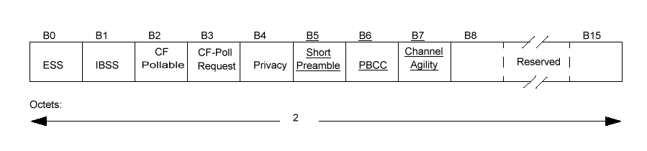

7.3.1.9 Status Code field

[Editor’s Note] This section should revise table 19 to include an Extended Rate OFDM status code.

9.1 Multirate support

[Editor’s Note] This section should be revised to include reference to the associated new TXTIME calculation description.

Add the following text to the end of 9.6:

.

10.4.4 PLME_DSSTESTMODE

[Editor’s Note] This section should add additional switches for Extended Rate OFDM.

Add Clause 19 as follows:

19. Extended Rate, orthogonal frequency division multiplexing PHY specification

19.1 Overview

This clause specifies the Extended Rate extension of the PHY for the Direct Sequence Spread Spectrum (DSSS) system (Clause 15 of IEEE Std 802.11, 1999 Edition), hereinafter known as the Extended Rate PHY for the 2.4 GHz band designated for ISM applications.

This extension of the DSSS system builds on the existing payload data rates of 1, 2, 5.5, and 11 Mbps, as described in Clause 15 of IEEE Std 802.11 and clause 18 of IEEE Std 802.11b, 1999 Edition, to provide 6, 9, 12, 18, 24, 36, 48, and 54 Mbit/s payload data rates. Of these added rates, the support of 6, 12, and 24 Mbit/s data rates is mandatory. The modulation used to provide the extended rates is orthogonal frequency division multiplexing (OFDM). The new capability described in this clause is called Extended Rate Orthogonal Frequency Division Multiplexing (ER/OFDM). The Extended Rate PHY uses the same PLCP preamble and header as the DSSS PHY, so all PHYs can co-exist in the same BSS and can use the rate switching mechanism as provided. Furthermore, the short preamble of IEEE Std 802.11b is included as an option. Immediately following these current preambles, an OFDM-specific preamble based on the 802.11a preamble is transmitted. Following the OFDM-specific preamble, OFDM modulation using 52 subcarriers modulated using binary or quadrature phase shift keying (BPSK/QPSK), 16-quadrature amplitude modulation (QAM), or 64-QAM. Interleaving, data scrambling, and forward error correction coding are applied to the data bits prior to modulation in a manner identical to that of IEEE Std. 802.11a. Code rates of 1/2, 2/3, and 3/4 are obtained by puncturing a rate 1/2 convolutional code. The same occupied channel bandwidth as IEEE Std 802.11b is provided by the Extended Rate OFDM system. To provide compatibility within the existing SIFs intervals found in IEEE Std 802.11b, an additional null data field with a duration of 6 microseconds is transmitted after the data symbols. To provide a higher throughput operation, a new optional mode is defined. This mode, called Ultrashort Preamble mode, is identical to IEEE Std 802.11a except that it uses the same operating channels as IEEE Std 802.11b. The Ultrashort preamble mode will be described in Section 19.5. Appendix A specifies the radio and physical layer behavior of the transition from the Barker word modulated preamble and the OFDM modulated data.

19.1.1 Scope

This clause specifies the PHY entity for the ER/OFDM extension and the changes required in the base standard to accommodate the Extended Rate PHY.

The Extended Rate PHY layer consists of the following two protocol functions:

a) A physical layer convergence function, which adapts the capabilities of the physical medium dependent
(PMD) system to the PHY service. This function is supported by the PHY layer convergence procedure
(PLCP), which defines a method for mapping the MAC sublayer protocol data units (MPDU) into a framing format suitable for sending and receiving user data and management information between two or more STAs using the associated PMD system. The PHY exchanges PHY protocol data units
(PPDU) that contains PLCP service data units (PSDU). The MAC uses the PHY service, so each
MPDU corresponds to a PSDU that is carried in a PPDU.

b) A PMD system, whose function defines the characteristics and method of transmitting and receiving data through a wireless medium between two or more STAs, each using the Extended Rate PHY system.

19.1.2 Extended Rate PHY functions

The 2.4 GHz Extended Rate PHY architecture is depicted in the ISO/IEC basic reference model shown in Figure 137. The Extended Rate PHY contains three functional entities: the PMD function, the PHY convergence function, and the layer management function. Each of these functions is described in detail in 19.1.2.1, 19.1.2.2, and 19.1.2.3. For the purposes of MAC and MAC management, when Channel Agility is both present and enabled, the Extended Rate PHY shall be interpreted to be both an Extended Rate and a frequency-hopping PHY.

The Extended Rate PHY service shall be provided to the MAC through the PHY service primitives described in Clause 12 of IEEE Std 802.11, 1999 Edition.

19.1.2.1 PLCP sublayer

To allow the MAC to operate with minimum dependence on the PMD sublayer, a PLCP sublayer is defined. This function simplifies the PHY service interface to the MAC services.

19.1.2.2 PMD sublayer

The PMD sublayer provides a means and method of transmitting and receiving data through a wireless medium between two or more STAs, each using the Extended Rate system.

19.1.2.3 PHY management entity (PLME)

The PLME performs management of the local PHY functions in conjunction with the MAC management entity.

19.1.3 Service specification method and notation

The models represented by figures and state diagrams are intended to be illustrations of functions provided.
It is important to distinguish between a model and a real implementation. The models are optimized for simplicity and clarity of presentation; the actual method of implementation is left to the discretion of the Extended Rate PHY compliant developer.

The service of a layer or sublayer is a set of capabilities that it offers to a user in the next-higher layer (or
sublayer). Abstract services are specified here by describing the service primitives and parameters that characterize each service. This definition is independent of any particular implementation.

19.2 Extended Rate PLCP sublayer

19.2.1 Overview

This subclause provides a convergence procedure for the Extended Rate date rates specification, in which
PSDUs are converted to and from PPDUs. This subclause covers the mandatory long preamble and optional short preamble mode. The convergence procedure for the Ultrashort preamble is described in Section 19.5.XX. During transmission, the PSDU shall be appended to a PLCP preamble and header to create the PPDU. Two different preambles and headers are defined in this subclause: the mandatory Long Preamble and header originally defined in IEEE Std 802.11 and an optional Short Preamble and header originally defined in IEEE Std 802.11b. The UltraShort Preamble and header based on IEEE Std 802.11a will be described in Section 19.5.XX. At the receiver, the PLCP preamble and header are processed to aid in demodulation and delivery of the PSDU.

The optional Short Preamble and header are intended for applications where high throughput is desired and interoperability with non-short-preamble capable equipment is not a consideration. That is, the optional short preamble is to be used only in networks of like equipment, which can all handle the optional mode.

The optional UltraShort Preamble and header are intended for applications where the highest throughput possible is desired and interoperability with long preamble or short preamble based networks is not required.

19.2.2 PPDU format

Two different preambles and headers are defined in this Subclause: the mandatory supported Long Preamble and header which are interoperable with the current 1 Mbit/s and 2 Mbit/s DSSS specification (as described in IEEE Std 802.11, 1999 Edition) and an optional Short Preamble and header. The third optional UltraShort Preamble is defined in Section 19.5.XX.

19.2.2.1 Long PLCP PPDU format

Figure *** shows the format for the interoperable (long) PPDU, including the Extended Rate PLCP preamble, the Extended Rate PLCP header, and the PSDU. The PLCP preamble contains the following fields: synchronization (Sync) and start frame delimiter (SFD). The PLCP header contains the following fields: signaling (SIGNAL), service (SERVICE), length (LENGTH), and CCITT CRC-16. Each of these fields is described in detail in 19.2.3. The format for the PPDU, including the long Extended Rate PLCP preamble, the long Extended Rate PLCP header, and the PSDU, do not differ from IEEE Std 802.11, 1999 Edition for 1Mbit/s and 2 Mbit/s.

The only exception is the use of an additional bit in the SERVICE field to denote an OFDM transmission.

Figure *** —Long PLCP PPDU format

19.2.2.2 Short PLCP PPDU format (optional)

The short PLCP preamble and header (HR/DSSS/short) are defined as optional. The Short Preamble and
header may be used to minimize overhead and, thus, maximize the network data throughput. The format of
the PPDU, with HR/DSSS/short, is depicted in Figure ***.

Figure *** —SHORT PLCP PPDU format

The short PLCP preamble uses the 1 Mbit/s Barker code spreading with DBPSK modulation. The short PLCP header uses the 2 Mbit/s Barker code spreading with DQPSK modulation, and the PSDU is transmitted using OFDM at 6, 9, 12, 18, 24, 36, 48, or 54 Mbit/s. A STA transmitting the short PLCP will only be interoperable with another STA capable of receiving this short PLCP. To interoperate with a STA that is incapable of receiving a Short Preambleand header, the transmitter shall use the long PLCP preamble and header.

Stations without this option but perform active scanning will get a response even when the network is using Short Preambles, because all management traffic is returned with the same type preamble as received.

19.2.3 PLCP PPDU field definitions

In the PLCP, field definition subclauses (19.2.3.1 through 19.2.3.14), the definitions of the long (Clause 15)
PLCP fields are given first, followed by the definitions of the short PLCP. The names for the short PLCP fields are preceded by the term “short.”

19.2.3.1 Long PLCP SYNC field

The SYNC field shall consist of 128 bits of scrambled “1” bits. This field is provided so the receiver can perform the necessary synchronization operations. The initial state of the scrambler (seed) shall be [1101100], where the leftmost bit specifies the value to put in the first delay element (Z ¹) in Figure ***, and the right-most bit specifies the value to put in the last delay element in the scrambler.

To support the reception of DSSS signals generated with implementations based on Clause 15, the receiver
shall also be capable of synchronization on a SYNC field derived from any non-zero scrambler initial state.

19.2.3.2 Long PLCP SFD

The SFD shall be provided to indicate the start of PHY-dependent parameters within the PLCP preamble.

The SFD shall be a 16-bit field, [1111 0011 1010 0000], where the rightmost bit shall be transmitted first in time.

19.2.3.3 Long PLCP SIGNAL field

The 8-bit SIGNAL field indicates to the PHY the modulation that shall be used for transmission (and reception) of the PSDU. For support of 1, 2, 5.5, and 11 Mbits/second data rates of IEEE Std 802.11 and IEEE Std 802.11b, 1999 Edition, the data rate shall be equal to the SIGNAL field value multiplied by 100 kbit/s. For all rates in the extended OFDM rate set this value will be set to X’14’which corresponds to the 2Mbps rate. The set of possible values are given by the following 8-bit words

a) X’0A’ (msb to lsb) for 1 Mbit/s;

b) X’14’ (msb to lsb) for 2 Mbit/s;

c) X’37’ (msb to lsb) for 5.5 Mbit/s;

d) X’6E’ (msb to lsb) for 11 Mbit/s;

e) X’14’ (msb to lsb) for all OFDM data rates.

The Extended Rate PHY rate change capability is described in 19.2.3.14. This field shall be protected by the CCITT CRC-16 frame check sequence described in 19.2.3.6.

19.2.3.4 Long PLCP SERVICE field

Four bits have been defined in the SERVICE field to support the Extended Rate extension.

In Table **, the leftmost bit (bit 0) shall be used to indicate whether the PSDU modulation is ER/OFDM. When set to 1, this indicates that the modulation is OFDM.

Bit 2 shall be used to indicate that the transmit frequency and symbol clocks are derived from the same oscillator. For ER/OFDM, this bit must always be set since locked timing and carrier clocks are mandatory.

Bit 3 shall be used to indicate whether the modulation method is CCK <0> or PBCC <1> as described in IEEE Std 802.11b, 1999 Edition. For ER/OFDM this bit shall be ignored.
The SERVICE field shall be transmitted b0 first in time, and shall be protected by the CCITT CRC-16 frame check sequence described in 19.2.3.6.

An IEEE 802.11-compliant device shall set the values of the bits b1, b4, b5, b6, to 0. For the extended rate OFDM operation, the length extension bit is not used and shall be set to 0.

Table **—SERVICE field definitions

b0 | B1 | b2 | b3 | b4 | b5 | b6 | b7
Modulation selection  0 = non OFDM  1 = OFDM | Reserved | Locked Clock Bit  0 = not locked  1 = locked | Modulation  Selection  0 = CCK  1 = PBCC | Reserved | Reserved | Reserved | Length Extension Bit

19.2.3.5 Long PLCP LENGTH field

The PLCP length field shall be an unsigned 16-bit integer that indicates the number of microseconds required to transmit the PSDU. The transmitted value shall be determined from the LENGTH and DataRate parameters in the TXVECTOR issued with the PHY-TXSTART.request primitive described in 19.4.4.2.

The length field provided in the TXVECTOR is in octets and is converted to microseconds for inclusion in the PLCP LENGTH field. The LENGTH field is calculated using the following

LENGTH = PreambleLengthOFDM + PLCPSignalOFDM + 4 x Ceiling((PLCPServiceBits + 8 x (number-of-octets) + PadBits) / N_{DBPS}) + SignalExtension

where

PreambleLengthOFDM is 8microseconds;
PLCPSignalOFDM is 4 microseconds;

ceiling is a function that returns the smallest integer value greater than or equal to its
argument value;

PLCPServiceBits is 16 bits;

number-of-octets is the number of data octets in the PSDU;

PadBits is 6 bits;

N_{DBPS} is the number of data bits per OFDM symbol.

SignalExtension is 6 microseconds;

The length field is defined in units of microseconds and must correspond to the actual length of the packet. {Note to the editor: This includes all the OFDM overhead and SIFs pad.}

The least significant bit (lsb) shall be transmitted first in time. This field shall be protected by the CCITT
CRC-16 frame check sequence described in 19.2.3.6.

19.2.3.6 PLCP CRC (CCITT CRC-16) field

The SIGNAL, SERVICE, and LENGTH fields shall be protected with a CCITT CRC-16 frame check sequence (FCS). The CCITT CRC-16 FCS shall be the one’s complement of the remainder generated by the modulo 2 division of the protected PLCP fields by the polynomial

x¹⁶ + x¹² + x⁵ + 1

The protected bits shall be processed in transmit order. All FCS calculations shall be made prior to data scrambling. A schematic of the processing is shown in Figure ***.

As an example, the SIGNAL, SERVICE, and LENGTH fields for a DBPSK signal with a PPDU length of
192 µs (24 octets) would be given by the following:

0101 0000 0000 0000 0000 0011 0000 0000 [leftmost bit (b0) transmitted first in time]
b0.................................................................b48

The one’s complement FCS for these protected PLCP preamble bits would be the following:

0101 1011 0101 0111 [leftmost bit (b0) transmitted first in time]
b0.........................b16

Figure *** depicts this example.

TRANSMIT AND RECEIVE PLCP HEADER
CCIT CRC-16 CALCULATOR

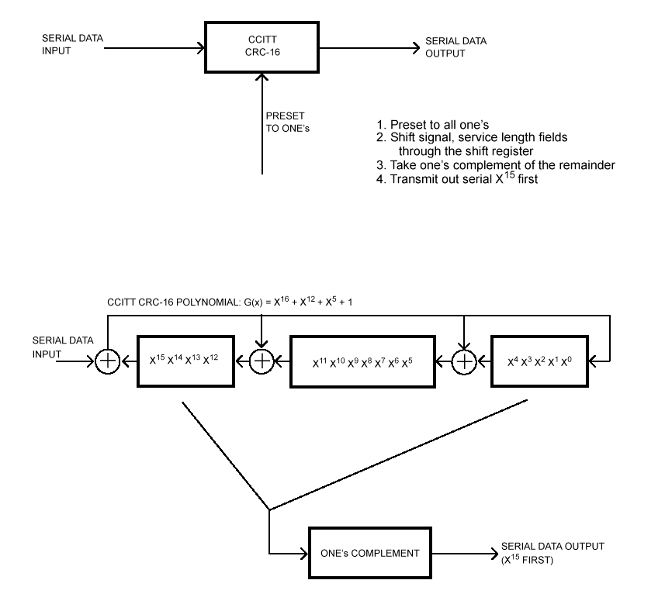

Figure ***—CCITT CRC-16 implementation

An illustrative example of the CCITT CRC-16 FCS using the information from Figure *** is shown in Figure ***.
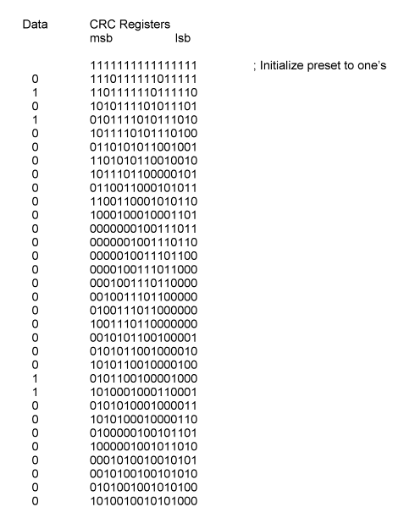

Figure ***—Example of CRC calculation

19.2.3.7 Long PLCP data modulation and modulation rate change

The long PLCP preamble and header shall be transmitted using the 1 Mbit/s DBPSK modulation. The SIGNAL and SERVICE fields combined shall indicate the modulation and data rate that shall be used to transmit the PSDU. The transmitter and receiver shall initiate the PSDU modulation and rate indicated by the SIGNAL and SERVICE fields, starting immediately after the last symbol of the PLCP Header. The PSDU transmission rate shall be set by the DATARATE parameter in the TXVECTOR, issued with the PHY-TXSTART.request primitive described in 19.4.4.2.

19.2.3.8 Short PLCP synchronization (shortSYNC)

The shortSYNC field shall consist of 56 bits of scrambled “0” bits. This field is provided so the receiver can perform the necessary synchronization operations. The initial state of the scrambler (seed) shall be [001 1011], where the left end bit specifies the value to place in the first delay element (Z ¹ ) in Figure ***, and the right end bit specifies the value to place in the last delay element (Z ⁷ ).

19.2.3.9 Short PLCP SFD field (shortSFD)

The shortSFD shall be a 16-bit field and be the time reverse of the field of the SFD in the long PLCP preamble (19.2.3.2). The field is the bit pattern 0000 0101 1100 1111. The right end bit shall be transmitted first in time. A receiver not configured to use the short header option will not detect this SFD.

19.2.3.10 Short PLCP SIGNAL field (shortSIGNAL)

The 8-bit SIGNAL field of the short header indicates to the PHY the data rate that shall be used for transmission (and reception) of the PSDU. A PHY operating with the ER/OFDM/short option supports mandatory rates given by the following 8-bit words, where the lsb shall be transmitted first in time and the number represents the rate in units of 100 kBit/s:

a) X’14’ (msb to lsb) for 2 Mbit/s;

b) X’37’ (msb to lsb) for 5.5 Mbit/s;

c) X’6E’ (msb to lsb) for 11 Mbit/s;

d) X’14’ (msb to lsb) for all ER/OFDM modes

19.2.3.11 Short PLCP SERVICE field (shortSERVICE)

The SERVICE field in the short header shall be the same as the SERVICE field described in 19.2.3.4.

19.2.3.12 Short PLCP LENGTH field (shortLENGTH)

The LENGTH field in the short header shall be the same as the LENGTH field described in 19.2.3.5

19.2.3.13 Short CCITT CRC-16 field (shortCRC)

The CRC in the short header shall be the same as the CRC field defined in 19.2.3.6. The CRC-16 is calculated over the shortSIGNAL, shortSERVICE, and shortLENGTH fields.

19.2.3.14 Short PLCP data modulation and modulation rate change

The short PLCP preamble shall be transmitted using the 1 Mbit/s DBPSK modulation. The short PLCP header shall be transmitted using the 2 Mbit/s modulation. The SIGNAL and SERVICE fields combined shall indicate the modulation and data rate that shall be used to transmit the PSDU. The transmitter and receiver shall initiate the PSDU modulation and rate indicated by the SIGNAL and SERVICE fields, starting immediately after the last symbol of the PLCP Header. The PSDU transmission rate shall be set by the DATARATE parameter in the TXVECTOR, issued with the PHY-TXSTART.request primitive described in 19.4.4.2.

19.2.4 PLCP/Extended Rate PHY data scrambler and descrambler

The polynomial G(z) = z⁻⁷ + z⁻⁴ + 1 shall be used to scramble all bits transmitted. The feedthrough configuration of the scrambler and descrambler is self-synchronizing, which requires no prior knowledge of the transmitter initialization of the scrambler for receive processing. Figure *** and Figure *** show typical implementations of the data scrambler and descrambler, but other implementations are possible.

The scrambler shall be initialized as specified in 19.2.3.8 for the short PLCP and 19.2.3.1 for the long PLCP. For a Long Preamble, this shall result in the scrambler registers Z 1 through Z 7 in Figure *** having the data pattern [1101100] (i.e., Z 1 = 1... Z 7 = 0) when the scrambler is first started. The scrambler shall be initialized with the reverse pattern [0011011] when transmitting the optional Short Preamble.

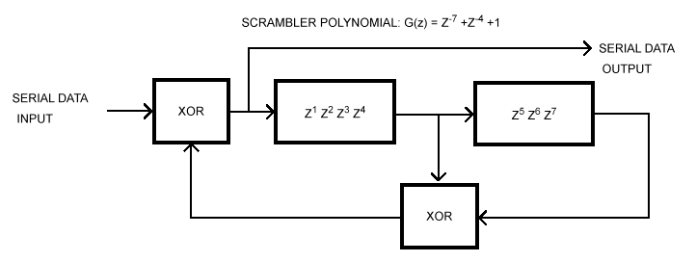

Figure ***—Data scrambler
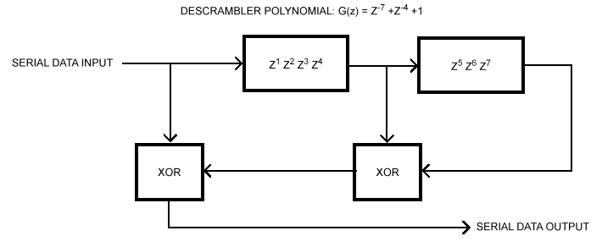

Figure ***—Data descrambler

19.2.6 PLCP transmit procedure

The transmit procedures for an Extended Rate PHY using the long PLCP preamble and header are the same as those described in IEEE Std 802.11 and IEEE Std 802.11b, 1999 Edition (15.2.6 and 18.2.6), and do not change apart from the ability to transmit the Extended Rates.

The procedures for a transmitter employing ER/OFDM/short are the same except for length and rate changes. The decision to use a long or short PLCP is beyond the scope of this standard.

19.2.7 PLCP receive procedure

The receive procedures configured to receive the mandatory and optional PLCPs, rates, and modulations are described in this subclause. A receiver that supports this Extended Rate extension of the standard is capable of receiving all rates specified in IEEE Std 802.11, 1999 Edition, and all mandatory rates in IEEE Std 802.11b, 1999 Edition. If the PHY implements the Short Preamble option, it shall detect both short and Long Preamble formats and indicate which type of preamble was received in the RXVECTOR.

The receiver shall implement the CCA procedure as defined in 19.4.8.4. Upon receiving a PPDU, the receiver shall distinguish between a long and short header format by the value of the SFD, as specified in 19.2.2. The receiver shall demodulate a long PLCP header using BPSK at 1 Mbit/s. The receiver shall demodulate a short PLCP header using QPSK at 2 Mbit/s. The receiver shall use the SIGNAL and SERVICE fields of the PLCP header to determine the data rate and modulation of the PSDU.

The receive procedures for an Extended Rate PHY using the long PLCP preamble and header are the same as those described in IEEE Std 802.11 and IEEE Std 802.11b, 1999 Edition (15.2.7and 18.2.7), and do not change apart from the ability to receive the Extended Rates.

The procedures for a transmitter employing ER/OFDM/short are the same except for length and rate changes. The decision to use a long or short PLCP is beyond the scope of this standard.

19.3 Extended Rate PLME

19.3.1 PLME_SAP sublayer management primitives

Table *** lists the MIB attributes that may be accessed by the PHY sublayer entities and intralayer or higher layer management entities (LMEs). These attributes are accessed via the PLME-GET, PLME-SET, and PLME-RESET primitives defined in Clause 10 of IEEE Std 802.11, 1999 Edition.

19.3.2 Extended Rate PHY MIB

All Extended Rate PHY MIB attributes are defined in Annex D of IEEE Std 802.11, 1999 Edition, with specific values defined in Table ***.

Table ***—MIB attribute default values/ranges

Managed object | Default value/range | Operational  semantics
dot11PhyOperationTable
dot11PHYType | Extended Rate–2.4 (X‘TBR’) | Static
dot11TempType | Implementation dependent | Static
dot11CurrentRegDomain | Implementation dependent | Static
dot11ShortPreambleOptionImplemented | Implementation dependent | Static
dot11PBCCOption | Implemented Implementation dependent | Static
dot11ChannelAgility Present | Implementation dependent | Static
dot11ChannelAgilityEnabled | False/Boolean | Dynamic
dot11PhyAntennaTable
dot11CurrentTxAntenna | Implementation dependent | Dynamic
dot11DiversitySupport | Implementation dependent | Static
dot11CurrentRxAntenna | Implementation dependent | Dynamic
dot11PhyTxPowerTable
dot11NumberSupportedPowerLevels | Implementation dependent | Static
dot11TxPowerLevel1 | Implementation dependent | Static
dot11TxPowerLevel2 | Implementation dependent | Static
dot11TxPowerLevel3 | Implementation dependent | Static
dot11TxPowerLevel4 | Implementation dependent | Static
dot11TxPowerLevel5 | Implementation dependent | Static
dot11TxPowerLevel6 | Implementation dependent | Static
dot11TxPowerLevel7 | Implementation dependent | Static
dot11TxPowerLevel8 | Implementation dependent | Static
dot11CurrentTxPowerLevel | Implementation dependent | Dynamic
dot11PhyDSSSTable
dot11CurrentChannel | Implementation dependent | Dynamic
dot11CCAModeSupported | Implementation dependent | Static
dot11CurrentCCAMode | Implementation dependent | Dynamic
dot11EDThreshold | Implementation dependent | Dynamic
dot11AntennasListTable
dot11SupportTxAntenna | Implementation dependent | Static
dot11SupportRxAntenna | Implementation dependent | Static
dot11DiversitySelectionRx | Implementation dependent | Dynamic
dot11RegDomainsSupportedTable
dot11RegDomainsSupported | Implementation dependent | Static
dot11SupportedDataRatesTx | Table Tx X’02’, X’04’,  X’0B’, X’16’, TBR | Static
dot11SupportedDataRatesRx | Table Rx X’02’, X’04’,  'X’0B’, X’16’, TBR | Static
NOTE—The column titled “Operational semantics” contains two types: static and dynamic.
Static MIB attributes are fixed and cannot be modified for a given PHY implementation.
Dynamic MIB attributes can be modified by some management entities.

19.3.3 DS PHY characteristics

The static DS PHY characteristics, provided through the PLME-CHARACTERISTICS service primitive, are shown in Table 101. The definitions of these characteristics are in 10.4.3 of IEEE Std 802.11, 1999 Edition.

19.3.4 Extended Rate TXTIME calculation

The value of the TXTIME parameter returned by the PLME-TXTIME.confirm primitive shall be calculated according to the following equation:

TXTIME = PreambleLengthCCK + PLCPHeaderTimeCCK + PreambleLengthOFDM + PLCPSignalOFDM + 4 x Ceiling((PLCPServiceBits + 8 x (number-of-octets) + PadBits) / N_{DBPS}) + SignalExtension

where

The value of PreambleLengthCCK is 144 µs if the TXPREAMBLE_TYPE value from the TXVECTOR
parameter indicates “LONGPREAMBLE,” or 72 µs if the TXPREAMBLE_TYPE value from the
TXVECTOR parameter indicates “SHORTPREAMBLE”;

The value of PLCPHeaderTimeCCK is 48 µs if the TXPREAMBLE_TYPE value from the TXVEC-TOR
parameter indicates “LONGPREAMBLE,” or 24 µs if the TXPREAMBLE_TYPE value from
the TXVECTOR parameter indicates “SHORTPREAMBLE”;

Ceiling is a function that returns the smallest integer value greater than or equal to its
argument value;

PreambleLengthOFDM is 8 microseconds;

PLCPSignalOFDM is 4 microseconds;

PLCPServiceBits is 16 bits;

number-of-octets is the number of data octects in the PSDU;

PadBits is 6 bits;

SignalExtension is 6 us;

N_{DBPS} is the number of data bits per OFDM symbol.

Table ***—Extended Rate PHY characteristics

Characteristic | Value
aSlotTime | 20 µs
aSIFSTime | 10 µs
aCCATime | <15 µs
aRxTxTurnaroundTime | <5 µs
aTxPLCPDelay | Implementors may choose any value for this delay as long as the requirements of aRxTxTurnaroundTime are met.
aRxPLCPDelay | Implementors may choose any value for this delay as long as the requirements of aSIFSTime and aCCATime are met.
aRxTxSwitchTime | <5 µs
aTxRampOnTime | Implementors may choose any value for this delay as long as the requirements of aRxTxTurnaroundTime are met.
aTxRampOffTime | Implementors may choose any value for this delay as long as the requirements of aSIFSTime are met.
aTxRFDelay | Implementors may choose any value for this delay as long as the requirements of aRxTxTurnaroundTime are met.
aRxRFDelay | Implementors may choose any value for this delay as long as the requirements of aSIFSTime and aCCATime are met.
aAirPropagationTime | 1 µs
aMACProcessingDelay | 0 (not applicable)
aPreambleLength | 144 µs
aPLCPHeaderLength | 48 bits
aMPUMaxLength | 14 < x < (2 12 – 1)
ACWmin | 31
aCWmax | 1023

19.3.5 Vector descriptions

Several service primitives include a parameter vector. These vectors are a list of parameters as described in Table ***. DATARATE and LENGTH are described in 12.3.4.4 of IEEE Std 802.11, 1999 Edition. The remaining parameters are considered to be management parameters and are specific to this PHY.

Table ***—Parameter vectors

Parameter Associated vector Value
DATARATE | RXVECTOR, TXVECTOR | The rate used to transmit the PSDU in Mbit/s.
LENGTH | RXVECTOR, TXVECTOR | The length of the PSDU in octets.
PREAMBLE_TYPE | RXVECTOR, TXVECTOR | The preamble used for the transmission of this PPDU. This is an enumerated type that can take the value SHORTPREAMBLE or LONGPRE-AMBLE.
MODULATION | RXVECTOR, TXVECTOR | The modulation used for the trans-mission of this PSDU. TBR for OFDM.

19.4 Extended Rate PMD sublayer

19.4.1 Scope and field of application

Subclause 19.4 describes the PMD services provided to the PLCP for the Extended Rate PHY. Also defined in this subclause are the functional, electrical, and RF characteristics required for interoperability of implementations conforming to this specification. The relationship of this specification to the entire Extended Rate PHY is shown in Figure ***.

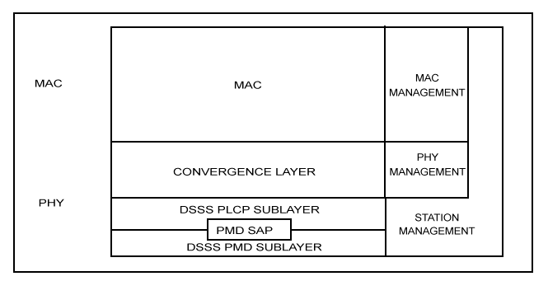

Figure ***—Layer reference model.

19.4.2 Overview of service

The Extended Rate PMD sublayer accepts PLCP sublayer service primitives and provides the actual means by which data is transmitted or received from the medium. The combined functions of the Extended Rate PMD sub-layer primitives and parameters for the receive function result in a data stream, timing information, and associated received signal parameters being delivered to the PLCP sublayer. A similar functionality is provided for data transmission.

19.4.3 Overview of interactions

The primitives associated with the PLCP sublayer to the Extended Rate PMD fall into two basic categories

a) Service primitives that support PLCP peer-to-peer interactions;

b) Service primitives that have local significance and that support sublayer-to-sublayer interactions.

19.4.4 Basic service and options

All of the service primitives described in this subclause are considered mandatory, unless otherwise specified.

19.4.4.1 PMD_SAP peer-to-peer service primitives

Table *** indicates the primitives for peer-to-peer interactions.

Table ***—PMD_SAP peer-to-peer service primitives

Primitive | Request | Indicate | Confirm | Response
PMD_DATA | X | X | — | —

19.4.4.2 PMD_SAP sublayer-to-sublayer service primitives

Table *** indicates the primitives for sublayer-to-sublayer interactions.

Table ***—PMD_SAP sublayer-to-sublayer service primitives

Primitive | Request | Indicate | Confirm | Response
PMD_TXSTART | X | — | — | —
PMD_TXEND | X | — | — | —
PMD_ANTSEL | X | X | — | —
PMD_TXPWRLVL | X | — | — | —
PMD_MODULATION | X | X | — | —
PMD_PREAMBLE | X | X | — | —
PMD_RATE | X | X | — | —
PMD_RSSI | — | X | — | —
PMD_SQ | — | X | — | —
PMD_CS | — | X | — | —
PMD_ED | X | X | — | —

19.4.5 PMD_SAP detailed service specification

[Editor’s Note: This section should look substantially like the corresponding section 18.4.5 in the High Rate standard with appropriate modifications for the addition of the Extended Rate primitives.]

19.4.6 PMD operating specifications, general

The following subclauses provide general specifications for the OFDM PMD sublayer. These specifications apply to both the Receive and Transmit functions and general operation of a OFDM PHY.

19.4.6.1 Operating frequency range

The Extended Rate PHY shall operate in the 2.4–2.4835 GHz frequency range, as allocated by regulatory bodies in the USA and Europe, or in the 2.471–2.497 GHz frequency range, as allocated by regulatory authority in Japan.

19.4.6.2 Number of operating channels

The channel center frequencies and CHNL_ID numbers shall be as shown in Table 105. The FCC (US), IC (Canada), and ETSI (Europe) specify operation from 2.4–2.4835 GHz. For Japan, operation is specified as 2.471–2.497 GHz. France allows operation from 2.4465–2.4835 GHz, and Spain allows operation from 2.445–2.475 GHz.

For each supported regulatory domain, all channels in Table *** marked with an “X” shall be supported.

Table ***—Extended Rate PHY frequency channel plan

 |  | Regulatory domains
CHNL_ID | Frequency (MHz) | X'10'  FCC | X'20'  IC | X'30'  ETSI | X'31'  Spain | X'32'  France | X'40'  MKK
1 | 2412 | X | X | X | — | — | —
2 | 2417 | X | X | X | — | — | —
3 | 2422 | X | X | X | — | — | —
4 | 2427 | X | X | X | — | — | —
5 | 2432 | X | X | X | — | — | —
6 | 2437 | X | X | X | — | — | —
7 | 2442 | X | X | X | — | — | —
8 | 2447 | X | X | X | — | — | —
9 | 2452 | X | X | X | — | — | —
10 | 2457 | X | X | X | X | X | —
11 | 2462 | X | X | X | X | X | —
12 | 2467 | — | — | X | — | X | —
13 | 2472 | — | — | X | — | X | —
14 | 2484 | — | — | — | — | — | X

In a multiple cell network topology, overlapping and/or adjacent cells using different channels can operate simultaneously without interference if the distance between the center frequencies is at least 25 MHz.

Channel 14 shall be designated specifically for operation in Japan.

19.4.6.3 Modulation and channel data rates

Twelve modulation formats and data rates are specified for the Extended Rate PHY. The basic access rate shall be based on 1 Mbit/s DBPSK modulation. The enhanced access rate shall be based on 2 Mbit/s DQPSK. The High Rate specification defines two additional data rates based on the CCK modulation scheme for 5.5 Mbit/s and 11 Mbit/s. The Extended Rate specification defines three additional mandatory data rates based on the OFDM modulation scheme. These mandatory data rates are6 Mbit/s, 12 Mbit/s, and 24 Mbit/s. The Extended Rate specification also defines five optional data rates, 9 Mbit/s, 18 Mbit/s, 36 Mbit/s, 48 Mbit/s, and 54 Mbit/s.

19.4.6.4 Spreading sequence and modulation for 1 and 2 Mbit/s

The following 11-chip Barker sequence shall be used as the PN code sequence for the 1 and 2 Mbit/s modulation:

+1, –1, +1, +1, –1, +1, +1, +1, –1, –1, –1

The leftmost chip shall be output first in time. The first chip shall be aligned at the start of a transmitted symbol. The symbol duration shall be exactly 11 chips long.

The DBPSK encoder for the basic access rate is specified in Table ***. The DQPSK encoder is specified in Table ***. (In these tables, +j" shall be defined as counterclockwise rotation.)

Table ***—1 Mbits/s DBPSK encoding table

Bit input | Phase change (+jw)
0 | 0
1 | Pi

Table ***—2 Mbits/s DQPSK encoding table

Dibit pattern (d0, d1)  (d0 is first in time) | Phase change (+jw)
00 | 0
01 | Pi/2
11 | Pi
10 | 3Pi/2(-Pi/2)

19.4.6.5 Formatting and OFDM modulation of the PSDU for 6, 9, 12, 24, 36,48, and 54 Mbps

The PSDU for the ER/OFDM system consists of four parts:

OfdmSync – provides for synchronization and channel estimation,

b.) OFDM Signal Field – provides rate and length information for the OFDM processc.) OFDM Symbols – the data carrying part of the PSDU,
d.) Signal Extension – an extension of the signal to account for implementation dependant latency incurred as a result of convolutional decoding and deinterleaving.

The following subclauses define these parts of the PSDU.

Furthermore, all three parts of the PSDU shall be transmitted with the same average power as the PLCP Preamble and PLCP Header.

19.4.6.5.1 OfdmSync

The OfdmSync field is used for synchronization. It consists of two long symbolsand a guard interval twice the length of the OFDM cyclic extension that are described in this subclause.

A long OFDM training symbol consists of 53 subcarriers (including a zero value at dc), which are modulated by the elements of the sequence L, given by

L –26, 26 = {1, 1, –1, –1, 1, 1, –1, 1, –1, 1, 1, 1, 1, 1, 1, –1, –1, 1, 1, –1, 1, –1, 1, 1, 1, 1, 0,

1, –1, –1, 1, 1, –1, 1, –1, 1, –1, –1, –1, –1, –1, 1, 1, –1, –1, 1, –1, 1, –1, 1, 1, 1, 1}

A long OFDM training symbol shall be generated according to the following equation:
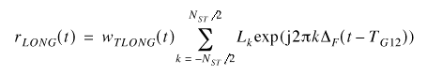

where

T_{G12} = 1.6 µs. Two periods of the long sequence are transmitted for improved channel estimation accuracy, yielding T_{LONG} = 1.6 + 2 × 3.2 = 8 µs.

19.4.6.5.2 Signal Field(SIGNAL)

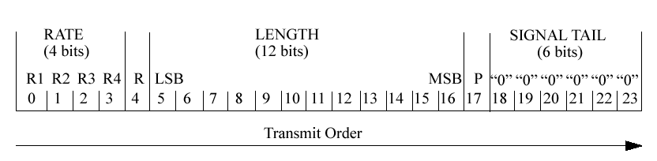
The OFDM training symbols shall be followed by the SIGNAL field, which contains the RATE and the LENGTH fields of the TXVECTOR. The RATE field conveys information about the type of modulation and the coding rate as used in the rest of the packet. The encoding of the SIGNAL single OFDM symbol shall be performed with BPSK modulation of the subcarriers and using convolutional coding at R = 1/2. The encoding procedure, which includes convolutional encoding, interleaving, modulation mapping processes, pilot insertion, and OFDM modulation, follows the steps described in 17.3.5.5, 17.3.5.6, and 17.3.5.8, as used for transmission of data at a 6 Mbit/s rate. The contents of the SIGNAL field are not scrambled. The SIGNAL field shall be composed of 24 bits, as illustrated in Figure 111. The four bits 0 to 3 shall encode the RATE. Bit 4 shall be reserved for future use. Bits 5–16 shall encode,the data portion of the packet in octets without the SIFs extension. The least significant bit (LSB) is transmitted first.

The process of generating the SIGNAL OFDM symbol is illustrated in Annex G (G.4).

19.4.6.5.2.1 Data rate (RATE)

The bits R1–R4 shall be set, dependent on RATE, according to the values in Table 80.

Rate (Mbits/s) | R1–R4
6 | 1101
9 | 1111
12 | 0101
18 | 0111
24 | 1001
36 | 1011
48 | 0001
54 | 0011

Table XXX. Data Rate Bit Field Definition

19.4.6.5.2.2 PLCP length field (LENGTH)

The PLCP length field shall be an unsigned 12-bit integer that indicates the number of octets in the PSDU that the MAC is currently requesting the PHY to transmit. This value is used by the PHY to determine the number of octet transfers that will occur between the MAC and the PHY after receiving a request to start transmission. The transmitted value shall be determined from the LENGTH parameter in the TXVECTOR issued with the PHY-TXSTART.request primitive described in 12.3.5.4 (IEEE Std 802.11, 1999 Edition). The LSB shall be transmitted first in time. This field shall be encoded by the convolutional encoder described in 17.3.5.5.

19.4.6.5.2.3 Parity (P), Reserved (R), and Signal tail (SIGNAL TAIL)

Bit 4 shall be reserved for future use. Bit 17 shall be a positive parity (even parity) bit for bits 0–16. The bits 18–23 constitute the SIGNAL TAIL field, and all 6 bits shall be set to zero.

19.4.6.5.3 Overview of the OFDM symbol encoding process

The encoding process is composed of many detailed steps, which are described fully in later subclauses, as noted below. The following overview intends to facilitate understanding the details described in these subclauses:

a) Calculate from RATE field of the TXVECTOR the number of data bits per OFDM symbol (N_{DBPS} ), the coding rate (R), the number of bits in each OFDM subcarrier (N_{BPSC} ), and the number of coded bits per OFDM symbol (N_{CBPS} ).

d) Extend the data bit string with “zero” bits (at least 6 bits) so that the resulting length will be a multiple of the number of data bits per OFDM symbol (N_{DBPS} ).

e) Initiate the scrambler with the state last observed while processing the PLCP Header, generate a sequence of scrambled data bits.

f) Replace the six scrambled “zero” bits following the “data” with six nonscrambled “zero” bits.
(Those bits return the convolutional encoder to the “zero state” and are denoted as “tail bits.”)

g) Encode the extended, scrambled data string with a convolutional encoder (R = 1/2). Omit (puncture) some of the encoder output string (chosen according to “puncturing pattern”) to reach the desired “coding rate.”

h) Divide the encoded bit string into groups of N_{CBPS} bits. Within each group, perform an “interleaving” (reordering) of the bits according to a rule corresponding to the desired RATE.

i) Divide the resulting coded and interleaved data string into groups of N_{CBPS} bits. For each of the bit groups, convert the bit group into a complex number according to the modulation encoding tables.

j) Divide the complex number string into groups of 48 complex numbers. Each such group will be
associated with one OFDM symbol. In each group, the complex numbers will be numbered 0 to 47 and mapped hereafter into OFDM subcarriers numbered –26 to –22, –20 to –8, –6 to –1, 1 to 6, 8 to 20, and 22 to 26. The subcarriers –21, –7, 7, and 21 are skipped and, subsequently, used for inserting pilot subcarriers. The “0” subcarrier, associated with center frequency, is omitted and filled with zero value.

k) Four subcarriers are inserted as pilots into positions –21, –7, 7, and 21. The total number of the sub-carriers is 52 (48 + 4).

l) For each group of subcarriers –26 to 26, convert the subcarriers to time domain using inverse Fourier transform. Prepend to the Fourier-transformed waveform a circular extension of itself thus forming a guard interval (GI), and truncate the resulting periodic waveform to a single OFDM symbol length by applying time domain windowing.

19.4.6.5.3.1 RATE-dependent parameters

The modulation parameters dependent on the data rate used shall be set according to Table ***.

Table***—Rate-dependent parameters

Data rate (Mbits/s) | Modulation | Coding rate  (R) | Coded bits  per  subcarrier  (N BPSC ) | Coded bits  per OFDM  symbol  (N CBPS ) | Data bits  per OFDM  symbol  (N DBPS )
6 | BPSK | 1/2 | 1 | 48 | 24
9 | BPSK | 3/4 | 1 | 48 | 36
12 | QPSK | 1/2 | 2 | 96 | 48
18 | QPSK | 3/4 | 2 | 96 | 72
24 | 16-QAM | 1/2 | 4 | 192 | 96
36 | 16-QAM | 3/4 | 4 | 192 | 144
48 | 64-QAM | 2/3 | 6 | 288 | 192
54 | 64-QAM | 3/4 | 6 | 288 | 216

19.4.6.5.3.2 Timing related parameters

Table *** is the list of timing parameters associated with the OFDM PLCP.

Table ***—Timing-related parameters

Parameter | Value
N SD : Number of data subcarriers | 48
N SP : Number of pilot subcarriers | 4
N ST : Number of subcarriers, total | 52 (N SD + N SP )
: Subcarrier frequency spacing | 0.3125 MHz (=20 MHz/64)
T FFT : IFFT/FFT period | 3.2 µs (1/!F)
T OFDMSYNC : OfdmSync duration | 12 µs (T SHORT + T LONG )
T GI : GI duration | 0.8 µs (T FFT /4)
T GI2 : Training symbol GI duration | 1.6 µs (T FFT /2)
T SYM : Symbol interval | 4 µs (T GI + T FFT )
T SHORT : Short training sequence duration | 4 µs (5× T FFT /4)
T LONG : Long training sequence duration | 8 µs (T GI2 + 2 × T FFT )

19.4.6.5.3.3 Mathematical conventions in the signal descriptions

The transmitted signals will be described in a complex baseband signal notation. The actual transmitted signal is related to the complex baseband signal by the following relation:
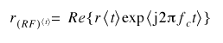
where

Re(.) represents the real part of a complex variable;

f c denotes the carrier center frequency.

The transmitted baseband signal is composed of contributions from several OFDM symbols.

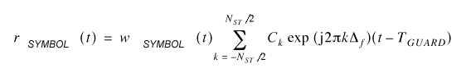
All the symbols of the signal are constructed as an inverse Fourier transform of a set of coefficients, C k , with C k defined later as data or pilots.

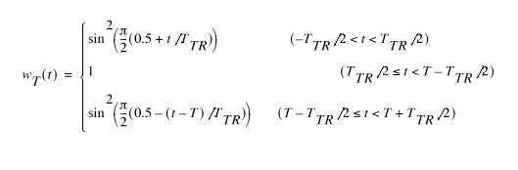
The parameters $Δ_{f}$and N ST are described in Table ***. The resulting waveform is periodic with a period of T FFT = 1/$Δ_{f}$. Shifting the time by T GUARD creates the “circular prefix” used in OFDM to avoid ISI from the previous frame. Three kinds of T GUARD are defined: for the short training sequence (= 0 µs), for the long training sequence (= T GI2 ), and for data OFDM symbols (= T GI ). The boundaries of the symbol are set by a multiplication by a time-windowing function, w TSUBFRAME (t), which is defined as a rectangular pulse, w T (t), of duration T, accepting the value T SUBFRAME . The time-windowing function, w T (t), depending on the value of the duration parameter, T, may extend over more than one period, T FFT . In particular, window functions that extend over multiple periods of the Fast Fourier Transform (FFT) are utilized in the definition of the preamble. Figure *** illustrates the possibility of extending the windowing function over more than one period, T FFT, and additionally shows smoothed transitions by application of a windowing function. In particular, window functions that extend over multiple periods of the FFT are utilized in the definition of the preamble.

In the case of vanishing T TR , the windowing function degenerates into a rectangular pulse of duration T. The normative specifications of generating the transmitted waveforms shall utilize the rectangular pulse shape. In implementation, higher T TR is typically implemented in order to smooth the transitions between the consecutive subsections. This creates a small overlap between them, of duration T TR , as shown in Figure ***. The transition time, T TR , is about 100 ns. Smoothing the transition may be required in order to reduce the spectral side-lobes of the transmitted waveform. However, the binding requirements are the spectral mask and modulation
accuracy requirements, as detailed in ***. Time domain windowing, as described here, is
just one way to achieve those objectives. The implementer may use other methods to achieve the same goal, such as frequency domain filtering. Therefore, the transition shape and duration of the transition are informative parameters.
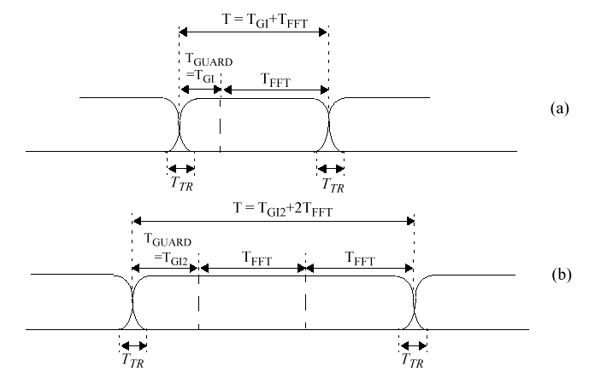

Figure ***—Illustration of OFDM frame with cyclic extension and windowing for (a) single
reception or (b) two receptions of the FFT period

19.4.6.6 Structure of the OFDM Symbol field

The following sub-clauses describe the modulation structure of the PSDU.

19.4.6.6.1 OFDM Data Symbol field

The OFDM Data Symbol field contains the PSDU data, TAIL bits, and PAD bits, if needed, as described in 19.4.6.6.2 and 19.4.6.6.3. All bits in the OFDM Symbol field are scrambled, as described in 19.2.4.

19.4.6.6.2 PSDU tail bits

The tail bit field shall be six bits of “0,” which are required to return the convolutional encoder to the “zero state.” This procedure improves the error probability of the convolutional decoder, which relies on future bits when decoding and which may be not be available past the end of the message. The tail bit field shall be produced by replacing six scrambled “zero” bits following the message end with six non-scrambled “zero” bits.

19.4.6.6.3 PSDU pad bits

The number of bits in the OFDM Symbol field shall be a multiple of N CBPS , the number of coded bits in an OFDM symbol (48, 96, 192, or 288 bits). To achieve that, the length of the message is extended so that it becomes a multiple of N DBPS, the number of data bits per OFDM symbol. At least 6 bits are appended to the message, in order to accommodate the TAIL bits, as described in 19.4.6.6.2. The number of OFDM symbols, N SYM; the number of bits in the DATA field, N DATA; and the number of pad bits, N PAD, are computed from the length of the PSDU (LENGTH) as follows:

N SYM = Ceiling ((16 + 8 × LENGTH + 6)/N DBPS )

N DATA = N SYM × N DBPS

N PAD = N DATA – (16 + 8 × LENGTH + 6)

The function ceiling (.) is a function that returns the smallest integer value greater than or equal to its argument value. The appended bits (“pad bits”) are set to “zeros” and are subsequently scrambled with the rest of the bits in the OFDM Symbol field.

19.4.6.6.4 Convolutional encoder

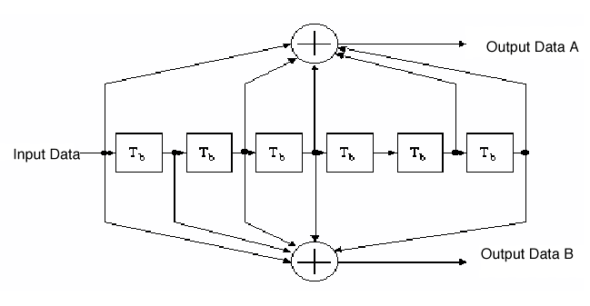
The DATA field, composed of SERVICE, PSDU, tail, and pad parts, shall be coded with a convolutional encoder of coding rate R = 1/2, 2/3, or 3/4, corresponding to the desired data rate. The convolutional encoder shall use the industry-standard generator polynomials, g 0 = 133 8 and g 1 = 171 8 , of rate R = 1/2, as shown in Figure 114. The bit denoted as “A” shall be output from the encoder before the bit denoted as “B.” Higher rates are derived from it by employing “puncturing.” Puncturing is a procedure for omitting some of the encoded bits in the transmitter (thus reducing the number of transmitted bits and increasing the coding rate) and inserting a dummy “zero” metric into the convolutional decoder on the receive side in place of the omitted bits. The puncturing patterns are illustrated in Figure ***.

Figure ***—Convolutional encoder (k = 7)

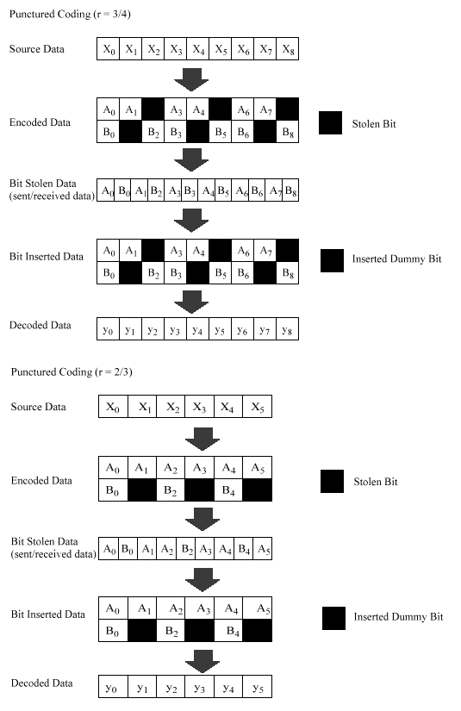
Figure 115—An example of the bit-stealing and bit-insertion procedure (r = 3/4, 2/3)

19.4.6.6.5 Data interleaving

All encoded data bits shall be interleaved by a block interleaver with a block size corresponding to the number of bits in a single OFDM symbol, N CBPS . The interleaver is defined by a two-step permutation. The first permutation ensures that adjacent coded bits are mapped onto nonadjacent subcarriers. The second ensures that adjacent coded bits are mapped alternately onto less and more significant bits of the constellation and, thereby, long runs of low reliability (LSB) bits are avoided.

We shall denote by k the index of the coded bit before the first permutation; i shall be the index after the first and before the second permutation, and j shall be the index after the second permutation, just prior to modulation mapping.

The first permutation is defined by the rule

i = (N CBPS /16) (k mod 16) + floor(k/16) k = 0,1,…,N CBPS – 1

The function floor (.) denotes the largest integer not exceeding the parameter.

The second permutation is defined by the rule

j = s × floor(i/s) + (i + N CBPS – floor(16 × i/N CBPS )) mod s i = 0,1,… N CBPS – 1

The value of s is determined by the number of coded bits per subcarrier, N BPSC , according to

s = max(N BPSC /2,1)

The deinterleaver, which performs the inverse operation, is also defined by two permutations.

Here we shall denote by j the index of the original received bit before the first permutation; i shall be the index after the first and before the second permutation, and k shall be the index after the second permutation, just prior to delivering the coded bits to the convolutional (Viterbi) decoder.

The first permutation is defined by the rule

i = s × floor(j/s) + (j + floor(16 × j/N CBPS )) mod s j = 0,1,… N CBPS – 1

where

s is defined above for the interleaver.

This permutation is the inverse of the interleaver permutation described above.

The second permutation is defined by the rule

k = 16 × i – (N CBPS – 1)floor(16 × i/N CBPS ) i = 0,1,… N CBPS – 1

This permutation is the inverse of the interleaver permutation described above.

19.4.6.6.6 Subcarrier modulation mapping

The OFDM subcarriers shall be modulated by using BPSK, QPSK, 16-QAM, or 64-QAM modulation, depending on the RATE requested. The encoded and interleaved binary serial input data shall be divided into groups of N BPSC (1, 2, 4, or 6) bits and converted into complex numbers representing BPSK, QPSK, 16-QAM, or 64-QAM constellation points. The conversion shall be performed according to Gray-coded constellation mappings, illustrated in Figure ***, with the input bit, b 0 , being the earliest in the stream. The output values, d, are formed by multiplying the resulting (I+jQ) value by a normalization factor K MOD, as described in this equation.

d = (I + jQ) × K MOD

The normalization factor, K MOD, depends on the base modulation mode, as prescribed in Table ***. The purpose of the normalization factor is to achieve the same average power for all mappings. In practical implementations, an approximate value of the normalization factor can be used, as long as the device conforms with the modulation accuracy requirements described in ***.

Table ***—Modulation-dependent normalization factor K MOD

Modulation | K MOD
BPSK | 1
QPSK | 1/√2
16-QAM | 1/√10
64-QAM | 1/√42

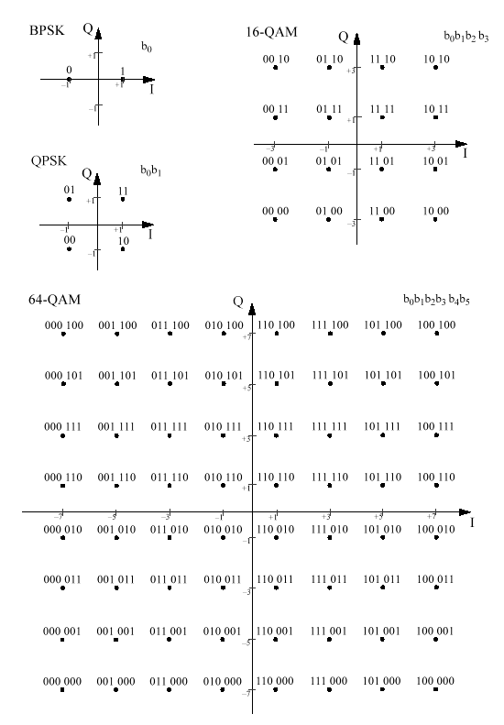
Figure ***—BPSK, QPSK, 16-QAM, and 64-QAM constellation bit encoding

For BPSK, b 0 determines the I value, as illustrated in Table ***. For QPSK, b 0 determines the I value and b 1 determines the Q value, as illustrated in Table ***. For 16-QAM, b 0 b 1 determines the I value and b 2 b 3 determines the Q value, as illustrated in Table ***. For 64-QAM, b 0 b 1 b 2 determines the I value and b 3 b 4 b 5 determines the Q value, as illustrated in Table ***.

Table ***—BPSK encoding table

Input bit (b 0 ) | I-out | Q-out
0 | –1 | 0
1 | 1 | 0

Table ***—QPSK encoding table

Input bit (b 0 ) | I-out |  | Input bit (b 1 ) | Q-out
0 | –1 |  | 0 | –1
1 | 1 |  | 1 | 1

Table ***—16-QAM encoding table

Input bits (b 0 b 1 ) | I-out |  | Input bits (b 2 b 3 ) | Q-out
00 | –3 |  | 00 | –3
01 | –1 |  | 01 | –1
11 | 1 |  | 11 | 1
10 | 3 |  | 10 | 3

Table ***—64-QAM encoding table

Input bits (b 0 b 1 b 2 ) | I-out |  | Input bits (b 3 b 4 b 5 ) | Q-out
000 | –7 |  | 000 | –7
001 | –5 |  | 001 | –5
011 | –3 |  | 011 | –3
010 | –1 |  | 010 | –1
110 | 1 |  | 110 | 1
111 | 3 |  | 111 | 3
101 | 5 |  | 101 | 5
100 | 7 |  | 100 | 7

19.4.6.6.7 Pilot subcarriers

In each OFDM symbol, four of the subcarriers are dedicated to pilot signals in order to make the coherent detection robust against frequency offsets and phase noise. These pilot signals shall be put in subcarriers –21, –7, 7 and 21. The pilots shall be BPSK modulated by a pseudo-random binary sequence to prevent the generation of spectral lines. The contribution of the pilot subcarriers to each OFDM symbol is described in 19.4.6.6.8.

19.4.6.6.8 OFDM modulation

The stream of complex numbers is divided into groups of N SD = 48 complex numbers. We shall denote this by writing the complex number d k,n , which corresponds to subcarrier k of OFDM symbol n, as follows:

d_{k,n} = d_{k+ NSD x n} , k = 0, ... N SD – 1, n = 0, ... N SYM – 1

where

N SYM is the number of OFDM symbols.

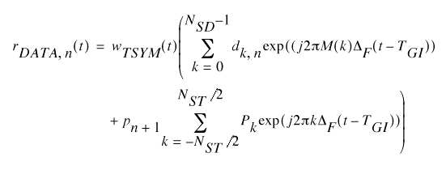
An OFDM symbol, r DATA,n (t), is defined as
where the function, M(k), defines a mapping from the logical subcarrier number 0 to 47 into frequency offset indices -26 to 26, skipping the pilot subcarrier locations and the 0 th (dc) subcarrier.
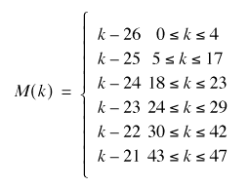

The contribution of the pilot subcarriers for the n th OFDM symbol is produced by Fourier transform of sequence P, given by

P –26, 26 = {0, 0, 0, 0, 0, 1, 0, 0, 0, 0, 0, 0, 0, 0, 0, 0, 0, 0, 0, 1, 0, 0, 0, 0, 0, 0, 0,

0, 0, 0, 0, 0, 0, 1, 0, 0, 0, 0, 0, 0, 0, 0, 0, 0, 0, 0, 0, –1, 0, 0, 0, 0, 0}

The polarity of the pilot subcarriers is controlled by the sequence, p n , which is a cyclic extension of the 127 elements sequence and is given by

P 0..126v = {1,1,1,1, -1,-1,-1,1, -1,-1,-1,-1, 1,1,-1,1, -1,-1,1,1, -1,1,1,-1, 1,1,1,1, 1,1,-1,1,
1,1,-1,1, 1,-1,-1,1, 1,1,-1,1, -1,-1,-1,1, -1,1,-1,-1, 1,-1,-1,1, 1,1,1,1, -1,-1,1,1,
-1,-1,1,-1, 1,-1,1,1, -1,-1,-1,1, 1,-1,-1,-1, -1,1,-1,-1, 1,-1,1,1, 1,1,-1,1, -1,1,-1,1,
-1,-1,-1,-1, -1,1,-1,1, 1,-1,1,-1, 1,1,1,-1, -1,1,-1,-1, -1,1,1,1, -1,-1,-1,-1, -1,-1,-1}

The sequence, p n , can be generated by the scrambler defined by Figure *** when the “all ones” initial state is used, and by replacing all “1’s” with –1 and all “0’s” with 1. Each sequence element is used for one OFDM symbol. The first element, p 0 , multiplies the pilot subcarriers of the first symbol, while the elements from p 1 on are used for the subsequent pilot symbols.
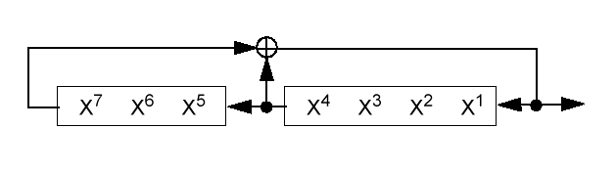
Figure *** - Pilot pn sequence generator

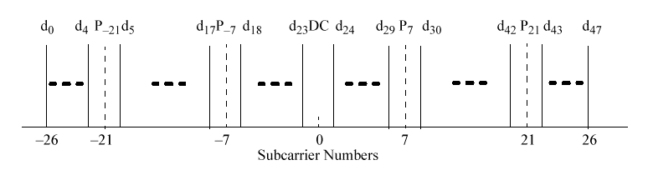
The subcarrier frequency allocation is shown in Figure ***. To avoid difficulties in dealing with D/A and A/D converter
DC offsets and carrier feedthrough in the RF system, the subcarrier falling at DC (0 th subcarrier) is not used.

Figure *** - Subcarrier frequency allocation

The concatenation of N SYM OFDM symbols can now be written as
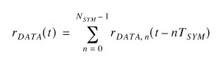

19.4.6.6.9 Signal Extension

The Signal Extension is a 6 microsecond cyclic extension of the last OFDM symbol. More precisely if for t=0 to 4 microseconds is the last OFDM symbol, then the signal extension is:

19.4.6.7 Channel Agility (optional)

This Channel Agility option allows an implementation to overcome some inherent difficulty with static channel assignments (a tone jammer), without burdening all implementations with the added cost of this capability. When the Channel Agility option is enabled, the PHY shall meet the requirements on channel switching and settling time, as described in 19.4.6.12, and the hop sequences described below. This option can also be used to implement IEEE 802.11-compliant systems that are interoperable between both FH and DS modulations. Annex F contains a description of the expected behavior when such networks are employed.

19.4.6.7.1 Hop sequences

The hop sequences for each of the specified geographical areas are defined with two sets. Extended Rate frequency channels referred to in this subclause are defined in Table ***.

The first set (Figure *** and Figure ***) uses non-overlapping frequency channels to allow the Extended Rate systems to minimize interference degradation. The synchronization of frequency hopping is performed by the MAC sublayer management entity, as defined in 11.1.15 of IEEE 802.11, 1999 Edition for the FH PHY. The PLME SAP service primitives used to command a new frequency channel are defined in 10.4 of IEEE Std 802.11, 1999 Edition.

The second set (Figure *** and Figure ***) uses half overlapping frequency channels, with 10 MHz center frequency spacing, to enable interoperability with 1 Mbit/s and 2 Mbit/s FH systems hopping with the approved IEEE 802.11 hop sequences. The Extended Rate hop frequency is calculated from the specific 1 MHz channel chosen for a given hop by picking the closest Extended Rate channel within the set. Where there is a choice of two channels, the lower one shall be the one chosen. Therefore, the chosen channel shall be no more than ± 5 MHz of the channel center of the FH channel. When operating on the FH channels beyond ± 5 MHz of the closest Extended Rate channel specified in the set, the Extended Rate mode shall not be used and all FH transmissions shall occur at the 1 Mbit/s or 2 Mbit/s rate.

19.4.6.7.2 Operating channels

The operating channels for specified geographical areas are defined in Table *** and Table ***.

Table ***—North American operating channels

Set | Number of channels | ER/OFDM channel  numbers
1 | 3 | 1, 6, 11
2 | 6 | 1, 3, 5, 7, 9, 11

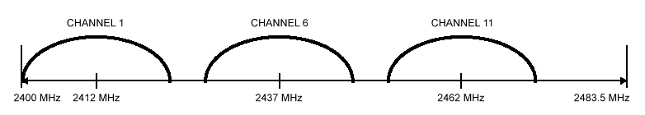

Figure ***—North American channel selection—non-overlapping

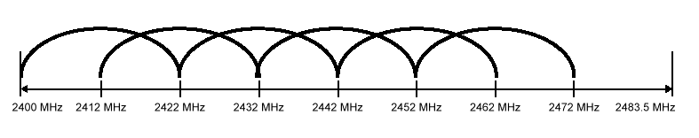

Figure ***—North American channel selection—overlapping

Table ***—European operating channels (except France and Spain)

Set | Number of channels | ER/OFDM channel  numbers
1 | 3 | 1, 7, 13
2 | 7 | 1, 3, 5, 7, 9, 11, 13

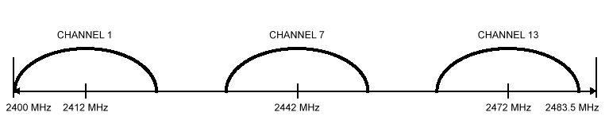

Figure 143—European channel selection—non-overlapping

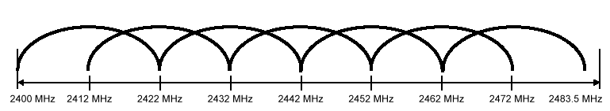

Figure ***—European channel selection—overlapping

19.4.6.7.3 Hop patterns

A frequency-hopping pattern, Fx, consists of a permutation of all frequency channels defined in Table 111 and Table 112. For a given pattern number, x, the hopping sequence can be written as

Fx = {fx (1), fx (2), ..., fx (p)}

where

fx (i) is the channel number (as defined in 14.6.4) for ith frequency in the xth hopping pattern;

p is the number of hops in pseudo-random hopping pattern before repeating sequence (79 for North America and most of Europe).

The frequency-hopping patterns for Set 1 of each geographic area are based on the hop patterns in Table *** and Table ***.

The frequency-hopping patterns for Set 2 of each geographic area are defined by the 1/2 Mbit/s FH PHY hop sequences, as described in the FH PHY (14.6.8). Given the hopping pattern number, x, and the index for the next frequency, i (in the range 1 to p), the channel number (as defined in 19.4.6.2) shall be selected with the following algorithm:

North America

f'x (i) = f'x (i) for 1 ' f'x (i) ' 11;

f'x (i) = null for f'x (i) < 1 and f'x (i) > 11;

f'x (i) = 2 × Int [({[b(i) + x] mod (79) +2} – 6) / 10] – 1;

with b(i) defined in Table 42 (14.6.8) of IEEE Std 802.11, 1999 Edition.

Most of Europe

f'x (i) = f'x (i) for 1 ' f'x (i) ' 13;

f'x (i) = null for f'x (i) < 1 and f'x (i) > 13;

f'x (i) = 2 × Int [({[b(i) + x] mod (79) +2} – 6) / 10] – 1;

with b(i) defined in Table 42 (14.6.8) of IEEE Std 802.11, 1999 Edition.

Table ***—North American Set 1 hop patterns

Index | Pattern 1 | Pattern 2
1 | 1 | 1
2 | 6 | 11
3 | 11 | 6

Table ***—European Set 1 hop patterns (except France and Spain)

Index | Pattern 1 | Pattern 2
1 | 1 | 1
2 | 7 | 13
3 | 13 | 7

19.4.6.8 Transmit and receive in-band and out-of-band spurious emissions

The Extended Rate PHY shall conform to in-band and out-of-band spurious emissions as set by regulatory bodies. For the USA, refer to FCC 15.247, 15.205, and 15.209. For Europe, refer to ETS 300–328. For Japan, refer to the MPT ordinance for Regulating Radio Equipment, Article 49-20.

19.4.6.9 Transmit-to-receive (TX-to-RX) turnaround time

The TX-to-RX turnaround time shall be less than 10 µs, including the power-down ramp specified
in 19.4.7.6.

The TX-to-RX turnaround time shall be measured at the air interface from the trailing edge of the last transmitted symbol including the signal extension/SIFs pad to the valid CCA detection of the incoming signal. The CCA should occur within 25 µs (10 µs for turnaround time, plus 15 µs for energy detect), or by the next slot boundary occurring after the 25 µs has elapsed (see 19.4.8.4). A receiver input signal 3 dB above the ED threshold described in 19.4.8.4 shall be present at the receiver.

19.4.6.10 Receive-to-transmit (RX-to-TX) turnaround time

The RX-to-TX turnaround time shall be measured at the MAC/PHY interface using PHYTXSTART.request, and shall be 5 µs. This includes the transmit power-up ramp described in 19.4.7.6.

19.4.6.11 Slot time

The slot time for the Extended Rate PHY shall be the sum of the RX-to-TX turnaround time (5 µs) and the energy detect time (15 µs specified in 19.4.8.4). The propagation delay shall be regarded as being included in the energy detect time.

19.4.6.12 Channel switching/settling time

When the Channel Agility option is enabled, the time to change from one operating channel frequency to another, as specified in 19.4.6.2, is 224 µs. A conformant PMD meets this switching time specification when the operating channel center frequency has settled to within ±60 kHz of the nominal channel center. Stations shall not transmit until after the channel change settling time.

19.4.6.13 Transmit and receive antenna port impedance

The impedance of the transmit and the receive antenna port(s) shall be 50 Ohms if the port is exposed.

19.4.6.14 Transmit and receive operating temperature range

Two temperature ranges are specified for full operation compliance to the Extended Rate PHY. Type 1 shall be defined as 0 °C to 40 °C, and is designated for office environments. Type 2 shall be defined as –30 °C to +70 °C, and is designated for industrial environments.

19.4.7 PMD transmit specifications

Subclauses 19.4.7.1 through 19.4.7.8 describe the transmit functions and parameters associated with the PMD sublayer.

19.4.7.1 Transmit power levels

The maximum allowable output power, as measured in accordance with practices specified by the appropriate regulatory bodies, is shown in Table ***. In the USA, the radiated emissions should also conform with the ANSI uncontrolled radiation emission standards (IEEE Std C95.1-1999).

Table ***—Transmit power levels

Maximum output  power | Geographic location | Compliance document
1000 mW | USA | FCC 15.247
100 mW (EIRP) | Europe | ETS 300–328
10 mW/MHz | Japan | MPT ordinance for Reg-ulating  Radio Equip-ment,  Article 49-20

19.4.7.2 Transmit power level control

Power control shall be provided for transmitted power greater than 100 mW. A maximum of four power levels may be provided. As a minimum, a radio capable of transmission greater than 100 mW shall be capable of switching power back to 100 mW or less.

19.4.7.3 Transmit spectrum mask

The transmitted spectrum shall have a 0 dBr (dB relative to the maximum spectral density of the signal) bandwidth not exceeding 18 MHz, –20 dBr at 11 MHz frequency offset, –28 dBr at 20 MHz frequency offset and –40 dBr at 30 MHz frequency offset and above. The transmitted spectral density of the transmitted signal shall fall within the spectral mask, as shown in Figure ***. The measurements shall be made using a 100 kHz resolution bandwidth and a 30 kHz video bandwidth.

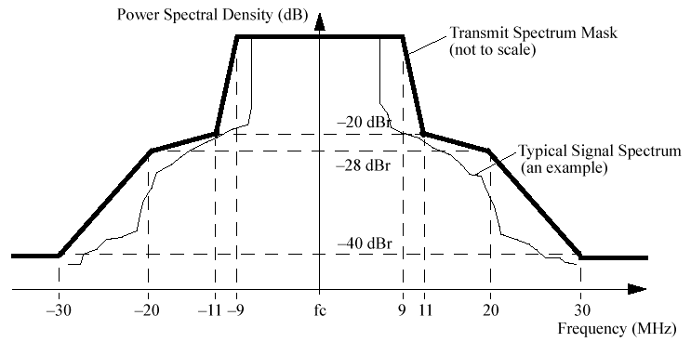
Figure ***- Transmit Spectrum Mask

19.4.7.4 Transmit center frequency tolerance

The transmitted center frequency tolerance shall be ± 20 ppm maximum. The transmit center frequency and the symbol clock frequency shall be derived from the same reference oscillator.

19.4.7.5 Transmit symbol clock frequency tolerance

The symbol clock frequency tolerance shall be ± 20 ppm maximum. The transmit center frequency and the symbol clock frequency shall be derived from the same reference oscillator.

19.4.7.6 Transmit power-on and power-down ramp

The transmit power-on ramp for 10% to 90% of maximum power shall be no greater than 2 µs. The transmit power-on ramp is shown in Figure ***.

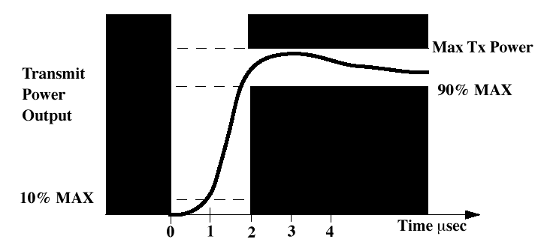
Figure ***—Transmit power-on ramp

The transmit power-down ramp for 90% to 10% maximum power shall be no greater than 2 µs. The transmit power-down ramp is shown in Figure ***.

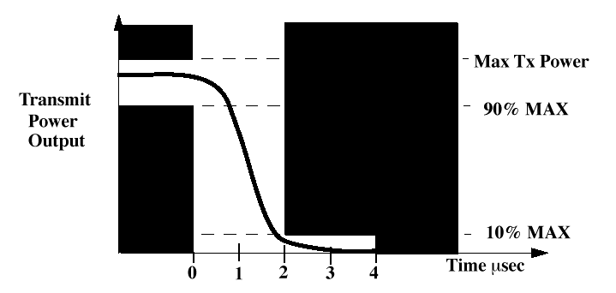
Figure ***—Transmit power-down ramp

The transmit power ramps shall be constructed such that the Extended Rate PHY emissions conform with spurious frequency product specification defined in 19.4.6.8.

19.4.7.7 Transmitter center frequency leakage

Modulation accuracy requirements are specified separately for the PLCP Preamble and PLCP Header and for the PSDU.

19.4.7.7.1 PLCP Preamble and PLCP Header transmitter RF carrier suppression

The RF carrier suppression, measured at the channel center frequency, shall be at least 15 dB below the peak SIN(x)/x power spectrum. The RF carrier suppression shall be measured while transmitting a repetitive 01 data sequence with the scrambler disabled using DQPSK modulation. A 100 kHz resolution bandwidth shall be used to perform this measurement.

19.4.7.7.2 PSDU transmitter center frequency leakage

Certain transmitter implementations may cause leakage of the center frequency component. Such leakage (which manifests itself in a receiver as energy in the center frequency component) shall not exceed -15 dB relative to overall transmitted power or, equivalently, +2 dB relative to the average energy of the rest of the subcarriers. The data for this test shall be derived from the channel estimation phase.

19.4.7.8 Transmit modulation accuracy

Modulation accuracy requirements are specified separately for the PLCP Preamble and PLCP Header and for the PSDU. A separate requirement covers the entire packet including the PLCP and PSDU.

19.4.7.8.1 PLCP Preamble and PLCP Header transmit modulation accuracy

The transmit modulation accuracy requirement for the Extended Rate PHY PLCP Preamble and PLCP Header shall be based on the difference between the actual transmitted waveform and the ideal signal waveform. Modulation accuracy shall be determined by measuring the peak vector error magnitude during each chip period. Worst-case vector error magnitude shall not exceede 0.35 for the normalized sampled chip data. The ideal complex I and Q constellation points associated with DQPSK modulation, (0.707,0.707), (0.707, –0.707), (–0.707, 0.707), (–0.707, –0.707), shall be used as the reference. These measurements shall be from baseband I and Q sampled data after recovery through a reference receiver system.

Figure*** illustrates the ideal DQPSK constellation points and range of worst-case error specified for modulation accuracy.

Error vector measurement requires a reference receiver capable of carrier lock. All measurements shall be made under carrier lock conditions. The distortion induced in the constellation by the reference receiver shall be calibrated and measured. The test data error vectors described below shall be corrected to compensate for the reference receiver distortion.

The IEEE 802.11b-compatible radio shall provide an exposed TX chip clock, which shall be used to sample the I and Q outputs of the reference receiver.

The measurement shall be made under the conditions of continuous DQPSK transmission using scrambled all one’s.

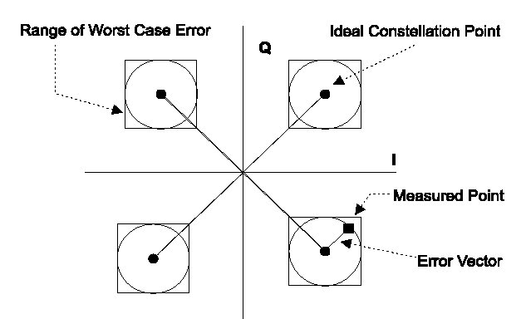

Figure ***—Modulation accuracy measurement example

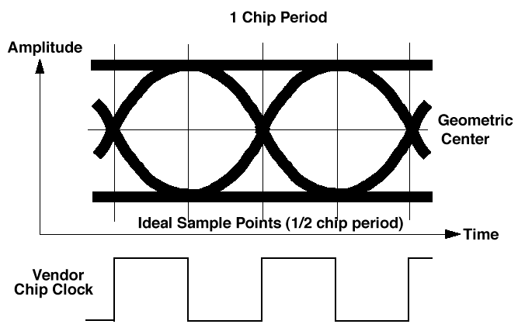
The eye pattern of the I channel shall be used to determine the I and Q sampling point. The chip clock provided by the vendor radio shall be time delayed, such that the samples fall at a 1/2 chip period offset from the mean of the zero crossing positions of the eye (see Figure 149). This is the ideal center of the eye and may not be the point of maximum eye opening.

Figure ***—Chip clock alignment with baseband eye pattern

Using the aligned chip clock, 1000 samples of the I and Q baseband outputs from the reference receiver are captured. The vector error magnitudes shall be calculated as follows:

Calculate the dc offsets for I and Q samples
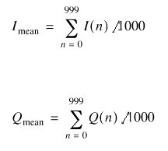

Calculate the dc corrected I and Q samples for all n = 1000 sample pairs

I dc (n) = I(n) – I mean

Q dc (n) = Q(n) – Q mean

Calculate the average magnitude of the I and Q samples
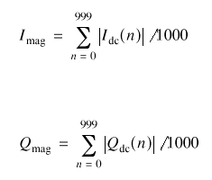

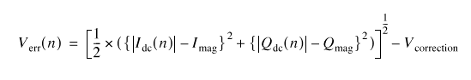
Calculate the normalized error vector magnitude for the I dc (n)/Q dc (n) pairs

where

V correction is the error induced by the reference receiver system.

A vendor Extended Rate PHY implementation shall be compliant if for all n = 1000 samples, the following condition is met:

V err (n) < 0.35

19.4.7.8.2 PSDU transmitter constellation error

The relative constellation RMS error, averaged over subcarriers, OFDM frames, and packets, shall not exceed a data-rate dependent value according to Table ***.

Table 90—Allowed relative constellation error versus data rate

Data rate (Mbits/s) | Relative constellation  error (dB)
6 | –5
9 | –8
12 | –10
18 | –13
24 | –16
36 | –19
48 | –22
54 | –25

19.4.7.8.3 PSDU transmit modulation accuracy test

The transmit modulation accuracy test shall be performed by instrumentation capable of converting the transmitted signal into a stream of complex samples at 20 Msamples/s or more, with sufficient accuracy in terms of I/Q arm amplitude and phase balance, dc offsets, phase noise, etc. A possible embodiment of such a setup is converting the signal to a low IF frequency with a microwave synthesizer, sampling the signal with a digital oscilloscope and decomposing it digitally into quadrature components. The sampled signal shall be processed in a manner similar to an actual receiver, according to the following steps, or an equivalent procedure:

a) Start of frame shall be detected.

b) Transition from short sequences to channel estimation sequences shall be detected, and fine timing (with one sample resolution) shall be established.

c) Coarse and fine frequency offset estimations shall be performed.

d) The packet shall be derotated according to estimated frequency offset.

e) The complex channel response coefficients shall be estimated for each of the subcarriers.

f) For each of the OFDM data symbols: transform the symbol into subcarrier received values, estimate the phase from the pilot subcarriers, derotate the subcarrier values according to estimated phase, and divide each subcarrier value by its complex estimated channel frequency response coefficient.

g) For each data-carrying subcarrier, find the closest constellation point and compute the Euclidean distance from it.

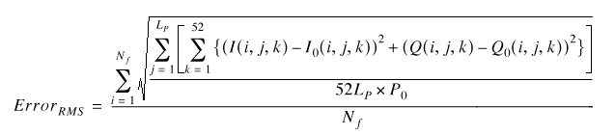
h) Compute the RMS average of all errors in a packet. It is given by:

where

L P is the length of the packet;

N f is the number of frames for the measurement;

(I 0 (i,j,k), Q 0 (i,j,k)) denotes the ideal symbol point of the i th frame, j th OFDM symbol of the
frame, k th subcarrier of the OFDM symbol in the complex plane;

(I(i,j,k), Q(i,j,k)) denotes the observed point of the i th frame, j th OFDM symbol of the frame,

k th subcarrier of the OFDM symbol in the complex plane;

P 0 is the average power of the constellation.

The vector error on a phase plane is shown in Figure ***.

The test shall be performed over at least 20 frames (N f ), and the RMS average shall be taken. The packets under test shall be at least 16 OFDM symbols long. Random data shall be used for the symbols.
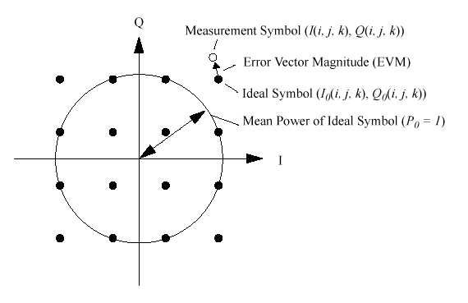

Figure ***- Constellation Error

19.4.7.8.4 Packet Transmit Accuracy

19.4.8 PMD receiver specifications

Subclauses 19.4.8.1 through 19.4.8.4 describe the receive functions and parameters associated with the PMD sublayer.

19.4.8.1 Receiver minimum input level sensitivity

The packet error rate (PER) shall be less than 10% at a PSDU length of 1000 bytes for rate-dependent input levels shall be the numbers listed in Table *** or less. The minimum input levels are measured at the antenna connector (NF of 10 dB and 5 dB implementation margins are assumed).

Table ***—Receiver performance requirements

Data rate (Mbits/s) | Minimum sensitivity  (dBm) | Adjacent channel  rejection (dB) | Alternate adjacent  channel rejection (dB)
6 | –82 | 16 | 32
9 | –81 | 15 | 31
12 | –79 | 13 | 29
18 | –77 | 11 | 27
24 | –74 | 8 | 24
36 | –70 | 4 | 20
48 | –66 | 0 | 16
54 | –65 | –1 | 15

19.4.8.2 Receiver maximum input level

The receiver shall provide a maximum FER of 8×10^{–2} at a PSDU length of 1024 octets for a maximum input level of –30 dBm measured at the antenna. This FER shall be specified for all ER/OFDM data rates. For receivers capable of extended rate (ER/OFDM) data rates, this requirement shall also apply to basic rate (BR/DSSS) and high rate (HR/DSSS) data rates.

19.4.8.3 Receiver adjacent channel rejection

The adjacent channel rejection shall be measured by setting the desired signal's strength 3 dB above the rate-dependent sensitivity specified in Table 91 and raising the power of the interfering signal until 10% PER is reached for a PSDU length of 1000 bytes. The power difference between the interfering and the desired channel is the corresponding adjacent channel rejection. The interfering signal in the adjacent channel shall be a conformant OFDM signal, unsynchronized with the signal in the channel under test. For a conformant OFDM PHY the corresponding rejection shall be no less than specified in Table ***.

19.4.8.4 CCA

The Extended Rate PHY shall provide the capability to perform CCA according to at least one of the following three methods:

— CCA Mode 1: Energy above threshold. CCA shall report a busy medium upon detecting any energy above the ED threshold.

— CCA Mode 4: Carrier sense with timer. CCA shall start a timer whose duration is 3.65 ms and report a busy medium only upon the detection of an Extended Rate PHY signal. CCA shall report an IDLE medium after the timer expires and no Extended Rate PHY signal is detected. The 3.65 ms timeout is the duration of the longest possible 5.5 Mbit/s PSDU.

— CCA Mode 5: A combination of carrier sense and energy above threshold. CCA shall report busy at least while an Extended Rate PPDU with energy above the ED threshold is being received at the antenna.
The energy detection status shall be given by the PMD primitive, PMD_ED. The carrier sense status shall be given by PMD_CS. The status of PMD_ED and PMD_CS is used in the PLCP convergence procedure to indicate activity to the MAC through the PHY interface primitive, PHY-CCA.indicate.

A busy channel shall be indicated by PHY-CCA.indicate of class BUSY. A clear channel shall be indicated by PHY-CCA.indicate of class IDLE.

The PHY MIB attribute, dot11CCAModeSupported, shall indicate the appropriate operation modes. The PHY shall be configured through the PHY MIB attribute, dot11CurrentCCAMode.

The CCA shall indicate TRUE if there is no energy detect or carrier sense. The CCA parameters are subject to the following criteria:

a) If a valid Extended Rate signal is detected during its preamble within the CCA assessment window, the energy detection threshold shall be less than or equal to –76 dBm for TX power > 100 mW;
–73 dBm for 50 mW < TX power < 100 mW; and –70 dBm for TX power < 50 mW.

b) With a valid signal (according to the CCA mode of operation) present at the receiver antenna within 5 µs of the start of a MAC slot boundary, the CCA indicator shall report channel busy before the end of the slot time. This implies that the CCA signal is available as an exposed test point. Refer to Figure 47 of IEEE Std 802.11, 1999 Edition for a slot time boundary definition.

c) In the event that a correct PLCP header is received, the Extended Rate PHY shall hold the CCA signal inactive (channel busy) for the full duration, as indicated by the PLCP LENGTH field. Should a loss of carrier sense occur in the middle of reception, the CCA shall indicate a busy medium for the intended duration of the transmitted PPDU. Upon reception of a correct PLCP header, the timer of CCA Mode 2 shall be overridden by this requirement.

Conformance to the Extended Rate PHY CCA shall be demonstrated by applying an equivalent Extended Rate compliant signal above the appropriate ED threshold (item a), such that all conditions described in items (b) and (c) above are demonstrated.

19.5 UltraShort Preamble Description (802.11a for 2.4 GHz band)

19.5.1 Overview

The ultrashort preamble option is provided for applications that do not require interoperability with existing IEEE Std 802.11b networks. The ultrashort preamble option is identical to IEEE Std 802.11a with the exception that the band of operation is the 2.4 GHz band previously occupied by 802.11b devices.

(Note: The 802.11a standard is described in subclause 17. To describe the ultrashort preamble mode, the whole of Subclause 17 could be inserted here with changes to the frequency specification.)

IEEE P802.11
Wireless LANs
Appendix A for Draft Standard CCK-OFDM:
Single-Carrier to Multi-Carrier Transition Requirements
July 9, 2001
Mark Webster, Steve Halford and Mike Seals
Intersil Corporation
Palm Bay, Florida
e-Mail: shalford@intersil.com,

Abstract

Draft IEEE Std 802.11g-2001

APPENDIX A

A. Single-Carrier to Multi-carrier Transition Requirements

The single-carrier signal segment of the packet is required to have a coherent relationship with the OFDM segment of the packet. Signal state information will be transferable from one symbol to the next, even when transitioning to OFDM. This enables high-performance, coherent receiver operation across the whole packet.

This requirement is no different in nature than that stated in other standards such as the IEEE802.11 DSSS standard, the IEEE802.11b standard and the IEEE802.11a standard. The distinction being, there the standards use a signaling scheme that is either wholly single-carrier or wholly multi-carrier. In contrast, for this mode of the 802.11g standard, both single-carrier and multi-carrier signaling is used within the context of a single packet.

This section specifies the coherent relationship between the single-carrier segment and the OFDM segment, so that the receiver has the opportunity to track through the transition without any forced parameter reacquisition. The single-carrier preamble and header provide all parametric information required for demodulation of the OFDM to within conventional estimation-in-noise accuracy. While multi-carrier sync features are provided for convenience at OFDM onset, if and how to use the multi-carrier sync for reacquisition is an implementer’s decision. Multi-carrier sync is not necessary. The packet is coherent throughout.

As shown in Figure X-1, the ideal transition would provide a constant carrier-frequency and -phase, a constant power, a constant spectrum and a constant timing relationship. The following subparagraphs establish the ideal transition characteristics for the transmit signal. An additional paragraph specifies the required implementation fidelity or accuracy.

Figure X-1 Single-carrier to multi-carrier transition definition.

A.1 Spectral Binding Requirement

The spectral binding requirement allows the receiver’s equalizer information to be transferred from the single-carrier packet segment to the multi-carrier packet segment. This requirement establishes a coherent relationship between the end-to-end frequency responses of the single-carrier and multi-carrier segments.

During reception of the single-carrier preamble-and-header, the receiver may estimate the channel impulse response (CIR). In practice, this could be accomplished through Barker-code correlation. The channel impulse response contains end-to-end frequency response information about the linear distortion experienced by the signal due to filters and multipath. This distortion can be mitigated with an equalizer or other commonly known techniques.

The CIR estimate generated during the single-carrier packet segment will include the single-carrier’s pulse-shaping-filter frequency response used to control the single-carrier’s transmit spectrum and transmit impulse response. The single-carrier’s pulse-shaping filter may be distinct from the shaping technique used for the multi-carrier segment.

The spectral binding requirement states that the linear distortion experienced by the single-carrier signal and the linear distortion experienced by the multi-carrier signal will have a known relationship. This relationship is defined by this specification and will be manifested by all compliant transmit radios. This will allow any receiver to exploit channel information derived during the single-carrier segment and reuse the channel information during the multi-carrier segment, if desired.

Three elements have been itemized for specification to achieve spectral binding. All three elements are necessary to achieve spectral binding, and they are discussed in the next three sub-sections. The first element itemized for specification focuses on distortions common to both the single-carrier packet segment and the multi-carrier packet segment. The second element itemized for specification deals with pulse shaping unique to the OFDM packet segment. The third element itemized for specification deals with pulse shaping unique to the single-carrier packet segment. The multi-carrier pulse shape discussion precedes the single-carrier’s pulse shape discussion because it is believed this will be a more comfortable progression, due to similar multi-carrier pulse shaping considerations contained in the 802.11a specification.

A.1.1 Common Linear Distortions

Separate from the single-carrier and the multi-carrier pulse shaping, transmit signal generated will be designed to provide linear distortion continuity to the receiver’s demodulation algorithms. The common linear distortion requirement is illustrated in Figure A.1.1-1, where it is shown that the processing at the receiver assumes that the dominant linear distortions are induced on all waveform segments. The receiver observes the composite linear distortion due to transmit radio filters, due to multipath filtering, and due to receive radio filters. In general, the receiver is unable to decompose the distortion into separate physical components and is only able to observer the aggregate effect. This specification constrains only the linear distortions in the transmit radio, since that is what is necessary to ensure interoperability.

Figure A.1.1-1 Linear distortions common to the single-carrier and multi-carrier signal segments.

In short, this common linear distortion requirement states that the dominant filters in the transmit radio will stay invariant and common to all waveform segments. Once the receiver has determined the end-to-end impulse response, channel information is assumed to be common to both the single-carrier signal and the multi-carrier signal. This will enable receiver design of linear-distortion mitigation techniques that do not require a reacquisition after transitioning to OFDM.

An example transmit radio analog component effected by this requirement is a surface acoustic wave (SAW) filter as depicted in Figure A.1.1-2. This filter may possess receiver-discernable amplitude ripple in the passband of the signal. Consequently, this filter must be used on both the single-carrier and multi-carrier packet segments if it is a dominant distortion mechanism.

Figure A.1.1-2 Example linear distortions in the transmit radio common to the waveform segments.

A.1.2 Symbol Shaping Unique to the OFDM Segment

OFDM spectral shaping can be achieved using two mechanisms. One, time-domain convolution filtering can be used to shape the spectrum. Two, time-domain window tapering of OFDM symbol onset and termination can be used to shape the spectrum. This second mechanism can be viewed as frequency domain convolution. The first mechanism must be common to both the OFDM and single-carrier if it is a dominant distortion mechanism. The second mechanism can be unique to the OFDM segment, since it does not affect the frequency response of the 52 sub-carriers.

The first spectral shaping mechanism using time-domain convolution filtering must be relatively common to both the single-carrier and multi-carrier segments for the reasons described in the preceding section. The receiver must not see intra-packet frequency response discontinuities that are not coherent.

Relatively common means that the designer has implementation options. Convolution filtering can be budgeted in various ways. One option would be to use a single filter which both the single-carrier and multi-carrier segments use. Another option would be to use two different physical filter realizations, one for the single-carrier segment and a second for the multi-carrier segment, say for reason of distinct sample rates or bit precision. With this second implementation option, the designer must ensure the frequency response of the filter is common to both packet segments.

The second shaping mechanism, which uses frequency-domain convolution through time-domain sub-carrier onset-and-termination shaping, can be unique to the OFDM segment. This unique technique is acceptable because it does not modify the required frequency response of the 52 sub-carriers.

Spectral shaping by tapering the OFDM symbol onset-and-termination using a time-domain window is described in the 802.11a standard and is equally germane to 802.11g systems. For convenience, one of the relevant figures from the 802.11a standard is repeated here as Figure A.1.2-1. The 802.11a suggested tapering transition duration is 0.1 usecs.

Figure A.1.2-1 Spectral shaping achieved by OFDM symbol onset and termination shaping.

The effect of time-domain windowing on a single sub-carrier’s power spectrum is shown in Figure A.1.2-2 for two cases. The first case is rectangular time-domain windowing of an OFDM symbol. The second case is for the 802.11a suggested time-domain windowing of an OFDM symbol with a 0.1 usec transition. Note the difference in frequency dependent amplitude roll-off. Adding the 52 frequency-bin-centered individual sub-carrier power spectral densities generates the composite 52 sub-carrier power-spectrum.

Figure A.1.2-2 Sub-carrier spectrum for rectangular windowing and 802.11a suggested windowing.

This type of OFDM spectrum control does not affect the relative amplitudes and phases of the individual sub-carriers. Instead it affects each sub-carrier’s power spectral density. Consequently, this type of spectrum control has a benign effect on the relative spectrums of single-carrier and the multi-carrier packet segments. That is why it can be unique.

To achieve the design goal, the implementer can budget spectral shaping in the transmit radio. Some of the spectral shaping can be achieved using time-domain convolution filtering and some may be achieved through time-domain windowing of the OFDM. In any case the transmit implementation must provide frequency response coherency.

A.1.3 Pulse Shaping Unique to the Single Carrier Segment

This section describes the pulse shaping requirements of the single-carrier packet segment. To establish frequency response coherency, it is necessary to specify the frequency response of the single-carrier signal. The way to do this is to mandate the use of a particular pulse shape by all transmitters. The frequency response of this pulse shape establishes a coherent relationship to the frequency response of the OFDM.

The frequency response of the single-carrier pulse is patterned after the tandem OFDM. The pattern is the OFDM signal as described in the 802.11a standard, with an example provided in 802.11a Annex G. The ideal OFDM signal has a flat amplitude response and zero-phase offset across 52 sub-carriers. The 802.11a standard establishes the ideal frequency-response relationship between the 12 short SYN sub-carriers, 52 long SYNC sub-carriers, the 52 SIGNAL field sub-carriers and the 52 data field sub-carriers. Similarly, the ideal relationship to the single-carrier frequency response is defined.

Relative to the ideal OFDM, the single-carrier signal will have the pulse shape established herein. In a particular implementation, it is acceptable to deviate from this ideal but only in a manner that is common to both the single-carrier signal and the multi-carrier signal across the passband of the OFDM signal. This provides the required frequency response coherency.

The specified single-carrier pulse has several nice features. The pulse is continuous in time so that it can be described independent of digital implementation. The pulse is defined with an equation, so designers can generate their own copy without loss in precision. The pulse duration is small, so digital FIR implementation generates a small number of taps without loss of precision. The bandwidth of the pulse is constrained, so a convenient range of sample rates adequately satisfies the Nyquist criteria. This enables a range of sample-rate implementation options. The pulse can be used to design multi-rate filters without loss of precision. The pulse has a distinct single-peak time-domain shape that provides easy acquisition by legacy 802.11b systems.

The frequency response of the single-carrier pulse is patterned after the tandem OFDM. The single-carrier pulse is derived from a time-windowed sinc function as shown in Figure A.1.3-1. The sinc function is the time response of an ideal brickwall filter. The brickwall filter is set equal to the bandwidth of an ideal OFDM signal. In particular, the bandwidth of the brickwall filter has been set to 52 times the 802.11a sub-carrier spacing of 20/64 MHz, or 312.5 KHz.

Figure A.1.3-1 The foundational brickwall filter.

The infinite duration impulse response of the brickwall filter must be windowed to something practical. A continuous time version of the Hanning window was used. The Hanning window and an overlay of the sinc function are shown in Figure A.1.3-2.

Figure A.1.3-2 The continuous time Hanning window.

The pulse specified for use with the single-carrier packet segment is obtained by application of the window as shown in Figure A.1.3-3. Notice that its duration is equal to an 802.11a short sync cycle, only 0.8 usecs.

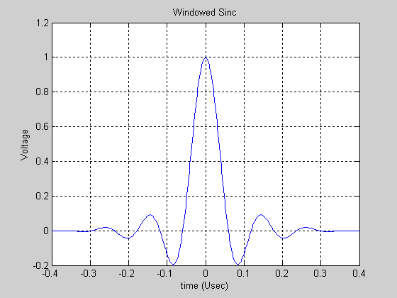
Figure A.1.3-3 The specified pulse.

The frequency response of the derived pulse is shown in Figure A.1.3-4. This pulse generates a single-carrier signal that has a spectrum nearly equal to that of the OFDM signal. This means that the receiver will experience essentially no change in receive signal power behavior even in the presence of multipath. At the point of the outer most sub-carrier in the OFDM signal, the single-carrier spectrum is down only about 4 dB. This is deemed adequate because the single-carrier preamble-header is long in duration compared to the 802.11a sync. Plenty of time is available to generate CIR information that is sufficiently accurate.

Figure A.1.3-4 The single-carrier frequency response.

In summary, the specified single-carrier pulse provides frequency response coherency between the single-carrier and multi-carrier segments of the packet. This does not mean that the spectrums are identical between segments. Rather, it means the ideal frequency responses of both are known. Beyond this, all linear distortion is common to both. It is not necessary to use this single-carrier pulse during 802.11b packet transmissions.

A.2 Sample-Power Matching Requirement

The transmit signal power shall be equal for the single-carrier and multi-carrier signal segments. The point of comparison is shown in Figure A.2-1.

Figure A.2-1 Comparing signal power.

A.3 Transition Time Alignment

This section describes how the single-carrier signal and multi-carrier signal are time aligned. The single-carrier signal uses a chip rate of 11 MHz. The OFDM signal uses a kernel sample rate of 20 MHz. The signals are easily aligned by first aligning the 11 MHz clock and the 20 MHz clock on 1-usec boundaries as shown in Figure A.3-1.

The 11 Barker chips of the preamble and header are transmitted aligned with this timing epoch. The first Barker chip is transmitted synchronous to the epoch, then the remaining 10 chips follow. This repeated over the during of the preamble and header.

Figure A.3-1 Aligning the 11 MHz and 20 MHz clock.

The peak of the continuous-time single-carrier pulse shall be aligned to this epoch as shown in Figure A.3-2.

The first full strength OFDM sample is sent on the 1-usec-epoch boundary as illustrated in Figure A.3-2. Tapering can precede this. The peak corresponds to the first full-strength sample described in 802.11a Annex G.

Figure A.3-2 Single-carrier to OFDM time alignment.

A.4 Single-Carrier Termination Requirement

The single carrier segment of a packet shall terminate in nominally 100 nsecs with the same type shaping described for 802.11a. This is depicted in Figure A.4-1. It is not necessary to completely flush the single-carrier pulse-shaping filter. This minimizes the transition time overhead.

This termination can be performed explicitly in the baseband processor or it may be provided by filters in the transmit radio.

Figure A.4-1 Single-carrier termination requirement.

A.5 Transition Carrier Frequency Requirement

The carrier frequency shall be coherent across the packet segments. This effect is depicted in Figure A.5-1.

Figure A.5-1 Carrier frequency coherency shall be maintained.

A.6 Transition Carrier Phase Requirement

The carrier phase shall be coherent across the single-carrier to multi-carrier transition. This coherency shall be differentially established relative to the phase of the last Barker word transmitted (the last 11 single-carrier chips). The OFDM as described in 802.11a shall be transmitted with one of 4 phase offsets: 0, 90, 180 or 270 degrees, depending upon the phase of the last Barker word. The phase of the OFDM shall be 45 degrees less than the phase of the last Barker word.

In a transmit implementation using I/Q signaling, it is common to maximally energize in the I-and-Q channels concurrently for BPSK or QPSK signaling. The analog stages of the transmit radio tend to perform best with this configuration. To achieve this effect, typically the BPSK or QPSK I-and-Q alignment of the Barker words are at 45 degrees, 135 degrees, -135 degrees and -45 degrees as shown in Figure A.6-1. This Barker word alignment is used to establish the phase of the OFDM signal.

Figure A.6-1 BPSK and QPSK signaling with the I/Q channels maximally energized.

Figure A.6-2 is a series of diagrams illustrating the phase relationship between the last Barker word, not the last chip, in the 802.11g header and subsequent OFDM symbols. For example, if the phase of the last Barker word is in the first quadrant at 45 degrees, then the phase of the OFDM symbols will be transmitted as described in Annex G of the 802.11a standard unmodified. However, if the phase of the last Barker word is in the second quadrant (135 degree phase) then the phase of the OFDM symbols will be rotated by +90 degrees relative to the phase of the samples in 802.11a Annex G. If the phase of the last Barker word is in the third quadrant (-135 degree phase) then the phase of the OFDM symbols will be rotated by +180 degrees relative to the phase of the samples in 802.11a Annex G. If the phase of the last Barker word is in the fourth quadrant (-45 degree phase) then the phase of the OFDM symbols will be rotated by +270 degrees relative to the phase of the samples in 802.11a Annex G.

If the transmitter generates the Barker words at some other angular relationship to the I/Q axes, then the OFDM will be transmitted at a phase 45 degrees less than the phase of the last 11-chip Barker word.

Figure A.6-2 The phase of the OFDM is established by the last Barker word.

A.7 Accuracy Requirement

The preceding sections establish signal requirements without mention of required accuracy. This section now establishes the associated accuracies. The accuracy is set in harmony with the 802.11a specification.

The required accuracy for a given transmit packet is data rate dependent. The packet accuracy is set by the data rate of the OFDM portion of the packet. The preamble and header will be transmitted with the same fidelity requirement as the fidelity requirement levied on the OFDM portion of the packet. The accuracy is shown in the following table, which is a copy of the error vector magnitude (EVM) specification set by 802.11a. For the single-carrier portion of the packet, the EVM is interpreted as normalized mean-squared error (NMSE).

Figure A.7-1 shows how the fidelity of the single-carrier portion of the packet can be measured. This document describes the ideal transmitter characteristic. An implementation is evaluated relative to this ideal. The mean squared error between an actual implementation and the ideal transmitter can be computed. The quantity is normalized by the ideal transmit signal power. The NMSE fidelity shall be no worse than the limits set by the EVM specification for 802.11a. When making the measurement, the linear distortions common to both the single-carrier and multi-carrier can be backed out. In addition, other alignments can be made that do not change the intent of this section.

Figure A.7-1 Measuring single-carrier fidelity using normalized mean-squared error.

A.8 Locked Oscillator Requirement

The oscillator driving the sample rate and the carrier frequency shall be derived off a common reference. This will allow the timing recovery to be derived using information from the carrier recovery loop.

