IEEE P802.11
Wireless LANs
Response to Functional Requirements and Comparison Criteria for Supergold Proposal for IEEE 802.11g High-Rate Standard
[date]
Tim O’Farrel, Enrique Aguado, and Colum Caldwell
Supergold Communication Ltd.
Abstract

The following are the responses to the Functional Requirements and Comparison Criteria for our proposal to IEEE 802.11g.

Functional Requirements

General Requirements

- The proposal must be an extension of the IEEE 802.11b standard.
This proposal is an extension of the IEEE 802.11b standard, incorporating all the IEEE 802.11b mandatory and optional modulation modes and the long and short preambles defined in the IEEE 802.11b standard. The proposal adds a new higher rate modulation mode with transmission bit rates at 22 and 30Mbps and a new shorter preamble.
- The proposal shall specify a PHY that implements all mandatory portions of the IEEE 802.11b PHY standard
All mandatory portions of the IEEE 802.11b PHY standard remain as such in the proposal.
- Must comply with IEEE 802 patent policy
Supergold Communication will abide fully by the IEEE patent policy.
- Backward compatibility with 802.11b
The proposed PHY will be able to interoperate with any 802.11b systems using the legacy modulation modes and preambles.
- All proposals must not render existing 802.11b compliant products non-conformant with the resulting, supplemented IEEE 802.11 2.4GHz standard.
The proposed PHY does not render existing 802.11b compliant products non-conformant with the new suplemented IEEE 802.11 2.4GHz standard
- The proposal shall not repeal any options in the IEEE 802.11b standard.
This proposal does not repeal or disable any options of the IEEE 802.11b standard.

MAC Interface Requirements
- The proposal must be compatible with the IEEE 802.11 MAC standard. Clarification note: Compatibility with the IEEE 802.11 MAC may be achieved by changes to MIB variables.
This proposed PHY will be fully compatible IEEE 802.11b MAC standard and its upcoming extensions in the same manner as the 802.11b PHY. Some minor changes to MIB variables may be required to accommodate the new transmission modes.

Performance Requirements
- The maximum PHY data rate of the proposal must be at least 20Mbps
The data rates in the new modulation mode are 22 Mbps and 30 Mbps, both above the required minimum.

RF Requirements

- All proposals shall operate in the 2.4GHz band
The proposed PHY is for the operation in the 2.4 GHz ISM band.
- Channelization same as 802.11b, i.e. same 5MHz channel spacing and center frequencies
The proposed PHY uses the same channelization as the IEEE 802.11b standard.

Comparison Criteria

General
- Modulation Technique, e.g. QPSK, QAM, OFDM, etc.
16-QAM.
- Data rates
22 Mbps and 30 Mbps.
- Reference submissions
IEEE 802.11-00/366r3 “Sequence Coded Modulation for the Higher Rate Extension to 802.11b Standard”, T. O’Farrell, L.E.Aguado, and C. Caldwell (Supergold Communication Ltd.).

MAC Related
- Required changes to interface to 802.11 MAC

Minor changes required to identify the new 22Mbps and 30 Mbps modulation modes.

Interoperability and Coexistence
- Means of achieving backward compatibility and interoperability with 802.11b
Backward compatibility is achieved by using a common radio architecture with 802.11b and supporting the 1, 2, 5.5 and 11 Mbps data rates using Barker, CCK and PBCC modulation modes and long and short preambles, as specified in the IEEE 802.11b standard.
- Impact on options in 802.11b
None. It is proposed that the 802.11b short preamble is made mandatory for 802.11g devices.
- Level of coexistence with Bluetooth 1.0b (802.15.1) and other 802 standards in the 2.4GHz. (Response to this item is optional.)
Similar to 802.11b. The proposed 802.11g solution has a band occupancy of 14MHz thanks to improved filtering, thus the probability of Bluetooth collisions is slightly reduced compared with 802.11b. Also, high rate modes will reduce the packet times, and hence the collision probability per packet.

Channelization
- Spectral characteristics
Exactly the same channelisation as used in IEEE 802.11b is adopted, 14 overlapping channels 5MHz appart in the 2.4 GHz ISM band. The power spectral density of the waveform at the input and the outout of the PA for different values of the PA parameter ‘p’ and PA backoff is shown in Figures 6 and 7.
- Adjacent channel and co-channel interference rejection
Conforms to the IEEE 802.11b spectral mask; adjacent channel interference is atenuated by 40 dB by the pulse shaping filter alone (see Figure 8).
Co-channel interference is supported by the use of MBCK modulation sequences and a robust coding scheme.

RF Characteristics
- Required carrier frequency accuracy in PPM

Same as in 802.11b, namely, ± 25 ppm.
- RF PA backoff from 1 dB compression point
To be selected as a trade-off with PER performance. Typically 4-6 dB from full saturation. This is in the region of 2-5 dB from the 1 dB compression point depending on the PA parameter p [00/393]. See PER performance versus backoff figures in point 17.

Complexity
- Equalizer complexity and performance impact. (Prefer but do not mandate description of receiver structure(s).)
The proposed waveform can be equalised by the same type as equalisers as those in IEEE 802.11b. Performance data is shown for case studies using textbook linear MMSE and MMSE-DFE equalisers to illustrate the amenability of the waveform to equalisation. These equalisers are T/4 fractionally spaced and include the pulse shape matched filter. Substantial scope exists to optimise the performance of these equalisers.
- RF/IF complexity relative to current 802.11b PHYs
Exactly the same RF/IF architecture is used as in 802.11b; as QAM is used some consideration to the PA backoff is required. Raised cosine filtering is proposed for pulse shaping, as opposed to the Butterworth filter.
- Baseband processing complexity relative to current 802.11b PHYs (gate counts, MIPS, etc.)
The additional baseband functions are the MBCK codec and the Reed-Solomon codec. Estimated implementation gate counts for these functions are 10K gates for the MBCK codec and 8K gates for the RS codec (RS(63,41) and RS(63,57)).

Performance
Additive White Gaussian Noise Interference

- AWGN PER performance at packet lengths of 100B, 1000B and 2346B
Figure 1.- BER v. E_{b}/N₀ performance for Higer Rate modes at 22 Mbps and 30 Mbps.
Figure 2.- PER v. SNR for 22 Mbps mode for different packet lengths.
Figure 3.- PER v. SNR for 30 Mbps mode for different packet lengths
- CCA mechanism description
Fundamentally supported by CC modes 1 and 5 in 802.11b.
Non-Ideal Power Amplifier Effects
- Simulate PER performance versus AWGN with packet lengths of 1000B with non-ideal power amplifier. Simulation should be run at oversample rate of 4x. Use RAPP power amplifier model as specified in document 00/294. Use P-parameters of 2 and 3. Specify backoff from full saturation used in the simulation calculated as
PA_{Backoff} = –10 log₁₀(Average TX Power/Power at saturation)
Figure 4.- PER v SNR performance for the Rapp PA model with p = 2 and a range of OBO values for the 22 Mbps mode.
Figure 5.- PER v SNR performance for the Rapp PA model with p = 3 and a range of OBO values for the 22 Mbps mode.
- Using the RAPP power amplifier model in doc. 00/294, show change in spectral characteristics due to non-ideal power amplifier as input power is swept over a reasonable range.
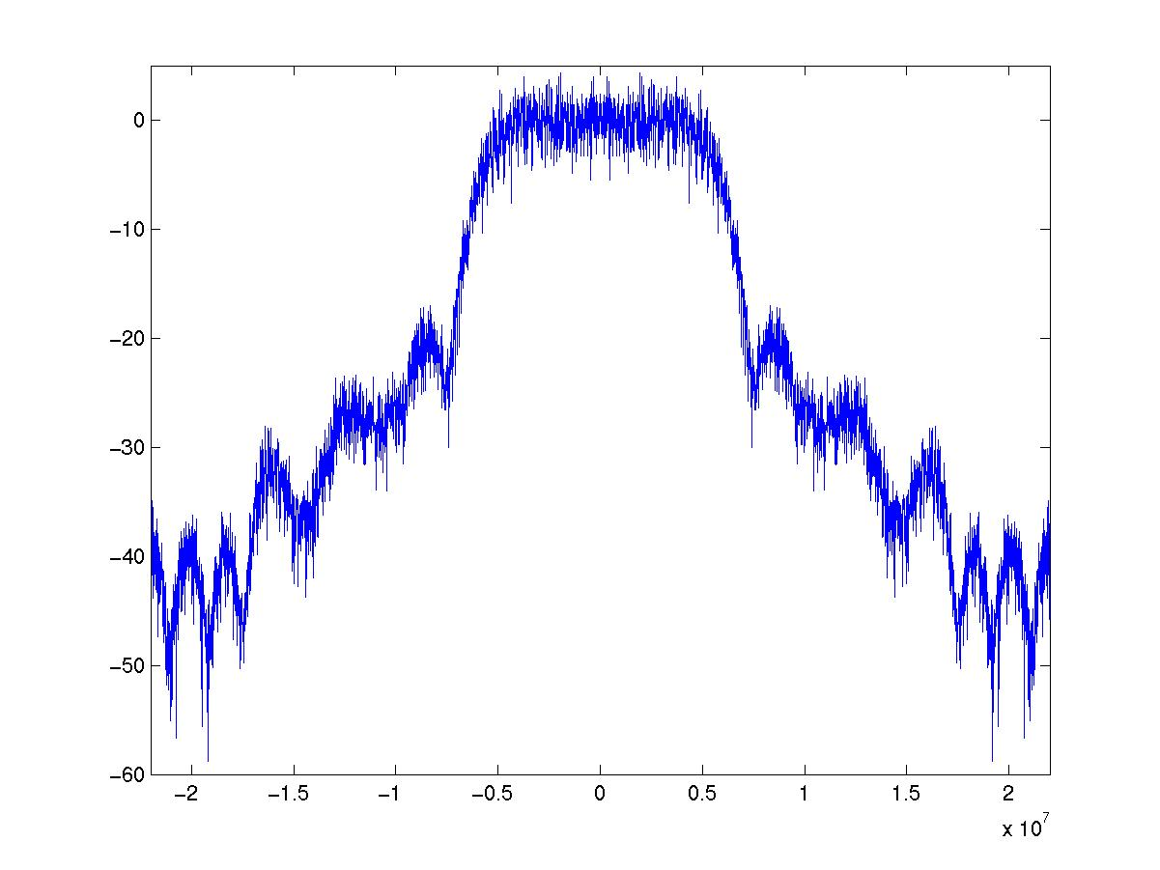
Figure 6.- Spectral characteristics for p = 2 and OBO = 4.1dB.
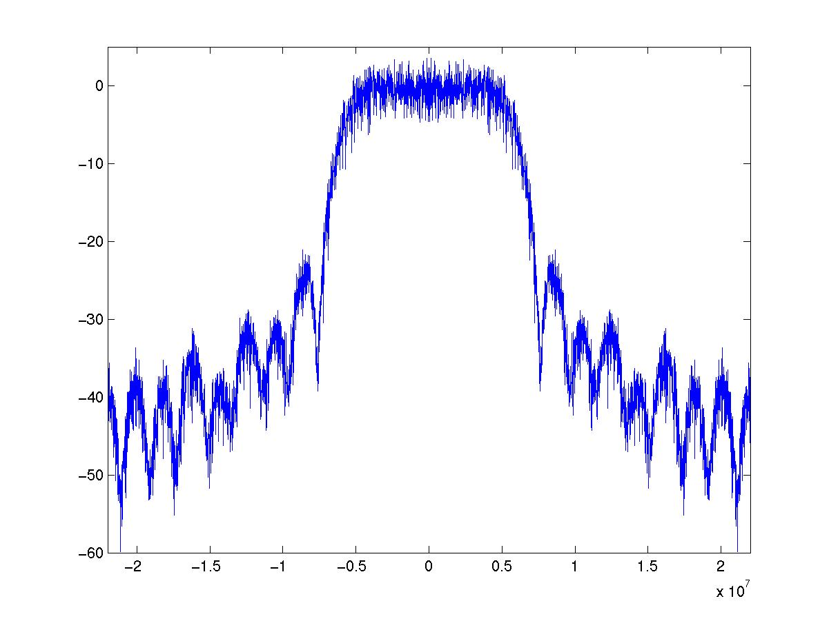
Figure 7.- Spectral characteristics for p = 3 and OBO = 3.7dB
19. Describe the pulse shaping filter used at the input to the power amplifier in items 17 and 18. Show the resulting power spectrum at the input to the PA
A square root raised cosine filter with a rolloff factor of α = 0.25 is used.
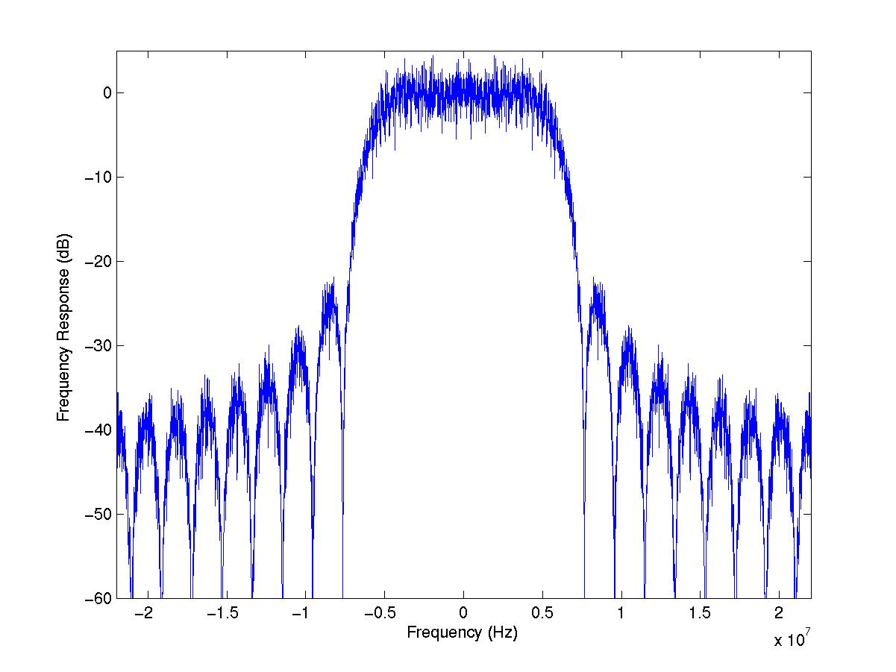
Figure 8.- Power spectrum at the input of the PA.

Throughput and Overhead

- What are the possible preambles?

The 802.11b long and short preambles are used for interoperability. To maximise throughput, use of the short preamble is preferred and, for this purpose, a new 46 μs shor preamble is proposed. The proposed preamble is not essential to the operation of the 22 Mbps and 30 Mbps higher rate extensions being proposed. A 25 μs preamble as proposed by Intersil is welcomed.

- Maximum data throughput at all combinations of:
  - Packet sizes of 100B, 1000, and 2346B
  - With and without acknowledges (ACKs)
  - All proposed preamble lengths (including 802.11b short and long preambles)

Table 1.- Throughput at 22 Mbps with ACK
Parameter | Symbol | Test condition | Value | Units
Throughput with long Preamble | S_{LP} | 100 B  1000 B  2346 B | 1.66  9.78  14.44 | Mb/s
Throughput with short preamble | S_{SP} | 100 B  1000 B  2346 B | 2.75  12.93  16.94 | Mb/s
Throughput with proposed preamble | S_{PP} | 100 B  1000 B  2346 B | 5.36  16.79  19.43 | Mb/s

Table 2.- Throughput at 22 Mbps without ACK
Parameter | Symbol | Test condition | Value | Units
Throughput with long Preamble | S_{LP} | 100 B  1000 B  2346 B | 3.36  14.14  17.79 | Mb/s
Throughput with short preamble | S_{SP} | 100 B  1000 B  2346 B | 5.62  17.03  19.57 | Mb/s
Throughput with proposed preamble | S_{PP} | 100 B  1000 B  2346 B | 11.21  20.07  21.13 | Mb/s

Table 3.- Throughput at 30 Mbps with ACK
Parameter | Symbol | Test condition | Value | Units
Throughput with long Preamble | S_{LP} | 100 B  1000 B  2346 B | 1.69  11.22  17.51 | Mb/s
Throughput with short preamble | S_{SP} | 100 B  1000 B  2346 B | 2.85  15.36  21.33 | Mb/s
Throughput with proposed preamble | S_{PP} | 100 B  1000 B  2346 B | 5.76  21.12  25.44 | Mb/s

Table 4.- Throughput at 30 Mbps without ACK
Parameter | Symbol | Test condition | Value | Units
Throughput with long Preamble | S_{LP} | 100 B  1000 B  2346 B | 3.56  17.07  22.68 | Mb/s
Throughput with short preamble | S_{SP} | 100 B  1000 B  2346 B | 6.03  21.47  25.65 | Mb/s
Throughput with proposed preamble | S_{PP} | 100 B  1000 B  2346 B | 12.97  26.52  28.41 | Mb/s

- Aggregate throughput in the 2.4GHz band (specify assumptions)
Aggregated throughput for three simultaneous co-located LANs in parallel channels operating without ACK at 22 Mbit/s or 30 Mbit/s:
Thoughput(22 Mbit/s) x 3 channels = 63.39 Mbit/s
Thoughput(33 Mbit/s) x 3 channels = 85.23 Mbit/s

Non-AWGN Distortions

- PER versus Eb/No and Es/No (where Es is measured at the output of the transmitter) with 1000B packets simulated down to a PER of 0.01 or further.
  - With flat fading only
  - RMS delay spreads of 25, 100 and 250ns using model in document 282r2 with multipath and fading
  - RMS delay spreads of 25, 100, and 250ns using model in document 282r1 with no fading, i.e. normalized channels. Normalization should be done in simulation by scaling the signal at the output of the channel on a per packet basis, not by scaling the channel response. This is demonstrated on slide 12 of document 282r2.
For b and c the multipath channel sampling rate should be 4x the fundamental symbol rate of the transmitted waveform. The receiver may be run at a sampling rate other than 4x the fundamental symbol rate of the transmitted waveform, i.e. at 1x or 2x using a downsampling scheme. Provide assumptions used in simulations.
The sampling rate used was 4x the fundamental symbol rate of the transmitted waveform for all the cases.
Simulation results are presented for case b with a linear equaliser (MMSE) and with a decision feedback equaliser (MMSE-DFE). In both cases the MMSE filter taps are T/4-spaced.
Figure 9.- PER v. SNR for the 22 Mbps mode in the flat fading channel.
Figure 10.- PER v. SNR for the 30 Mbps mode in the flat fading channel.
Figure 11.- PER v. SNR performance for the 22 Mbps mode in the fading multipath channel with fractionally spaced linear MMSE equaliser.
Figure 12.- PER v. SNR performance bound for the 22 Mbps mode in the fading multipath channel with MMSE-DFE equaliser.
Figure 13. PER vs. SNR performance for an example of a fixed length MMSE-DFE equaliser for the 22 Mbit/s mode in the fading multipath channel. The forward filter has 50 T/4 –spaced taps and the backward filter has 8 T-spaced taps.

Figure 14.- PER v. SNR for 30 Mbps mode in the fading multipath channel with MMSE equaliser.
Figure 15.- PER v. SNR for 22 Mbps mode in the ISI-only channel with MMSE equaliser.
- For each modulation mode detemine and state the SNR (Es/No) at which in AWGN only, the waveform can achieve a PER of 0.01 for packets lengths of 1000B. Using the multipath model including fading (see item 23b above), fix the amount of AWGN at the 0.01 PER level for AWGN only. Increase the RMS delay spread until the PER for 1000B packets reaches 0.1. State the RMS delay spread at this point.
For the MMSE equaliser case:
 | SNR(PER(AWGN) = 0.01) | T_rms(PER(MP) = 0.1)
22 Mbps mode | 11.1 dB | 25 ns
30 Mbps mode | 12.3 dB | 25 ns

- Performance using FCC jamming margin test. (Test specified in Section 15.247)
Figure 16.- Minimum S/J required for PER = 10⁻² with jamming as in FCC jamming test.

Non-ideal Receiver Effects

- Carrier frequency offset and degradation at worst case carrier frequency offset.
Same as 802.11b.
- Baseband timing offset accuracy and degradation at worst case baseband timing offset
Figure 17. Evaluation PER vs. SNR in the AWGN channel in the Presence of Timing Offset (Tj_rms: rms. timing jitter as percentage of symbol period) for a T/4 Time Bin
- Simulate sensitivity to phase noise using model in document 296r1. Use 3dB bandwidth of 20kHz. Sweep the RMS phase noise in degrees over a reasonable range. Show influence of carrier degradation in AWGN. Provide all assumptions, e.g. whether or not tracking loop is enabled or not. (Also reference doc. 98-156r3.)
Figure 18.- PER v. SNR performance for a range of rms. phase noise for the 22 Mbps mode.
Figure 19.- PER v. rms. phase noise performance at different SNRs for the 22 Mbps mode.

Diversity
- How does the preamble allow for training of the receiver?
Preambles function as in the 802.11b standard. A proposed preamble of 23 μs is suggested in order to illustrate the need for short preambles if throughput is to be maintained at high data rates. The proposal is not dependent on the new proposed preamble.
- Designed for receiver diversity?
None of the performance evaluations included the use of antenna diversity.
- If answer to previous question is YES, state antenna diversity and performance impact. (Prefer but do not mandate description of receiver structure(s).)
Not applicable.

Marketability
- Implementation complexity
Implementation of the MBCK codec is less complex than that of CCK. To incorporate MBCK and an RS(63,41) codec in the existing 802.11b baseband processor would require an increase in gate count of less than 20K additional gates.
- Maturity of solution and technology
MBCK is based on the same concepts and principles as the MBOK/CCK modulations. RS coding is widely used in digital communication systems as DVB-T. As there is no significant change in the RF front end, the same RF chip sets that are already available on the market could be used for the higer rate mode.
- Power consumption estimate in TX, RX (decoding packet), IDLE (listening but no packet), and SLEEP (not listening) modes. Specify model and assumptions.
Similar power consumption levels as existing WLAN cards is expected. MBCK adds an incremental power overhead of 5.54 mW for 7 kgates in the baseband processor.

